COURSE CODE: PRAC101 Section: BSIT - 41014
COURSE TITLE: OJT / PRACTICUM 1
TERM: 1st Semester, SY 2026-2027
PROFESSOR: MR. IAN ERGUIZA
NAME OF STUDENT: CAÑELAS CHRISTIAN D.

OJT NARRATIVE REPORT
A. TOPIC: BSIT MODULES 7 & 8 LECTURE SESSION - ADVANCED TECHNIQUES FOR SECURING WEB APPLICATIONS (PART 2)
B. SPEAKER: MR. MARC TONIDO
C. DURATION: 8:00 AM - 9:00 AM
D. DATE: September 23, 2026
E. SCREENSHOT OF DUTY
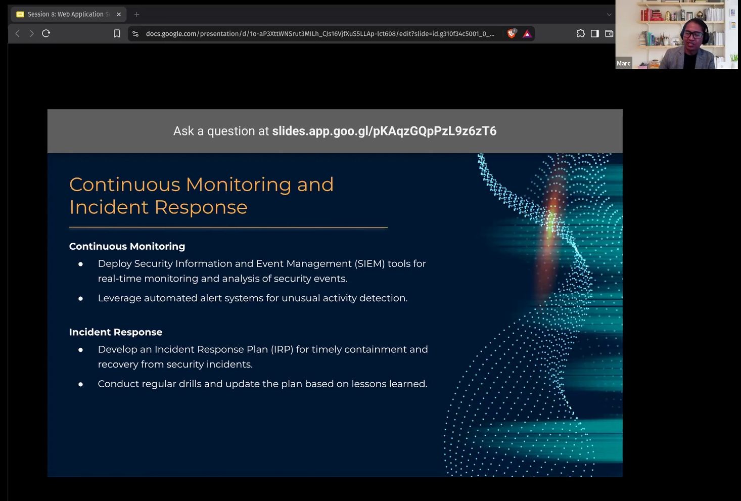

F. REFLECTION
This session was the second part of Modules 7 and 8, and it felt like a direct continuation of the previous discussion, since the last session ended with me hoping we'd get into how threats like SQL Injection, XSS, and CSRF are actually detected and dealt with once they happen. Mr. Tonido opened with a slide on Continuous Monitoring and Incident Response, and it was reassuring to see the module actually pick up right where I expected it to. He started with Continuous Monitoring, explaining that organizations typically deploy Security Information and Event Management tools, or SIEM, to gather and analyze security events in real time instead of relying on someone manually checking logs after the fact. He also mentioned leveraging automated alert systems that flag unusual activity as it happens, which made sense to me since a lot of the attacks we talked about last time, especially something like SQL Injection, would probably show up as unusual database query patterns if a proper monitoring system was actually watching for that kind of behavior.
From there, he moved into Incident Response, and the first thing he emphasized was the importance of having an actual Incident Response Plan, or IRP, in place before anything even happens, rather than scrambling to figure things out in the middle of an active breach. He described it as the document that outlines how an organization should contain a security incident and recover from it in a timely manner, which made me realize that speed really matters here, since the longer an attacker has undetected access, the more damage they can potentially do. This connected back to something we touched on in an earlier session too, since one of the reasons Jonathan James was able to explore multiple NASA systems undetected was precisely because there wasn't a fast enough response once the intrusion started, which made this part of the lecture feel a lot more concrete than just theory.
He also stressed that an IRP isn't something you just write once and forget about, since he specifically mentioned conducting regular drills and updating the plan based on lessons learned from those drills or from actual incidents. This part stuck with me because it's easy to treat a plan like this as a one-time checkbox item, but the way he framed it made it sound more like a living document that has to evolve alongside new threats and whatever gaps get exposed the last time it was actually put to the test. It made me think of it almost like a fire drill, where the value isn't really in having the plan written down somewhere, it's in everyone actually knowing what to do when something goes wrong, which only comes from practicing it regularly instead of assuming it'll just work when the time comes.
Overall, this session felt like the missing half of the previous lecture, since knowing about SQLi, XSS, and CSRF is only really useful once you also know how an organization actually catches these attacks in progress and responds to them properly. Pairing Continuous Monitoring with Incident Response also made sense as a combination, since monitoring is what lets you catch a problem early, and the response plan is what determines whether that early detection actually translates into minimal damage or turns into a much bigger mess. Going forward, I'm hoping we eventually get into more specifics on how a typical SIEM tool actually works under the hood, since right now it's still a bit abstract to me beyond just knowing that it exists and that it's meant to centralize security event monitoring.

