**Data Exploration**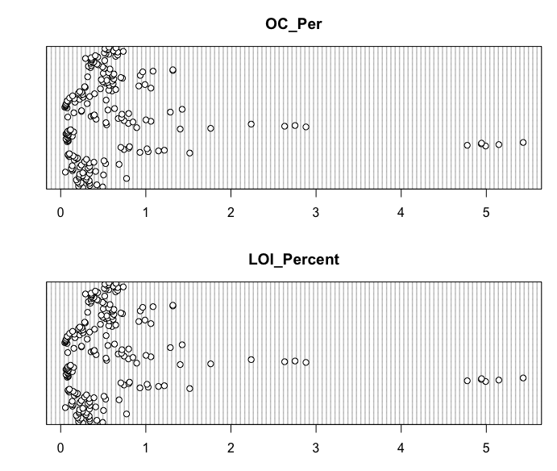

**%OC ~ LOI Regressions**

1.Model with response and predictor variable both log transformed

Model_LOI_1

2.Model with only predictor variable log transformed

Model_LOI_2

3.Model with response variable log transformed

Model_LOI_3

3.Model with response variable log transformed

Model_LOI_4

Fourqurean et al. 2012

[Paper](https://www.researchgate.net/publication/232722634_Seagrass_ecosystems_as_a_significant_global_carbon_stock)

[Supplementary](https://static-content.springer.com/esm/art%3A10.1038%2Fngeo1477/MediaObjects/41561_2012_BFngeo1477_MOESM233_ESM.pdf) – *where methods and regression is*

