**Figure 1** Graphical illustration of hypotheses for how temperature affects primary producer biomass (A-C) and net ecosystem oxygen flux (D-F) for communities dominated by autotrophs (A), autotrophs plus grazers (AG), and autotrophs plus grazers and predators (AGP). Exponential responses to temperature as modelled in Eqn 1 are plotted as linearized (log-transformed) and on 1/kT axes for later comparison with predicted slopes from Eqns 1 and 5 in the main text. If, within communities, species with different thermal niches can compensate for the effects of temperature on other species’ performance (i), we would predict no effect of temperature on biomass but positive effects of increasing temperature on net oxygen production and consumption. In the first-order metabolic scaling hypotheses (ii), NEP in systems without consumers depends on temperature consistent with the weaker temperature dependence of photosynthesis relative to respiration, which is expected to have a dominant influence on the temperature dependence of oxygen flux in systems with consumers. If trophic control of community structure (iii) modifies metabolic scaling effects on ecosystem level biomass and oxygen flux, the temperature dependence is expected to be strongest in communities in which grazers are abundant and not limited by predators.

What about allowing NEP to be positive and ER to be negative? Or at least making more clear that we are looking at *absolute* oxygen flux rates.

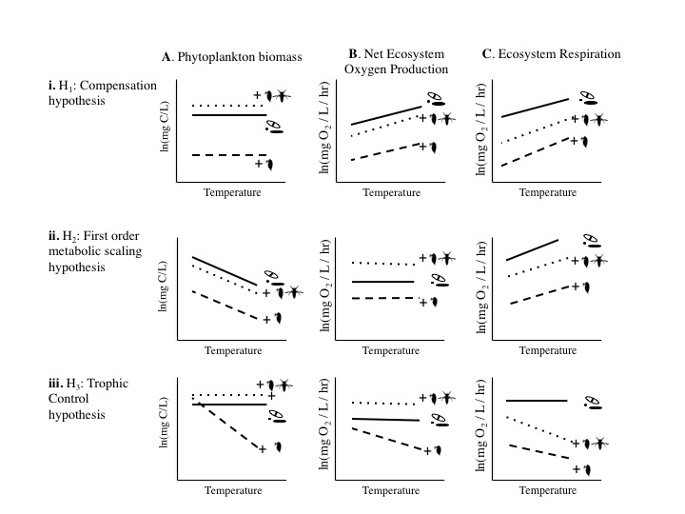

**Figure 2:** Trophic cascade strength was estimated as the natural log of the ratio of algal biomass (chlorophyll a concentration) in ecosystems at each temperature treatment in the presence and absence of predators. Each experimental system was sampled once per week for 8 weeks. Lines represent fitted effects of temperature, centered on each ecosystem’s grand mean temperature, for the model given in XX. Estiamted temperature effects ranged from Ea = XX in week 3 to Y in week 8.

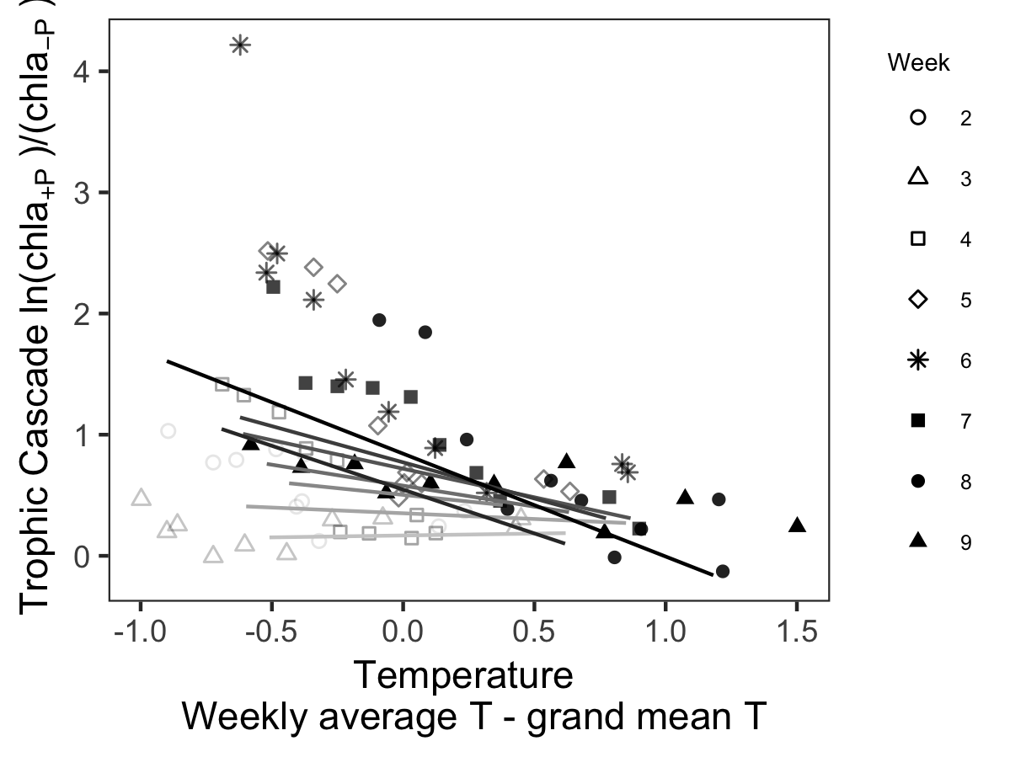

**Figure 3:** The effect of mean ecosystem temperature on A) phytoplankton biomass, B) net ecosystem productivity (NEP), and C) net ecosystem respiration (ER) for three community types that varied in their trophic interactions: i) algae-only (A), ii) algae + grazers (AG), and iii) algae + grazers + notonectid predators (AGP). Black lines indicate the among-ecosystem effects of temperature, modelled by equation 5 using hierarchical regressions fit to among-ecosystem variation in temperature, after taking into account within-group variation temperature effects (light lines) (Table 2), and may be compared with predicted effects of temperature and species interactions depicted in Figure 1. Activation energies and confidence intervals estimated by best model or best model set (Table 1, Supplementary Material 2). Temperature in Celsius is shown for comparison only, models were fit to inverse temperature. For clarity here, the three trophic treatments are separated into three rows of panels. Response variables were estimated once per week (for 6 weeks post bloom) in each replicate ecosystem (n = 30). For each ecosystem (shade of grey), 6 points are shown, one point for each week (symbols). Temperatures within tanks declined over time (Fig S1.1C).

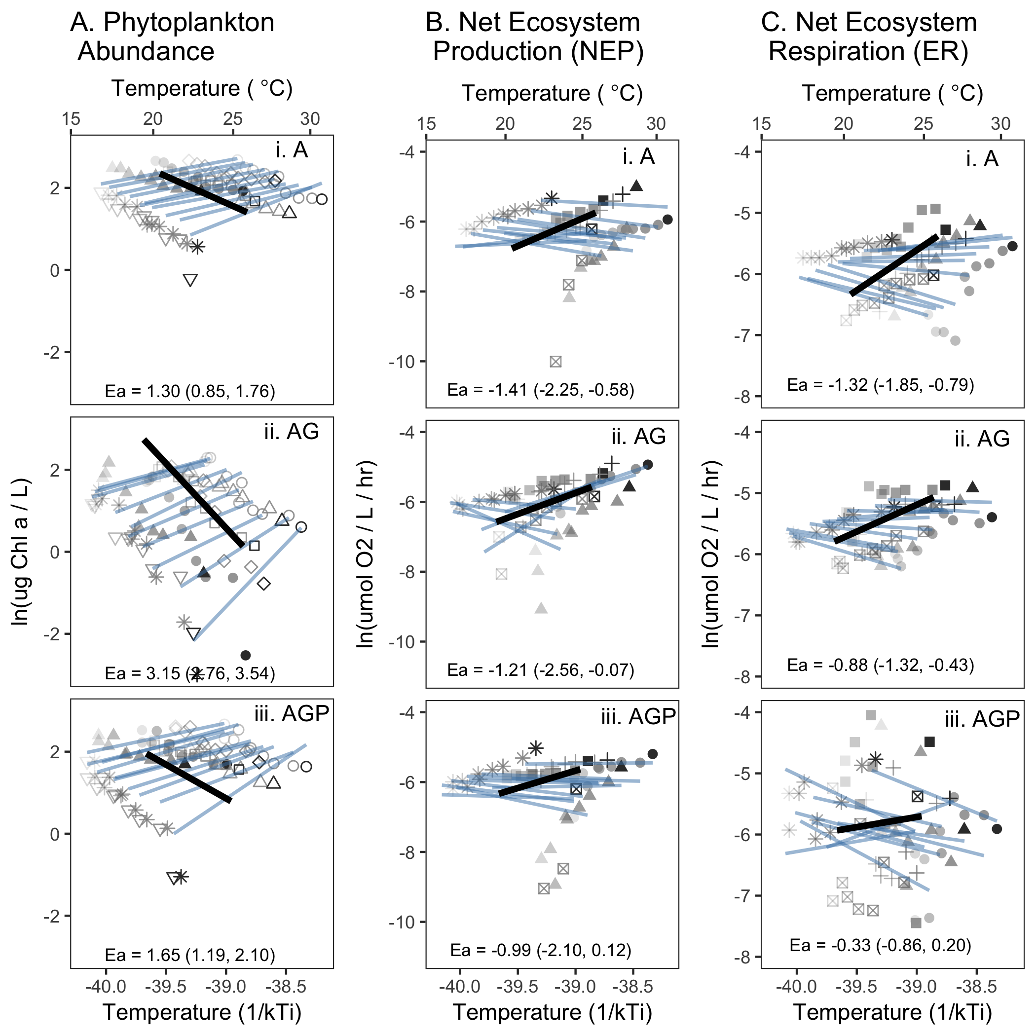

**Add a grazer figure? And maybe break figure 3 into 2 – one for among-ecosystem trends and one for within?**