private school organizer

DOCUMENTATION

Created by Zhenya Yordanova, Radoslav Stoychev, Ivan Ivanov and Magdalena Omayska

Contents

Description: 2

Diagram: 2

Explanation of functions: 3

Private school organizer

# Description:

Our project is an application to help teachers organise students’ names, EGNs and marks. It is easy to use and very useful for keeping track of grades.

# Diagram:

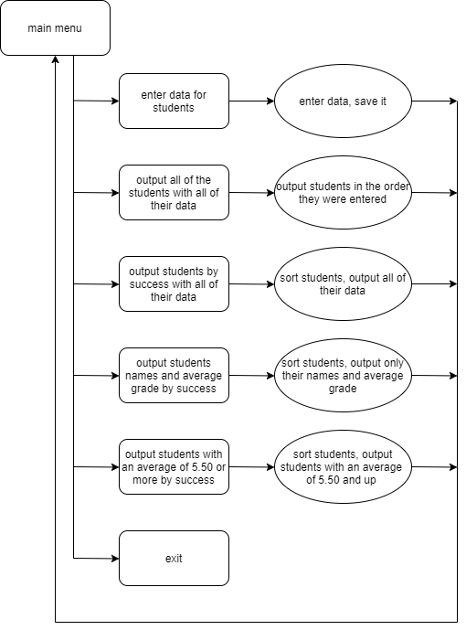

# Explanation of functions:

|  |  |  |
| --- | --- | --- |
| Function name | Purpose | Arguments |
| displayMenu | Displaying the main menu of the program | - |
| beginProgram | Chooses what function to proceed to after the user inputs their choice in the main menu | - |
| read_student | Enter student’s data | Student& students-pointer to array of type Student |
| insertDate | Make new element in the array of students (it proceeds to *read_student*) | Student* students-pointer to array of type Student |
| print_student | Outputs a student’s data (called by the function *output*) | Student& student-pointer to ?????? |
| print_student_success | Outputs student’s data after it had been sorted by the function *output_succeess* and *output_success_best* | Student& student-pointer to ?????? |
| output | Outputs all of the students’ data in order of average grade in school | Student* students-pointer to array of type Student |
| output_success | Outputs the students’ names and average grade | Student* students-pointer to array of type Students |
| output_success_best | Outputs students’ names and average grade in order of success (only if the average is 5.50 or higher) | Student* students-pointer to array of type Student |
| average | Calculates the average of each student’s grades | double* a-ponter to array of type double |
| sortStudents | Sorts students by their average grade | int n-variable of type integer  Student a[]-array of type Student (the array holds the average grades) |