VIETNAM NATIONAL UNIVERSITY OF HO CHI MINH CITY

THE INTERNATIONAL UNIVERSITY

SCHOOL OF COMPUTER SCIENCE AND ENGINEERING

****

# **CREDITCARD FRAUD DETECTION**

Topic 14 group 7

By

Nguyen Van Dat – ITITIU19100

Pham Nguyen Ngoc Mai – ITITWE19019

Nguyen Minh Quan – ITITIU18271

Do Hoang Tuan – ITITIU19229

A final project submitted to Principle of Database Management course in partial fulfillment of the requirements for the degree of finish course

Ho Chi Minh city, VietNam

Year 2021

# **TABLE OF CONTENTS**

# **INTRODUCTION**

# **CHAPTER I: LITERATURE REVIEW/ RELATED WORKS**

* 1. *WEB APPLICATION* 
     1. Why choose web application?
     2. Type of web application
  2. *REACT PROGRAMING FRONT-END FRAMEWORK*
     1. What is React?
     2. Comparing to alternative (Angular)
  3. JAVASCRIPT *PROGRAMING LANGUAGE*
     1. What is Javascript?
     2. Comparing to alternative (Dart)
  4. *MYSQL DATABASE SERVICE*
     1. What is MySQL?
     2. Why choose MySQL?

# **CHAPTER II: METHODOLOGIES/ REQUIREMENT ANALYSIS AND DESIGN**

*2.1 DATABASE DESIGNS*

2.1.1 Entity Relational Diagram

2.1.2 Relatioship Diagram

# **CHAPTER III: PROJECT IMPLEMENTATION**

*3.1 FRONT-END IMPLEMENTATIONS*

3.1.1 Implementing Logic and Authentication Services

3.1.2 Implementing State Management

3.1.3 Implementing Find User Information

3.1.4 Implementing Control User Account Logic

3.1.5 Implementing Announcement For User

3.1.6 Implementing Transaction Record Logic

3.1.7 Implementing Control Profie Logic

3.1.8 Implementing Navigation and User Interface

3.1.9 Connecting to Back-end Logic

*3.2 BACK-END IMPLEMENTATIONS*

3.2.1 Setting Up Database

3.2.2 Connecting to MySQL Database

3.2.3 Connecting to Front-end Logic

3.2.4 Implementing data update to database Logic

3.2.5 Implementing Request and Response Logic to Front-end

*3.3 RESULT*

3.3.1 Login and State Management

3.3.2 Navigation Drawer

3.3.3 Find User

3.3.4 Control User Account

3.3.5 Announcement for user

3.3.6 Profie

3.3.7 Transaction Record

# **CHAPTER IV: CONCLUSION AND FURTHER WORKS**

*4.1 CONCLUTION*

*4.2 FURTHER WORKS*

# **REFERENCES**

# **Introduction**

MDQT Bank Web Application has always been a medium for customer and employee of MDQT Bank to exchange and perform management. The transaction has been manually operated throughout the year with many difficulties. Along with the ever-growing trend of development of technology, mobile, laptop, computer are more and more powerful and convenient to aid users in many everyday tasks. One of the many web application that we can put into good use is that of Banking Web Application. MDQT Banking WebApp idea was created with the goals of electronics devices like mobile, laptop,… with many optimized real-time feature into making customer can transfer online and employee of the bank can manages the customer and account.

# **CHAPTER I: LITERATURE REVIEW/ RELATED WORKS**

* 1. *WEB APPLICATION* 
     1. Why choose web application?

Web aplication have more interactive with user. Web App is not only created to help users perform tasks and operations, but Web App is also developed with full functions and features of a complete application.In addition, the difficulty in designing a Web App is also much higher than designing a website and its administration is also quite large. Web App does not take much space to store.

* + 1. Type of web application

There are many types of web application:

* Static web application
* Dynamic web application
* Portal web application
* Animated web application
  1. *React Programing Front-end FrameWork*
     1. What is react?

React is the most popular JavaScript library for building user interfaces (UIs). It gives excellent response speed to user input using a new method of rendering web pages.

Components of this tool are developed by Facebook. It was launched as an open source JavaScript engine in 2013. It is now ahead of major competitors like Angular and Bootstrap, the two best-selling JavaScript libraries of the time.

* + 1. Comparing to alternative (Angular)
       1. *How it started?*

**[React](https://reactjs.org/" \t "_blank)**, developed by Facebook, was initially released in 2013. Facebook uses React extensively in their products (Facebook, Instagram, and WhatsApp). The current stable version is 17.X, released in October 2020 (with smaller incremental updates since then).

**[Angular](https://angular.io/" \t "_blank)**, developed by Google, was first released in 2010, making it the oldest of the lot. It is a TypeScript-based JavaScript framework. A substantial shift occurred in 2016 on the release of Angular 2 (and the dropping of the “JS” from the original name – AngularJS). Angular 2+ is known as just *Angular*. Although AngularJS (version 1) still gets updates, we will focus the discussion on Angular. The latest stable version is Angular 11, which was released in November 2020.

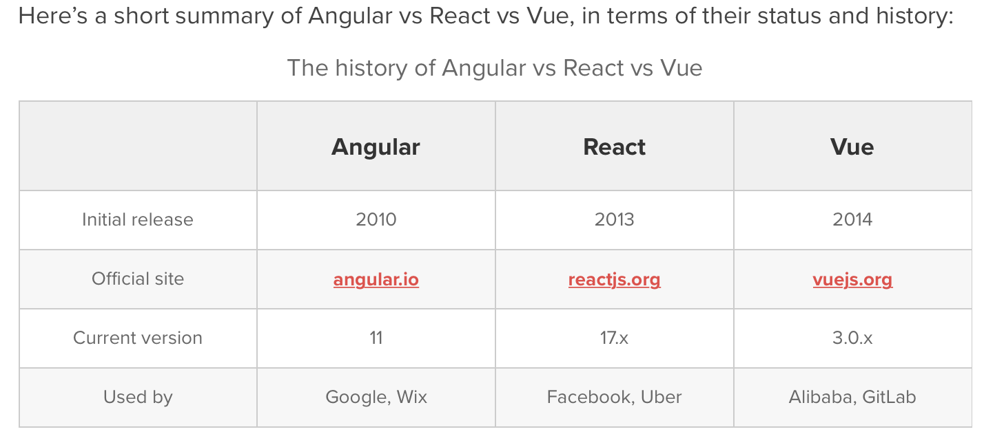

* + - 1. *Table

         Description automatically generatedCommunity and development*
      2. *Component*

React, interestingly, combines the UI and behavior of components. For instance, here is [the code to create a hello world component in React](https://reactjs.org/docs/hello-world.html" \t "_blank). In React, the same part of the code is responsible for creating a UI element and dictating its behavior.

In Angular, components are referred to as [directives](https://angular.io/api/core/Directive" \t "_blank). Directives are just markers on DOM elements, which Angular can track and attach specific behavior too. Therefore, Angular separates the UI part of components as attributes of HTML tags, and their behaviors in the form of JavaScript code. This is what sets it apart when looking at Angular vs React.

* 1. *JAVASCRIPT PROGRAMING LANGUAGE*
     1. What is Javascript?

JavaScript is commonly known as a browser scripting language, but it has also extended to many server-side and mobile application development environments. JS has been present for almost 20 years and it is safe to say that it is indeed a mature and stable programming language. JS became a lot more popular after Facebook released React and React Native frameworks.

JavaScript has its own package managers like NPM and Yarn. Although JavaScript is preferred and popular at the moment, it still has some mixed reviews among the programming community. Nevertheless, it is safe to say that JavaScript’s popularity cannot be questioned as it contains almost 2 million questions tagged on StackOverFlow.

* + 1. Comparing to alternative (Dart)

***JavaScript***

**Advantages**

* JavaScript can be used for both web and mobile apps.
* It can be used for both frontend and backend, so JavaScript can run on every device.
* JavaScript has a huge community and great frameworks available online.
* Lightweight and flexible.
* Ample amount of learning material can be found

**Disadvantages**

* Although JS has a huge set of libraries, there are ample libraries which are of poor quality and maintainence.
* Errors found only during run time.

## ***Dart***

**Advantages**

* Open source
* Backed by a large company — Google
* Typesafe and compiled with JIT and AOT.
* Backbone of Flutter
* Relatively faster in certain instances

**Disadvantages**

* Relatively new to programmers
* Learning materials are not widely available compared to JavaScript
  1. *MYSQL DATABASE SERVICE*
     1. What is mSQL?

MySQL is a database is a structured collection of data. It may be anything from a simple shopping list to a picture gallery or the vast amounts of information in a corporate network. To add, access, and process data stored in a computer database, you need a database management system such as MySQL Server. Since computers are very good at handling large amounts of data, database management systems play a central role in computing, as standalone utilities, or as parts of other applications.

* + 1. Why choose MySQL?

**The MySQL Database Server is very fast, reliable, scalable, and easy to use.** MySQL Server was originally developed to handle large databases much faster than existing solutions and has been successfully used in highly demanding production environments for several years. Although under constant development, MySQL Server today offers a rich and useful set of functions. Its connectivity, speed, and security make MySQL Server highly suited for accessing databases on the Internet.

# **CHAPTER II: METHODOLOGIES/ REQUIREMENT ANALYSIS AND DESIGN**

*2.1 DATABASE DESIGNS*

2.1.1 Entity Relational Diagram

*Account:*

**

*Type of Account:*

**

*Status of Account:*

**

*Customer:*

**

*Type of Customer:*

**

*Login Log:*

**

*Status of Login:*

**

*Transaction log:*

**

*Type of Transaction Log:*

2.1.2 Relatioship Diagram