Image Fidelity and Mechanical Screening in Text Guided Structural Plan Generation

Abstract
Image fidelity alone does not establish the engineering acceptability of generated structural layouts. We train a complete 2 × 2 × 2 factorial of text-guided generative adversarial networks — text encoder (discrete concept encoding, DCE, versus frozen CLIP ViT-B/32), conditioning fusion (Hadamard gating versus cross-attention), and an SN+EMA regularization treatment — at two native resolutions, and evaluate 96 plan–condition pairs grouped into 24 base plans. Decomposing the factorial, rather than reading configuration rankings off a table, yields three results that individual pairwise contrasts cannot show. First, at high resolution the fusion mechanism is the dominant design decision: cross-attention raises ScoreIoU by 0.077 (13.6% of the grand mean), accounts for 63% of the between-configuration sum of squares against 14% for the encoder and 1.5% for regularization, and is favoured in all four background conditions. Second, the encoder and the fusion mechanism act as substitutes rather than as complements: replacing DCE with CLIP is worth +15.1% under Hadamard gating but −0.1% once cross-attention is present, an encoder × fusion interaction of −0.037 that cancels the encoder main effect of +0.037. This quantifies why the fully augmented configuration does not lead. Third, resolution gates the entire comparison: at 256 × 128 no architectural main effect exceeds 0.005, between-configuration variance is 37 times smaller than at high resolution, the full spread of all eight configurations is only 35% of a single high-resolution fusion effect, and the two grids rank the same eight configurations almost independently (Spearman ρ = −0.24). A complementary P01 case study converts 19 source layouts into distinct ETABS 22 models. All models satisfy the specified numerical quality-control checks, but all 16 matched eight-degree models exceed the 0.001 elastic storey-drift benchmark, with governing drifts of 1.31–4.25 times that benchmark, and the configuration with the highest dataset-level composite image score does not produce the lowest drift. These findings separate geometric resemblance, numerical solvability and structural performance as distinct evaluation outcomes, and they relocate the design recommendation from a single winning configuration to a ranked set of design decisions.

Keywords
Text-guided structural design; Generative adversarial networks; Cross-modal fusion; Factorial ablation; Structural fidelity; Finite-element analysis; ETABS

Highlights
• Fusion choice dominates high-resolution fidelity: 63% of between-configuration variance.
• Text encoder and cross-attention are substitutes; their interaction cancels the encoder effect.
• At 256 × 128 every architectural main effect vanishes and rankings do not transfer (ρ = −0.24).
• Cross-attention returns about 13 times the ScoreIoU per added parameter of the CLIP branch.
• Numerical quality-control success does not establish drift acceptability.

1 Introduction
Conceptual structural design converts architectural geometry and engineering requirements into a load-bearing layout. These early decisions shape subsequent analysis, detailing, and construction cost [1]. Generative models propose candidate layouts from architectural plans and design conditions, but their usefulness depends on how those candidates are evaluated.
Knowledge-based systems [2,3], optimization [4,5], and learned generative models [6–10] provide complementary routes to structural-design automation. This study considers image-conditioned generation, in which an architectural raster and a design-condition representation are mapped to a structural-plan candidate.
Structural-plan images encode discrete walls and openings whose boundaries, proportions, and continuity affect engineering interpretation. Image similarity measures geometric resemblance, whereas structural response also depends on connectivity, physical scale, member properties, and loading. A candidate can therefore resemble a reference drawing without satisfying deformation requirements.
Previous GAN- and graph-based studies have generated wall, beam, slab, frame, and shell layouts [14–23]. However, the contribution of an encoder, fusion mechanism, or regularization package may depend on its companion modules and the target output resolution. These dependencies remain difficult to infer when several components change simultaneously.
We examine these two evaluation levels using eight GAN configurations and a common-plan reconstruction study. A complete factorial design varies text encoding, feature fusion, and SN+EMA regularization at two native resolutions. Decomposing that design into its three main effects and four interactions, rather than listing the twelve single-factor contrasts it contains, describes checkpoint performance on 96 test pairs. Nineteen P01 layouts are then reconstructed in ETABS 22 to distinguish numerical quality control from elastic response assessment. Figure 1 illustrates this pipeline from architectural sketches and design sentences to the final structural design.
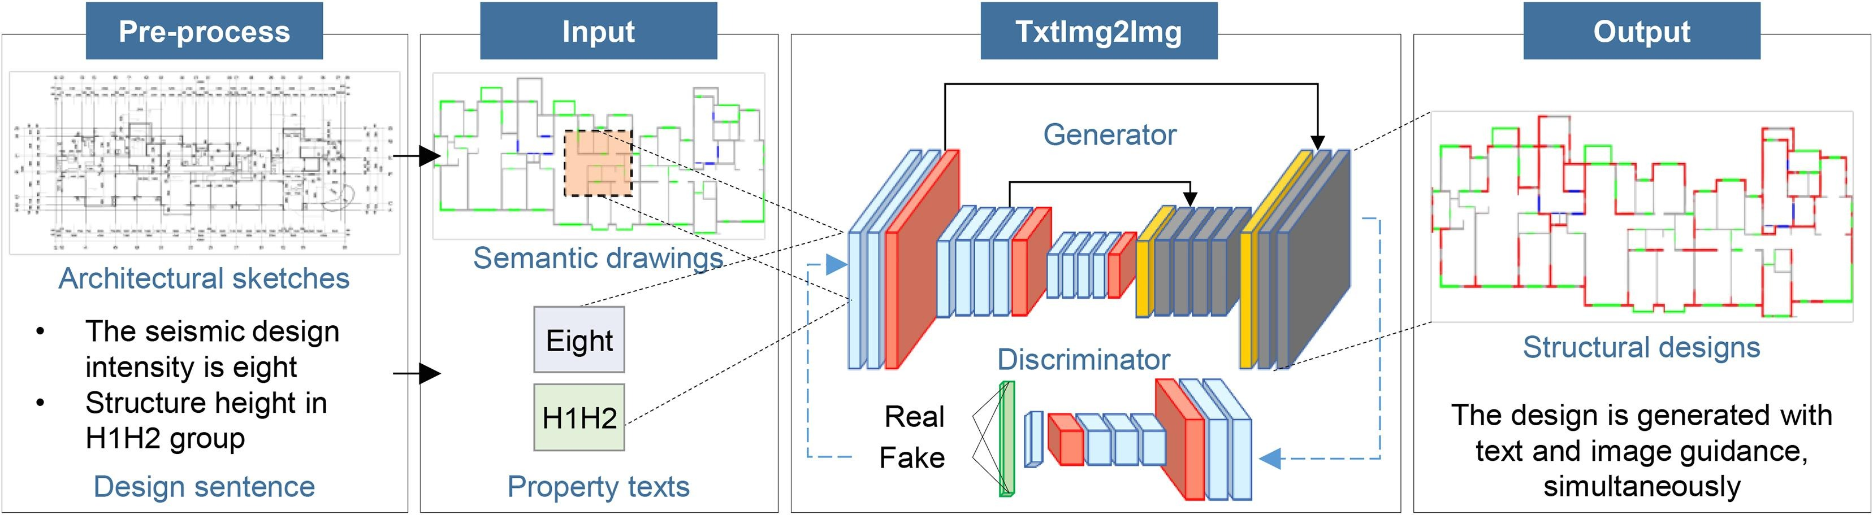
Figure 1. Architectural-image and design-condition inputs to the structural-plan generator. Architectural sketches and the design sentence (here, seismic intensity 8 and structure-height class H1H2) are pre-processed into semantic drawings and property texts, which jointly condition the TxtImg2mg generator to synthesise the final structural design. Image evaluation and mechanical assessment are described in Sections 3.4 and 3.5.
The contribution is an explicit connection between component comparison and auditable geometry-to-analysis reconstruction. Dataset-level image metrics identify geometric preferences, while the P01 models reveal response differences under a shared modeling protocol. The two analyses address complementary questions rather than interchangeable definitions of design quality.

2 Related Work
The study draws on four technical areas: generative structural design, text encoding for design conditions, cross-modal fusion, and adversarial-training regularization. We organize this literature around the component choices evaluated in the factorial comparison.

2.1 Generative Approaches for Structural Design
Generative structural-design research includes GANs [14,15,17,18], variational autoencoders [21–23], graph neural networks [15,19,20], and diffusion models [10]. Recent reviews describe their use across building and structural systems [6,11–13].
For shear-wall and frame systems, GAN- and graph-based models learn mappings from architectural layouts to structural components [14–20]. Knowledge-enhanced variants add mechanical evaluators or rule-based losses [17,18], while convolutional approaches condition wall-layout generation on design variables [29,30]. Related work has extended generative layout design to steel frame-brace systems [31].
For spatial and continuous structures, latent-variable models support design-space exploration under geometric or performance constraints [21–23]. Neural approaches have also been applied to topology optimization [32,33]. These studies broaden the application domain but do not isolate the component interactions examined here.
ControlNet [27] provides a diffusion architecture for spatial conditioning, complementing conditional image-to-image GANs [36] and denoising diffusion models [37]. These approaches motivate alternative generators, but they are not empirical baselines in the present factorial experiment. Accordingly, this study compares components within a GAN backbone and makes no claim of superiority over diffusion or retrieval methods.
Fei et al. [44] combine structural optimization with diffusion-based data enhancement for shear-wall design. Their work places training-data quality alongside generator architecture as a route to better structural layouts. The present study instead examines component choices and reconstruction-based assessment; it does not directly benchmark that diffusion workflow.

2.2 Text Encoding for Structural Design
CLIP [24] learns a shared vision-language representation from large-scale image-text pairs and is widely used to condition modern generative models. Its semantic breadth can support flexible descriptions, but it was not trained to distinguish the tightly specified attributes of structural design.
Engineering briefs use a restricted vocabulary whose terms carry explicit physical or regulatory meanings. A pretrained representation may capture broad semantics, whereas a discrete encoder can preserve direct control over the encoded design parameters (Figure 2).
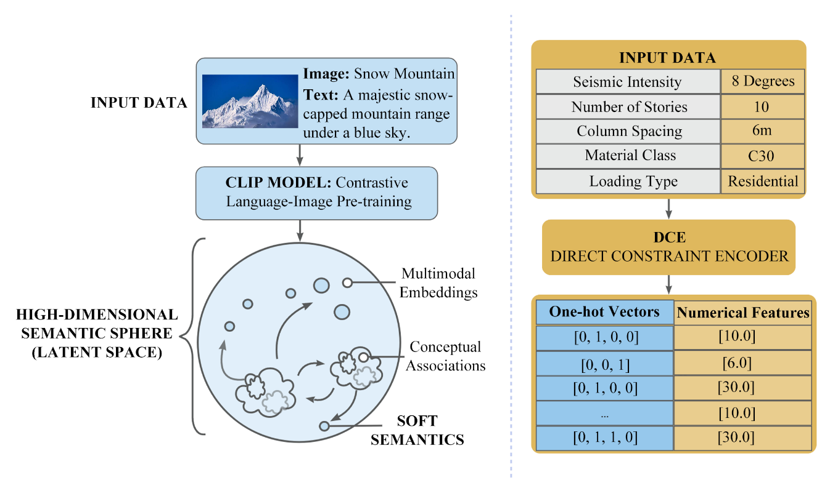
Figure 2. Comparison of pretrained vision-language encoding and discrete concept encoding (DCE).
Left: the CLIP encoder maps the paired architectural image and design text into a shared high-dimensional semantic sphere, yielding soft multimodal embeddings and conceptual associations. Right: DCE converts the structured design parameters—seismic intensity, number of storeys, column spacing, material class, and loading type—into one-hot vectors and numerical features that preserve explicit physical units and enable direct constraint checking.DCE represents each brief through parsed design parameters [6,14,16,17]. Here, the NLTK-based DCE branch and frozen CLIP ViT-B/32 encode the same dataset conditions, allowing their effects to be compared within a shared generator backbone.

2.3 Cross Modal Fusion
Fusion determines how a design-condition representation modulates image features. Cross-attention lets each image query weight the conditioning sequence, whereas Hadamard fusion applies element-wise gating. SPADE [28] and FiLM [41] provide related spatial and affine conditioning strategies.
In cross-attention [9], image features provide queries and text-derived representations provide keys and values. Each spatial query forms a weighted combination of conditioning elements. The operation therefore depends on the structure of the supplied conditioning sequence.
Hadamard fusion multiplies image features by a text-derived conditioning tensor. This operation provides element-wise modulation. Earlier structural-generation comparisons changed the encoder and regularization together [26], motivating comparisons with fixed background factors. Parameter counts can still change when the fusion module changes, so these contrasts evaluate module substitutions rather than parameter-matched mechanisms (Figure 3).
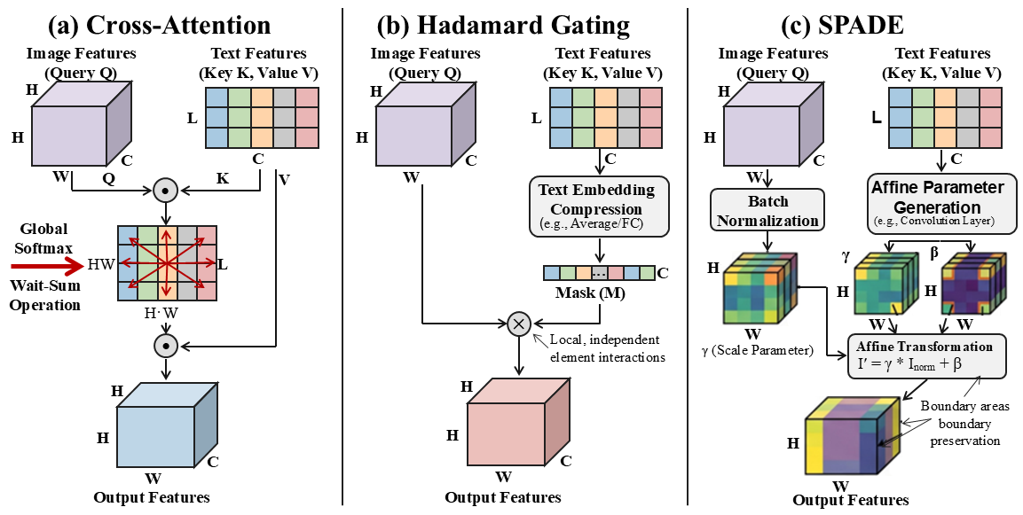Figure 3. Conditioning mechanisms considered in this study. (a) Cross-attention treats image features as queries and text features as keys and values, aggregating global context through softmax-weighted attention. (b) Hadamard gating compresses the text embedding into a channel-wise mask that modulates image features through element-wise multiplication. (c) Spatially adaptive normalization (SPADE) derives the affine parameters γ and β from the text embedding and applies them after batch normalization, which helps preserve wall-boundary areas in the output features.
SPADE derives spatially varying scale and bias from a pixel-aligned semantic layout [28]. Because the present engineering briefs provide global rather than dense spatial conditions, the factorial comparison focuses on Hadamard fusion and cross-attention.

2.4 Regularization in Generative Adversarial Networks
High-resolution adversarial training can be sensitive to the balance between generator and discriminator updates. We therefore evaluate spectral normalization (SN) and exponential moving average (EMA) as a combined regularization treatment (Figure 4).
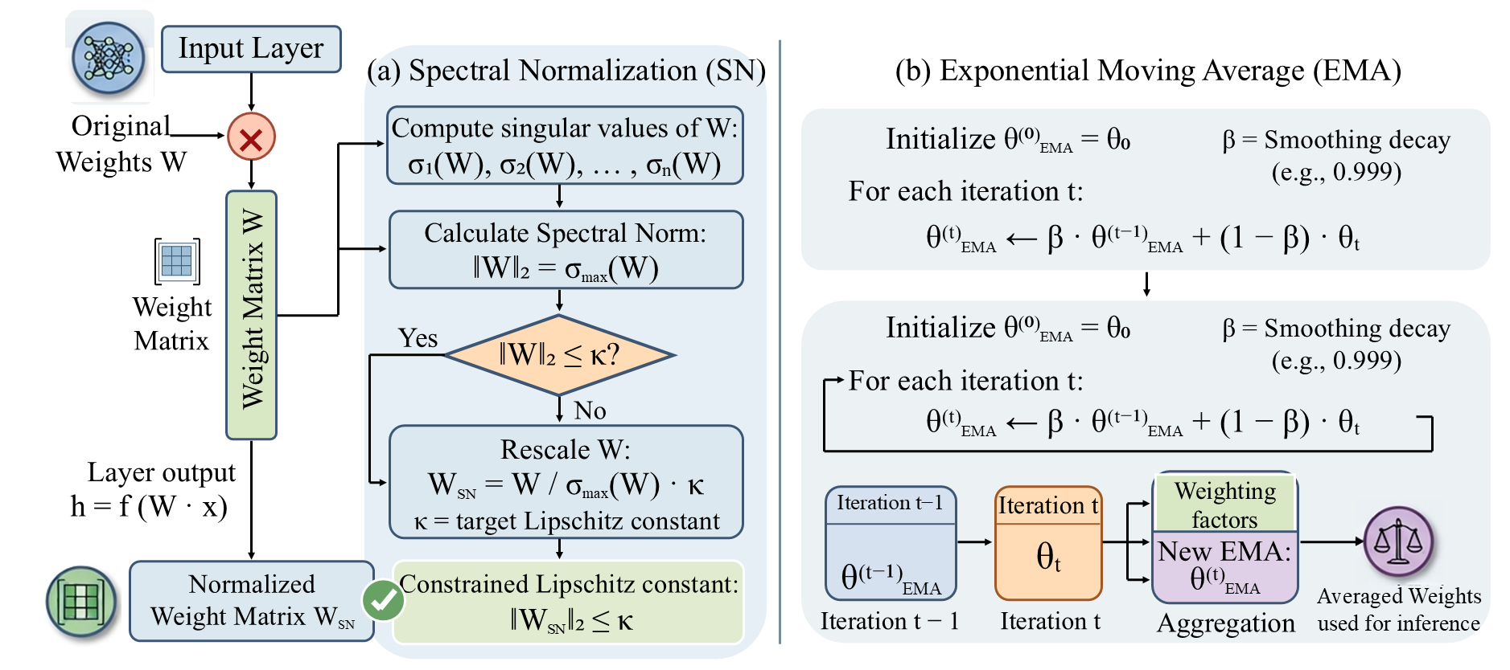
Figure 4. Training-stabilization techniques. (a) Spectral normalization rescales each discriminator weight matrix W by its largest singular value σ_max(W), bounding the layer-wise Lipschitz constant by κ. (b) Exponential moving average maintains a smoothed copy θ_EMA of the generator weights, updated with decay β (e.g., 0.999) at every iteration; the averaged weights are used at inference to suppress training oscillations.
SN constrains the scale of each discriminator layer by normalizing its weight matrix with the largest singular value [25]. In this study, SN is applied to every discriminator convolutional layer.
EMA maintains a running average of generator parameters for inference [38,39,42]. It smooths the optimization trajectory without changing the discriminator function class.
SN and EMA are evaluated jointly as one treatment. The factorial design describes how this package behaves under both encoders and fusion mechanisms; it does not identify the separate contribution of SN or EMA.

2.5 Inductive Bias Compatibility
The reviewed components define four design axes that contrast general-purpose and domain-oriented choices (Table 1). Each pairing represents a hypothesis about which inductive bias best matches discrete, topologically constrained structural layouts.
Table 1. Design axes and the hypothesized implications of each option pairing.
Design axis | Option A | Option B | Hypothesized implication
Conditioning semantics | DCE (discrete design parameters) | CLIP ViT-B/32 | Precision and interpretability vs. semantic breadth
Fusion locality | Hadamard gating | Cross-attention | Element-wise gating vs. query-specific conditioning
Optimization control | None | SN+EMA | Capacity and responsiveness vs. adversarial stability
Spatial representation | HR (1024×512, n_down = 4) | LR (256×128, n_down = 4) | Boundary detail vs. pixel density
These axes connect component design to the representation and evaluation of structural geometry.
Conditional compatibility is the hypothesis that a component's benefit depends on its companion modules and output resolution. Fixed-background contrasts make this hypothesis inspectable. Establishing statistical interactions, however, requires replicated training outcomes in addition to the factorial configuration grid.
Table 2. Representative studies on generative structural design (n.r., not reported).
Study | Generative model | Conditioning | Reported ablation control | Structural evaluation
Zhao et al. [14–16] | GAN / GNN | DCE text + architectural image | Single factor (architecture) | Class IoU
Fei et al. [17,18] | Knowledge-enhanced GAN | DCE text + image | Single factor | Class IoU + rule loss
Pizarro et al. [29,30] | CNN | Design-condition vector + image | n.r. | Pixel accuracy
Liao et al. [26] | GAN (TxtImg2Img) | DCE / CLIP text + image | Confounded (encoder + regularization) | 5-class IoU, η_SWratio
ControlNet [27] | Latent diffusion | Edge / depth / segmentation | n.r. | Natural-image metrics
This study | Conditional GAN | DCE or CLIP text + image | Complete factorial (eight configurations) | Five-class IoU, SIoU, η_SWratio, ScoreIoU, native-resolution analysis
The eight configurations provide an exploratory comparison within a shared GAN backbone. Native-grid image evaluation characterizes each deployed resolution, and the common-plan mechanical study examines a separate physical outcome. This separation prevents geometric rankings from being interpreted directly as engineering rankings.

3 Methodology
The methodology connects configuration comparison, image evaluation, and ETABS 22 reconstruction. Image metrics describe geometric fidelity under a common test protocol. Structural analysis then reports numerical checks and response benchmarks separately.

3.1 Problem Formulation and Notation
Let I denote the architectural input image and t the design brief. Following the deterministic image-conditioned formulation of pix2pixHD [40], the generator produces a structural plan as Ŝ = G(I, e(t)) without an additional noise vector.
DCE denotes the NLTK-based parsed-parameter branch, with n_captions = 2 and n_maxpersen = 16. The frozen CLIP ViT-B/32 branch produces a 512-dimensional representation followed by a learned 512 → 512 → 16384 projection. The projected representation is reshaped into the conditioning sequence used by the fusion module.
At the bottleneck, Hadamard fusion applies h′ = h ⊙ φ(e(t)). Cross-attention uses Q = hW_Q, K = EW_K, V = EW_V, and h′ = softmax(QKᵀ/√d_k)V. Here, h has shape B × N × C and E has shape B × L × d_e. B is batch size, N is the number of image positions, L is conditioning-sequence length, and d_e and d_k are embedding and key dimensions.

3.2 Dataset and Native Resolution Protocol
The inherited structs dataset [26] contains 896 training pairs and 96 held-out plan-condition pairs. The test set comprises 24 base groups, each evaluated under four condition variants: base, 7dH1, 7dH2, and 8dH1H2. Every configuration uses the same 96 cases, and the 24 base groups define the units for cluster bootstrap resampling.
Table 3. Dataset and split protocol.
Item | Value
Source | structs dataset of Liao et al. [26]
Total image–text pairs | 992 (896 training / 96 test)
Test grouping | 24 base groups, each with four condition variants
Condition variants per group | 4 (base, 7dH1, 7dH2, 8dH1H2)
Test plans per configuration | 96 (24 × 4), identical across configurations
Split unit | Inherited pair-level partition;
Prompt vocabulary / mean length | Not re-estimated; inherited from [26]
Representative prompts | base, 7dH1, 7dH2, 8dH1H2;
Image preprocessing | five-class HSV raster; HR 1024×512; LR 256×128
Low-resolution protocol | Models trained and evaluated at native 256 x 128; no test-time resizing
Pixel-to-physical scale | Not used in image metrics
The inherited training/test partition was retained without modification. The evaluation unit is a base plan, with four condition variants nested within each plan. Models are trained and evaluated at native high resolution (HR; 1024 × 512 pixels) or low resolution (LR; 256 × 128 pixels).

3.3 Architecture Configurations and Contrasts
All eight configurations use the pix2pixHD GlobalGenerator [40] with ngf = 64, nine residual blocks, instance normalization, and n_downsample_global = 4. Both resolutions use a two-scale PatchGAN discriminator with n_layers_D = 3 and ndf = 64. This shared backbone controls the architectural background while allowing the specified modules and their parameter counts to vary.
The three binary factors are the text encoder (DCE or CLIP ViT-B/32), fusion mechanism (Hadamard or cross-attention), and regularization treatment (none or SN+EMA). Their eight combinations define the complete 2 × 2 × 2 design shown in Table 4.
Table 4. Eight architecture configurations.
Model | Text Encoder | Fusion Mechanism | Spectral Norm (SN) | EMA
A0 | DCE (NLTK) | Hadamard (elementwise product) | No | No
A1 | DCE (NLTK) | Cross-attention | No | No
A2 | CLIP | Hadamard | Yes | Yes
A3 | CLIP | Hadamard | No | No
A4 | DCE (NLTK) | Cross-attention | Yes | Yes
A5 | CLIP | Cross-attention | Yes | Yes
A6 | DCE (NLTK) | Hadamard | Yes | Yes
A7 | CLIP | Cross-attention | No | No
Table 4 defines A0-A7; A5 is the complete SCAF configuration reported in prior work [26]. The factorial grid yields 12 single-factor contrasts, four per factor. Table 5 lists each contrast and the two fixed background factors.
Each contrast changes one specified factor while holding the other two fixed. HR and LR are analyzed separately because they correspond to independently trained models evaluated on different native grids.
Table 5. Twelve single-factor architecture contrasts and their fixed backgrounds.
Contrast | Factor varied | Fixed background
A0 → A1 | Fusion | DCE; no regularization
A3 → A7 | Fusion | CLIP; no regularization
A6 → A4 | Fusion | DCE; SN+EMA
A2 → A5 | Fusion | CLIP; SN+EMA
A0 → A3 | Encoder | Hadamard; no regularization
A1 → A7 | Encoder | Cross-attention; no regularization
A6 → A2 | Encoder | Hadamard; SN+EMA
A4 → A5 | Encoder | Cross-attention; SN+EMA
A0 → A6 | Regularization | DCE; Hadamard
A1 → A4 | Regularization | DCE; cross-attention
A3 → A2 | Regularization | CLIP; Hadamard
A7 → A5 | Regularization | CLIP; cross-attention

3.4 Evaluation Metrics
Reference and generated images are converted into five structural classes using HSV thresholds inherited from Liao et al. [26]. WIoU_c, SIoU, η_SWratio, and ScoreIoU provide complementary geometric summaries. The inherited composite score is retained for traceability, alongside its components. SSIM, FID, CLIP score, pixel accuracy, WallIoU, and WinIoU are secondary descriptions.

3.4.1 HSV Structural Classification
Table 6. Five structural classes and their HSV thresholds [26].
Class | Color | HSV Thresholds
Shear Wall (SW) | Red | (H < 10 or H > 156) and S ≥ 43 and V ≥ 46
Infill Wall (IW) | Gray | S < 43 and V ≥ 46 and V ≤ 220
Window (Win) | Green | 35 ≤ H ≤ 77 and S ≥ 43 and V ≥ 46
Door (Door) | Blue | 100 ≤ H ≤ 124 and S ≥ 43 and V ≥ 46
Background | White/Other | All remaining pixels

3.4.2 Primary Metric Definitions
The structural metrics measure class overlap, contour agreement, and wall-ratio preservation. FID uses 96 images with high-dimensional, natural-image Inception features; its covariance estimates are rank-deficient at this sample size. FID is therefore retained as a descriptive record and excluded from configuration selection. CLIP score is also auxiliary because CLIP-conditioned generators and this evaluator share a representation.
Class-weighted intersection over union (WIoU_c) combines per-class IoU for background, shear wall, infill wall, window, and door using weights [0, 0.4, 0.4, 0.1, 0.1]:
$$WIoU_c = 0.4·IoU_SW + 0.4·IoU_IW + 0.1·IoU_Win + 0.1·IoU_Door$$
The inherited weighting emphasizes wall classes while retaining lower weights for openings [26]. Equal segmentation weights for shear and infill walls do not imply equal structural roles.
The shear-wall ratio-preservation factor (η_SWratio) compares generated and reference shear-wall-to-infill-wall area ratios:
$$η_SWratio = 1 - |r_out - r_tar| / (r_out + ε)$$
Here, r_out and r_tar are generated and reference shear-wall-to-infill-wall area ratios, and epsilon is a positive numerical stabilizer. The denominator makes the inherited factor asymmetric: underprediction and overprediction of the same magnitude receive different penalties. The factor can be negative and is not a normalized similarity in [0, 1]. Its values are reported under the original definition, without relabeling them as a bounded score.
SIoU is the inherited contour-overlap metric [26], using OpenCV contours (RETR_TREE and CHAIN_APPROX_SIMPLE) and Shapely polygons. Its reference-directed matching is not constrained to be one-to-one. Contour hierarchy, holes, and repeated matching can therefore affect the aggregation. SIoU is reported as an implementation-specific contour score rather than assumed equivalent to IoU between two binary masks. A change to one-to-one matching would require recomputing all affected scores and rankings.
ScoreIoU combines class coverage, contour agreement, and wall-ratio preservation:
$$ScoreIoU = η_SWratio · (0.5·SIoU + 0.5·WIoU_c)$$
ScoreIoU is calculated for each image and then averaged over the 96 test pairs. Substituting the separately averaged component metrics into the formula does not reproduce this mean because the components covary across images. The composite inherits the asymmetric ratio term and is not guaranteed to lie in [0, 1]. Rankings refer to this specific legacy definition and should be read together with the component metrics.

3.4.3 Secondary Metrics
SSIM [34] describes luminance, contrast, and structural similarity. FID [35] summarizes InceptionV3 feature distributions, subject to the sample-size and domain limitations above. CLIP score reports text-image cosine similarity with ViT-B/32. WallIoU averages shear- and infill-wall IoU, WinIoU averages window and door IoU, and pixel accuracy reports the correctly classified pixel fraction.

3.4.4 Composite Score Sensitivity
The adopted ScoreIoU gives equal weight to WIoU_c and SIoU before multiplication by η_SWratio. Table 13 compares alternative mixed and single-metric aggregations. This analysis tests sensitivity to weighting, not robustness to revised contour matching, a bounded ratio factor, or independently trained seeds.

3.5 Reconstruction and Mechanical Assessment Protocol
The mechanical study uses the P01 architectural plan and 19 distinct ETABS 22 models. Sixteen models represent A0–A7 at HR and LR under 8dH1H2; two represent A7-HR under 7dH1 and 7dH2. A manually prepared layout is reconstructed separately as a geometric reference, not an independently validated design model. P01 was selected by filename and availability across configurations before inspecting ETABS responses. The three conditions use 16, 30, and 30 storeys at 3.2 m per storey, with wall thicknesses of 220, 280, and 300 mm, respectively.
The pipeline extracts semantic geometry, nodes shear-wall axes, infers beams, and inserts two slab openings per storey. RuleDesign-2 denotes the implemented beam-classification and sizing rules detailed in Appendix A, adapted within the beam-and-slab design context of [16]. Each model solves MODAL, DEAD, LIVE, SDL, PDELTA_GRAV, and separate X- and Y-direction code-based response-spectrum cases. Numerical checks require successful solution, positive modal eigenvalues, expected object counts, correct beam insertion points, zero free frame endpoints, and at least 90% cumulative modal mass in both horizontal directions.

4 Results and Discussion
The results distinguish checkpoint-level geometric fidelity, native-grid ranking behavior, and elastic response of reconstructed P01 layouts. Image comparisons use 96 test pairs grouped into 24 base plans. Mechanical comparisons use one architectural plan with alternative generated layouts, not 19 independent buildings.

4.1 Checkpoint-Level Image Fidelity
Tables 7 and 8 report geometric metrics and generator parameter counts for the evaluated HR and LR checkpoints. Figures 5–8 show metric decomposition and the reported test-group uncertainty.
Table 7. Image-evaluation results at high resolution (1024 × 512).
Model | Encoder | Fusion | Reg. | FID* | SSIM | η_SWratio | WIoU_c | SIoU | ScoreIoU | Params (M)
A0 | DCE | Hadamard | None | 19.62 | 0.970 | 0.858 | 0.616 | 0.550 | 0.512 | 228.6
A1 | DCE | Cross-Attn | None | 13.31 | 0.977 | 0.869 | 0.691 | 0.653 | 0.598 | 229.9
A2 | CLIP | Hadamard | SN+EMA | 14.65 | 0.975 | 0.876 | 0.665 | 0.602 | 0.569 | 237.3
A3 | CLIP | Hadamard | None | 14.33 | 0.975 | 0.886 | 0.666 | 0.571 | 0.556 | 237.3
A4 | DCE | Cross-Attn | SN+EMA | 12.85 | 0.977 | 0.931 | 0.705 | 0.586 | 0.607 | 229.9
A5 | CLIP | Cross-Attn | SN+EMA | 13.79 | 0.977 | 0.870 | 0.694 | 0.632 | 0.591 | 238.6
A6 | DCE | Hadamard | SN+EMA | 16.52 | 0.968 | 0.888 | 0.612 | 0.431 | 0.465 | 228.6
A7 | CLIP | Cross-Attn | None | 12.95 | 0.977 | 0.906 | 0.708 | 0.622 | 0.613 | 238.6
Values summarize evaluated checkpoints (96 pairs; 24 base plans). Display rounding does not represent measurement uncertainty; Figure 5 shows the reported test-group intervals.
Table 8. Image-evaluation results at low resolution (256 × 128).
Model | Encoder | Fusion | Reg. | FID* | SSIM | η_SWratio | WIoU_c | SIoU | ScoreIoU | Params (M)
A0 | DCE | Hadamard | None | 37.93 | 0.940 | 0.857 | 0.558 | 0.524 | 0.476 | 228.6
A1 | DCE | Cross-Attn | None | 36.13 | 0.932 | 0.852 | 0.526 | 0.497 | 0.449 | 229.9
A2 | CLIP | Hadamard | SN+EMA | 36.60 | 0.932 | 0.864 | 0.539 | 0.507 | 0.464 | 237.3
A3 | CLIP | Hadamard | None | 38.65 | 0.930 | 0.852 | 0.534 | 0.511 | 0.458 | 237.3
A4 | DCE | Cross-Attn | SN+EMA | 34.85 | 0.935 | 0.855 | 0.545 | 0.523 | 0.470 | 229.9
A5 | CLIP | Cross-Attn | SN+EMA | 33.09 | 0.937 | 0.848 | 0.549 | 0.522 | 0.468 | 238.6
A6 | DCE | Hadamard | SN+EMA | 36.66 | 0.939 | 0.858 | 0.557 | 0.509 | 0.470 | 228.6
A7 | CLIP | Cross-Attn | None | 38.32 | 0.936 | 0.848 | 0.548 | 0.524 | 0.469 | 238.6
Values summarize evaluated checkpoints (96 pairs; 24 base plans). Display rounding does not represent measurement uncertainty; Figure 5 shows the reported test-group intervals.
At HR the observed ScoreIoU spans 0.465–0.613, and the component metrics do not order the configurations identically: the highest composite, wall-ratio and contour values fall in different rows (A7, A4 and A1, respectively). At LR the same eight configurations span a much narrower 0.449–0.476. The margins between adjacent configurations are small relative to the reported test-group intervals — A7 exceeds A4 by 1.0% of ScoreIoU — so these tables are not read here as a ranking. Section 4.2 instead analyses the same eight cells as the factorial design they form.

4.2 Factorial Effect Decomposition
The eight configurations form a complete 2 × 2 × 2 design, so the twelve pairwise contrasts of Table 5 can be replaced by the seven orthogonal terms of the design itself. Table 9 reports, for each resolution separately, the effect of every main factor and interaction on ScoreIoU together with its share of the between-configuration sum of squares. Because the eight cells are single evaluated checkpoints rather than replicated training runs, these terms are exact decompositions of the observed grid and not estimates of population effects; we therefore report them alongside the sign-consistency evidence of Table 11, which requires no replication. The twelve individual contrasts are retained as a record in Appendix C.
Table 9. Factorial decomposition of ScoreIoU (complete 2 × 2 × 2, each resolution analysed separately).
Term | HR effect | HR % of mean | HR SS share | LR effect | LR % of mean | LR SS share
Encoder (CLIP − DCE) | +0.0367 | +6.5% | 14.4% | −0.0015 | −0.3% | 0.9%
Fusion (cross-attn − Hadamard) | +0.0767 | +13.6% | 62.9% | −0.0030 | −0.6% | 3.6%
Regularization (SN+EMA − none) | −0.0118 | −2.1% | 1.5% | +0.0050 | +1.1% | 10.0%
Encoder × Fusion | −0.0373 | −6.6% | 14.8% | +0.0105 | +2.3% | 44.1%
Encoder × Regularization | +0.0072 | +1.3% | 0.6% | −0.0025 | −0.5% | 2.5%
Fusion × Regularization | +0.0052 | +0.9% | 0.3% | +0.0050 | +1.1% | 10.0%
Encoder × Fusion × Reg. | −0.0228 | −4.0% | 5.5% | −0.0085 | −1.8% | 28.9%
Grand mean | 0.5639 | — | — | 0.4655 | — | —
Effect = mean(+ level) − mean(− level) over the four cells at each level. SS share is the term’s share of the total between-configuration sum of squares. Computed from the original unrounded checkpoint summaries of Tables 7 and 8; the eight cells are single checkpoints, so the terms are exact for the observed grid and are not estimates across training seeds.
At high resolution the decomposition is strongly concentrated. The fusion mechanism contributes +0.0767 ScoreIoU, 13.6% of the grand mean and 62.9% of the between-configuration sum of squares, against 14.4% for the text encoder and 1.5% for the SN+EMA treatment. Cross-attention is favoured in all four background conditions, with a median contrast of +0.0715 (Table 11); a sign test on four backgrounds cannot reach conventional significance (p = 0.125), but no other factor achieves a unanimous sign pattern at either resolution. Within the evaluated checkpoints, therefore, the conditioning mechanism — not the text encoder and not the regularization package — is the design decision that separates configurations.
The encoder × fusion interaction (−0.0373) is almost exactly as large as the encoder main effect (+0.0367) and opposite in sign, which means the two are not independent design choices. Table 10 gives the marginal means. Under Hadamard gating, replacing DCE with CLIP raises ScoreIoU from 0.4885 to 0.5625 (+15.1%); under cross-attention the same substitution changes ScoreIoU from 0.6025 to 0.6020 (−0.1%). Symmetrically, cross-attention is worth +23.3% on top of DCE but only +7.0% on top of CLIP. The two components therefore behave as substitutes for one another rather than as complements: each supplies a route by which the design condition can modulate image features at finer granularity, and whichever is introduced first captures nearly all of the available gain. Figure 9(b) shows this as the convergence of the two encoder levels.
Table 10. Marginal means and conditional effects of encoder and fusion at HR (ScoreIoU).
Encoder | Hadamard | Cross-attention | Fusion effect
DCE | 0.4885 | 0.6025 | +23.3%
CLIP | 0.5625 | 0.6020 | +7.0%
Encoder effect | +15.1% | −0.1% | E × F = −0.0373
DCE (A6 winsorised) | 0.5149 | 0.6025 | +17.0%
Encoder effect (winsorised) | +9.2% | −0.1% | E × F = −0.0240
Each marginal mean averages the two regularization levels. The final two rows repeat the analysis with the anomalous A6-HR SIoU replaced by the seven-configuration minimum (Section 4.4); the substitution pattern is unchanged.
This substitution accounts quantitatively for the behaviour of the fully augmented configuration. Adding cross-attention alone to A0 is worth +0.086 and adding CLIP alone is worth +0.044, so a purely additive model predicts 0.642 for A7; the observed value is 0.613, a shortfall of 0.029. Equivalently, the CLIP upgrade retains only 34% of its standalone value once cross-attention is already present (+0.015 against +0.044), and the stacked pair realises 78% of the sum of the two separate gains. The further addition of SN+EMA (A5) does not close the gap. The ordering A7 > A5 is thus not evidence that regularization is harmful; it is the expected consequence of combining two components that address the same bottleneck.
The SN+EMA treatment has no detectable main effect at this sample size: −0.0118 ScoreIoU, 1.5% of the sum of squares, with two positive and two negative signs across backgrounds and a median contrast of −0.0065. We therefore report it as undetermined under the present protocol rather than as a stability–detail trade-off, which the data do not resolve.
Table 11. Sign consistency across the four background conditions, and parameter cost.
Factor | HR sign pattern | HR median Δ | LR sign pattern | LR median Δ | Added params | ScoreIoU per added M-param (HR)
Fusion (cross-attn) | + + + + (4/4) | +0.0715 | − + 0 + (2/4) | +0.0020 | +1.3 M | 0.066 – 0.073
Encoder (CLIP) | + + + − (3/4) | +0.0295 | − + − − (1/4) | −0.0040 | +8.7 M | 0.005 – 0.007
Regularization (SN+EMA) | − + + − (2/4) | −0.0065 | − + + − (2/4) | +0.0025 | 0 M | —
The sign pattern lists the four fixed-background contrasts of Table 5 in the order given there; 0 denotes an exactly zero contrast (A4 − A6 at LR). Added parameters are relative to the DCE + Hadamard baseline; the inference-time EMA copy is excluded, as in Figure 8. Marginal efficiency is the ScoreIoU gain over A0 divided by the added parameters, across the two backgrounds in which the component is added.
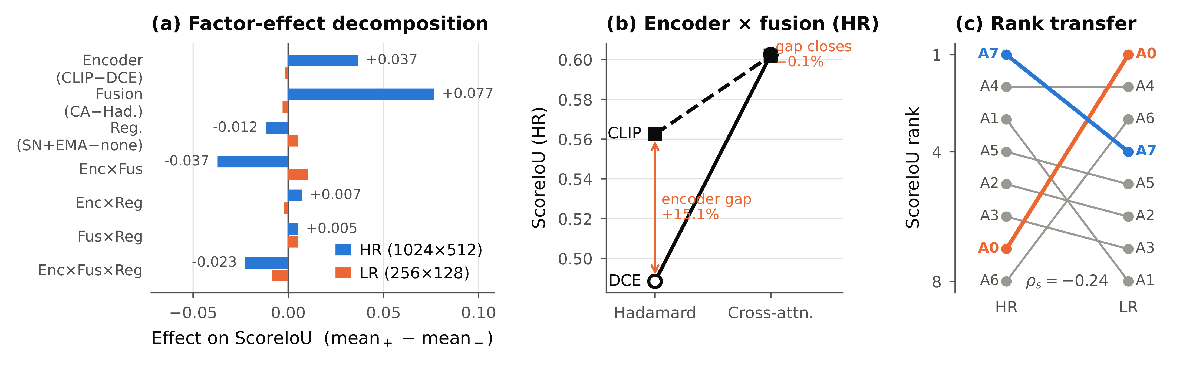
Figure 9. Factorial analysis of the eight configurations. (a) Effect decomposition of ScoreIoU at both native resolutions; at LR every term collapses towards zero. (b) Encoder × fusion interaction at HR: the two encoders differ by 15.1% under Hadamard gating and converge to within 0.1% once cross-attention is present, that is, the two components act as substitutes. (c) ScoreIoU rank of the same eight configurations on the two native grids (Spearman ρ = −0.24); the HR leader A7 ranks fourth at LR and the LR leader A0 ranks seventh at HR.

4.2.1 Resolution as a Gating Factor
The two native grids do not behave as two levels of a fourth factor with a simple main effect; the low-resolution grid suppresses the architectural factors altogether. No LR main effect exceeds 0.005 in absolute value, against a largest HR effect of 0.077; the between-configuration variance is 37.5 times smaller (7.1 × 10⁻⁵ against 2.68 × 10⁻³), and the coefficient of variation drops from 9.17% to 1.82%. The comparison that makes this concrete is one of scale: the full spread of all eight configurations at LR (0.027) is only 35% of the single fusion main effect at HR (0.077). Architectural choices that are worth making at 1024 × 512 are not worth making at 256 × 128, where the LR terms with the largest sum-of-squares shares are the interaction terms — that is, residual variation without a consistent direction.
Rankings consequently do not transfer. Across the eight configurations the two grids give Spearman ρ = −0.24 and Kendall τ = −0.11 on ScoreIoU, with the same absence of agreement on WIoU_c (ρ = −0.31), SIoU (ρ = −0.24) and η_SWratio (ρ = −0.06). The HR leader A7 ranks fourth at LR; the LR leader A0 ranks seventh at HR; the weakest HR configuration A6 ranks third at LR (Figure 9c). A configuration selected on one native grid therefore carries essentially no information about its standing on the other, and reporting a single architecture ranking without naming the deployment resolution is not meaningful.
Section 4.6 relates this collapse to the bottleneck capacity of the shared GlobalGenerator, which presents sixteen times fewer spatial query positions at LR than at HR and therefore bounds what any conditioning mechanism can exploit; the same capacity argument predicts the direction of the encoder effect, which is also absent at LR.

4.3 Metric Decomposition, Composite Behaviour, and Parameter Cost
Figures 5-7 separate structure-aware, generic image, and pixel-level metrics, while Figure 8 reports generator parameters. This decomposition identifies which aspect of fidelity drives each configuration's composite result.
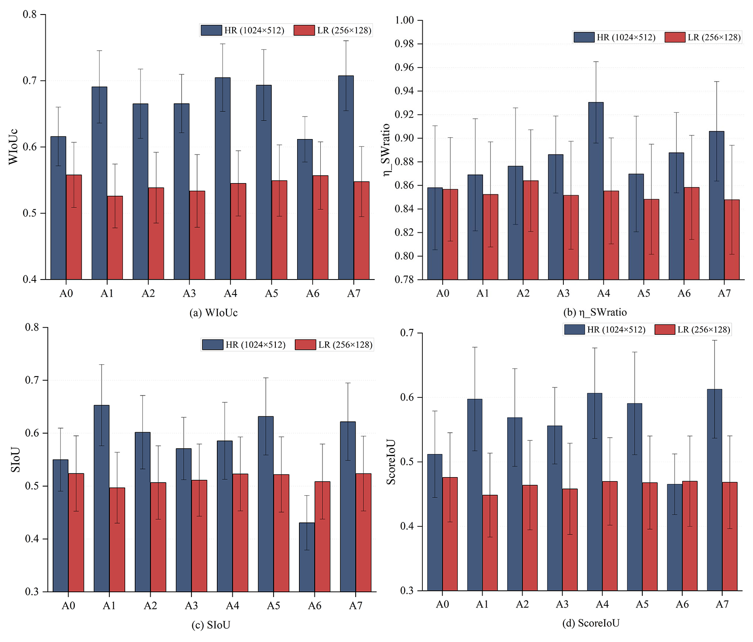
Figure 5. Structural metrics for A0–A7 at native HR (1024×512) and LR (256×128) resolutions. (a) WIoU_c; (b) η_SWratio; (c) SIoU; (d) ScoreIoU.
Error bars denote reported 95% cluster bootstrap intervals over 24 base plans, each with four condition variants (10,000 resamples; 96 images per checkpoint). Metric values use the inherited definitions; differences between native grids are descriptive. Bars show means over the 96 test pairs, and error bars denote 95% cluster-bootstrap intervals. HR checkpoints consistently outperform their LR counterparts. The cross-attention configurations (A1, A4, A5, A7) reach the highest HR WIoU_c and ScoreIoU, whereas the DCE + Hadamard configuration A6 records the lowest HR SIoU. LR values cluster tightly across configurations, indicating that input resolution dominates structural-overlap quality at this scale.
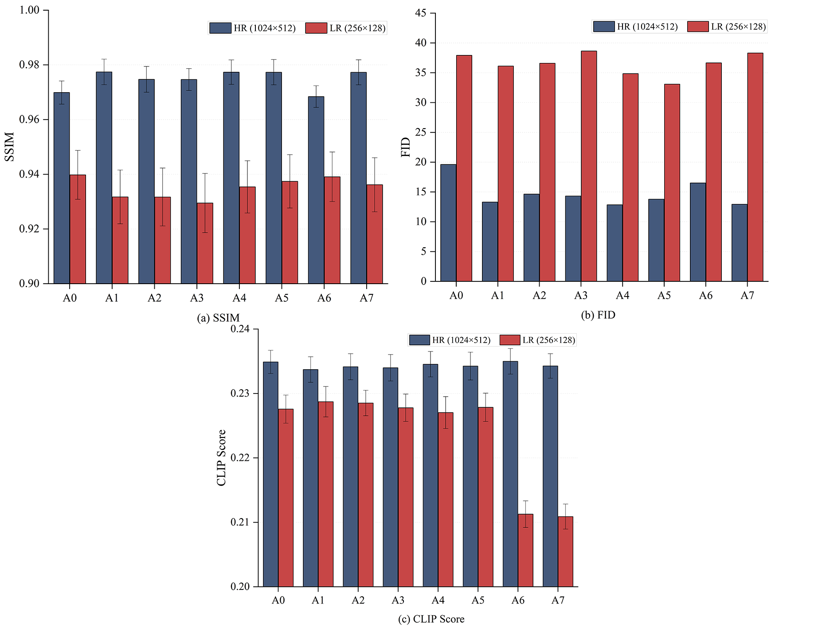
Figure 6. Perceptual and text-alignment quality for the evaluated checkpoints. (a) SSIM; (b) FID (lower is better); (c) CLIP score.
CLIP scores varied little across configurations. SSIM ranges from 0.97 to 0.98 at HR versus 0.93 to 0.94 at LR, and FID improves from roughly 33–39 at LR to 12–19 at HR, a threefold reduction attributable to input resolution. CLIP scores remain within a narrow band (≈0.21–0.24) with only a modest HR advantage, indicating that text–image alignment is far less sensitive to resolution than photometric fidelity.
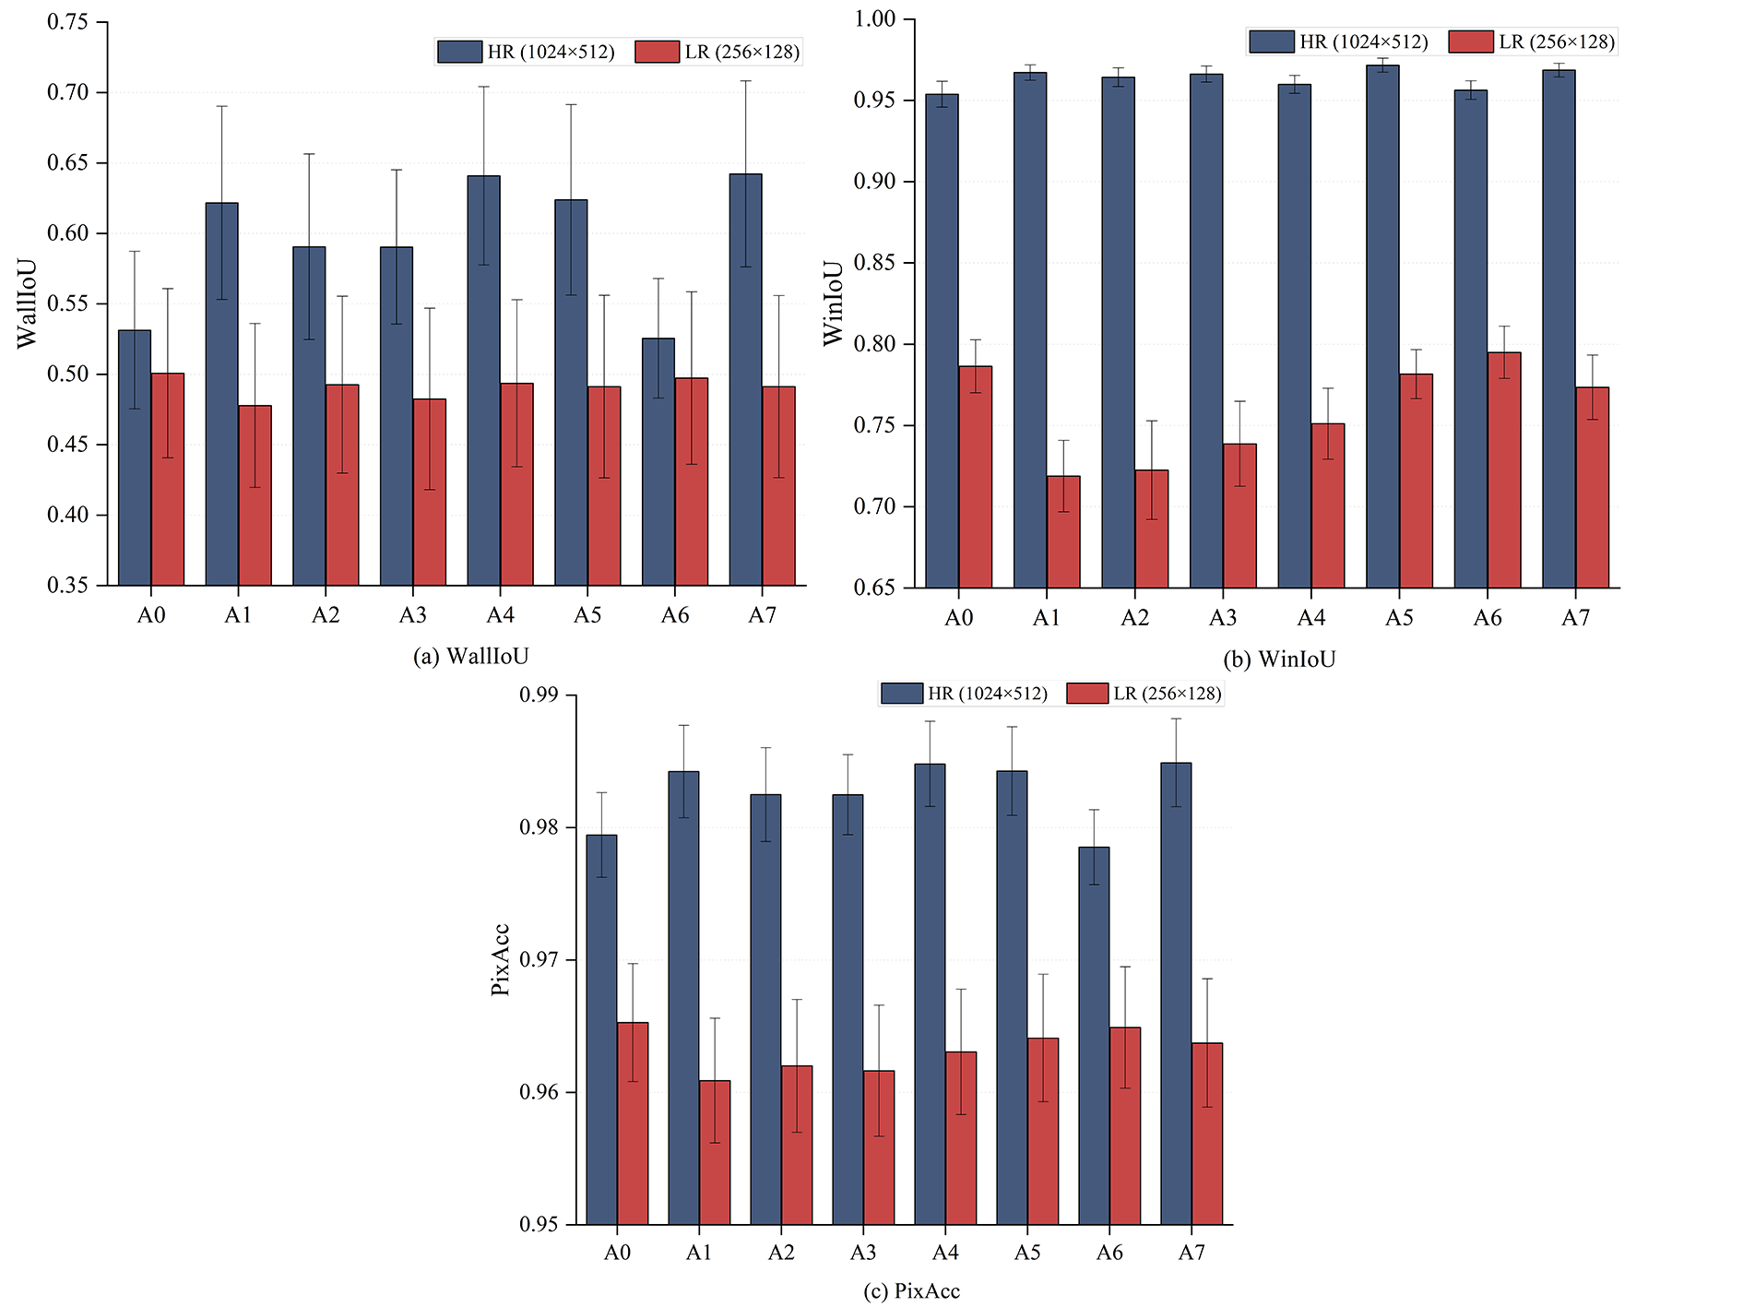
Figure 7. Pixel-level segmentation metrics on native HR (1024×512) and LR (256×128) grids. (a) WallIoU; (b) WinIoU; (c) overall pixel accuracy (PixAcc).
Error bars denote reported 95% cluster bootstrap intervals over 24 base plans. Pixel accuracy remained high and closely grouped, whereas class-specific scores separated configurations more clearly. HR checkpoints attain WallIoU of 0.53–0.64 versus 0.48–0.50 at LR, and WinIoU shows the largest resolution gap (0.95–0.97 versus 0.71–0.80), whereas PixAcc remains above 0.96 for every checkpoint. Window-level overlap is thus the component most sensitive to training resolution, although classification accuracy stays uniformly high.
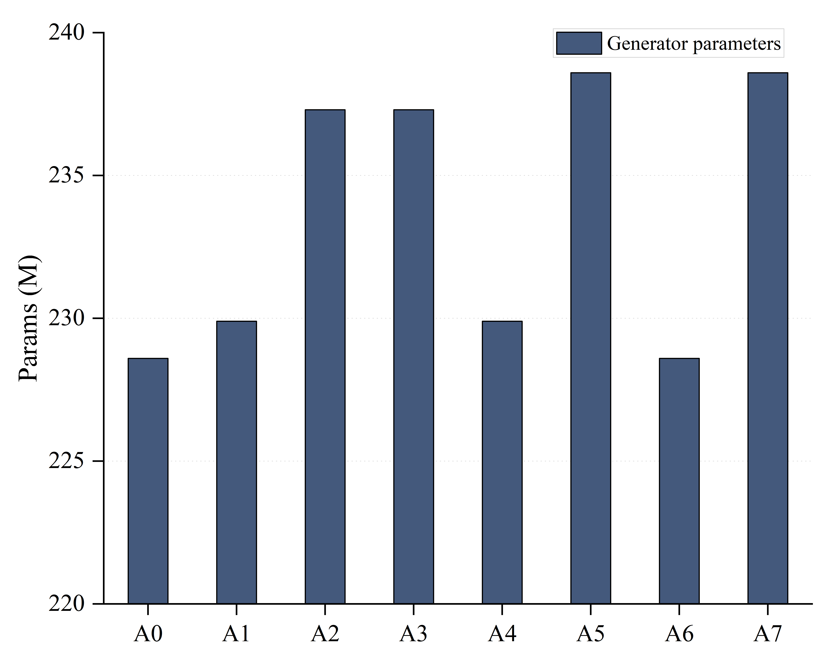
Figure 8. Deduplicated generator parameter counts for A0–A7 in millions. Counts are resolution-invariant; discriminator, frozen CLIP, and EMA-copy parameters are excluded.
Generator counts ranged from 228.6 million for DCE-Hadamard to 238.6 million for CLIP-cross-attention. Cross-attention added 1.3 million parameters within an encoder family, and the CLIP conditioning branch added 8.7 million. The DCE + Hadamard baselines (A0, A6) are the smallest at ≈228 M; adding cross-attention (A1, A4) raises the count to ≈230 M; switching to the CLIP encoder contributes a further ≈7 M, giving ≈237 M for A2/A3 (CLIP + Hadamard) and ≈239 M for A5/A7 (CLIP + cross-attention).
The composite ranking is not driven by the three components in equal measure. Regressing ScoreIoU on its standardised components across the eight configurations (Table 12) gives β = 0.675 for SIoU, 0.267 for η_SWratio and 0.233 for WIoU_c at HR (R² = 0.9995), because the components differ sharply in dispersion: the coefficient of variation is 11.9% for SIoU, 5.7% for WIoU_c and 2.7% for η_SWratio. Two consequences follow. First, the asymmetry and unboundedness of η_SWratio discussed in Section 3.4.2, although real, have limited influence on the ordering reported here, since η varies by only 0.073 across all eight configurations. Second, and less comfortably, the ordering is governed principally by SIoU, which is the component whose implementation carries the weakest guarantee: its reference-directed contour matching is not constrained to be one-to-one, so hierarchy, holes and repeated matching can affect the aggregate. Any future revision of the contour-matching rule would therefore act directly on the reported rankings, and we flag this as the principal metric-side limitation of the comparison.
Table 12. Standardised regression of ScoreIoU on its three components across the eight configurations.
Resolution | β WIoU_c | β SIoU | β η_SWratio | R² | CV WIoU_c | CV SIoU | CV η
HR (1024 × 512) | +0.233 | +0.675 | +0.267 | 0.9995 | 5.7% | 11.9% | 2.7%
LR (256 × 128) | +0.518 | +0.494 | +0.247 | 0.9983 | 2.0% | 2.0% | 0.6%
β are standardised coefficients; CV is the coefficient of variation of each component across the eight configurations. At HR the composite ranking is driven principally by SIoU, the component with the weakest implementation guarantee (non one-to-one contour matching, Section 3.4.2).
A related caveat can now be quantified. ScoreIoU is averaged per image, and substituting the separately averaged components into the formula does not reproduce that mean; the gap is +0.0101 on average at HR but varies from +0.0019 (A6) to +0.0142 (A5) across configurations. This 0.012 spread is of the same order as the 0.022 that separates A7 from A5, so the covariance between components is itself capable of reordering adjacent configurations.
The parameter accounting reinforces the same conclusion as the effect decomposition. Cross-attention adds 1.3 M generator parameters, 0.6% of the baseline, and is associated with a 14.6% higher mean HR ScoreIoU; the CLIP conditioning branch adds 8.7 M, 3.8% of the baseline, for 6.7%. Expressed as ScoreIoU gained per additional million parameters relative to A0, cross-attention returns 0.066–0.073 and the CLIP branch 0.005–0.007, a difference of roughly thirteen-fold. At LR the marginal return of every addition is negative. Where parameter count is constrained, A4 (DCE + cross-attention + SN+EMA) is within 1.0% of A7 while using 8.7 M fewer parameters.
Table 13 examines the sensitivity of the ordering to the aggregation rule itself, holding the checkpoints fixed.
Table 13. Sensitivity of architecture rankings to ScoreIoU aggregation (n = 8 configurations per resolution).
Aggregation scheme | Spearman ρ vs. adopted (HR) | Spearman ρ vs. adopted (LR) | Best at HR | Best at LR
S1 adopted: η × (0.5 WIoU_c + 0.5 SIoU) | 1.000 | 1.000 | A7 | A0
S2: η × (0.7 WIoU_c + 0.3 SIoU) | 0.976 | 0.976 | A4 | A0
S3: (WIoU_c + SIoU + η)/3 | 1.000 | 0.976 | A7 | A0
S4: SIoU only | 0.738 | 0.702 | A1 | A0
S5: WIoU_c only | 0.952 | 0.905 | A7 | A0
The adopted aggregation ranked A7 first at HR and A0 first at LR. Alternative mixed-metric aggregations gave similar full rankings (Spearman ρ ≥ 0.976), although the 0.7 WIoU_c weighting selected A4 at HR.

4.4 Robustness: Influence of the A6-HR Checkpoint
One evaluated checkpoint dominates the largest reported contrasts and requires separate treatment. A6-HR (DCE + Hadamard + SN+EMA) records SIoU = 0.431 against 0.550–0.653 for the other seven HR checkpoints, a standardised deviation of −4.74; its WIoU_c (0.612, z = −2.05) and η_SWratio (0.888, z = +0.11) are within the normal range, and its LR counterpart ranks third of eight. The failure is therefore specific to contour agreement at high resolution and is not reproduced when the same configuration is trained on the low-resolution grid, which is more consistent with a degenerate contour structure in one checkpoint than with a property of the DCE + Hadamard + SN+EMA combination.
Three of the twelve contrasts in Appendix C involve A6, and they are the first, second and fifth largest by absolute magnitude at HR (+30.3%, +22.2%, −9.1%). The mean absolute contrast is 20.5% among the three A6 contrasts and 5.8% among the remaining nine. We therefore repeat the decomposition with A6-HR winsorised to the seven-configuration minimum SIoU. The fusion main effect falls from +0.0767 to +0.0635 and its sum-of-squares share rises to 75%; the encoder main effect falls from +0.0367 to +0.0235 and the encoder × fusion interaction from −0.0373 to −0.0240, so the interaction continues to cancel the main effect and the substitution pattern of Table 10 is preserved (+9.2% under Hadamard gating, −0.1% under cross-attention). Restricting the fusion contrast to the three backgrounds that do not involve A6 leaves +0.0550, or +10.1% relative to the Hadamard cells against which it is measured. The conclusions of Section 4.2 therefore do not depend on this checkpoint, although the magnitudes reported in Appendix C do.

4.5 Numerical Quality Control and Elastic Response
All 19 ETABS 22 models passed the specified numerical quality-control checks. Each completed the seven analysis cases with return code 0, positive modal eigenvalues, two slab openings per storey, and zero free frame endpoints. Source-geometry and model hashes were unique. Using 20–40 modes, cumulative mass participation reached 95.67–97.89% in X and 92.48–95.48% in Y.
The 16 matched 8dH1H2 models contained 148–218 wall segments and 40–58 inferred beams per storey. First-mode periods ranged from 2.511 to 4.970 s, with a median of 3.123 s. Governing storey drifts ranged from 0.001312 to 0.004251, with a median of 0.001904. All 16 exceeded the 0.001 elastic drift benchmark for shear-wall buildings below 150 m [45], by factors of 1.31–4.25 (Figure 10).
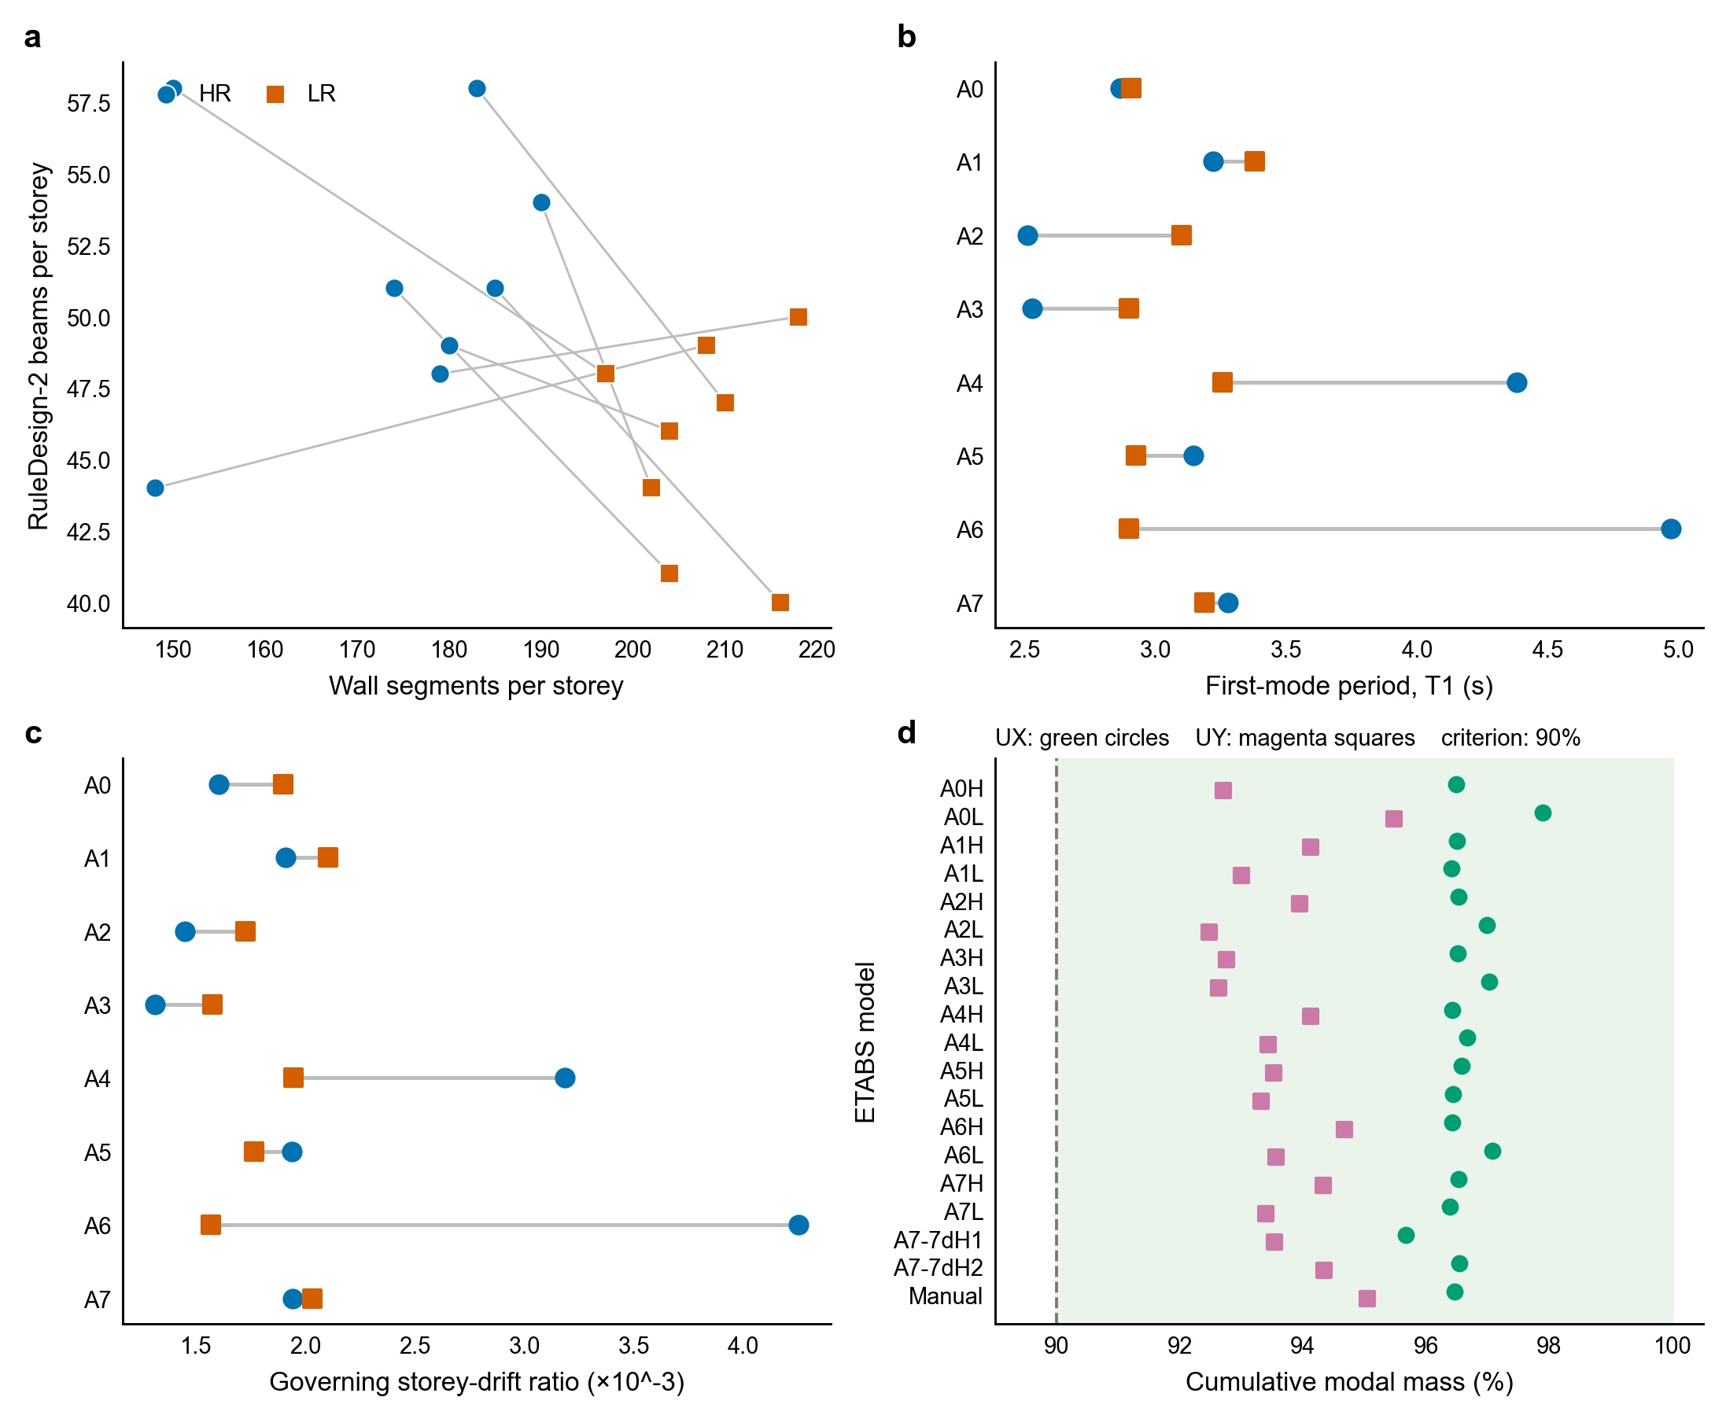
Figure 10. Geometry and response of the reconstructed P01 models. (a) Wall segments and inferred beams for the 16 matched 8dH1H2 models; lines join HR and LR outputs of the same configuration. (b,c) First-mode periods and governing storey drifts. All 16 drifts exceed 0.001. (d) Modal mass participation for all 19 models; the shaded ≥90% region denotes numerical adequacy only. Each point is one deterministic model; model-form and calibration uncertainty are not represented by error bars.
Table 14. Reconstructed geometry and ETABS 22 responses for the 19 P01 models.
Model | Condition | Stories/tw (mm) | Geometry per story: walls; beams (F+C) | T1 (s) | Cum. mass UX/UY (%) | Governing drift (1/N; case)
A0-HR | 8dH1H2 | 30/300 | 190; 54 (31+23) | 2.864 | 96.49/92.71 | 0.001602 (1/624; RS8_Y_FORMAL)
A0-LR | 8dH1H2 | 30/300 | 202; 44 (29+15) | 2.907 | 97.89/95.48 | 0.001898 (1/527; RS8_Y_FORMAL)
A1-HR | 8dH1H2 | 30/300 | 180; 49 (32+17) | 3.220 | 96.50/94.13 | 0.001909 (1/524; RS8_Y_FORMAL)
A1-LR | 8dH1H2 | 30/300 | 204; 46 (36+10) | 3.379 | 96.41/93.00 | 0.002103 (1/476; RS8_X_FORMAL)
A2-HR | 8dH1H2 | 30/300 | 185; 51 (25+26) | 2.511 | 96.52/93.94 | 0.001447 (1/691; RS8_Y_FORMAL)
A2-LR | 8dH1H2 | 30/300 | 216; 40 (29+11) | 3.099 | 96.99/92.48 | 0.001725 (1/580; RS8_X_FORMAL)
A3-HR | 8dH1H2 | 30/300 | 183; 58 (30+28) | 2.528 | 96.51/92.75 | 0.001312 (1/762; RS8_Y_FORMAL)
A3-LR | 8dH1H2 | 30/300 | 210; 47 (35+12) | 2.899 | 97.03/92.62 | 0.001575 (1/635; RS8_X_FORMAL)
A4-HR | 8dH1H2 | 30/300 | 148; 44 (30+14) | 4.380 | 96.42/94.12 | 0.003182 (1/314; RS8_X_FORMAL)
A4-LR | 8dH1H2 | 30/300 | 208; 49 (34+15) | 3.257 | 96.67/93.43 | 0.001946 (1/514; RS8_X_FORMAL)
A5-HR | 8dH1H2 | 30/300 | 174; 51 (24+27) | 3.146 | 96.58/93.52 | 0.001938 (1/516; RS8_X_FORMAL)
A5-LR | 8dH1H2 | 30/300 | 204; 41 (28+13) | 2.926 | 96.43/93.32 | 0.001766 (1/566; RS8_Y_FORMAL)
A6-HR | 8dH1H2 | 30/300 | 150; 58 (42+16) | 4.970 | 96.42/94.67 | 0.004251 (1/235; RS8_X_FORMAL)
A6-LR | 8dH1H2 | 30/300 | 197; 48 (33+15) | 2.897 | 97.07/93.56 | 0.001567 (1/638; RS8_Y_FORMAL)
A7-HR | 8dH1H2 | 30/300 | 179; 48 (31+17) | 3.276 | 96.53/94.33 | 0.001940 (1/515; RS8_X_FORMAL)
A7-LR | 8dH1H2 | 30/300 | 218; 50 (35+15) | 3.186 | 96.39/93.39 | 0.002032 (1/492; RS8_Y_FORMAL)
A7-HR-7dH1 | 7dH1 | 16/220 | 177; 47 (31+16) | 1.542 | 95.67/93.54 | 0.000517 (1/1936; RS7_X_FORMAL)
A7-HR-7dH2 | 7dH2 | 30/280 | 179; 48 (31+17) | 3.348 | 96.54/94.34 | 0.000909 (1/1100; RS7_X_FORMAL)
Manual ref. | 8dH1H2 | 30/300 | 118; 46 (35+11) | 5.784 | 96.46/95.04 | 0.005215 (1/192; RS8_Y_FORMAL)
A3-HR had the smallest drift among the matched models (0.001312), whereas A6-HR had the largest (0.004251). A4-HR, despite its high dataset-level composite score, had the second-largest drift (0.003182). The manually prepared reference had T1 = 5.784 s and drift = 0.005215, exceeding the benchmark by a factor of 5.22.
Table 15. Condition-specific responses of the three A7-HR ETABS models.
Condition | Stories/height (m) | tw (mm) | Formal spectrum | T1 (s) | Governing drift (1/N) | Critical case/story
7dH1 | 16/51.2 | 220 | RS7 X/Y | 1.542 | 0.000517 (1/1936) | RS7_X_FORMAL/Story8
7dH2 | 30/96.0 | 280 | RS7 X/Y | 3.348 | 0.000909 (1/1100) | RS7_X_FORMAL/Story18
8dH1H2 | 30/96.0 | 300 | RS8 X/Y | 3.276 | 0.001940 (1/515) | RS8_X_FORMAL/Story18
The A7-HR 7dH1 and 7dH2 cases had governing drifts of 0.000517 and 0.000909, respectively, below the 0.001 benchmark. The 8dH1H2 case had drift = 0.001940. Appendix B reports drift utilization and directional base-shear-to-weight ratios for all models.

4.6 Mechanistic Interpretation of the Observed Results
The preceding sections report checkpoint-level geometric metrics, factor contrasts, and ETABS responses. This section interprets why these patterns arise. Because the factorial comparison is based on evaluated checkpoints rather than replicated training seeds, the explanations below are mechanistic and consistent with the architecture and reconstruction pipeline rather than statistically established causal effects.
A resolution-dependent effect of cross-attention is consistent with the bottleneck capacity of the shared GlobalGenerator. With n_downsample_global = 4, the HR (1024×512) input yields roughly 64×32 = 2048 spatial query positions at the bottleneck, whereas the LR (256×128) input yields only 16×8 = 128 positions, a sixteen-fold reduction. Cross-attention conditions the decoder by querying text features at every spatial position, so its advantage is largest when spatial resolution is abundant and disappears once the LR bottleneck becomes the limiting factor. This is consistent with the reduced spatial capacity at the LR bottleneck rather than a property of the conditioning mechanism itself.
The mixed DCE-versus-CLIP results are also unsurprising in light of encoder–task compatibility. CLIP provides broad semantic coverage, but the conditioning space here is a small vocabulary of discrete engineering variables (seismic intensity, storey count, spacing class, material, loading type). With only 896 training pairs, the additional semantic capacity of CLIP (and its extra parameters) is not necessarily converted into useful design information. A plausible explanation is that the additional semantic capacity of CLIP is not fully aligned with the restricted engineering vocabulary and the small training set, so DCE remains competitive despite its far smaller representational footprint.
The SN+EMA treatment cannot be characterised from these data. Its main effect on ScoreIoU is −0.0118, it accounts for 1.5% of the between-configuration sum of squares, and its four background contrasts split two positive and two negative. Spectral normalization bounds the discriminator and exponential moving averaging smooths the generator, so a stability–detail trade-off is a plausible mechanism, but the present grid neither supports nor excludes it, and the two components were applied jointly and cannot be separated. We report the treatment as undetermined and note that resolving it requires replicated training runs rather than a larger configuration grid.
The failure of the fully augmented A5 to outperform A7 is not a general argument for simplicity; it is the specific consequence of the encoder × fusion substitution quantified in Section 4.2. CLIP conditioning and cross-attention both increase the granularity with which the design brief can modulate image features — the first by enlarging the conditioning representation, the second by letting each spatial position query it — and the bottleneck can only exploit so much of that granularity. Once either is present, the marginal value of the other falls to within 0.1% of zero. Adding a third component that acts on neither the representation nor the query mechanism, as SN+EMA does, has no reason to recover the shortfall. The design rule that follows is narrower and more useful than “less is more”: components should be selected so that they relieve different bottlenecks, and two components that address the same one should be costed against each other rather than stacked.
The weak coupling between image ranking and structural response follows from what each objective actually measures. ScoreIoU and its components reward pixel-level class agreement, contour overlap, and wall-area-ratio preservation, whereas the ETABS drift depends on the reconstructed stiffness and mass distributions, wall-continuity, coupling, openings, eccentricity, and torsion. Image similarity and structural response are therefore related but not interchangeable objectives, and the best image model need not yield the smallest drift.
The reconstruction stage can also amplify small pixel differences into topological differences. The pipeline re-sizes the output, applies morphology and contour extraction, enforces a beam-classification and sizing threshold, and quantizes coordinates, so a minor blur or a one-pixel shift at a wall edge can change whether a beam is inferred, an opening is inserted, or a wall segment is connected. This thresholding is a plausible contributor to why numerically stable, high-fidelity models can still exceed the drift benchmark, and it explains why numerical solvability—which only certifies that the model was built without error—does not, by itself, establish drift acceptability.
Taken together, these mechanisms imply a three-tier evaluation workflow: geometric fidelity, numerical solvability, and structural performance are distinct levels that should be checked in sequence. The generator configuration first alters pixel geometry, the image-evaluation functions then rank it according to fixed weights, the reconstruction algorithm converts it into discrete topology, and finally the resulting stiffness and mass determine the response. Treating image metrics as a screening stage and reserving mechanical analysis for final acceptance follows directly from this layered, and only partially coupled, chain.

5 Conclusion
This study connects a factorial GAN comparison with automated reconstruction and elastic assessment of generated structural layouts. Eight text-guided configurations (A0–A7), built from two text encoders (DCE and CLIP), two fusion mechanisms (Hadamard gating and cross-attention), and an optional SN+EMA stabilization treatment, were trained at native high (1024×512) and low (256×128) resolutions and screened with structural, perceptual, and pixel-level metrics before the most promising checkpoints were reconstructed in ETABS and subjected to elastic analysis.
Decomposing the complete factorial, rather than ranking the eight configurations, yields three results. First, the conditioning mechanism is the dominant design decision at high resolution: cross-attention contributes +0.077 ScoreIoU, 62.9% of the between-configuration sum of squares, and is favoured in all four background conditions, while the text encoder contributes 14.4% and the SN+EMA treatment 1.5% with no consistent sign. Second, the text encoder and the fusion mechanism are substitutes rather than complements: their interaction (−0.037) cancels the encoder main effect (+0.037), so upgrading the encoder is worth +15.1% under Hadamard gating and −0.1% once cross-attention is present. This is the mechanism behind the failure of the fully augmented A5 to lead, and it generalises beyond this grid as a costing rule: components that relieve the same bottleneck should be chosen between, not accumulated. Third, native resolution gates the comparison rather than shifting it. At 256 × 128 no architectural main effect exceeds 0.005, the full spread of all eight configurations is 35% of a single high-resolution fusion effect, and the two grids rank the configurations almost independently (ρ = −0.24). We therefore report design decisions rather than a winning configuration: the margin between the leading configurations (A7 over A4, 1.0%) is an order of magnitude smaller than the fusion effect that separates the design families, and should not be read as a recommendation.
The reconstruction and elastic-assessment stage shows that this image-side ordering does not carry over to mechanical adequacy. Although all 19 reconstructed P01 models passed numerical quality control and reached cumulative mass participation of 95.67–97.89% in X and 92.48–95.48% in Y, the 16 matched eight-degree (8dH1H2) models governed by storey drift all exceeded the 0.001 elastic storey-drift benchmark, with governing drifts of 1.31–4.25 times that threshold. Numerical quality-control success therefore does not, by itself, establish drift acceptability, and image ranking and mechanical assessment serve distinct selection decisions.
Two limitations bound these conclusions and set the immediate agenda. The eight cells are single evaluated checkpoints, so the decomposition is exact for the observed grid but is not an estimate of effects across training seeds; the sign-consistency and winsorisation analyses of Sections 4.2 and 4.4 are the strongest evidence available without replication, and replicated runs remain the necessary next step, particularly for the SN+EMA treatment, which the present data leave undetermined. Separately, the high-resolution ordering is governed principally by SIoU (standardised β = 0.675), the metric component whose contour matching is not constrained to be one-to-one; revising that rule would act directly on the reported rankings. Beyond these, the factorial should be extended to conditioning mechanisms that act on the bottleneck in different ways — spatially dense conditioning such as SPADE, or an enlarged bottleneck — since the substitution result implies that further gains will come from relieving a different bottleneck rather than from stacking components that relieve the same one, and future work should test whether explicit geometric or mechanical objectives can close the remaining gap between visual fidelity and drift-limited structural adequacy.

Appendix A Detailed ETABS Reconstruction Settings
Colour semantics identify shear walls (red), architectural walls (grey), windows (green), and doors (blue). A 0.90 m door spanning 24 HR pixels defines the nominal source scale of 0.0375 m/pixel. The converter resizes both architectural and structural images to 512 × 256 with OpenCV's default bilinear interpolation, then uses 0.075 m/pixel. Thus HR is downsampled by two and LR is upsampled by two before semantic extraction; LR retains a nominal source sampling interval of 0.15 m. Morphological operations, contour extension, and coordinate quantization subsequently modify the extracted geometry. The exported P01 floor envelope is 38.9 × 13.7 m, giving H/B = 7.01 at H = 96 m and 3.74 at H = 51.2 m. These are reconstructed dimensions, not independently surveyed dimensions. Scale and outline calibration must therefore be distinguished from image-canvas size.
The implemented RuleDesign-2 procedure derives candidate axes from grey architectural walls and removes overlaps with shear walls. A beam is classified as coupling when both ends have aligned shear-wall support and its axis length L is below 2.6 m. Coupling depth is min(0.4L, 1.2 m), with width equal to wall thickness. For other beams, depth h_b = min[max(0.4 m, L/12), 0.8 m] and width b = max(0.2 m, 5h_b/12). Here h_b denotes beam depth, not building or storey height. The implementation rounds width and depth to 0.01 m and assigns frame insertion point 8 for slab-top alignment. These are reconstruction rules, not member-sizing results from capacity design.
Walls and beams use C40 concrete, and 120 mm slabs use C35 concrete. Floor areas are assigned semi-rigid diaphragms and contain two reconstructed openings per storey. The nominal wall and slab mesh size is 750 mm. Superimposed dead and live loads are 1.5 and 2.0 kN/m², and the mass source is DEAD + SDL + 0.5LIVE. A gravity case named PDELTA_GRAV uses the same load combination. Its existence alone does not establish that the modal case uses gravity-updated stiffness; that dependency must be verified before interpreting second-order response. Code-based spectra follow GB 50011-2010 (2016 edition) [43], with Tg = 0.40 s, 5% damping, and acceleration scale 9.80665 m/s². Seven-degree cases use 0.10g and αmax = 0.08; eight-degree cases use 0.20g and αmax = 0.16. Separate U1 and U2 cases use 5% accidental eccentricity. The reported drifts are envelopes of these separate directional cases, not demonstrated 100%+30% orthogonal combinations. Modal extraction begins at 20 modes and increases if either cumulative translational mass is below 90%; 18 models used 20 modes and one used 40.
Model auditing confirms semi-rigid floor assignments and records modal- and directional-combination API codes of 1 for each spectrum case. Reproducibility additionally requires the version-specific interpretation of these codes, material elastic properties, stiffness modifiers, frame end offsets, and shell-edge constraints. The present numerical checks do not establish mesh convergence or independently calibrated stiffness. The nominal door calibration and the reported reconstructed dimensions should be validated against a known plan dimension before design-level use.

Appendix B Drift Benchmarks and Directional Base Shear
Table 16 adds diagnostics calculated from the existing ETABS exports; no new finite-element analyses are represented. W is the sum of vertical base reactions for DEAD + SDL + 0.5LIVE. Directional coefficients are c_x = |V_x,RSX|/W and c_y = |V_y,RSY|/W. The drift utilization uses the values in Table 14. These coefficients precede any independently verified code-based minimum-shear adjustment.
Table 16. Drift utilization and directional base-shear-to-weight ratios for P01 models. Every model passed the numerical checks. “Within” refers only to the 0.001 drift benchmark.
Model | Uθ | Drift benchmark | c_x | c_y
A0-HR | 1.602 | Exceeds | 0.0278 | 0.0421
A0-LR | 1.898 | Exceeds | 0.0321 | 0.0370
A1-HR | 1.909 | Exceeds | 0.0261 | 0.0324
A1-LR | 2.103 | Exceeds | 0.0282 | 0.0360
A2-HR | 1.447 | Exceeds | 0.0299 | 0.0397
A2-LR | 1.725 | Exceeds | 0.0310 | 0.0425
A3-HR | 1.312 | Exceeds | 0.0308 | 0.0447
A3-LR | 1.575 | Exceeds | 0.0303 | 0.0415
A4-HR | 3.182 | Exceeds | 0.0216 | 0.0285
A4-LR | 1.946 | Exceeds | 0.0292 | 0.0389
A5-HR | 1.938 | Exceeds | 0.0257 | 0.0323
A5-LR | 1.766 | Exceeds | 0.0286 | 0.0372
A6-HR | 4.251 | Exceeds | 0.0197 | 0.0222
A6-LR | 1.567 | Exceeds | 0.0281 | 0.0383
A7-HR | 1.940 | Exceeds | 0.0258 | 0.0361
A7-LR | 2.032 | Exceeds | 0.0285 | 0.0338
A7-HR-7dH1 | 0.517 | Within | 0.0184 | 0.0257
A7-HR-7dH2 | 0.909 | Within | 0.0111 | 0.0153
Manual ref. | 5.215 | Exceeds | 0.0188 | 0.0242
The 17 eight-degree models, including the manual reference, exceed the drift benchmark; the two seven-degree examples fall below it. Neither outcome establishes complete code acceptance. Directional coefficients must be interpreted using the applicable period-dependent minimum-shear provisions and storey-level demands [43]. Torsional period ratios, maximum-to-average displacement ratios, stiffness-to-weight ratios, and member checks cannot be inferred from these base reactions and remain unverified.

Appendix C Single-Factor Contrast Record
Table 17 retains the twelve single-factor contrasts of Table 5 as a record of the individual cell comparisons that underlie the decomposition of Section 4.2. Percentages are relative ScoreIoU changes computed from the original unrounded checkpoint summaries; they are not inferential effect estimates across seeds, and three of them involve the A6-HR checkpoint analysed in Section 4.4.
Table 17. Descriptive relative ScoreIoU changes for 12 single-factor contrasts, computed from the original unrounded checkpoint summaries. Percentages are not inferential effect estimates across seeds.
Contrast | Factor varied | ΔScoreIoU (HR) | ΔScoreIoU (LR) | Interpretation
A0 → A1 | Fusion | +16.7% | -5.8% | DCE; no regularization
A3 → A7 | Fusion | +10.2% | +2.2% | CLIP; no regularization
A6 → A4 | Fusion | +30.3% | -0.1% | DCE; SN+EMA
A2 → A5 | Fusion | +3.8% | +0.9% | CLIP; SN+EMA
A0 → A3 | Encoder | +8.7% | -3.7% | Hadamard; no regularization
A1 → A7 | Encoder | +2.5% | +4.5% | Cross-attention; no regularization
A6 → A2 | Encoder | +22.2% | -1.3% | Hadamard; SN+EMA
A4 → A5 | Encoder | -2.6% | -0.4% | Cross-attention; SN+EMA
A0 → A6 | Regularization | -9.1% | -1.2% | DCE; Hadamard
A1 → A4 | Regularization | +1.5% | +4.7% | DCE; cross-attention
A3 → A2 | Regularization | +2.3% | +1.2% | CLIP; Hadamard
A7 → A5 | Regularization | -3.6% | -0.1% | CLIP; cross-attention
All four HR fusion contrasts favored cross-attention in the evaluated checkpoints, with relative ScoreIoU differences of +16.7%, +10.2%, +30.3%, and +3.8%. LR contrasts ranged from −5.8% to +2.2%.
For unregularized HR models, replacing DCE with CLIP changed ScoreIoU by +8.7% with Hadamard fusion and +2.5% with cross-attention. Under regularized cross-attention, DCE had the higher point estimate (A4, 0.607; A5, 0.591).
Adding SN+EMA changed HR ScoreIoU by −9.1% for DCE-Hadamard, +2.3% for CLIP-Hadamard, and +1.5% for DCE-cross-attention. For CLIP-cross-attention, the unregularized A7 had the higher point estimate.
These contrasts are reported here as a record of the individual cell comparisons. The corresponding main effects, interactions, sign consistency and robustness to the A6-HR checkpoint are given in Sections 4.2 and 4.4.

References
[1] B. C. Paulson, Jr., "Designing to reduce construction costs," Journal of the Construction Division, vol. 102, no. 4, pp. 587–592, 1976.
[2] D. Sriram, M. L. Maher, and S. J. Fenves, "Knowledge-based expert systems in structural design," Computers & Structures, vol. 20, no. 1–3, pp. 1–9, 1985.
[3] M. L. Maher, "Expert systems for structural design," Ph.D. dissertation, Carnegie Mellon University, 1985.
[4] H. Adeli and S. Kumar, "Distributed genetic algorithm for structural optimization," Journal of Aerospace Engineering, vol. 8, no. 3, pp. 156–163, 1995.
[5] R. E. Perez and K. Behdinan, "Particle swarm approach for structural design optimization," Computers & Structures, vol. 85, no. 19–20, pp. 1579–1588, 2007.
[6] W. Liao, X. Lu, Y. Fei, Y. Gu, and Y. Huang, "Generative AI design for building structures," Automation in Construction, vol. 157, p. 105187, 2024.
[7] D. P. Kingma and M. Welling, "Auto-encoding variational Bayes," in Proceedings of the International Conference on Learning Representations (ICLR), 2013.
[8] I. Goodfellow, J. Pouget-Abadie, M. Mirza, B. Xu, D. Warde-Farley, S. Ozair, A. Courville, and Y. Bengio, "Generative adversarial networks," Communications of the ACM, vol. 63, no. 11, pp. 139–144, 2020.
[9] A. Vaswani, N. Shazeer, N. Parmar, J. Uszkoreit, L. Jones, A. N. Gomez, L. Kaiser, and I. Polosukhin, "Attention is all you need," in Advances in Neural Information Processing Systems, vol. 30, 2017.
[10] F.-A. Croitoru, V. Hondru, R. T. Ionescu, and M. Shah, "Diffusion models in vision: A survey," IEEE Transactions on Pattern Analysis and Machine Intelligence, vol. 45, no. 9, pp. 10850–10869, 2023.
[11] N. Yüksel, H. R. Borklu, H. K. Sezer, and O. E. Canyurt, "Review of artificial intelligence applications in engineering design perspective," Engineering Applications of Artificial Intelligence, vol. 118, p. 105697, 2023.
[12] S. K. Baduge et al., "Artificial intelligence and smart vision for building and construction 4.0: Machine and deep learning methods and applications," Automation in Construction, vol. 141, p. 104440, 2022.
[13] A. N. Wu, R. Stouffs, and F. Biljecki, "Generative adversarial networks in the built environment: A comprehensive review of the application of GANs across data types and scales," Building and Environment, vol. 223, p. 109477, 2022.
[14] P. J. Zhao, W. J. Liao, Y. L. Huang, and X. Z. Lu, "Intelligent design of shear wall layout based on attention-enhanced generative adversarial network," Engineering Structures, vol. 274, p. 115170, 2023.
[15] P. J. Zhao, W. J. Liao, Y. L. Huang, and X. Z. Lu, "Intelligent design of shear wall layout based on graph neural networks," Advanced Engineering Informatics, vol. 55, p. 101886, 2023.
[16] P. J. Zhao, W. J. Liao, H. J. Xue, and X. Z. Lu, "Intelligent design method for beam and slab of shear wall structure based on deep learning," Journal of Building Engineering, vol. 57, p. 104838, 2022.
[17] Y. F. Fei, W. J. Liao, S. Zhang, P. F. Yin, B. Han, P. J. Zhao, X. Y. Chen, and X. Z. Lu, "Integrated schematic design method for shear wall structures: A practical application of generative adversarial networks," Buildings, vol. 12, no. 9, p. 1295, 2022.
[18] Y. F. Fei, W. J. Liao, Y. L. Huang, and X. Z. Lu, "Knowledge-enhanced generative adversarial networks for schematic design of framed tube structures," Automation in Construction, vol. 144, p. 104619, 2022.
[19] P. J. Zhao, W. J. Liao, Y. L. Huang, and X. Z. Lu, "Intelligent beam layout design for frame structure based on graph neural networks," Journal of Building Engineering, vol. 63, p. 105499, 2023.
[20] K. Chang and C. Cheng, "Learning to simulate and design for structural engineering," in Proceedings of the 37th International Conference on Machine Learning (ICML), 2020.
[21] G. Mirra and A. Pugnale, "Comparison between human-defined and AI-generated design spaces for the optimisation of shell structures," Structures, vol. 34, pp. 2950–2961, 2021.
[22] J. de M. Rodríguez, M. E. Villafañe, L. Piškorec, and F. S. Caparrini, "Generation of geometric interpolations of building types with deep variational autoencoders," Design Science, vol. 6, p. e30, 2020.
[23] R. Danhaive and C. T. Mueller, "Design subspace learning: Structural design space exploration using performance-conditioned generative modeling," Automation in Construction, vol. 127, p. 103664, 2021.
[24] A. Radford, J. W. Kim, C. Hallacy, A. Ramesh, G. Goh, S. Agarwal, G. Sastry, A. Askell, P. Mishkin, J. Clark, G. Krueger, and I. Sutskever, "Learning transferable visual models from natural language supervision," in Proceedings of the 38th International Conference on Machine Learning (ICML), pp. 8748–8763, 2021.
[25] T. Miyato, T. Kataoka, M. Koyama, and Y. Yoshida, "Spectral normalization for generative adversarial networks," in Proceedings of the International Conference on Learning Representations (ICLR), 2018.
[26] W. Liao, Y. Huang, Z. Zheng, and X. Lu, “Intelligent generative structural design method for shear wall building based on ‘fused-text-image-to-image’ generative adversarial networks,” Expert Systems with Applications, vol. 210, p. 118530, 2022.
[27] L. Zhang, A. Rao, and M. Agrawala, "Adding conditional control to text-to-image diffusion models," in Proceedings of the IEEE/CVF International Conference on Computer Vision (ICCV), pp. 3836–3847, 2023.
[28] T. Park, M.-Y. Liu, T.-C. Wang, and J.-Y. Zhu, "Semantic image synthesis with spatially-adaptive normalization," in Proceedings of the IEEE/CVF Conference on Computer Vision and Pattern Recognition (CVPR), pp. 2337–2346, 2019.
[29] P. N. Pizarro, L. M. Massone, F. R. Rojas, and R. O. Ruiz, "Use of convolutional networks in the conceptual structural design of shear wall buildings layout," Engineering Structures, vol. 239, p. 112311, 2021.
[30] P. N. Pizarro and L. M. Massone, "Structural design of reinforced concrete buildings based on deep neural networks," Engineering Structures, vol. 241, p. 112377, 2021.
[31] B. Fu, Y. Gao, and W. Wang, "Dual generative adversarial networks for automated component layout design of steel frame-brace structures," Automation in Construction, vol. 146, p. 104661, 2023.
[32] N. A. Kallioras and N. D. Lagaros, "DzAN: Deep learning based generative design," Procedia Manufacturing, vol. 44, pp. 591–598, 2020.
[33] C. Huang, J. Bai, and J. Chen, "A deep learning approach for topology optimization," Structural and Multidisciplinary Optimization, vol. 64, no. 6, pp. 3897–3915, 2021.
[34] Z. Wang, A. C. Bovik, H. R. Sheikh, and E. P. Simoncelli, "Image quality assessment: From error visibility to structural similarity," IEEE Transactions on Image Processing, vol. 13, no. 4, pp. 600–612, 2004.
[35] M. Heusel, H. Ramsauer, T. Unterthiner, B. Nessler, and S. Hochreiter, "GANs trained by a two time-scale update rule converge to a local Nash equilibrium," in Advances in Neural Information Processing Systems, vol. 30, 2017.
[36] P. Isola, J.-Y. Zhu, T. Zhou, and A. A. Efros, "Image-to-image translation with conditional adversarial networks," in Proceedings of the IEEE Conference on Computer Vision and Pattern Recognition (CVPR), pp. 1125–1134, 2017.
[37] J. Ho, A. Jain, and P. Abbeel, “Denoising diffusion probabilistic models,” in Advances in Neural Information Processing Systems, 2020, pp. 6840–6851.
[38] A. Brock, J. Donahue, and K. Simonyan, “Large scale GAN training for high fidelity natural image synthesis,” in International Conference on Learning Representations, 2019.
[39] T. Karras, S. Laine, and T. Aila, “A style-based generator architecture for generative adversarial networks,” in IEEE/CVF Conference on Computer Vision and Pattern Recognition, 2019, pp. 4401–4410.
[40] T.-C. Wang, M.-Y. Liu, J.-Y. Zhu, A. Tao, J. Kautz, and B. Catanzaro, “High-resolution image synthesis and semantic manipulation with conditional GANs,” in IEEE/CVF Conference on Computer Vision and Pattern Recognition, 2018, pp. 8798–8807.
[41] E. Perez, F. Strub, H. de Vries, V. Dumoulin, and A. Courville, “FiLM: Visual reasoning with a general conditioning layer,” in AAAI Conference on Artificial Intelligence, 2018, pp. 3942–3951.
[42] T. Karras, M. Aittala, J. Hellsten, S. Laine, J. Lehtinen, and T. Aila, “Training generative adversarial networks with limited data,” in Advances in Neural Information Processing Systems, 2020, pp. 12104–12114.
[43] GB 50011-2010 (2016 edition), Code for Seismic Design of Buildings, China Architecture & Building Press, Beijing, 2016.
[44] Y. Fei, X. Lu, W. Liao, and H. Guan, “Data enhancement for generative AI design of shear wall structures incorporating structural optimization and diffusion models,” Advances in Structural Engineering, vol. 29, no. 3, pp. 545–565, 2026. doi:10.1177/13694332251353614. First published online July 1, 2025.
[45] JGJ 3-2010, Technical Specification for Concrete Structures of Tall Building, China Architecture & Building Press, Beijing, 2010, Section 3.7.3 and Table 3.7.3.

Declaration of Competing Interest
The authors declare that they have no known competing financial interests or personal relationships that could have appeared to influence the work reported in this paper.

Data Availability
The structural-plan dataset originates from Liao et al. [26]. The present study uses generated images, checkpoint evaluation records, reconstruction scripts, ETABS model files, and exported response tables. These materials are available from the corresponding author upon reasonable request. No public repository or permanent dataset identifier is reported here. Reuse of the source dataset remains subject to its original terms.

