Software Requirements Specification
Version 1.0

thegioididong.com

Fresher Academy
2019

1.0. Introduction

1.1. Purpose
The purpose of this document is to present a detailed description of the thegioididong.com system. It will explain the purpose and features of the system, the interfaces of the system, what the system will do, the constraints under which it must operate and how the system will react to external stimuli. This document is intended for both the stakeholders and the developers of the system and will be proposed to the potential clients for its approval.

1.2. Scope of Project
This software product will be the website for buyer and the manager thegioididong.com.

1.3. Glossary
Term | Definition
Administrator | Users could login to add, update, delete data.
Customer | Users want to find and buy items

2.0. Overall Description

2.1 System Environment
End users could be project managers, quality assurance team and other project members. There are more than 500 possible users.

TBD

2.2 Functional Requirements Specification

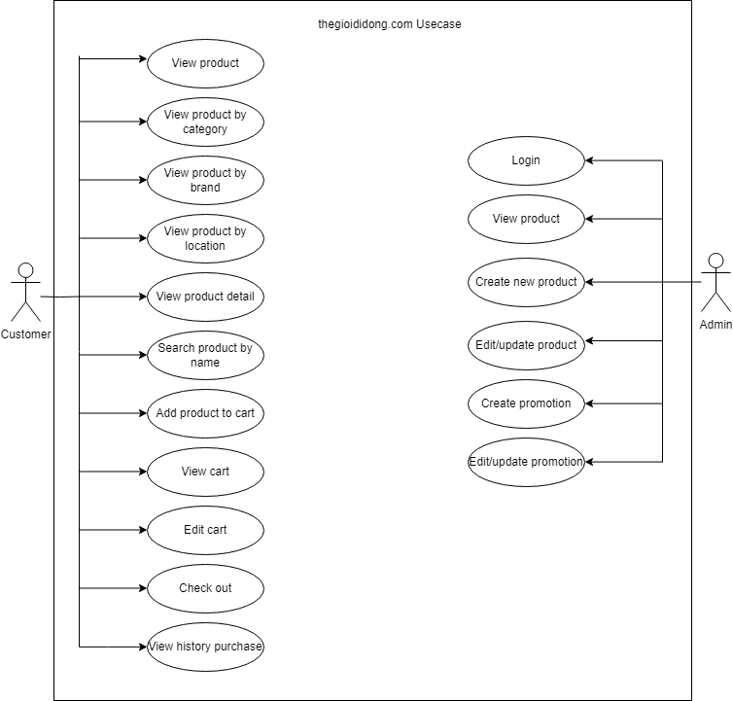
Figure 1 – thegioididong.com System Use Case

This section outlines the use cases for each of the active user separately.

2.2.1 Thegioididong.com Customer Use Case

Use case: Customer View List Products
Diagram:

Customer

View List Products

Brief Description
The customer accesses the thegioididong.com to view list products.

Initial Step-By-Step Description
Before this use case can be initiated, the user has already accessed the Thegioididong.com website with role customer.
- The customer accesses the home page
- The main page will show the list of products
- The system allows the user to perform others activities

Use case: Customer View product by category
Diagram:

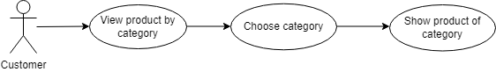

Brief Description
The customer accesses the thegioididong.com to view type of product.

Initial Step-By-Step Description
Before this use case can be initiated, the user has already accessed the thegioididong.com website with role customer.

- The customer accesses the home page.
- The main page will show the category of product in a taskbar (laptop, mobile, tablet,…)
- The customer selects one of them to access each type
- The system redirects to the detail page of the type that the customer choses
- The system allows the user to perform others activities.

Use case: Customer View products from brand
Diagram:
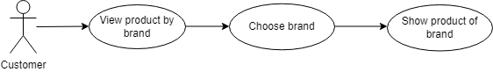

Brief Description
The customer access the thegioididong.com to view products from brand
Initial Step-By-Step Description
Before this use case can be initiated, the user has already accessed the Thegioididong.com website with role customer.

- The customer accesses the home page.
- The system redirects to list all product
- The customer select the brand
- The system redirects to the list of products consist of the brand that the customer choose
- The system allows the user to perform others activities

Use case: Customer View products from brand
Diagram:
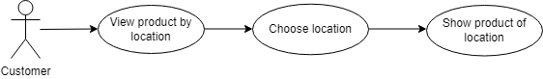

Brief Description
The customer access the thegioididong.com to view products by location.
Initial Step-By-Step Description
Before this use case can be initiated, the user has already accessed the Thegioididong.com website with role customer.

- The customer accesses the home page.
- The system redirects to list all product
- The customer select location
- The system redirects to the list of products in location(store,..) that the customer choose
- The system allows the user to perform others activities

Use case: Customer View products detail

Diagram:

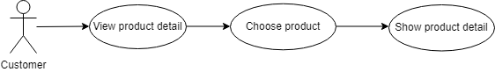

Brief Description
The customer accesses the thegioididong.com to view detail of product
Initial Step-By-Step Description
Before this use case can be initiated, the user has already accessed the Thegioididong.com website with role customer.

- The customer accesses the home page.
- The system redirects to list all product
- The customer select the product
- The system redirects to product detail page
- The system allows the user to perform others activities

Use case: Customer Search product by name
Diagram:
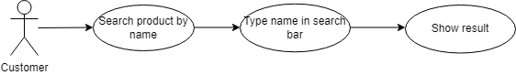

Brief Description
The customer accesses thegioididong.com type in search bar

Initial Step-By-Step Description
Before this use case can be initiated, the user has already accessed the Thegioididong.com website with role customer.

- The customer accesses thegioididong.com website.
- The customer type in the search bar the product name
- The system show all the products that have the name mentioned.
- The system allows the user to perform other activities.

Use case: Customer Add product to cart
Diagram:
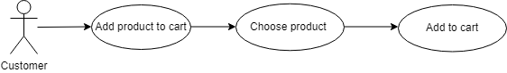

Brief Description
The customer accesses the Thegioididong.com to add product to cart.

Initial Step-By-Step Description
Before this use case can be initiated, the user has already accessed the Thegioididong.com website with role customer.

- The customer accesses thegioididong website.
- The customer chooses a product he/she wants.
- The system show product’s description and buy option buttons.
- The customers choose the color and number of product they want to buy and click buy button.
- The system will add the items in the cart and notify the customer.
- The system allows the user to perform other activities.

Use case: Customer View cart
Diagram:

Customer
View Cart

Brief Description
The customer accesses the Thegioididong.com to views his/her shopping cart

Initial Step-By-Step Description
Before proceeding to view the cart, customer has accessed in the store website and has or has not added products to the cart

- Customer accesses home page of the website
- Customer performs any other activities
- Customer clicks on the shopping cart icon
- The website changes to the cart viewing page
- Customer can now check their cart details or do any other activities.

Use case: Customer Edit cart
Diagram:

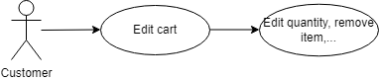

Brief Description
The customer accesses the Thegioididong.com to edit cart after puting some items into the cart.

Initial Step-By-Step Description
Before this use case can be initiated, the user has already accessed the Thegioididong.com website with role customer and must have added 1 or more product to the cart prior to that

- Customer adds 1 or more products to the cart
- Customer clicks on the view cart icon
- System redirects to the cart viewing page
- Customer can now edit the details of the cart: remove, increase quantity of product(s), adjust delivery informations, use a promote code
- The system allows the user to perform other activities.

Use case: Customer checkout the cart
Diagram:

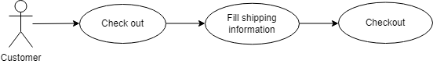

Brief Description
The customer accesses the Thegioididong.com to checkout cart after they add/edit items.

Initial Step-By-Step Description
Before making a payment, customer must have added 1 or more items to the cart, checked and edit it. Next fill in the delivery infos(delivery address, customer name and phone number), then choose payment method and provide some infos on the payment. Finally, the system does some other steps to verify the purchase.

- Customer edit the cart and fill in the delivery info
- Customer clicks on the Order button and system redirects to payment page
- Customer choose a payment method and fill in infos for the payment
- Customer clicks on the Finish button and website changes to the purchase verify page
- System checks unit stocks of the items in the cart
- If 1 or more item is out of stock, the system notifies customer so they can edit the cart again
- If no items in the cart are out of stock, system then verifies the purchase with customer
- The system allows the user to perform other activities.

Use case: Customer view history purchase
Diagram:

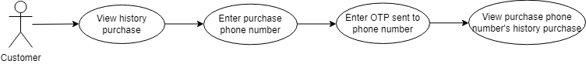

Brief Description
The customer accesses the Thegioididong.com to view history purchase.

Initial Step-By-Step Description
Before viewing purchase history, customers must have purchased items on the website to display the purchase history.

      - Customer go to view history purchase page.
      - Enter purchase phone number.
      - OTP code will be sent to phone number that the customer enter.
      - Customer enter OTP code.
      - Show all history purchase using that phone number.
      - System allows user to perform orther activities

2.2.2 Thegioididong.com Admin Use Case

Use case: Admin login
Diagram:

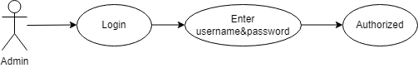

Brief Description
The admin accesses the Thegioididong.com to login.

Initial Step-By-Step Description
Before this use case can be initiated, the user has already accessed the login page on Thegioididong.com website.

1. Admin accesses to home page
2. Admin fill username and password
3. The system validates input and response error message if error happened
4. The system redirect to next page if correct username/password
5. The system allows the user to perform other activities.

Use case: Admin create new product
Diagram:
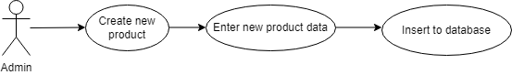

Brief Description
The admin accesses the Thegioididong.com to add new product.

Initial Step-By-Step Description
Before this use case can be initiated, the user has already accessed the Thegioididong.com website with role admin.

1. Admin accesses to add product page .
2. Click create button to create new product .
3. Fill in product’s information .
4. The system will check the duplication of some important properties : Product ID, Product name , …..
5. If everything is correct , new product will be created and insert to database and show in product page.
6. The system allows the user to perform other activities.

Use case: Admin view list of product
Diagram:

Admin
View List Products

Brief Description
The admin accesses the Thegioididong.com to view list products.

Initial Step-By-Step Description
Before this use case can be initiated, the user has already accessed the Thegioididong website with role admin.

- The admin accesses the home page.
- The system displays to list all products.
- The system allows the admin to perform other activities.

Use case: Admin edit/update product
Diagram:

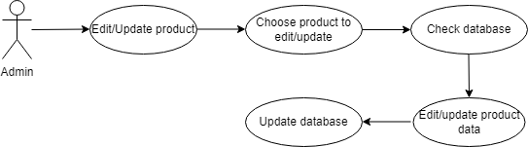

Brief Description
The admin accesses the Thegioididong.com to edit products.

Initial Step-By-Step Description
Before this use case can be initiated, the user has already accessed the Thegioididong.com with role admin.

- The admin accesses the home page.
- The system displays to list all products.
- The admin clicks the edit icon of the product that the admin wants to edit.
- Edit what admin needs and click “Save”.
- The system allows the admin to perform other activities.

Use case: Admin add promotion
Diagram:
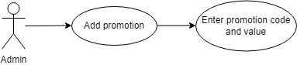

Brief Description
The admin accesses the Thegioididong.com to add promotion to product.

Initial Step-By-Step Description
Before this use case can be initiated, the user has already accessed the Thegioididong.com website with role admin.

1. Admin accesses to add promotion page .
2. Admin create promotion code and value. (Ex: SALE20 for 20% discount)
3. Enter start & end day.
4. The system allows the admin to perform other activities.

Use case: Admin edit/update promotion
Diagram:
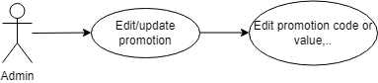

Brief Description
The admin accesses the Thegioididong.com to edit/update promotion to product.

Initial Step-By-Step Description
Before this use case can be initiated, the user has already accessed the Thegioididong.com website with role admin.

1. Admin accesses to eidt/update promotion page .
2. Admin eidt/update promotion information .
3. Enter promotion information and click “Save.
- The system allows the admin to perform other activities.

2.3 User Characteristics
TBD

2.4 Non-Functional Requirements
TBD

3.0. Requirements Specification

3.1 External Interface Requirements
TBD

3.2 Functional Requirements
The Logical Structure of the Data is contained in Section 3.3.1.

Customer View List Product
Use Case Name | Customer View List Product
XRef | Section 2.2.1, Customer View List Product
Trigger | The user accesses the Thegioididong.com website
Precondition | None
Basic Path | - The customer accesses the home page  - The main page will show the list of products  - The system allows the user to perform others activities
Alternative Paths | None
Postcondition | None
Exception Paths | None
Other | None

Customer View Type of Product
Use Case Name | Customer View Type of Product
XRef | Section 2.2.1, Customer View List Product
Trigger | The user accesses the Thegioididong.com website
Precondition | Customer choose type of product they want to see.
Basic Path | - The customer accesses the home page.  - The main page will show the type of product in a taskbar (laptop, mobile, tablet,…)  - The customer selects one of them to access each type  - The system redirects to the detail page of the type that the customer chooses  - The system allows the user to perform other activities.
Alternative Paths | None
Postcondition | None
Exception Paths | None
Other | None

Customer View Product From Brand
Use Case Name | Customer View Product From Brand
XRef | Section 2.2.1, Customer View Detail Product
Trigger | The user accesses the Thegioididong.com website
Precondition | The customer selects a brand to see all product of the brand.
Basic Path | - The customer accesses the home page.  - The system redirects to list all products  - The customer selects the brand  - The system redirects to the list of products consisting of the brand that the customer chooses  - The system allows the user to perform other activities
Alternative Paths | None
Postcondition | None
Exception Paths | None
Other | None

Customer View Product Detail
Use Case Name | Customer View Product Detail
XRef | Section 2.2.1, Customer View Detail Product
Trigger | The user accesses the Thegioididong.com website
Precondition | The customer selects a product to see detail of product.
Basic Path | - The customer accesses the home page.  - The system redirects to list all products  - The customer selects the product  - The system redirects to product detail page  - The system allows the user to perform other activities
Alternative Paths | None
Postcondition | None
Exception Paths | None
Other | None

Customer Search product by name
Use Case Name | Customer Search product by name
XRef | Section 2.2.1, Customer Search product by name
Trigger | The user accesses the Thegioididong.com website
Precondition | The customer type name of product they want to search.
Basic Path | - The customer accesses thegioididong.com website.  - The customer type in the search bar the product name  - The system shows all the products that have the name mentioned.  - The system allows the user to perform other activities.
Alternative Paths | None
Postcondition | None
Exception Paths | None
Other | None

Customer Add product to cart
Use Case Name | Customer Add product to cart
XRef | Section 2.2.1, Customer Add product to cart
Trigger | The user accesses the Thegioididong.com website
Precondition | The system exist product
Basic Path | - The customer accesses thegioididong.com website.  - The customer chooses a product he/she wants.  - The system shows the product’s description and buys option buttons.  - The customers choose the color and number of products they want to buy and click the buy button.  - The system will add the items to the cart and notify the customer.  - The system allows the user to perform other activities.
Alternative Paths | None
Postcondition | The system shows success message
Exception Paths | None
Other | None

Customer View cart
Use Case Name | Customer View cart
XRef | Section 2.2.1, Customer View cart
Trigger | The user accesses the Thegioididong.com website
Precondition | Customer add product to cart before/or not.
Basic Path | - Customer accesses the home page of the website  - Customer performs any other activities  - Customer clicks on the shopping cart icon  - The website changes to the cart viewing page  Customer can now check their cart details or do any other activities.
Alternative Paths | None
Postcondition | None
Exception Paths | None
Other | None

Customer Edit cart
Use Case Name | Customer Edit cart
XRef | Section 2.2.1, Customer Edit cart
Trigger | The user accesses the Thegioididong.com website
Precondition | Exist products on cart
Basic Path | - Customer adds 1 or more products to the cart  - The customer clicks on the view cart icon  - The system redirects to the cart viewing page  - Customers can now edit the details of the cart: remove, increase the quantity of product(s), adjust delivery information, and use a promotional code  - The system allows the user to perform other activities.
Alternative Paths | None
Postcondition | None
Exception Paths | None
Other | None

Customer check out the cart
Use Case Name | Customer check out the cart
XRef | Section 2.2.1, Customer check out the cart
Trigger | The user accesses the Thegioididong.com website
Precondition | Exist products on cart.
Basic Path | - Customer edits the cart and fills in the delivery info  - The customer clicks on the Order button and the system redirects to payment page  - The customer chooses a payment method and fills in Infos for the payment  - The customer clicks on the Finish button and the website changes to the purchase verify page  - System checks unit stocks of the items in the cart  - If 1 or more item is out of stock, the system notifies the customer so they can edit the cart again  - If no items in the cart are out of stock, the system then verifies the purchase with customer.  - The system allows the user to perform other activities.
Alternative Paths | None
Postcondition | Show success message.
Exception Paths | None
Other | None

Admin login
Use Case Name | Admin login
XRef | Section 2.2.2, Admin login
Trigger | The user accesses the login page of Thegioididong.com website
Precondition | The login form display
Basic Path | 1. Admin accesses to home page  2. Admin fill username and password  3. The system validates input and response error messages if an error happens  4. The system redirects to the next page if the correct username/password  5. The system allows the user to perform other activities.
Alternative Paths | None
Postcondition | None
Exception Paths | None
Other | None

Admin create new product
Use Case Name | Admin create new product
XRef | Section 2.2.2, Admin create new product
Trigger | The admin accesses the Thegioididong.com website
Precondition | User access with role admin.
Basic Path | - The admin accesses to add product page.  - The admin fills new product information and click add product.  - The system insert new product to database and clear form.  - The system allows the admin to perform other activities.
Alternative Paths | None
Postcondition | None
Exception Paths | None
Other | None

Admin view product
Use Case Name | Admin view product
XRef | Section 2.2.2, Admin view product
Trigger | The admin accesses the Thegioididong.com website
Precondition | User access with role admin.
Basic Path | - The admin accesses the home page.  - The system displays to list of all products.  - The system allows the admin to perform other activities.
Alternative Paths | None
Postcondition | None
Exception Paths | None
Other | None

Admin edit product
Use Case Name | Admin edit product
XRef | Section 2.2.2, Admin edit product
Trigger | The admin accesses the Thegioididong.com website
Precondition | User access with role admin.
Basic Path | - The admin accesses the home page.  - The system displays to list of all products.  - The admin clicks the edit icon of the product that the admin wants to edit.  - Edit what the admin needs and click “Save”.  - The system allows the admin to perform other activities.
Alternative Paths | None
Postcondition | None
Exception Paths | None
Other | None

Admin remove product
Use Case Name | Admin remove product
XRef | Section 2.2.2, Admin remove product
Trigger | The admin accesses the Thegioididong.com website
Precondition | User access with role admin.
Basic Path | - The admin accesses the home page.  - The system displays to list of all products.  - The admin clicks on the trash can icon of the product admin want to delete.  - Confirmation.  - The system allows the admin to perform other activities.
Alternative Paths | None
Postcondition | None
Exception Paths | None
Other | None

3.3 Detailed Non-Functional Requirements

3.3.1 Logical Structure of the Data

The logical structure of the data to be stored on the system is given below:

Figure 2 - Logical Structure of the Thegioididong.com

3.3.2 Security

TBD

Performance

TBD

ScreenFlow Admin

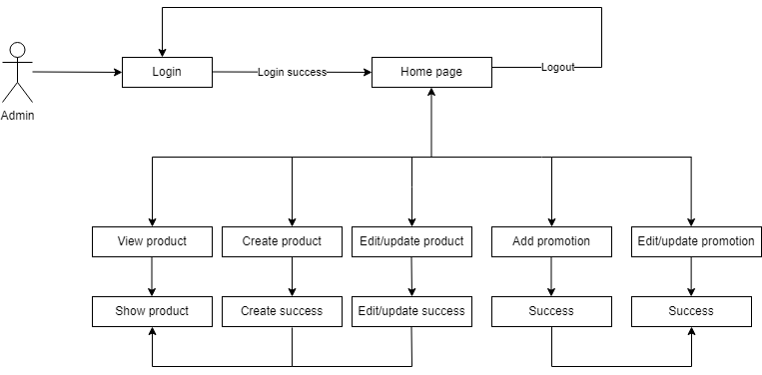
ScreenFlow Customer

