# Download the AIfES® library

* Got to: <https://github.com/Fraunhofer-IMS/AIfES_for_Arduino>
* Download AIfES® as ZIP archive using "Download ZIP”

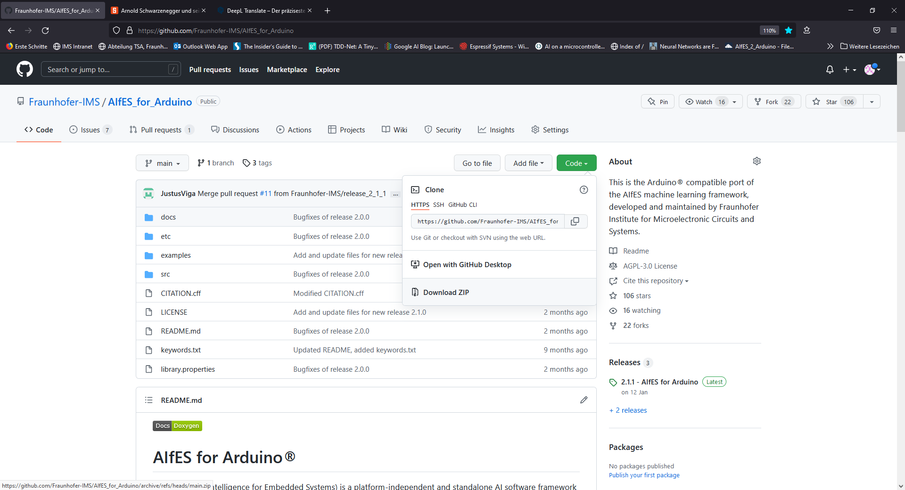

Figure : Download AIfES, by using the "Download Zip" Function

# Prepare AIfES®

We have different configuration files for AIfES® to make it compatible with different IDEs. In the default configuration it is of course optimized for the Arduino IDE. Arduino specific functions like "*serial.print()*" are used. By changing the configuration files, you can make AIfES® universal. Then the classic "*printf()*" functions are used. You can then use AIfES® almost everywhere, on the PC, in a microcontroller IDE of your choice, even in a hardware simulator.

How this works is explained here step by step:

* Extract the ZIP file
* Navigate to the “***src/***” folder
* Replace the files “***aifes_config.cpp***” and “***aifes_config.h***” in the “***src/***” directory by the ones found in “***etc/aifes_configurations/pc/***”
* Note that the new config file has the extension ***\*.c*** and not ***\*.cpp***
* That's it

# Use Arm CMSIS

Of course, you can also use CMSIS in the universal version if you use e.g. another microcontroller IDE. For the installation please follow this [guide](https://github.com/Fraunhofer-IMS/AIfES_for_Arduino/tree/main/src/CMSIS).

The only difference is that you don't make the changes in the file structure of the Arduino IDE, but in your just downloaded copy.

# Your guide

Your description.

# Legal Disclaimer

The author of this installation guide assumes no responsibility or liability for any errors or omissions in the contents of this document that may result in damage to any kind of hardware or software. The information contained in this manual is provided without warranty of completeness, functionality, accuracy, usefulness or timeliness...