This AREA is for designing the different diagrams…

System

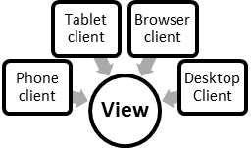

**Storage Abstraction**

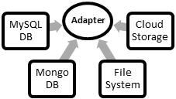

**Blog Controller**

This AREA has compiled diagrams (grouped as 1 dragable element)

