Miqurios Platform Architecture
Engineering a signal from the noise.
This document summarizes the architecture of Miqurios and outlines how its design philosophy enables performance, adaptability, and long-term scalability.

Overview
Content overload defines the modern world. Miqurios cuts through it with precision AI analysis, transforming siloed content into structured insight in seconds. This is not another summarizer or bookmarking tool. It is an intelligence layer for how thinking individuals consume information.
This overview presents the technical foundation and design philosophy behind Miqurios.

System Architecture
Miqurios is built on three principles: modularity, velocity, and intelligence.
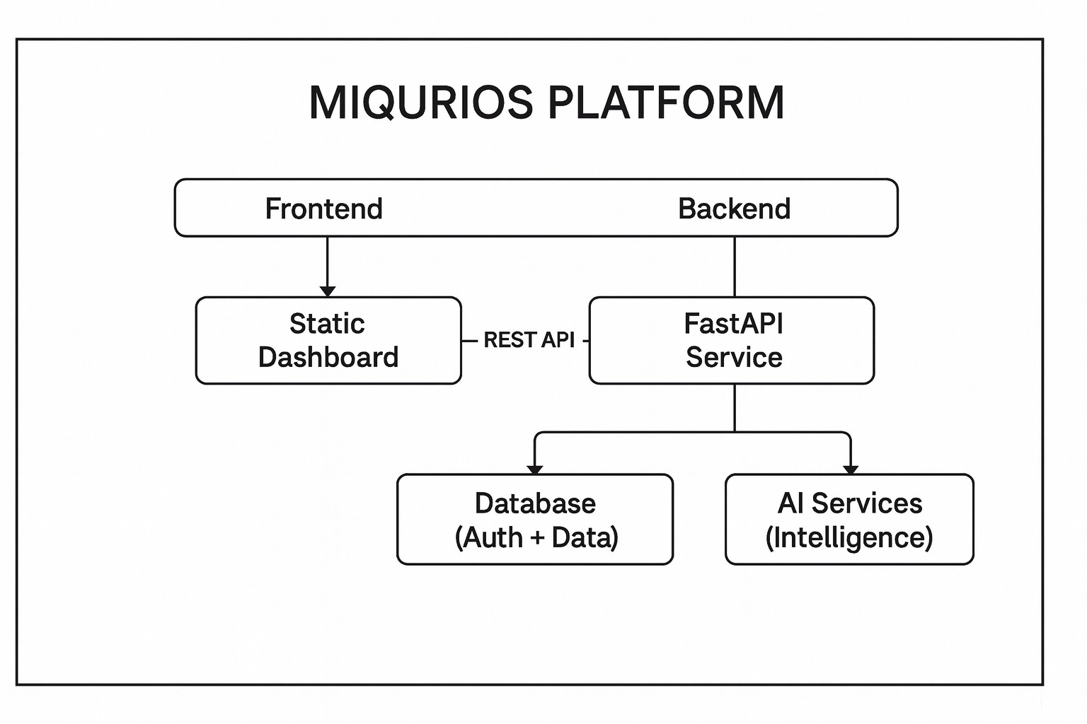
Stack
• Frontend: Static web application, globally distributed via CDN
• Backend: Python/FastAPI microservice architecture
• Intelligence: AI integration with custom orchestration layer
• Data: PostgreSQL with JWT authentication
• Infrastructure: Git-driven continuous deployment

Backend Architecture
The backend follows a layered microservice pattern designed for clarity and independent scalability.
backend/
│
├── Entry point and orchestration layer
│
├── Core infrastructure
│ ├── Configuration management
│ ├── External service clients
│ └── AI orchestration logic
│
├── Data models
│ └── Request/response schemas
│
├── Business logic layer
│ ├── Content analysis orchestration
│ └── Web extraction engine
│
└── API endpoints
├── Identity and access
├── Analysis operations
├── Content ingestion
└── User intelligence
Why this structure matters
• New features deploy in hours, not weeks
• Issues are isolated by service boundary
• Multiple developers work without merge conflicts
• Services scale independently based on load
This is enterprise-grade architecture built with startup velocity.

Frontend
frontend/
│
├── Main interface
├── Design system and styling
├── Application logic
│ ├── Core functionality
│ ├── Authentication flow
│ └── Backend communication
├── Demo and examples
└── Brand assets
Design philosophy
• Minimal dependencies, maximum performance
• Global CDN distribution for sub-second load times
• Clean separation between UI and business logic

Intelligence Pipeline
Content Ingestion
↓
Adaptive extraction
↓
Preprocessing
↓
Multi-dimensional AI analysis
↓
Insight synthesis
↓
User contextual adaptation
Core approach
• Custom AI orchestration
• Adaptive extraction handles real-world web complexity
• Stateless design enables infinite horizontal scaling
• Type-safe contracts eliminate entire classes of bugs
Why This Architecture Wins
Velocity
Git push → Production in seconds. Zero manual deployment steps.
Resilience
Independent deployment of frontend, backend, and data layer. Failures stay contained.
Intelligence
AI is architectural, not supplemental. Context flows through every layer.
Clarity
Single-purpose modules. Explicit boundaries. Fast debugging and feature development.
Scale-Ready
Microservice extraction prepared. 10 users to 10 million without architectural rewrites.

Strategic Advantage
Miqurios learns from interaction itself. Each analysis session strengthens contextual understanding. The system becomes more adaptive and valuable over time, creating compounding intelligence that transforms a product into a platform.

Technical Differentiation
Typical MVP | Miqurios
Monolithic codebase | Layered microservice architecture
Manual deployments | Automated CI/CD from Git
Generic AI integration | Adaptive AI orchestration layer
Fragile web scraping | Adaptive extraction engine
Security as afterthought | JWT + OAuth from day one
Scaling = full rewrite | Scaling = configuration adjustment

