**IT255 – DZ03**

Servis: http://jsonplaceholder.typicode.com/posts/2

Get metoda:

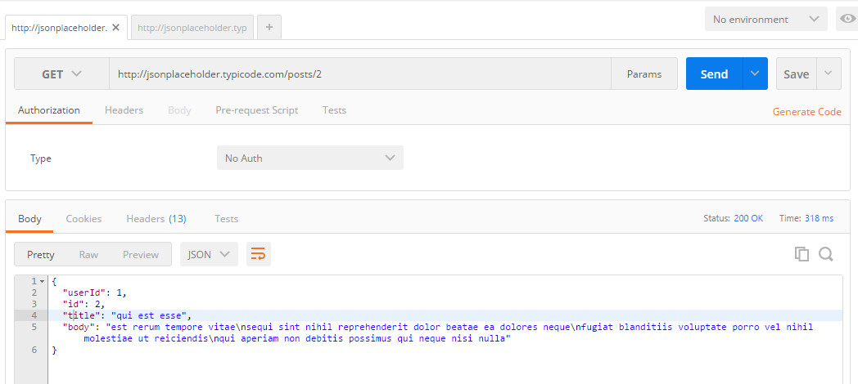

Put metoda:

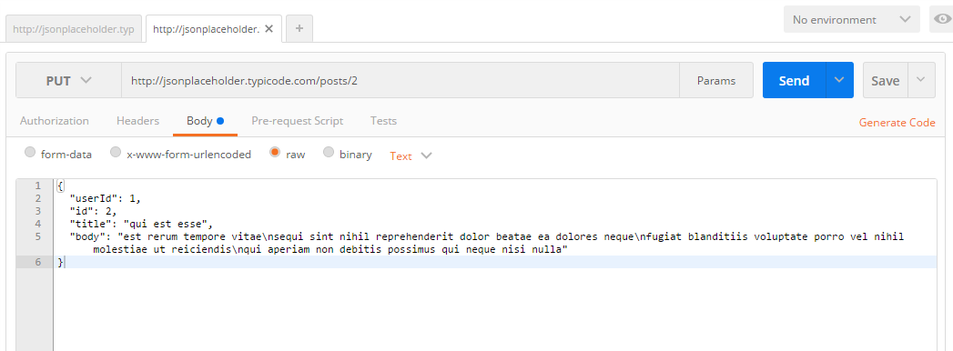

Rezultat put metode:

