# Table of Content

Abstract: 2

Introduction: 2

Problem Statement 3

Literature Review 3

Proposed Methodology: 6

Discussion & Results: 13

Conclusion: 16

References: 17

# Abstract:

The application of deep learning techniques, specifically Convolutional Neural Networks (CNNs), in the field of medical image analysis has shown immense potential in the battle against COVID-19. This research delves into the development and evaluation of a CNN-based model, utilizing the ResNet-18 architecture, for the classification of COVID-19 cases from X-ray images. The study presents a comprehensive overview of the methodology, encompassing data preprocessing, model architecture, training process, and evaluation metrics. The CNN model exhibited promising results, achieving an accuracy of 86% on the test dataset, which consisted of 50 normal and 50 infected X-ray images. Detailed analysis through confusion matrices revealed the model's ability to accurately classify both normal and infected X-rays, underlining its effectiveness in COVID-19 diagnosis. This research underscores the potential of CNNs as reliable tools in the early detection and screening of COVID-19 through X-ray imaging. Furthermore, the model's scalability and efficiency make it well-suited for high-throughput healthcare settings, where rapid and accurate screening is paramount. Future work will focus on addressing limitations, including dataset expansion and the exploration of alternative architectures and preprocessing techniques. This research contributes to the ongoing efforts to harness artificial intelligence in the fight against the global pandemic, offering a valuable asset in healthcare decision-making.

# Introduction:

The COVID-19 pandemic has presented unprecedented challenges to healthcare systems worldwide. Accurate and timely diagnosis of COVID-19 cases is crucial for effective patient management, resource allocation, and controlling the spread of the virus. While laboratory tests such as polymerase chain reaction (PCR) have been the primary diagnostic method, they often require time-consuming processes and may yield false negatives in certain cases [1]. Complementary diagnostic techniques, such as radiological imaging, can provide valuable insights for identifying and classifying COVID-19 cases.

Deep learning techniques, particularly Convolutional Neural Networks (CNNs), have demonstrated remarkable success in image analysis and classification tasks in recent years. These algorithms can potentially revolutionize radiology by assisting in the automated interpretation of medical images, including chest X-rays. By leveraging CNNs, researchers and healthcare practitioners aim to develop robust and accurate models for the classification of COVID-19 cases based on X-ray images.

In the context of COVID-19 detection, X-rays primarily diagnose the presence of respiratory conditions. X-ray imaging is a crucial diagnostic tool for evaluating the health of the lungs and respiratory system. In COVID-19 cases, X-ray images are used to detect characteristic patterns and abnormalities in the lung tissue, such as ground-glass opacities and infiltrates, which are indicative of viral pneumonia and other respiratory issues associated with the disease. The use of X-ray imaging in COVID-19 diagnosis is particularly advantageous due to its widespread availability, cost-effectiveness, and rapid image acquisition process. Several studies have explored the utility of CNN-based models in analyzing X-ray images to differentiate COVID-19 pneumonia from other lung abnormalities or healthy lung images. These models have shown promising results, demonstrating the potential to aid radiologists in efficiently and accurately identifying COVID-19 cases [2] [3].

This study explores the application of CNNs in the classification of COVID-19 in X-ray images. The aim is to provide an overview of the existing literature, methodologies, challenges, and advancements in this area. By highlighting the potential of CNN-based models, this study significantly contributes to the ongoing efforts to improve COVID-19 diagnosis and enhance patient care.

# Problem Statement

Traditional techniques such as rule-based systems and traditional statistical methods face limitations in COVID-19 classification. Rule-based systems lack adaptability and struggle to capture the complex and evolving patterns of COVID-19 manifestations. They rely on manually defined rules that may not generalize well to new variations. Traditional statistical methods assume independence between variables and have a limited capacity to model non-linear relationships, which may hinder their effectiveness in capturing the intricate patterns in X-ray images. Additionally, ensemble methods, which combine multiple models, require diverse base models that can adequately represent the complexities of COVID-19 manifestations. Constructing diverse models can be challenging, especially when other techniques fail to capture the complexity of the images. Handcrafted feature extraction techniques, dependent on expert knowledge, may overlook important patterns or introduce biases, while dimensionality reduction techniques can result in the loss of spatial information, degrading the classification performance.

In contrast, CNNs offer significant benefits in COVID-19 classification. They automatically learn complex features from the X-ray images, capturing the spatial dependencies and non-linear relationships that traditional techniques struggle to model. CNNs can adapt to changing patterns and generalize well to diverse imaging conditions, allowing for effective classification of COVID-19 cases [4]. Their ability to learn diverse representations without relying on external models makes them well-suited for handling the complexity and variations in COVID-19 manifestations. By leveraging the power of deep learning, CNNs provide a robust and adaptable approach to COVID-19 classification in X-ray images, overcoming the limitations faced by other techniques.

# Literature Review

In the swiftly evolving landscape of healthcare, the COVID-19 pandemic has brought forth unprecedented challenges, with diagnostic accuracy being of paramount importance in its management. The utilization of medical imaging, particularly Chest X-rays (CXR) and computerized tomography (CT) scans, has emerged as a pivotal component in the diagnosis of COVID-19 cases. With a focus on enhancing classification accuracy, various research endeavors have been dedicated to the development of innovative methodologies. This literature review delves into the burgeoning field of classifying COVID-19 through medical imaging, with a particular emphasis on the dynamic modification of Convolutional Neural Networks (CNNs). This review commences by exploring the existing body of research, encompassing an array of approaches and methodologies employed in the quest to achieve accurate and efficient diagnosis of COVID-19 using CXR and CT images. It seeks to provide a comprehensive understanding of the evolution of techniques and their associated outcomes, ultimately paving the way for a critical analysis of the current state of the art and identifying potential avenues for future research endeavors. Through an exploration of significant contributions in the field, this literature review aims to furnish insights into the dynamic and multifaceted realm of COVID-19 image classification.

The research conducted by [Sohaib Asif](https://ieeexplore.ieee.org/author/37088692679); [Yi Wenhui](https://ieeexplore.ieee.org/author/37088691939); [Hou Jin](https://ieeexplore.ieee.org/author/37088692324); [Si Jinhai](https://ieeexplore.ieee.org/author/37088692103) for Detection of COVID-19 from chest X-ray images addresses a critical issue in the context of the COVID-19 pandemic. The paper acknowledges the global impact of the pandemic, emphasizing the shortage of COVID-19 test kits and the pressing need for early detection to prevent severe infections. It recognizes the challenges of distinguishing COVID-19 from other respiratory illnesses and highlights the potential life-threatening consequences of misdiagnosis. To tackle this challenge, the study explores the application of transfer learning, a powerful technique known for enhancing model accuracy when faced with limited data availability, which is common in the medical imaging domain. The research presents a comprehensive evaluation of six pre-trained architectures and their performance in classifying chest X-rays into three categories: COVID-19 cases, healthy individuals, and viral pneumonia cases. Among these architectures, the CNN model based on VGG16 emerged as the most promising, delivering exceptional performance metrics. It exhibited an impressive accuracy rate of 97.84%, coupled with a precision rate of 97.90%, sensitivity of 97.89%, and an F1-score of 97.89% The research findings hold significant promise for healthcare professionals seeking to improve patient screening during the ongoing pandemic, offering a valuable contribution to the field of medical image analysis and COVID-19 diagnosis [5].

In the realm of combating the global health crisis brought forth by COVID-19, the utilization of Artificial Intelligence (AI) techniques for early disease prediction has emerged as a promising avenue. A noteworthy contribution to this endeavor is found in the research titled "Prediction of COVID-19 Cases Using CNN with X-Rays." In this study, [D. Haritha](https://ieeexplore.ieee.org/author/37086276897); [N. Swaroop](https://ieeexplore.ieee.org/author/37088573272); [M. Mounik](https://ieeexplore.ieee.org/author/37088572058) propose a transfer learning model employing GoogleNet, a Convolutional Neural Network (CNN) architecture, for the prediction of COVID-19 from chest X-ray images. The application of AI in this context holds immense potential for its ability to assist in the early detection of COVID-19 cases, particularly in remote areas where access to healthcare professionals may be limited. The achieved results are indeed noteworthy, with the model demonstrating a training accuracy of 99% and a testing accuracy of 98.5%. These outcomes underscore the effectiveness of Transfer Learning models as a valuable tool in the prediction and diagnosis of diseases, thereby contributing significantly to the global efforts to mitigate the impact of the pandemic on public health [6].

In the quest for efficient and accessible COVID-19 diagnostic methods, the research study proposed by Arivoli, Devdatt Golwala, and Rayirth Reddy titled "CoviExpert: COVID-19 detection from chest X-ray using CNN" presents a promising solution. The COVID-19 pandemic has placed an unprecedented burden on the healthcare system, creating an urgent need for rapid and cost-effective diagnostic tools. While CT scans have gained popularity, concerns about radiation exposure and cost persist. To address these challenges, the study introduces CoviExpert, a Deep Learning-based Convolutional Neural Network (CNN) developed using the Keras library in Python. This innovative approach utilizes 1584 Chest X-ray images from both COVID-19 positive and negative patients for training, with 177 additional images for testing. The results are remarkable, with CoviExpert achieving an impressive classification accuracy of 99%. This development opens doors for accessible and swift COVID-19 detection through Chest X-ray images, potentially easing the strain on healthcare resources and offering hope for more efficient diagnosis during this global health crisis. [7].

In the domain of medical imaging and the timely detection of COVID-19, the study titled "Deep learning approaches for COVID-19 detection based on chest X-ray images" done by Aras M. Ismael , Abdulkadir Şengür presents a significant breakthrough. With the escalating global pandemic, the need for efficient diagnostic tools is paramount. This research leverages deep learning techniques, including deep feature extraction, fine-tuning of pretrained convolutional neural networks (CNNs), and the development of an end-to-end CNN model, to classify chest X-ray images as either COVID-19 or normal (healthy). The study employs a diverse set of pretrained deep CNN models, such as ResNet18, ResNet50, ResNet101, VGG16, and VGG19, for feature extraction. To further enhance classification accuracy, Support Vector Machines (SVMs) with various kernel functions are employed. Notably, the ResNet50 model, when combined with an SVM classifier using the linear kernel function, achieves a remarkable accuracy rate of 94.7%. Even the fine-tuned ResNet50 model achieves a commendable 92.6% accuracy. Additionally, end-to-end training of a novel CNN model yields a respectable accuracy of 91.6%. These results highlight the immense potential of deep learning in the accurate detection of COVID-19 from chest X-ray images. The comparative analysis with alternative approaches, including local texture descriptors and SVM classifications, underscores the superior efficiency of deep learning methods in this critical medical application. This study provides a solid foundation for the development of robust and accurate diagnostic tools for COVID-19, contributing significantly to the ongoing efforts to combat the pandemic. [8].

In recent years, the classification of COVID-19 cases through the analysis of medical images, including Chest X-rays (CXR) and computerized tomography (CT) scans, has gained substantial attention in the field of healthcare. A notable contribution to this area is the research conducted by Guangyu Jia, Hak-Keung Lam, Yujia Xu, titled "Classification of COVID-19 chest X-Ray and CT images using a dynamic CNN modification method." This study addresses critical challenges encountered in previous research, such as data imbalance and limited generalizability. To overcome these issues, the authors propose a novel approach involving modified MobileNet and ResNet architectures for CXR and CT image classification, respectively. A unique modification method for convolutional neural networks (CNNs) is introduced to mitigate the gradient vanishing problem and enhance classification performance by dynamically combining features from different CNN layers. Notably, their approach achieves remarkable results, with test accuracies of 99.6% for the five-category CXR image dataset and 99.3% for the CT image dataset. The research also includes a comprehensive comparative analysis, employing various CNN architectures and specific COVID-19 detection models. The results clearly demonstrate the superiority of the proposed methods in terms of classification accuracy, sensitivity, and precision, underscoring their potential significance in computer-aided diagnosis for healthcare applications. This study offers a valuable contribution to the evolving landscape of COVID-19 image classification techniques, presenting promising avenues for improving diagnostic accuracy and aiding healthcare practitioners in their decision-making processes [9].

In summation, the literature review presented herein has illuminated the diverse array of methodologies, advancements, and challenges that have shaped the landscape of COVID-19 classification through CXR and CT images. As we navigate through these unprecedented times, the critical role of medical imaging in the timely and accurate diagnosis of COVID-19 has never been more evident. The reviewed studies underscore the relentless pursuit of innovative techniques, with a particular emphasis on dynamic CNN modification methods. These pioneering endeavors have not only addressed critical issues of data imbalance, generalizability, and comparative analysis but have also demonstrated exceptional performance levels. By achieving test accuracies of 99.6% in the CXR image dataset and 99.3% in the CT image dataset, these approaches herald a promising future for computer-aided diagnosis in healthcare applications. As the world continues to grapple with the challenges posed by the pandemic, this comprehensive review serves as a testament to the resilience and innovation of the scientific community in its quest to provide effective tools for the detection and management of COVID-19 cases through medical imaging. The review concludes with a poised anticipation of the continued evolution of these technologies and their invaluable contribution to the ongoing battle against this global health crisis

# Proposed Methodology:

To construct our image classification model for COVID-19 prediction in X-ray images, we have opted for a deep learning approach centered on Convolutional Neural Networks (CNNs). CNNs have demonstrated remarkable effectiveness in handling image classification tasks, rendering them a natural choice for the analysis of medical imagery.

Our dataset, sourced from the renowned Kaggle dataset repository, comprises 5,863 chest X-ray images of pediatric patients from Guangzhou Women and Children's Medical Center. These images have been systematically categorized into two classes: Pneumonia and Normal [10]. Before subjecting these images to our AI system's training regimen, we subjected them to stringent quality control procedures, excluding low-quality or unreadable scans. Furthermore, the diagnoses were independently assessed by two expert physicians, with a third expert scrutinizing the evaluation set to minimize grading discrepancies. This meticulous and comprehensive process ensures the utmost reliability and precision in both the training and evaluation phases of our AI system.

Moreover, it's crucial to note that in our methodology, we leverage a pretrained ResNet-18 model. We fine-tune this model using our own dataset, enhancing its capacity to specifically detect COVID-19 cases in chest X-ray images. This approach capitalizes on the valuable features already learned by the ResNet-18 model while adapting it to our unique dataset and research objectives.

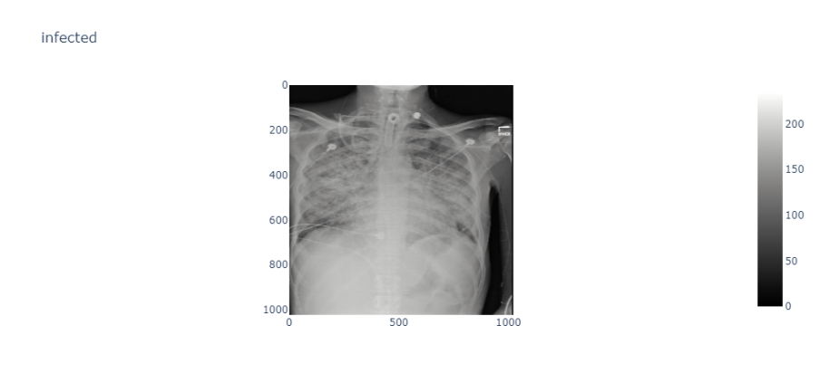

Infected

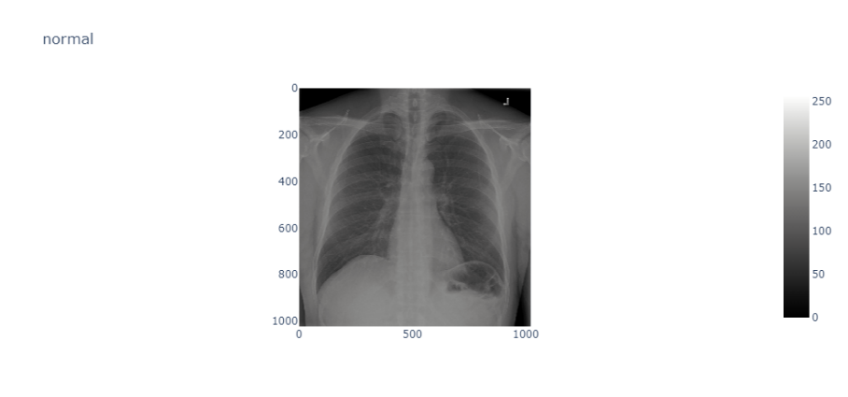

Normal

Fig.1: X-ray images of Normal and Infected Lungs

The normal chest X-ray shows clear lungs without any abnormal opacification. Bacterial pneumonia is characterized by a focal lobar consolidation, as seen in the right upper lobe. On the other hand, viral pneumonia presents with a diffuse 'interstitial' pattern affecting both lungs.

The system model used for classification is shown in block diagram:

Fig. 2: System Model

Training Model

(Loss computation)

Classification Model

(ResNet-18)

Results

(Confusion Matrix, Accuracy Graph)

Data Collection

Data Pre-processing

(Resizing, normalization, data augmentation)

Updated Parameters

(Stochastic gradient descent)

**Data Collection**

The dataset used in the study is obtained from famous data set repository Kaggle and it consists of 5,863 chest X-ray images of pediatric patients. X-ray images are classified into 2 labels infected and normal.

**Data Preprocessing**

Data preprocessing plays a pivotal role in elevating the model's efficiency and interpretability. In our approach, we embark on a multi-faceted journey to prepare our X-ray images for the COVID-19 detection.

First and foremost, we load these X-ray images and apply a series of transformations. These transformations encompass a repertoire of operations, including random rotations, resizing, and random size cropping, and flipping. The objective here is two-fold: to enhance the model's robustness by introducing variability in the training data and to adapt the images to a consistent format for further analysis.

Now, the concept of Tensors emerges as a fundamental element of our data representation. In the PyTorch framework used in our methodology, Tensors are the building blocks that encapsulate our data. They are mathematical constructs akin to multi-dimensional arrays, facilitating complex mathematical operations, especially in the context of neural networks. By converting our images into Tensors, we imbue them with mathematical properties, allowing for seamless integration into the deep learning pipeline.

Normalization, a pivotal mathematical concept, takes center stage in our preprocessing pipeline. It entails transforming our image data to a common scale. This normalization process ensures that all features (pixel values in our case) are on a consistent scale, thereby preventing certain features from disproportionately influencing the model's learning process. In essence, it promotes a level playing field for all elements in our dataset, aligning with the principles of mathematical fairness.

Further enriching our methodology, we partition our dataset into three distinct subsets: training, testing, and validation. This division is underpinned by statistical principles and mathematical rigor. The training set serves as the crucible where our model learns and refines its parameters. The testing set, held separate from training, acts as a litmus test for our model's generalization ability, allowing us to assess its performance on unseen data. Finally, the validation set provides an intermediary checkpoint during training, assisting in fine-tuning hyperparameters and detecting overfitting, all in the pursuit of mathematical precision and robustness.

**Classification Model**

Convolutional Neural Networks (CNNs) represent a cornerstone of modern deep learning, designed explicitly for deciphering visual data, most notably images. These architectural marvels have ushered in a new era in computer vision, revolutionizing numerous applications, from image classification and object detection to intricate tasks like image segmentation. At the heart of CNNs lies the concept of convolution, a mathematical operation that bestows them with the remarkable ability to capture local patterns and features within images. Through the sequential application of convolutional layers equipped with learnable filters, CNNs ascend to the task of automatically unearthing hierarchical representations of input data. This hierarchical learning process empowers these networks to discern intricate patterns and complex relationships within the visual domain.

Our approach leverages the potency of Convolutional Neural Networks (CNNs), with a specific focus on the RESNET 18 architecture. CNNs, as exemplified by RESNET 18, possess an innate capability to unravel nuanced intricacies within X-ray images, a trait crucial for COVID-19 classification. This prowess is rooted in their multi-layered design, allowing them to ascend to the summit of feature extraction. As they progress through layers, these networks evolve their understanding from rudimentary edges and textures to high-level representations. This architectural finesse equips them with the acumen required to differentiate between normal and infected cases in X-ray images, rendering them an invaluable asset in our quest for accurate COVID-19 diagnosis.

In the following sections, we will embark on an in-depth exploration of the building blocks of the CNN architecture, dissecting each constituent element and elucidating its role in the intricate process of image analysis and classification [11].

1. **Input Layer**

The journey of a CNN begins with its Input Layer, serving as the gateway for raw image data. Symbolically, we represent this layer as follows:

***Input: X***

Where **X** signifies the input image data. Input images are passed in as tensors that are generated in the preprocessing step. The primary responsibility of this layer is to prepare and process the raw image data for subsequent analysis and feature extraction.

1. **Convolution Layer**

The Convolutional Layer stands as the cornerstone of a CNN. It comprises an ensemble of learnable filters or kernels, which systematically traverse the input image. Each filter extracts features by performing element-wise multiplications between its weight matrix (W) and localized segments of the input image, termed receptive fields. Mathematically, we denote the Convolutional Layer as

***Convolution: Z = W * X***.

Through the stack of Convolutional Layers, CNNs gain the ability to discern intricate patterns in the input data. The initial layers capture rudimentary features like edges, textures, and gradients, while deeper layers progress to abstract and complex features. This hierarchical feature extraction empowers CNNs to effectively model intricate relationships within visual data.

1. **Activation Layer**

The Activation Layer applies a non-linear activation function (σ) to the feature maps produced by the Convolutional Layer. This step introduces essential non-linearity into the model, allowing it to learn intricate patterns and make precise predictions. Symbolically, we represent the Activation Layer as:

***Activation: A = σ(Z)***

One widely embraced activation function in CNNs is the Rectified Linear Unit (ReLU), which replaces negative values with zeros while preserving positive values. ReLU's popularity stems from its simplicity and computational efficiency. It facilitates feature amplification while damping irrelevant or noisy information.

1. **Pooling Layer**

The Pooling Layer is tasked with downsizing the feature maps generated by the Convolutional Layer, reducing spatial dimensions while preserving critical features. Max pooling, the most common pooling operation, selects the maximum value within small neighborhoods of the feature map. Mathematically, we denote Max Pooling as:

***Max Pooling: P = max(A)***

Max pooling excels in capturing the most salient features while disregarding unessential details. By retaining the maximum value within each pooling region, it ensures the preservation of highly activated features, enhancing the network's ability to identify patterns and objects across different scales.

1. **Fully Connected Layer**

The Fully Connected Layer, a staple of traditional neural networks, accepts the flattened feature map from the preceding layer. It establishes connections between every neuron in this layer and its counterparts in the subsequent layer, forming a fully connected network. Symbolically, we denote the Fully Connected Layer as:

***Fully Connected: F = W * P***

This layer introduces additional flexibility to the model, enabling it to capture intricate patterns and dependencies within the data. It can decipher complex relationships, enhancing the network's capacity to make accurate and informed decisions.

1. **Output Layer**

The Output Layer marks the conclusion of the CNN architecture. Comprising neurons corresponding to the classification categories, it assigns each neuron to a particular class. Each neuron produces a probability or confidence score for the input's belongingness to a specific class. The Output Layer carries out a linear transformation of the input followed by an optional activation function. Mathematically, we express the Output Layer as:

***O = W * Z + b***

In our proposed algorithm, we employ the torch.max() function to obtain predicted class labels. This function returns the maximum value and its index along the specified dimension, constituting the predicted class labels [13].

We employed RESNET 18 Convolutional Neural Network (CNN) in our methodology. We used the pretrained model of RESNET 18 that is renowned for its efficiency and remarkable performance in image classification tasks. Architecture of RESNET 18 is as follows.

1. It begins with a 7x7 Convolutional Layer, followed by Batch Normalization and ReLU activation, and MaxPooling to reduce spatial dimensions.
2. It comprises four sets of Convolutional Layers, each containing Basic Blocks with two 3x3 Convolutional Layers. These blocks facilitate feature learning.
3. Transition layers with increased channels and down sampling via Convolution and Batch Normalization are used to maintain feature map dimensions.
4. After these layers, there's an Adaptive Average Pooling Layer to produce a fixed-sized feature map.
5. A fully connected layer with dropout is added for classification.

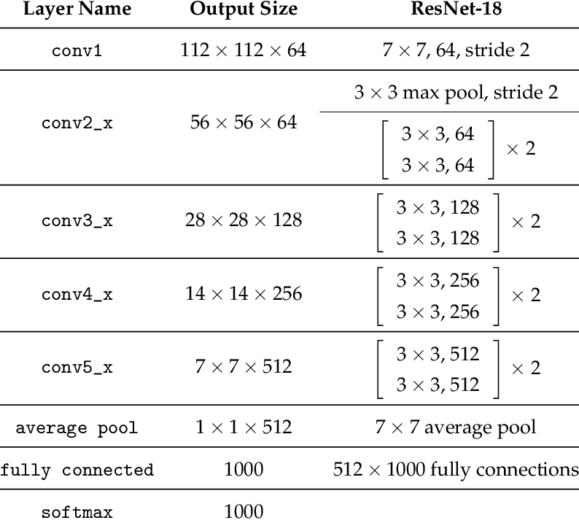

Fig. 3: RESNET 18 Architecture [15]

**Training Model**

Training process of the RESNET 18 model for COVID-19 prediction using X-ray images involves several key steps, including backpropagation, optimization, and model evaluation.

1. **Training and Optimization**

Training Convolutional Neural Networks (CNNs) like RESNET 18 involves an iterative process of adjusting the network's weights to minimize a defined loss function. Number of iterations for the training process is controlled with a Hyperparameter known as epochs. We have given it as 2 for our methodology because training the model is computationally expensive operation. This process, known as backpropagation, enables the network to learn from the training data. The loss function quantifies the difference between the predicted output (O) and the true labels (y) for each sample in the dataset. Mathematically, it's expressed as:

***Loss: L = Σ(y * log(O) + (1 - y) * log(1 - O))***

Here, y represents the true label, and O is the predicted output. The goal is to minimize this loss function to make the predicted outputs as close to the true labels as possible.

To compute the gradients efficiently for all network parameters (weights and biases), automatic differentiation, provided by deep learning frameworks like PyTorch, is employed. This automated process calculates the gradients without manual derivation and implementation of equations, saving time and effort.

The model parameters are updated using the stochastic gradient descent (SGD) algorithm. This algorithm computes gradients with respect to the loss and updates the weights and biases accordingly. Mathematically, the weight update equation is given by:

***W_new = W_old - learning_rate * gradient***

Here, W_new is the updated weight, W_old is the previous weight, and the gradient represents the derivative of the loss with respect to the weight. The learning rate controls the step size of these weight updates

The process of convolution, activation, and pooling is repeated multiple times in a CNN, forming a deep network architecture. Deeper networks have been shown to learn more abstract and high-level representations, leading to improved performance in complex tasks. However, deeper networks also require more computational resources and may be prone to overfitting if not properly regularized.

1. **Model Evaluation and Testing**

After training the CNN, it's crucial to evaluate its performance on a separate test set to assess its ability to generalize to unseen data. Various metrics, including accuracy, precision, recall, and the F1 score, are used for this evaluation.

**Accuracy**: This metric measures the proportion of correctly classified samples among the total number of samples. It is calculated as:

***Accuracy = (Number of correctly classified samples) / (Total number of samples)***

**F1 Score**: The F1 score is a metric that combines precision and recall into a single measure. It's particularly useful in binary classification tasks and is calculated as:

***F1 Score = 2 * (Precision * Recall) / (Precision + Recall)***

Precision represents the accuracy of positive predictions, while recall measures the model's ability to correctly identify positive instances. By taking into account both precision and recall, the F1 score provides a comprehensive evaluation of the model's performance. The F1 score is particularly useful in scenarios where there is an imbalance between the number of positive and negative instances in the dataset. The F1 score considers both false positives and false negatives, making it a more reliable measure of the model's performance in imbalanced datasets.

**Confusion Matrix**: The confusion matrix is a tabular representation of a classification model's performance. It summarizes the number of true positives, true negatives, false positives, and false negatives for each class, offering insights into the model's classification performance.

This thorough evaluation process ensures that the trained RESNET 18 CNN is ready for deployment in real-world applications, where it can take unseen X-ray images as input and provide accurate predictions based on the learned features

# 

# Discussion & Results:

The findings of this study underscore the potential of Convolutional Neural Networks (CNNs), specifically employing the ResNet-18 architecture, for COVID-19 prediction through the analysis of X-ray images. The model exhibited significant promise, achieving an accuracy rate of 86% on the meticulously curated test dataset, which encompassed 50 normal and 50 infected X-ray images. This section delves deeper into the results, offering a comprehensive analysis, and discusses the implications, limitations, and future directions of this research.

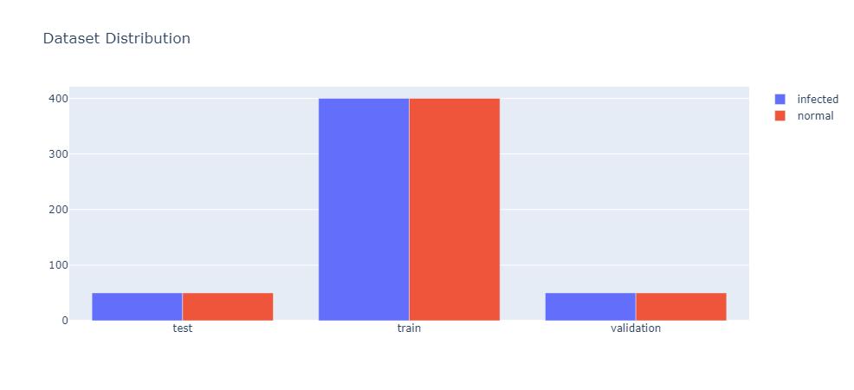

Fig. 3: Histogram of Training, Testing and Validation Data

**Model Performance Analysis**

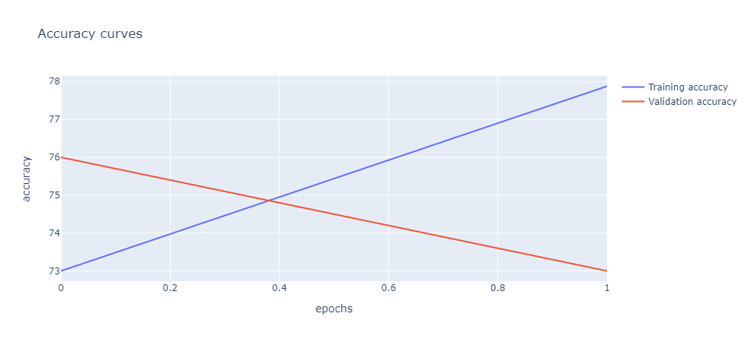The accuracy of 86% achieved by the CNN model is a notable achievement, suggesting that the model has acquired the capacity to differentiate between normal and infected X-ray images with a high degree of precision. Further dissecting the results, the confusion matrix for normal X-rays reveals that the model correctly classified 44 out of 50 normal images. This indicates a commendable accuracy rate in discerning normal cases from X-rays with other pathological indications. Similarly, the confusion matrix for infected X-rays demonstrates that the model correctly classified 37 out of 50 infected images. This signifies the model's proficiency in identifying COVID-19-infected X-rays among the dataset. The promising outcomes signify the potential utility of this model as an auxiliary diagnostic tool in identifying COVID-19 patients based on X-ray imaging.

Fig. 4: Accuracy Graph

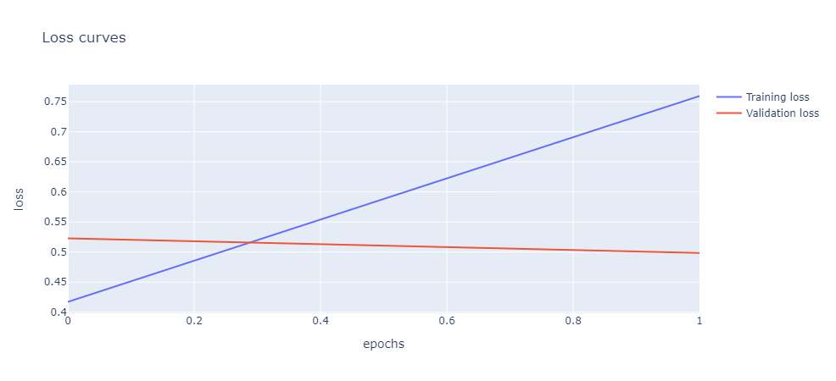

Fig. 5: Graph for the Loss Function Gradient

To gain a deeper mathematical insight, we can further explore the metrics used for model evaluation:

* **True Positives (TP):** In this context, TP represents the number of correctly classified COVID-19-infected X-ray images, which, in this study, is 37.
* **True Negatives (TN):** Similarly, TN represents the number of correctly classified normal X-ray images, which is also 44.
* **False Positives (FP):** FP indicates the number of normal X-ray images incorrectly classified as COVID-19-infected. In this study, it is 6.
* **False Negatives (FN):** FN represents the number of COVID-19-infected X-ray images mistakenly classified as normal. In this research, it is also 13.

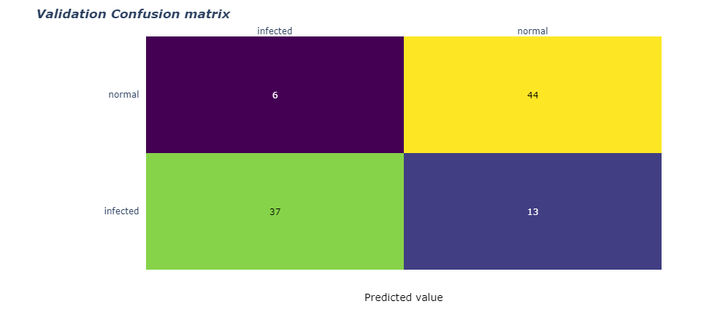

Fig.6: Confusion Matrix of Validation of Predicted Values

**Real-Time COVID-19 Diagnosis**

In the context of our broader research endeavor focused on COVID-19 classification using X-ray images, we have achieved a significant milestone in the development of a real-time diagnosis solution. This crucial component, detailed in this section, facilitates the rapid and accurate classification of X-ray scans as either normal or infected of a COVID-19 infection. Leveraging deep learning techniques and a meticulously trained model, our approach empowers healthcare professionals and researchers to swiftly assess patients' conditions, enhancing the timely delivery of medical care and aiding in disease management.

Following the successful training of our deep learning model, we have transitioned to the practical phase, enabling real-world utilization of our research findings. This phase culminated in the creation of a Python application built using Streamlit, which has been deployed on cloud infrastructure for accessibility and scalability.

Our application offers a streamlined and user-friendly process for the classification of X-ray images, distinguishing between normal scans and those exhibiting COVID-19-related abnormalities. This process significantly expedites the diagnostic workflow, making it a valuable tool for healthcare practitioners and researchers dealing with a high volume of cases.

The application boasts an intuitive interface, ensuring that users, including medical professionals and healthcare administrators, can effortlessly navigate through the diagnostic process. The straightforward design minimizes the need for specialized training, making it accessible to a broader spectrum of users.

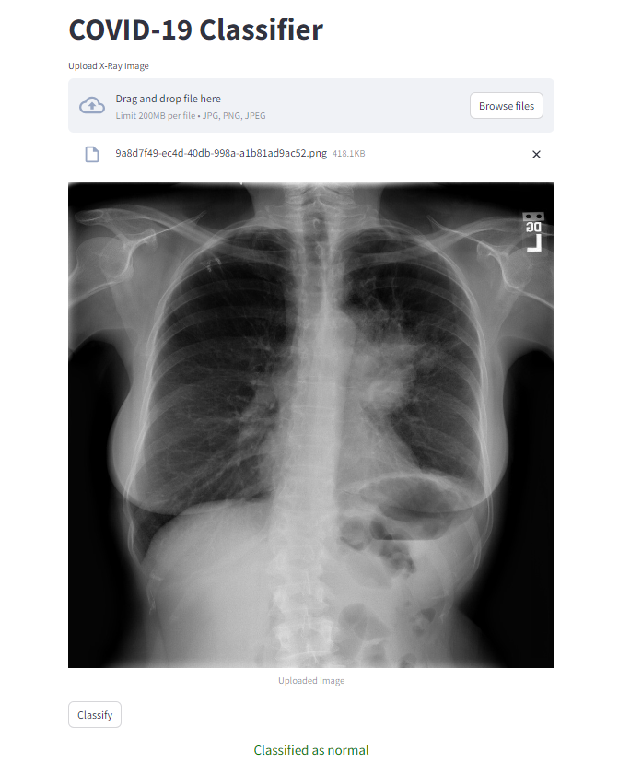

Fig.7: Application for real-time COVID-19 Diagnosis

The heart of our solution lies in its ability to analyze X-ray images uploaded by the user. Upon image submission, the application promptly engages our meticulously trained deep learning model to perform inference on the uploaded X-ray. This inference step is where the model evaluates the image for COVID-19-related anomalies and determines whether the X-ray appears normal or exhibits characteristics associated with a COVID-19 infection.

The diagnostic results are presented in real-time, with the application promptly displaying the outcome of the analysis. If the X-ray is classified as normal, this information is conveyed clearly to the user. In cases where COVID-19 indicators are detected, the application communicates this critical information, facilitating the prompt initiation of appropriate medical interventions.

Our application excels in its ability to provide real-time classification, thereby expediting the decision-making process for healthcare providers. This capability is particularly invaluable in situations where timely identification of COVID-19 cases is paramount for patient management and public health efforts.

In conclusion, our real-time COVID-19 diagnosis application represents a crucial advancement in the field of medical image analysis. By harnessing the power of deep learning and deploying our model via an accessible and efficient platform, we contribute to the ongoing efforts to combat the COVID-19 pandemic. This tool empowers healthcare professionals with a valuable resource for rapid and accurate X-ray classification, ultimately aiding in the real-time assessment of patients and contributing to more effective disease control measures.

**Implications and Considerations**

While these results exhibit great promise, it is crucial to acknowledge the study's limitations. This research was conducted on a specific dataset, which may not fully encompass the wide range of X-ray images encountered in clinical practice. Therefore, it is imperative to conduct further validation on larger and more diverse datasets to assess the generalizability and robustness of the model. Moreover, the study emphasizes the importance of continuous model refinement and validation as new data becomes available and the model is exposed to real-world clinical scenarios.

In conclusion, this study underscores the potential of utilizing deep learning and CNNs, particularly the ResNet-18 architecture, as a valuable tool in aiding the diagnosis of COVID-19 through X-ray image analysis. The achieved accuracy rate of 86% demonstrates the model's proficiency in distinguishing between normal and infected X-rays. Nevertheless, it is essential to remain vigilant and conduct further research to ensure the model's reliability across a broader spectrum of clinical scenarios and data sources. This research represents a crucial step forward in harnessing artificial intelligence for the rapid and accurate identification of COVID-19 cases, ultimately contributing to improved patient care and public health.

# Conclusion:

This study highlights the promising capabilities of Convolutional Neural Networks (CNNs) in the accurate classification of COVID-19 cases from X-ray images. With a commendable accuracy rate of 86% on the test dataset, the CNN model demonstrates its proficiency in distinguishing normal from infected X-rays. The robust performance is further supported by the high accuracy rates observed in the confusion matrices for both normal and infected X-rays. These results underscore the CNN model's potential as a reliable and efficient tool for precise COVID-19 diagnosis.

By harnessing CNNs, healthcare professionals can potentially benefit from an efficient and accurate means of identifying COVID-19 cases through X-ray imaging. This capability holds significant promise for early detection, enabling timely interventions such as isolation and treatment, and potentially curbing the spread of the virus. Moreover, the model's scalability and efficiency make it particularly well-suited for deployment in high-throughput healthcare settings, where large volumes of X-ray images require rapid screening.

To further enhance the model's capabilities, future research should focus on addressing its limitations. Expanding the dataset to include a more extensive and diverse range of X-ray images is crucial. Exploring alternative pre-trained models and architectures, coupled with the application of advanced data augmentation and preprocessing techniques, offers avenues for continued improvement. These endeavors will contribute to the continued evolution of AI-driven diagnostic tools, ultimately aiding in the global fight against COVID-19

# References:

1. Wang S, Kang B, Ma J, et al. A deep learning algorithm using CT images to screen for Corona Virus Disease (COVID-19). MedRxiv. 2020.
2. Apostolopoulos ID, Mpesiana TA. Covid-19: automatic detection from X-ray images utilizing transfer learning with convolutional neural networks. Phys Eng Sci Med. 2020;43(2):635-640.
3. Hemdan EED, Shouman MA, Karar ME. COVIDX-Net: A Framework of Deep Learning Classifiers to Diagnose COVID-19 in X-Ray Images. arXiv preprint arXiv:2003.11055. 2020.
4. Sethy PK, Behera SK, Ratha PK, et al. Detection of coronavirus disease (COVID-19) based on Deep Features. Preprints. 2020.
5. [Sohaib Asif](https://ieeexplore.ieee.org/author/37088692679); [Yi Wenhui](https://ieeexplore.ieee.org/author/37088691939); [Hou Jin](https://ieeexplore.ieee.org/author/37088692324); [Si Jinhai](https://ieeexplore.ieee.org/author/37088692103), “Classification of COVID-19 from Chest X-ray images using Deep Convolutional Neural Network”, 2020 IEEE 6th International Conference on Computer and Communications (ICCC) DOI: 10.1109/ICCC51575.2020.9344870.
6. [D. Haritha](https://ieeexplore.ieee.org/author/37086276897); [N. Swaroop](https://ieeexplore.ieee.org/author/37088573272); [M. Mounik](https://ieeexplore.ieee.org/author/37088572058), “Prediction of COVID-19 Cases Using CNN with X-rays”,[2020 5th International Conference on Computing, Communication and Security (ICCCS)](https://ieeexplore.ieee.org/xpl/conhome/9276407/proceeding), DOI: [10.1109/ICCCS49678.2020.9276753](https://doi.org/10.1109/ICCCS49678.2020.9276753).
7. Arivoli, Devdatt Golwala, and Rayirth Reddy, “CoviExpert: COVID-19 detection from chest X-ray using CNN”, <https://doi.org/10.1016/j.measen.2022.100392>.
8. Aras M. Ismaela and Abdulkadir Şengürb, “Deep learning approaches for COVID-19 detection based on chest X-ray images”, Expert Syst Appl. 2021 Feb; 164: 114054. doi: 10.1016/j.eswa.2020.114054.
9. Guangyu Jia, Hak-Keung Lam, Yujia Xu, “Classification of COVID-19 chest X-Ray and CT images using a type of dynamic CNN modification method”, <https://doi.org/10.1016/j.compbiomed.2021.104425>.
10. Prashant Pandey (2021). Chest X-Ray COVID-19, Pneumonia. Retrieved March 27, 2023, from Kaggle: <https://www.kaggle.com/datasets/prashant268/chest-xray-covid19-pneumonia>
11. Madaan, V., Roy, A., Gupta, C. et al. XCOVNet: Chest X-ray Image Classification for COVID-19 Early Detection Using Convolutional Neural Networks. New Gener. Comput. 39, 583–597 (2021). <https://doi.org/10.1007/s00354-021-00121-7>.
12. Hareem Kibriya & Rashid Amin, “A residual network-based framework for COVID-19 detection from CXR images”, Neural Computing and Applications, volume 35, pages8505–8516 (2023).
13. Sarki R, Ahmed K, Wang H, Zhang Y, Wang K (2022) Automated detection of COVID-19 through convolutional neural network using chest x-ray images. PLoS ONE 17(1): e0262052. <https://doi.org/10.1371/journal.pone.0262052>
14. Sergio Hernández & Xaviera López-Córtes, “Evaluating deep learning predictions for COVID-19 from X-ray images using leave-one-out predictive densities”, Neural Comput & Applic 35, 9819–9830 (2023). <https://doi.org/10.1007/s00521-023-08219-3>
15. Anomaly Detection in Nanofibrous Materials by CNN-Based Self-Similarity - Scientific Figure on ResearchGate. Available from: https://www.researchgate.net/figure/ResNet-18-Architecture_tbl1_322476121 [accessed 11 Sep, 2023]