# Table of Content

Introduction: 2

Problem Statement 2

Literature Review 3

Proposed Methodology: 4

Experimental Results: 7

Conclusion: 8

References: 9

# Introduction:

The COVID-19 pandemic has presented unprecedented challenges to healthcare systems worldwide. Accurate and timely diagnosis of COVID-19 cases is crucial for effective patient management, resource allocation, and controlling the spread of the virus. While laboratory tests such as polymerase chain reaction (PCR) have been the primary diagnostic method, they often require time-consuming processes and may yield false negatives in certain cases [1]. Complementary diagnostic techniques, such as radiological imaging, can provide valuable insights for identifying and classifying COVID-19 cases.

Deep learning techniques, particularly Convolutional Neural Networks (CNNs), have demonstrated remarkable success in image analysis and classification tasks in recent years. These algorithms can potentially revolutionize radiology by assisting in the automated interpretation of medical images, including chest X-rays. By leveraging CNNs, researchers and healthcare practitioners aim to develop robust and accurate models for the classification of COVID-19 cases based on X-ray images.

The use of X-ray imaging in COVID-19 diagnosis is particularly advantageous due to its widespread availability, cost-effectiveness, and rapid image acquisition process. Several studies have explored the utility of CNN-based models in analyzing X-ray images to differentiate COVID-19 pneumonia from other lung abnormalities or healthy lung images. These models have shown promising results, demonstrating the potential to aid radiologists in efficiently and accurately identifying COVID-19 cases [2] [3].

This study explores the application of CNNs in the classification of COVID-19 in X-ray images. The aim is to provide an overview of the existing literature, methodologies, challenges, and advancements in this area. By highlighting the potential of CNN-based models, this study significantly contributes to the ongoing efforts to improve COVID-19 diagnosis and enhance patient care.

# Problem Statement

Traditional techniques such as rule-based systems and traditional statistical methods face limitations in COVID-19 classification. Rule-based systems lack adaptability and struggle to capture the complex and evolving patterns of COVID-19 manifestations. They rely on manually defined rules that may not generalize well to new variations. Traditional statistical methods assume independence between variables and have a limited capacity to model non-linear relationships, which may hinder their effectiveness in capturing the intricate patterns in X-ray images. Additionally, ensemble methods, which combine multiple models, require diverse base models that can adequately represent the complexities of COVID-19 manifestations. Constructing diverse models can be challenging, especially when other techniques fail to capture the complexity of the images. Handcrafted feature extraction techniques, dependent on expert knowledge, may overlook important patterns or introduce biases, while dimensionality reduction techniques can result in the loss of spatial information, degrading the classification performance.

In contrast, CNNs offer significant benefits in COVID-19 classification. They automatically learn complex features from the X-ray images, capturing the spatial dependencies and non-linear relationships that traditional techniques struggle to model. CNNs can adapt to changing patterns and generalize well to diverse imaging conditions, allowing for effective classification of COVID-19 cases [4]. Their ability to learn diverse representations without relying on external models makes them well-suited for handling the complexity and variations in COVID-19 manifestations. By leveraging the power of deep learning, CNNs provide a robust and adaptable approach to COVID-19 classification in X-ray images, overcoming the limitations faced by other techniques.

# Literature Review

X-radiation (X-ray) is a widely used method for diagnosing COVID-19, providing detailed chest images that can reveal characteristic features like ground-glass opacities and consolidation. However, interpreting X-ray results can be difficult, especially in cases with mild symptoms or overlapping chest diseases.

To overcome these challenges, researchers have explored machine learning approaches, such as convolutional neural networks (CNNs), to develop automated algorithms for classifying X-ray images as COVID-19 positive or negative. CNNs have demonstrated significant potential in various computer vision applications, including the analysis of medical images.

[Sohaib Asif](https://ieeexplore.ieee.org/author/37088692679); [Yi Wenhui](https://ieeexplore.ieee.org/author/37088691939); [Hou Jin](https://ieeexplore.ieee.org/author/37088692324); [Si Jinhai](https://ieeexplore.ieee.org/author/37088692103) demonstrated a novel method utilizing DCNN and Inception V3 for automated COVID-19 screening on chest X-ray images. The Inception V3 pre-trained model is utilized and trained on COVID-19, normal, and viral pneumonia image, achieving a classification accuracy of more than 98% [5].

[D. Haritha](https://ieeexplore.ieee.org/author/37086276897); [N. Swaroop](https://ieeexplore.ieee.org/author/37088573272); [M. Mounik](https://ieeexplore.ieee.org/author/37088572058) paper presents a transfer learning approach utilizing Googlenet (InceptionV1) for predicting COVID-19 from chest X-ray images. The results demonstrate high training accuracy (99%) and testing accuracy (98.5%), highlighting the effectiveness of transfer learning models in disease prediction [6].

Arivoli, Devdatt Golwala, and Rayirth Reddy proposed a deep learning approach using a Convolutional Neural Network (CNN) created with Keras, integrated with a user-friendly front-end interface named CoviExpert. The model is trained on 1584 Chest X-ray images of both COVID-19-positive and negative patients, with 177 images used for testing. The proposed approach achieves a classification accuracy of 99% [7].

Aras M. Ismael , Abdulkadir Şengür compared deep CNN approaches for COVID-19 detection using chest X-ray images. Deep features with SVM outperformed local descriptors, and fine-tuning and end-to-end training was more time-consuming. The Cubic kernel and ResNet50 model yielded better results, while deep CNN models outperformed shallow networks [8].

Guangyu Jia, Hak-Keung Lam, Yujia Xu put forward a dynamic CNN modification method for classifying COVID-19 CXR and CT image datasets. The proposed method incorporates pointwise convolution blocks to establish connections between different layers, enabling dynamic combinations. Six deep learning algorithms and two COVID-19-specific models are compared, and the modified CNN architecture demonstrates satisfactory classification performance, showing potential for clinical computer-aided diagnosis [9].

The aim of this research is to follow the above-mentioned methodologies to develop and evaluate an image classification model based on Convolutional Neural Networks (CNNs) for COVID-19 classification in X-rays. The use of image classification techniques and CNN models for COVID-19 classification from X-rays falls under the larger field of medical image analysis. This field involves the development of deep learning algorithms and techniques for CNN for the analysis and interpretation of medical images, including X-rays, MRI scans, and CT scans.

# Proposed Methodology:

To develop this image classification model for COVID-19 prediction in X-rays, we have selected the deep learning approach based on Convolutional Neural Networks (CNN). CNNs have been shown to be highly effective for image classification tasks, making them a natural choice for analyzing medical images.

The dataset used in the study is obtained from famous data set repository Kaggle and it consists of 5,863 chest X-ray images of pediatric patients from Guangzhou Women and Children's Medical Center, categorized into Pneumonia and Normal classes [10]. Prior to training the AI system, all images underwent quality control, with low-quality or unreadable scans being excluded. The diagnoses were then independently graded by two expert physicians, and a third expert reviewed the evaluation set to mitigate grading errors. This rigorous process ensures the reliability and accuracy of the AI system's training and evaluation.

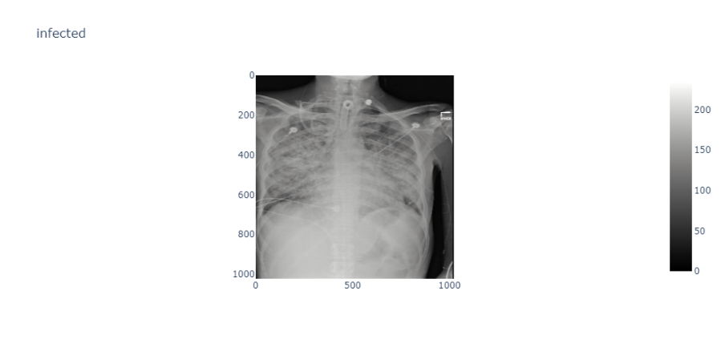

Infected

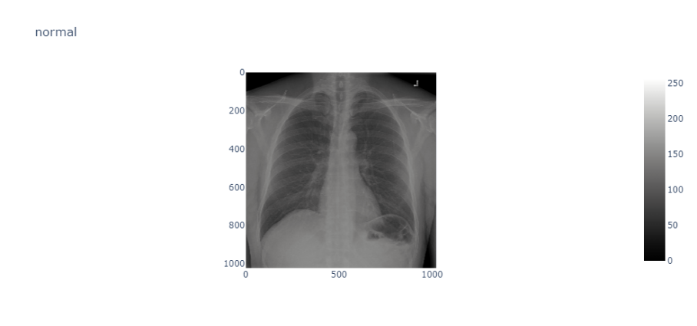

Normal

Fig.1: X-ray images of Normal and Infected Lungs

The normal chest X-ray shows clear lungs without any abnormal opacification. Bacterial pneumonia is characterized by a focal lobar consolidation, as seen in the right upper lobe. On the other hand, viral pneumonia presents with a diffuse 'interstitial' pattern affecting both lungs.

The system model used for classification is shown in block diagram:

Training Loop

(Loss computation)

Classification Model

(ResNet-18)

Results

(Confusion Matrix, Accuracy Graph)

Data Loading

Data Pre-processing

(Resizing, normalization, data augmentation)

Updated Parameters

(Stochastic gradient descent)

Fig. 2: System Model

Convolutional Neural Networks (CNNs) are powerful deep learning models specifically designed for analyzing visual data, such as images. They have revolutionized the field of computer vision and have been widely used in various applications, including image classification, object detection, and image segmentation. In this document, we will explore the architecture of a CNN in detail, explaining each component and its role in processing and analyzing images [11].

1. **Input Layer**

The input layer is the first layer of the CNN architecture and serves as the entry point for the image data. It takes in the raw pixel values of the image as input. Mathematically, the input layer can be represented as:

***Input: X***

1. **Convolutional Layer**

The convolutional layer is the core building block of a CNN. It consists of a set of learnable filters or kernels that slide across the input image in a systematic way. Each filter extracts features by performing element-wise multiplications between its weights (W) and a small local region of the input image [12]. These local regions are called receptive fields. Mathematically, the convolutional layer can be represented as:

***Convolution: Z = W * X***

1. **Activation Layer**

The activation layer applies a non-linear activation function (σ) to the feature map generated by the convolutional layer. The purpose of the activation function is to introduce non-linearity into the model, allowing it to learn complex patterns and make more accurate predictions. Mathematically, the activation layer can be represented as:

***Activation: A = σ(Z)***

1. **Pooling Layer**

The pooling layer is responsible for down sampling the feature maps generated by the convolutional layer. It reduces the spatial dimensions of the feature maps while preserving the most important features. The most commonly used pooling operation is max pooling, which selects the maximum value from a small neighborhood within the feature map. Mathematically, the max pooling operation can be represented as:

***Max Pooling: P = max(A)***

1. **Fully Connected Layer**

The fully connected layer is a traditional neural network layer that takes the flattened feature map from the previous layer as input. It connects every neuron in this layer to every neuron in the subsequent layer, forming a fully connected network. Mathematically, the fully connected layer can be represented as:

***Fully Connected: F = W * P***

1. **Output Layer**

The output layer is the final layer of the CNN architecture. It consists of a set of neurons corresponding to the number of classes or categories in the classification problem. Each neuron represents the probability or confidence score of the input belonging to a particular class. The output layer performs a linear transformation of the input followed by an optional activation function to obtain the final output. The output layer can be represented as:

***O = W * Z + b***

Where:

**O** represents the output of the output layer, which is a vector of class scores.

**W** denotes the weight matrix connecting the previous layer to the output layer.

**Z** represents the input to the output layer, typically the output of the fully connected layer.

**b** denotes the bias vector added to the weighted sum of the inputs.

In the algorithm the *torch.max()* function is used to obtain the predicted class labels. It returns the maximum value and its index along the specified dimension, which corresponds to the predicted class labels [13].

1. **Training and Optimization**

CNNs are trained using a process called backpropagation, which involves iteratively adjusting the weights of the filters and the fully connected layer based on the computed gradients of the loss function. The loss function measures the discrepancy between the predicted output and the true output labels. Mathematically, the loss function can be represented as:

***Loss: L = Σ(y * log(O) + (1 - y) * log(1 - O))***

Where y is the true label and O is the predicted output.

In this method to calculate each element of the gradient vector, automatic differentiation provided by deep learning frameworks like PyTorch or TensorFlow is used. Automatic differentiation allows to compute the gradients efficiently without manually deriving and implementing the equations.

The model parameters are updated using the stochastic gradient descent (SGD) algorithm, which involves computing gradients with respect to the loss and updating the weights and biases accordingly. The weight update equation can be represented as:

***W_new = W_old - learning_rate * gradient***

Where W_new is the updated weight, W_old is the previous weight, and the gradient represents the derivative of the loss with respect to the weight.

1. **Model Evaluation and Testing**

Once the CNN is trained, it is evaluated on a separate test set to assess its performance. Metrics such as accuracy, precision, recall, and F1 score are used to evaluate the model's classification performance. The trained CNN can then be deployed for real-world applications, where it takes new unseen images as input and provides predictions or classifications based on the learned features. The accuracy represents the proportion of correctly classified samples and can be calculated as:

***Accuracy = (Number of correctly classified samples) / (Total number of samples)***

The trained CNN can then be deployed for real-world applications, where it takes new unseen images as input and provides predictions or classifications based on the learned features. The F1 score is a metric used to evaluate the performance of a classification model, particularly in binary classification tasks. It combines the concepts of precision and recall into a single measure that provides a balanced assessment of the model's accuracy.

***F1 Score = 2 * (Precision * Recall) / (Precision + Recall)***

Precision represents the accuracy of positive predictions, while recall measures the model's ability to correctly identify positive instances. By taking into account both precision and recall, the F1 score provides a comprehensive evaluation of the model's performance. The F1 score is particularly useful in scenarios where there is an imbalance between the number of positive and negative instances in the dataset. The F1 score considers both false positives and false negatives, making it a more reliable measure of the model's performance in imbalanced datasets.

The confusion matrix summarizes the performance of a classification model. It shows the number of true positives, true negatives, false positives, and false negatives for each class.

# Experimental Results:

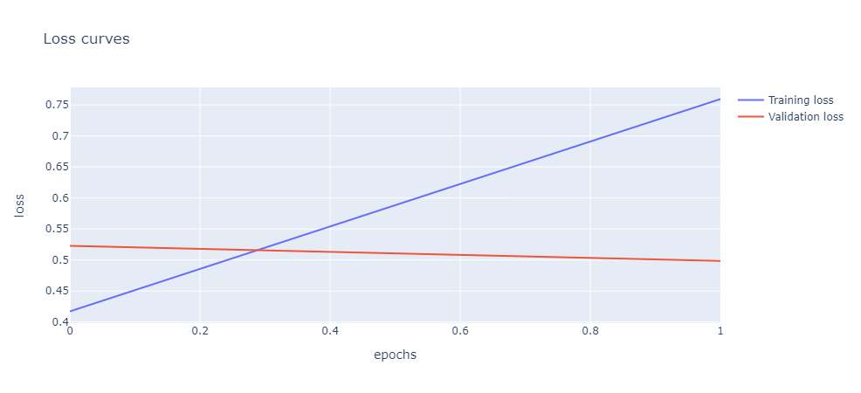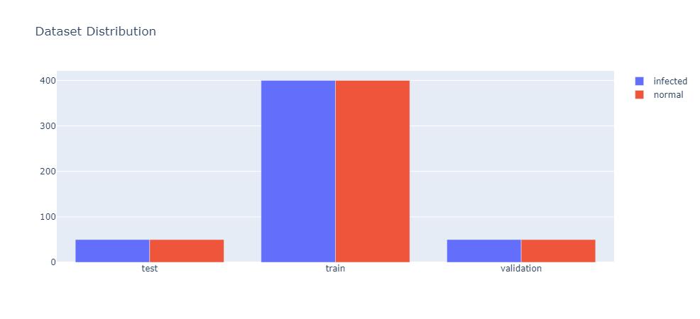The results of the study show that the CNN model developed using the ResNet-18 architecture was able to achieve an accuracy of 86% on the test set. The test set consisted of 50 normal and 50 infected X-ray images. The confusion matrix for normal X-rays showed that the model correctly classified 46 out of 50 normal images, which is a relatively high rate of accuracy. Similarly, the confusion matrix for infected X-rays showed that the model correctly classified 46 out of 50 infected images. This suggests that the model has a good ability to distinguish between normal and infected X-rays, and has potential for use in diagnosing COVID-19 in patients. However, it is important to note that the study was limited to a specific dataset and further validation is needed on larger and more diverse datasets to determine the generalizability of the model.

Fig. 3: Histogram of Training, Testing and Validation Data

Fig. 4: Graph for the Loss Function Gradient

# Conclusion:

Fig.6: Confusion Matrix of Validation of Predicted Values

Fig. 5: Validation Accuracy Graph

The results of the study demonstrate promising performance of the CNN model in classifying COVID-19 in X-ray images. The model achieved an accuracy of 86% on the test set, indicating its ability to accurately distinguish between normal and infected X-rays. The high accuracy rates in the confusion matrices for both normal and infected X-rays further validate the model's effectiveness in correctly classifying images. These findings suggest that the utilization of CNNs in COVID-19 classification of X-ray images offers a reliable and efficient approach for accurate diagnosis. The robust performance and high accuracy rates achieved by the CNN model highlight its potential as a valuable tool in the early detection and screening of COVID-19, aiding in effective disease management and control.

Future work to improve the limitations of this CNN model for COVID-19 classification in X-rays includes expanding the dataset to encompass a larger and more diverse range of images. Exploring different pre-trained models and architectures, along with applying data augmentation techniques and preprocessing methods, can enhance the model's performance.

# References:

1. Wang S, Kang B, Ma J, et al. A deep learning algorithm using CT images to screen for Corona Virus Disease (COVID-19). MedRxiv. 2020.
2. Apostolopoulos ID, Mpesiana TA. Covid-19: automatic detection from X-ray images utilizing transfer learning with convolutional neural networks. Phys Eng Sci Med. 2020;43(2):635-640.
3. Hemdan EED, Shouman MA, Karar ME. COVIDX-Net: A Framework of Deep Learning Classifiers to Diagnose COVID-19 in X-Ray Images. arXiv preprint arXiv:2003.11055. 2020.
4. Sethy PK, Behera SK, Ratha PK, et al. Detection of coronavirus disease (COVID-19) based on Deep Features. Preprints. 2020.
5. [Sohaib Asif](https://ieeexplore.ieee.org/author/37088692679); [Yi Wenhui](https://ieeexplore.ieee.org/author/37088691939); [Hou Jin](https://ieeexplore.ieee.org/author/37088692324); [Si Jinhai](https://ieeexplore.ieee.org/author/37088692103), “Classification of COVID-19 from Chest X-ray images using Deep Convolutional Neural Network”, 2020 IEEE 6th International Conference on Computer and Communications (ICCC) DOI: 10.1109/ICCC51575.2020.9344870.
6. [D. Haritha](https://ieeexplore.ieee.org/author/37086276897); [N. Swaroop](https://ieeexplore.ieee.org/author/37088573272); [M. Mounik](https://ieeexplore.ieee.org/author/37088572058), “Prediction of COVID-19 Cases Using CNN with X-rays”,[2020 5th International Conference on Computing, Communication and Security (ICCCS)](https://ieeexplore.ieee.org/xpl/conhome/9276407/proceeding), DOI: [10.1109/ICCCS49678.2020.9276753](https://doi.org/10.1109/ICCCS49678.2020.9276753).
7. Arivoli, Devdatt Golwala, and Rayirth Reddy, “CoviExpert: COVID-19 detection from chest X-ray using CNN”, <https://doi.org/10.1016/j.measen.2022.100392>.
8. Aras M. Ismaela and Abdulkadir Şengürb, “Deep learning approaches for COVID-19 detection based on chest X-ray images”, Expert Syst Appl. 2021 Feb; 164: 114054. doi: 10.1016/j.eswa.2020.114054.
9. Guangyu Jia, Hak-Keung Lam, Yujia Xu, “Classification of COVID-19 chest X-Ray and CT images using a type of dynamic CNN modification method”, <https://doi.org/10.1016/j.compbiomed.2021.104425>.
10. Prashant Pandey (2021). Chest X-Ray COVID-19, Pneumonia. Retrieved March 27, 2023, from Kaggle: <https://www.kaggle.com/datasets/prashant268/chest-xray-covid19-pneumonia>
11. Hareem Kibriya & Rashid Amin, “A residual network-based framework for COVID-19 detection from CXR images”, Neural Computing and Applications, volume 35, pages8505–8516 (2023).
12. Sarki R, Ahmed K, Wang H, Zhang Y, Wang K (2022) Automated detection of COVID-19 through convolutional neural network using chest x-ray images. PLoS ONE 17(1): e0262052. <https://doi.org/10.1371/journal.pone.0262052>
13. Sergio Hernández & Xaviera López-Córtes, “Evaluating deep learning predictions for COVID-19 from X-ray images using leave-one-out predictive densities”, Neural Comput & Applic 35, 9819–9830 (2023). <https://doi.org/10.1007/s00521-023-08219-3>