Comparison of Methods for Modular Exponentiation on 32-bit Intel 80x86 processors

M. Scott
School of Computer Applications
Dublin City University
11th June 1996

Informal Draft

Abstract

Modular exponentiation lies at the heart of many Public Key Encryption/Signature programs, like for example the well-known RSA (Rivest-Shamir Adleman algorithm). In these cases security is preportional to the size of the numbers involved. For example 2048 bit RSA is certainly more secure than 1024 bit RSA. Therefore it is of interest to know the size of calculation that can be carried out within a reasonable period without using special hardware. The vast majority of desk-top PCs use a member of the 32-bit Intel 80x86 as their main processor. The purpose of this investigation was to determine the relative performance of 5 different modular exponentiation techniques across a range of such processors.

Introduction

It is important to specify exactly the calculation that is of interest. It is the calculation of a^{b} mod c, where a, b and c are all large m-bit numbers. The most significant bit of each of these numbers is 1. None of a, b or c is of any special form, except that c is odd - for the purposes of these tests they were in fact randomly generated. Furthermore it is assumed that none of the parameters were available a priori for precomputation purposes. In particular the method of Brickell [1], which requires precalculations dependant on a fixed value for a, does not apply..

The problem therefore is to determine the shortest possible average time t in which the above calculation can be carried out for a given value of the parameter m.

All the algorithms tested use Montgomery’s n-residue technique [8] for modular multiplication without division. It is our experience that this method is always superior. Note that Montgomery suggested two implementations of his method for modular reduction, one using (apparently) two full full modular multiplications, and also a second (apparently somewhat faster) multiprecision variant. More on this later. The modular exponentiation algorithm used in all cases is a near-optimal Sliding Windows technique described recently by Koc [6].

For maximum speed all the techniques were implemented in assembly language, with a small amount of C driver code, which does not affect the timings significantly. One recognised problem with these tests is that the optimal code sequence varies from processor to processor. Time-optimal code for the 80486 will not in general be optimal for a Pentium. In fact for the Pentium the optimal code is in many cases very non-obvious (See Mike Schmidts book [10] for more information). The code used in these tests is hand optimized for the Pentium, which means that it is not optimal for the other processors in the test, which are therefore at a slight disadvantage. However I estimate this disadvantage to be small.

The five different techniques vary in the details of the implementation of modular multiplication and reduction. They are:-

- The “classic” method
- Comba’s method
- Karatsuba-Comba method
- Unlooped Floating Point method
- Looped FP method

1. Classic Method

Here multiprecision multiplication is carried out using accumulative looping code, described in Knuth [5]. Assuming that two n-digit numbers are being multiplied, an outer loop is executed n times. Inside this an inner nested loop is executed. If multiplying two n-digit numbers a total of n² partial products will be calculated. The inner loop code looks something like -

lp:
mov eax,[esi]
add esi,4
mul edi
add eax,ebp
mov ebp,[esi+ebx]
adc edx,0
add ebp,eax
adc edx,0
mov [esi+ebx],ebp
dec ecx
mov ebp,edx
jnz lp

The array of n digits pointed to by the esi register are being multiplied by edi. The partial products are being accumulated at the memory location pointed to by esi+ebx. Care is taken to ensure that carries are processed correctly. The strange ordering of the instructions is to optimize performance on the Pentium processor.

Squaring can always be carried out a little quicker than multiplication. A little thought tells us that only (n²+n)/2 partial products need to be calculated. Modular reduction uses Montgomery’s multiprecision redc() algorithm, the inner loop of which is very similar to the above.
2. Comba’s Method

The multiplication of the multiprecision numbers x and y can be calculated directly from the pyramid of partial products. For example if x and y are both 4 digits in length, then their product z can be calculated as:-

x₁y₄
x₂y₄ x₂y₃ x₁y₃
x₃y₄ x₃y₃ x₃y₂ x₂y₂ x₁y₂
x₄y₄ x₄y₃ x₄y₂ x₄y₁ x₃y₁ x₂y₁ x₁y₁
_________________________________________
z₇ z₆ z₅ z₄ z₃ z₂ z₁

Comba’s idea [2] is to unravel all program loops (as looping can be expensive), and to calculate each column in this pyramid directly. Care is then taken to properly propagate the carries as we proceed to the next column. Note that if the number base is b (and in our case b=2³²), then the sum of each column will be >b², so three registers (cl|edi|ebp) are needed to hold the total prior to carry-propagation.

Example code for processing the 4th column is given below.

;ebx -> x, esi -> y, edi-> z

push edi ;re-use this register
xor ecx,ecx ;Note ch=0 always
xor edi,edi ;sets edi=0
xor ebp,ebp ;z_{i} is calculated in cl|edi|ebp
;first column
........
........
;fourth column

mov eax,[ebx] ;get x₁, multiply by y₄
mul DWORD PTR [esi+12] ;result in edx|eax
add ebp,eax ;propagate carries
adc edi,edx
adc cl,ch

mov eax,[ebx+4] ;get x₂, multiply by y₃
mul DWORD PTR [esi+8]
add ebp,eax
adc edi,edx
adc cl,ch

mov eax,[ebx+8] ;get x₃, multiply by y₂
mul DWORD PTR [esi+4]
add ebp,eax
adc edi,edx
adc cl,ch
mov eax,[ebx+12] ;get x₄, multiply by y₁
mul DWORD PTR [esi]
add ebp,eax
adc edi,edx
adc cl,ch

mov edx,edi
pop edi
mov [edi+12],ebp ;store result z₄
push edi
mov ebp,edx ;carry to next column
mov edi,ecx
xor cl,cl

;etc

Note that only 5 instructions are now involved in the calculation of each partial product.

A problem with this approach is that it can generate a very large amount of code when dealing with bigger numbers. In fact for the larger values of m it becomes impracticable. Indeed for some processors it becomes relatively inefficient as the internal cache can no longer hold all the code.

As before this code is easily modified to perform faster squaring, and to implement Montgomery’s multiprecision redc() function.

3. Karatsuba-Comba Method
It is well-known that the complexity of multi-precision multiplication can be a lot better than O(n²). The simplest such algorithm is that due to Karatsuba, as described by Knuth [5], which has an asymptotic complexity of O(n ^{lg3}).
Consider the multiplication of two 2n-digit numbers. First partition each into two n-digit halves. The multiplication can be visualized as:-

a₂
a₁
b₂
b₁
a₁.b₁
a₂.b₁
a₁.b₂
a₂.b₂
+

This is of course no improvement, as it requires 4 multiplications of n-digit quantities to provide the product of the two 2n-digit quantities. However now consider the following rearangement:-

a₂
a₁
b₂
b1
a₁.b₁
a₁.b₁
a₂.b₂
a₂.b₂
+
(a₂-a₁).(b₁-b₂)

The advantage of this method is that only 3 multiplications of n-digit quantities are now required. Futhermore the idea can be used recursively. However the saved multiplication is to an extent offset by more additions. The key question is to determine the break-point at which it is no longer worth applying Karatsuba recursively, and faster to proceed with a multiplication.

The method as developed for these tests applies Karatsuba’s recursion down to the break-point, and then uses Comba’s method to perform a multiplication. The break-even point depends on the processor used - in fact it depends on the relative speed of the MUL and ADD instructons. The slower the former with respect to the latter, the deeper should the recursion proceed. In practise it was found that the break-point occurred at n=8 or n=16 depending on the processor. More on this later.

Again squaring can be done somewhat quicker. However a problem arises when attempting to “karatsubize” Montgomery’s multiprecision redc() function. This appears not to be possible. However Karatsuba’s method can be used with Montgomery’s original redc() function which appears to require two ordinary multiprecision multiplications. On the face of it this seems expensive. However on closer examination the first of Montgomery’s multiplications only requires the bottom half of the product (which is only about half the work of a full multiplication). The second multiplication requires a product for which the lower half of the result is already predetermined. This can again be exploited to reduce the work to that of a half-multiplication. So it turns out that the total work-load amounts to just a bit more than one full multiplication.

Thanks are due to Wei Dai [12] for passing this on to me. The idea is due to Montgomery.

4. Unlooped FP code

The speed of the Integer MUL instruction is critical to the speeds of the methods described so far. However since the object of the exercise is to carry out modular exponentiation as quickly as possible on the processor in question, it is as well to consider the possibility that multiplication may be faster using the Floating Point co-processor which is integral to the later members of the 80x86 family. And indeed this turns out to be the case - and thanks are due to Rubin [9] for pointing this out to me. For example on the Pentium processor the MUL instruction takes 10 machine cycles, whereas the FMUL can be executed in just one cycle.

To exploit this, the Comba code was reorganised to use the floating-point processor. The calculation of a single partial product uses a code sequence like:-

fld ...
fmul ...
fxch st(2)
fadd

It is actually quite difficult to get this to work. The code needs to be scheduled correctly to get the most out of the Pentium (hence the fxch instruction). Another problem is that the multiprecision numbers now need to be converted to floating-point representation. Also the propagation of carries turns out to be quite awkward. Furthermore since each internal FP register is only 64-bits in length, so the sum of each column in the pyramid of products must be kept below this value to avoid overflow. This in turn means that a number base of 2³² can no longer be used. For typical values of m the maximum base that can be used is 2²⁸ or 2²⁹. This in turn tends to make the method more inefficient, as more digits are required to represent the number. But, nonetheless, in many cases this method turns out to be fastest.
Montgomery’s multiprecision redc() can be implemented in an analagous fashion as for Comba’s method. However in this case it is fastest to postpone the final propagation of carries until after both the multiplication and reduction, as shown by Dusse & Kaliski [3].

5. Looped FP code

As with the integer Comba method, the above technique starts to generate too much code and run out of steam as the numbers get bigger. However whereas the Comba method can be used in conjuction with the Karatsuba idea for larger numbers, it does not seem at all easy to “karatsubize” the FP code. The only way to use it with larger numbers is to re-introduce looping. So now the same pyramid of products approach is used, but using a loop to accumulate the sum of each column. On the 80x86 the integer registers are available for this purpose.

Results

The results given here are not comprehensive. The author is well aware that there are many parameters that determine the operating speed of a computer. The processors tested were found in contexts that were conveniently available to me in the University where I work. All were in desktop PCs manufactured by Dell. To level the playing field, all tests were performed directly under the native DOS. The test programs were all compiled using the Borland C Version 4.5 32-bit compiler. They were run using Borland’s DOS extender technology, which enables 32 applications to run under this archaic 16-bit operating system.

The results given are representative of what might be expected. But the reader is at liberty to download the code [7] and try it out for themselves.

The Intel processors tested were the

- 80486DX 33MHz
- Pentium 60MHz
- Pentium Pro 200MHz

The values of m considered in the tests are 256, 512, 1024, 2048, 4096 and 8192 bits. Such numbers tend to be popular in Public Key applications. For each processor the optimal break-point value for use with the Karatsuba-Comba method was determined in advance, and only the timings for the optimal value are shown. Again break-point values were limited to powers-of-2. It turned out that 8 was optimal for the 80486DX, and Pentium, 16 for the Pentium Pro (with its fast 1 cycle integer MUL instruction).

The results are presented in the form of a bar-chart. The value of m is plotted along the x axis and the time taken is indicated by the value on the y axis. The times indicated on the y axis are correct in seconds for m=8192. For smaller values of m the time on the y axis should be progressively scaled down by 8. So for m=4096, the value on the y axis should be divided by 8, for m=2048 it should be divided by 64, etc. This reflects the basic O(n³) complexity behaviour of all except the Karatsuba-Comba method.

Note that the completely unlooped code (Comba, Unlooped FP) becomes impracticable for larger moduli, and so no timings are given.

This results can be compared favourably with those recently obtained by Koc, Acar and Kaliski [6]. They consider only algorithms for modular multiplication (not squaring), so direct comparisons are difficult. However our fastest implementation would appear to be nearly twice as fast as theirs on a Pentium P60. The results can also be compared to the “best possible” estimates suggested by Schroeppel et al [11]. These suggest that a 66MHz 486 processor can perform a full Diffie-Hellman Key Exchange in 150ms, assuming some tricks that are not used here (a special form of the modulus, the use of the method of [1] ). Even without these tricks we can obtain at least a 50% improvement.
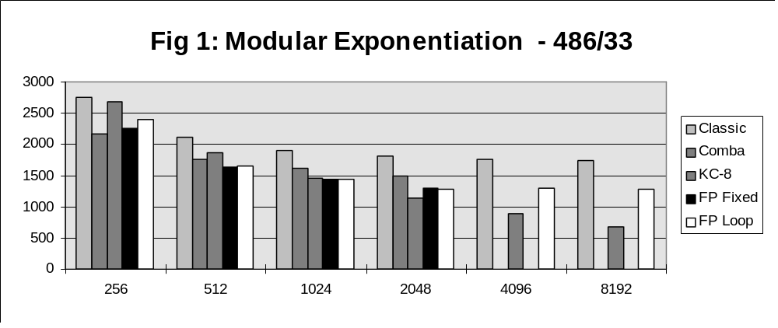

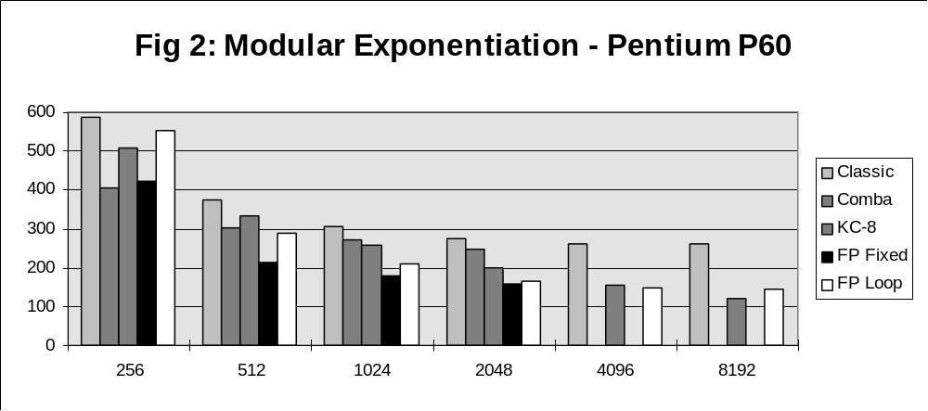

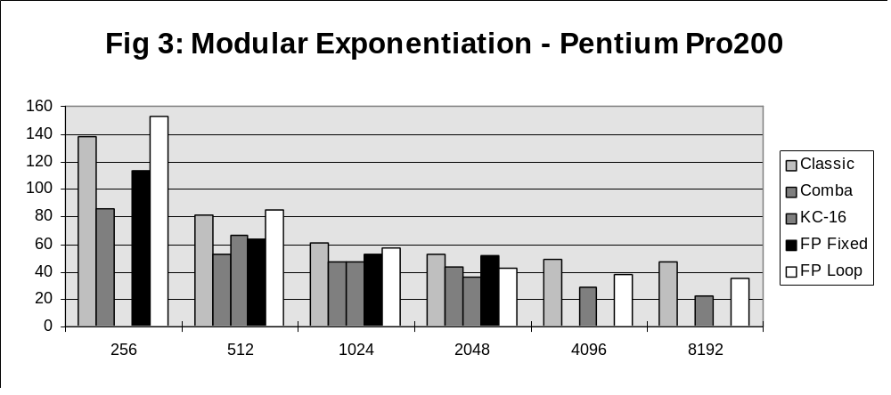
Conclusions - draw your own!

Each of the methods, except the classic method, is optimal under certain circumstances. If floating point is neglected the advice must be to use Comba’s method for smaller values of m less than or equal to 512 bits in length. For larger numbers use the Karatsuba-Comba variation. However Floating point is faster on all save the Pentium Pro, particularly for popular modulus sizes such as 512 and 1024 bits.

Perhaps the cryptographic significance of these results is that modular exponentiation can be carried out more quickly on a standard desktop PC than many would expect. For example the on-line part of a 2048-bit Diffie-Hellman key exchange can be calculated in less than 3 seconds on a relatively modest Pentium P60. A 2048-bit RSA private key decryption can be calculated (normally requiring two 1024-bit modular exponentiations using the Chinese Remainder Thereom) in less than .8 of a second on the same hardware. That’s not long to wait for vastly improved security. (Indeed personally I like a short delay - it convinces me that a substantial calculation is taking place.)

While the Cryptanalytic-tortoise makes steady progress is factoring larger and larger numbers, it is perhaps encumbant on the Cryptographic-hare to bound forward from time-to-time. I would suggest a move to 2048-bit moduli (or even 4096-bit if the fastest PCs are available).

References

[1] BRICKELL et al., Fast Exponentiation with Precomputation, In Advances in Cryptology, Eurocrypt ‘92, Springer-Verlag 1993

[2] COMBA, P.G. Exponentiation Cryptosystems on the IBM PC. IBM Systems Journal, Vol. 29, No. 4 1990, 526-538

[3] DUSSE, S.R. and KALISKI, B.S. A Cryptographic Library for the Motorola DSP56000, In Advances in Cryptology, Eurocrypt ‘90, Lecture Notes in Computer Science, Vol. 473, Springer-Verlag 1991, 230-244

[4] KOC C.K., ACAR, T. And KALISKI, B.S. Analysing and comparing Montgomery Multiplication Algorithms, IEEE Micro, June 1996

[5] KNUTH, D.E. The Art of Computer Programming. Vol. 2: Seminumerical Algorithms. Addison-Wesley, Reading, Mass., 1981

[6] KOC, C.K. Analysis of Sliding Window Techniques for Exponentiation, Math. & Applic. Vol. 30, 1995, 17-24

[7] MIRACL - Multiprecision Integer and Rational Arithmetic C Library. Available via anonymous ftp from ftp.compapp.dcu.ie in /pub/crypto

[8] MONTGOMERY, P. Modular Multiplication Without Trial Division. Math. Comp. , 44, (April 1985), 519-521

[9] RUBIN, P. Personal Communication, 1995

[10] SCHMIT, M. Pentium Processor Optimization Tools. Academic Press 1995.

[11] SCHROEPPEL, et al. Fast Key Exchange with Elliptic Curve Systems, Crypto’ 95, Springer-Verlag 1996

[12] WEI DAI. Personal Communication, 1996

