***BATHS Project – Part 2: Project Management & Team Evidence:***

***Team ID: CS49***

***Names: (Ohemaa Amoako-Atta, Miracle Ekinadose Ivo, Aisha Moussa and Ishika Patel)***

***Due Date: 07/04/2025***

***Contents:***

***Overview*: 1**

***Project Development Approach 1***

***Meeting Evidence 2***

***Trello Board Usage 2***

***GitHub Version Control 4***

***Final Reflection 4***

# ***Overview:***

This document outlines the collaborative strategies our team (CS49) used during the development of the BATHS assignment. Our aim was to maintain clear communication, structured task allocation, and steady progress tracking using platforms such as Trello, GitHub, and Zoom. These tools supported our Agile-inspired workflow, which ensured that each team member had a clear role and deliverables throughout the project lifecycle.

# ***Project Development Approach***

We adopted an Agile-like approach to managing our group work. At the start of each development week, we held meetings to define objectives, allocate responsibilities, and identify milestones. Agile suited our project as it allowed flexibility during unexpected issues - such as technical bugs or conflicting schedules - without compromising momentum.

Each task in the BATHS project was split into manageable chunks, with individual ownership clearly assigned and tracked via Trello. We used a minutes-taking strategy after every group call to document what was achieved and what was next. This built accountability and helped us adjust quickly as challenges emerged. While adaptability was essential, this structured approach ensured progress was consistent across sections like Testing, GUI, and Game Logic.

# ***Meeting Evidence***

Zoom was an essential part of our project. Due to distance between our team, this platform created easy forms of communication. Zoom meetings were used to assign different tasks and discuss everyone’s progress in the project. This was an advantage because when collaborating physically, everyone was already aware of what was intended in those meetings.

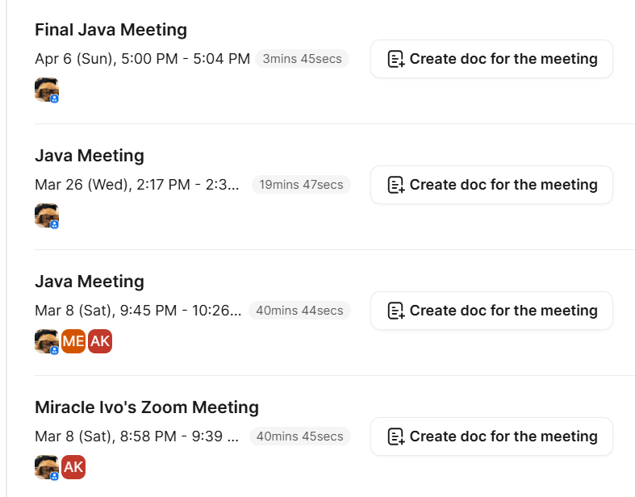

Whatsapp was also a vital aspect of communication between our team members. This enabled us to alert each other about transportation issues and update each other on progress in a less professional environment. The use of polls also allowed us to arrange impromptu meetings so that we would all be aware of everyone’s availability.

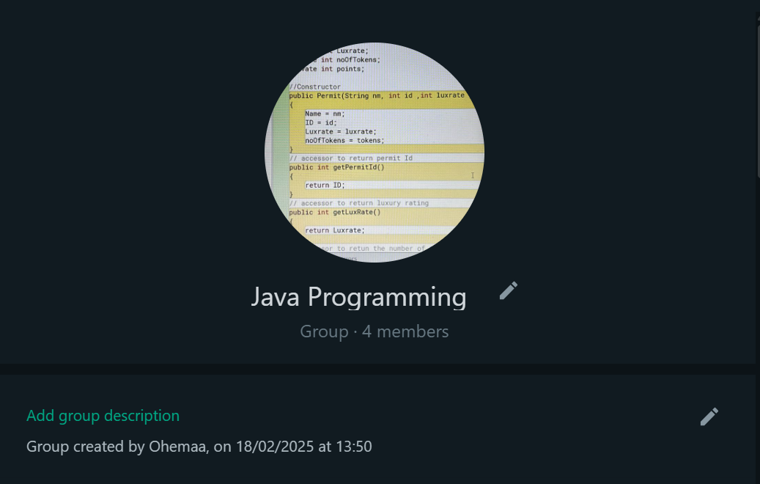 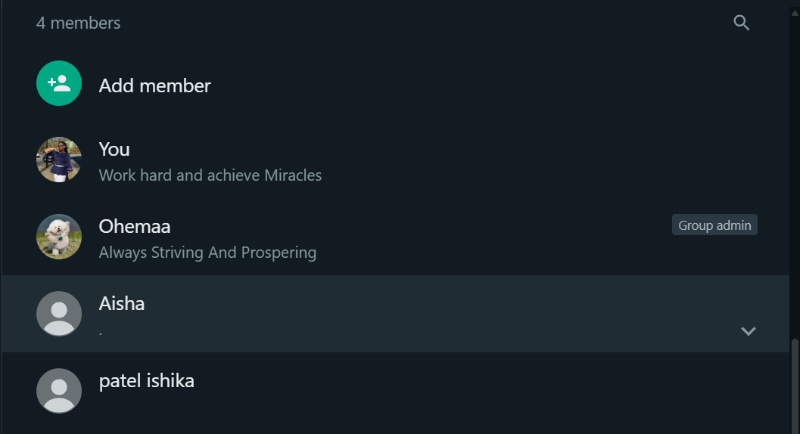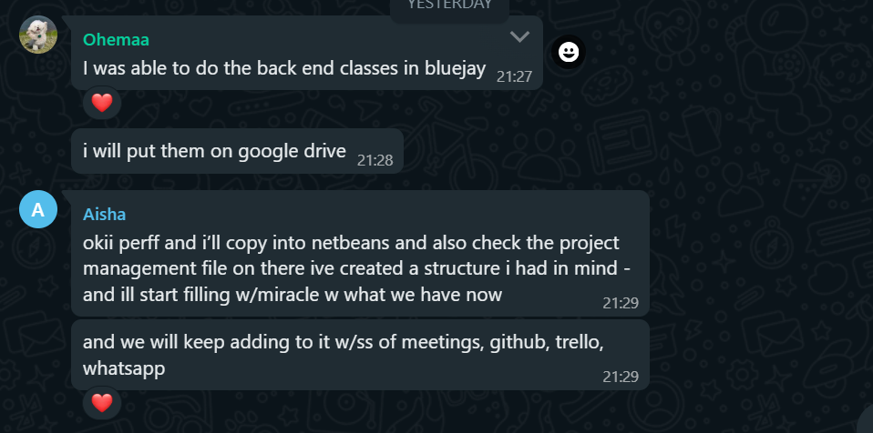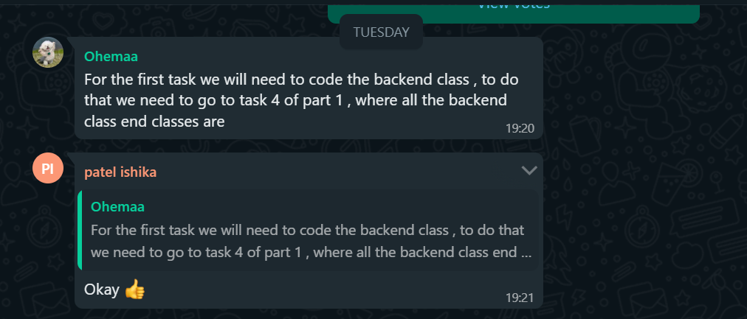

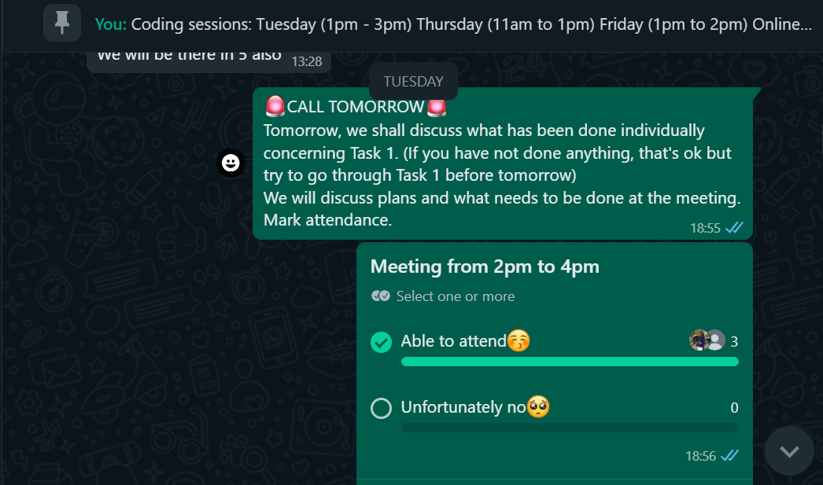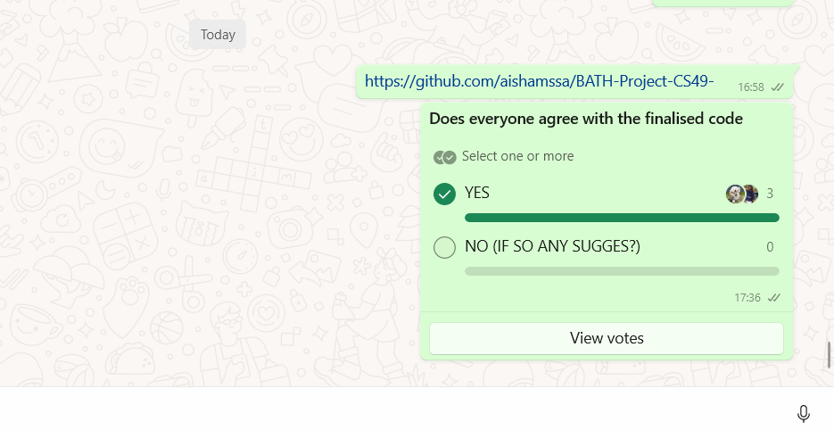

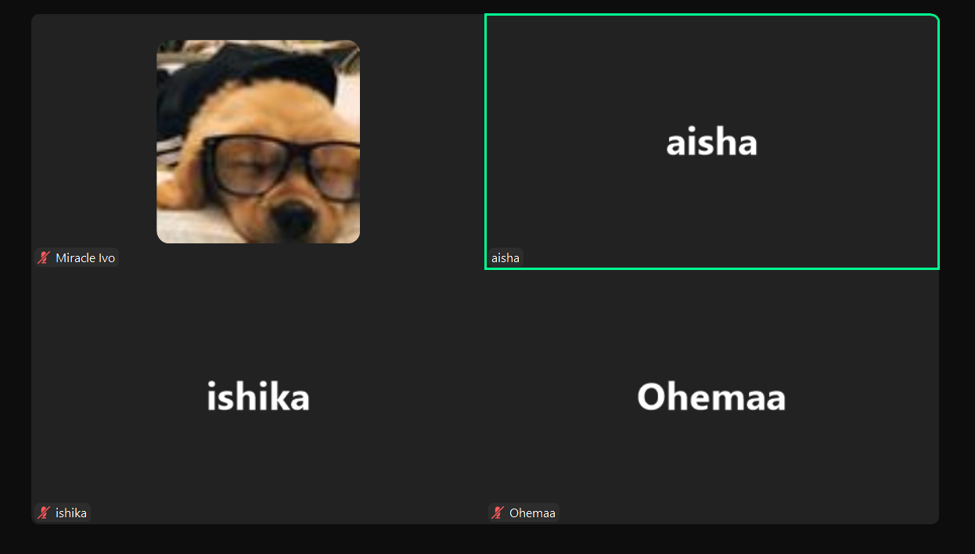

As mentioned earlier, each meeting was accounted for through a minutes strategy. Every meeting, a designated member of our team would acknowledge the *objectives, what was achieved and the goals for the next meeting.* This made each meeting more goal focused because no person within the group would be confused or disgruntled with what needed to be achieved.

# ***Trello Board Usage***

A crucial aspect of our collaboration was Trello. Trello played a vital role in most of our work. This made the assignment of work and communication easier. The usage of Trello made every teammate clear on the work that was required to be done within a certain timeframe.

These were the titles we incorporated into our work:

* Ohemaa
* Miracle
* Aisha
* Ishika
* Due Dates
* Meetings
* Goals

Trello is made specifically for visual collaboration which meant that we were able to integrate it into our workflow.

This platform was used for assigning individual tasks or group-wide goals. Everybody had their own section, with their designated tasks. However we also had group wide goals and milestones that we had to achieve within a certain time frame

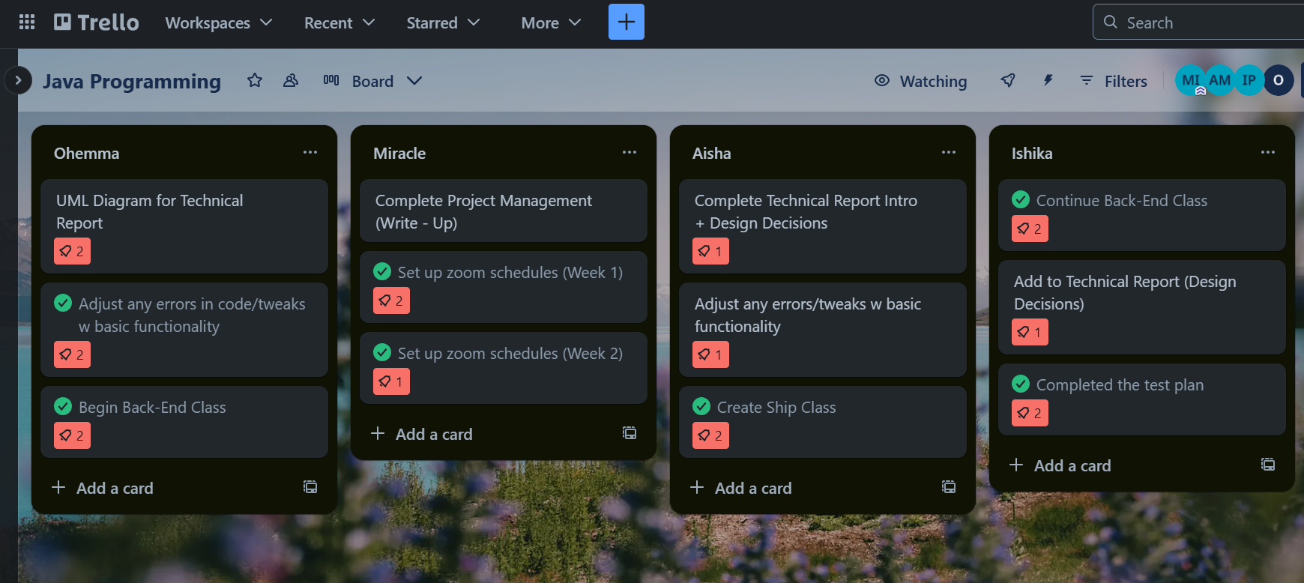

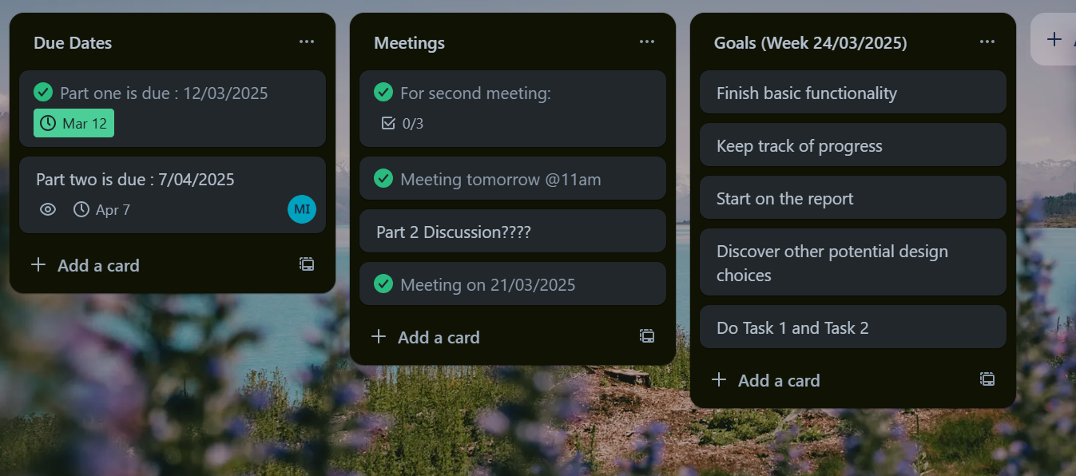

Trello was really effective in our work. This made communication extremely simplistic. We were also to keep each other up to date on our progress in different tasks.

# ***GitHub Version Control***

GitHub was essential for managing version control and collaborative work. It allowed us to avoid overwrite issues and maintain a clean project structure.

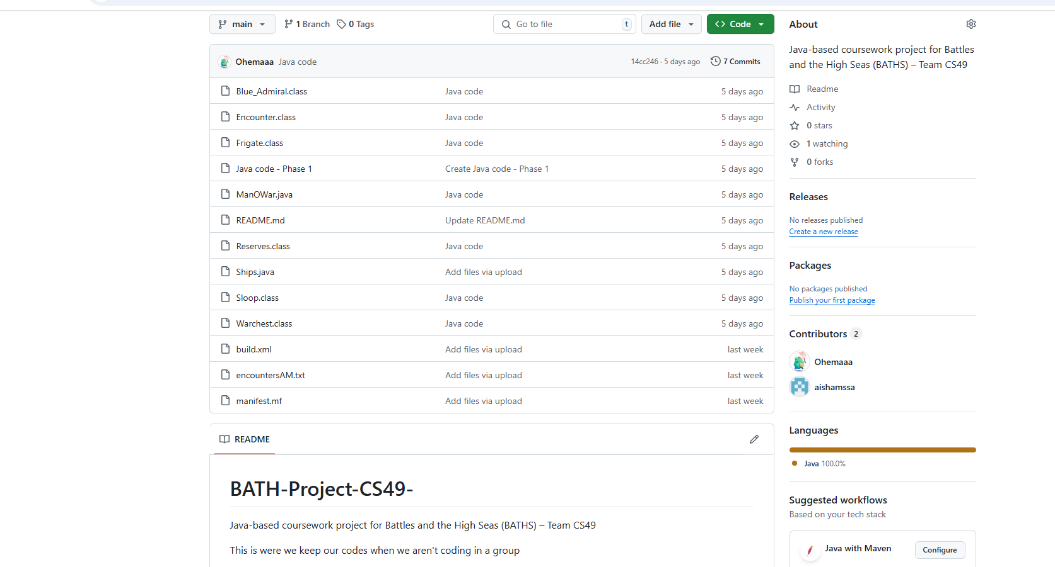

We ensured each team member committed regularly:

* **TM1 (Aisha)**: Initial Ship class setup/commit – *25/03*
* **TM2 (Ohemaa)**: HashMap structure in SeaBattles – *26/03*
* **TM3 (Miracle)**: GUI improvements – *29/03*
* **TM4 (Ishika)**: File saving & loading logic – *31/03*

While we didn’t use branches heavily, we used clear commit messages for tracking (e.g., “Added shipState enum” or “Connected GUI to GameLogic”).

# ***Final Reflection***

As a team, we embraced an Agile-inspired approach, which emphasized collaboration, adaptability, and iterative progress. Inspired by Sommerville’s *Software Engineering* (2016), we focused on clear task division, consistent feedback, and reflection after each sprint. Trello allowed us to visualise backlogs and progress, while GitHub ensured version control during simultaneous coding.

Zoom and WhatsApp bridged communication gaps, helping us stay aligned even under pressure. While challenges emerged—like time management and role overlap—we adapted quickly. Going forward, we’ll apply these Agile values and lessons in future software projects, appreciating how structured flexibility led to our growth as developers and as a team.