**Part-Time Job Board**

**A REPORT**

***Submitted to***



**ASSAM DON BOSCO UNIVERSITY**

***By***

**Miracle Rani**

**DC2024MCA0037**

**Glaricia Dred Laitthma**

**DC2024MCA0013**

***in partial fulfilment for completion of Assignment***

***of***

**2nd SEMESTER**

**OF**

**MASTER OF COMPUTER APPLICATIONS**

**DEPARTMENT OF COMPUTER APPLICATIONS**

**SCHOOL OF TECHNOLOGY**

**ASSAM DON BOSCO UNIVERSITY**

**AZARA, GUWAHATI 781017,**

**ASSAM, INDIA.**

**BATCH (2024-2026)**

## **ACKNOWLEDGEMENT**

## First and foremost, we would like to express our deepest gratitude to our main supervisor, Dr. Vijay Prasad, for his invaluable guidance, encouragement, and unwavering support throughout the course of this presentation. His expertise, patience, and insightful feedback have been instrumental in shaping this work.

## We extend our sincere thanks to the Head of the Department, Dr. Gypsy Nandi, for providing us with the necessary resources and a conducive environment to carry out our research.

## We are also deeply grateful to Prof. Manoranjan Kalita, Director of the School of Technology, for his continuous institutional support and encouragement throughout our time here.

## Finally, we are forever indebted to our families for their unconditional love, patience, and unwavering belief in us.

## Above all, we thank the Almighty for granting us the strength, health, and perseverance to complete this work.

**CONTENTS Page No**

1. **Overview ......................................................................................... iii**
2. **System Features...............................................................................**
3. **Requirements...................................................................................**
4. **Screenshots....................................................................................... iv-vi**
5. **Conclusion........................................................................................ vii**

**Overview**

A Part-Time Job Board is a dedicated online platform designed to connect students with part-time employment opportunities available both on and off campus. These portals serve as centralized hubs where employers-including university departments, local businesses, and external organizations-can post available part-time positions, while students can browse, search, and apply for jobs that fit their academic schedules and personal preferences.

The primary goal of a part-time job board is to simplify the job search process for students by offering a user-friendly interface tailored to their unique needs. Unlike general job portals, these boards focus exclusively on flexible, short-term, or part-time roles that accommodate students’ class schedules and other commitments. This makes it easier for students to find work that not only helps them earn income but also builds valuable skills and professional experience.

**System Features**

1. Registration
2. Login
3. Posting Jobs
4. Upload CV
5. Apply Jobs
6. View posted jobs

**Software Requirements**

Frontend: HTML, CSS, JavaScript

Backend: PHP, MYSQL, XAMPP

Development Tool: Visual Studio Code (VS Code)

**Screenshots**

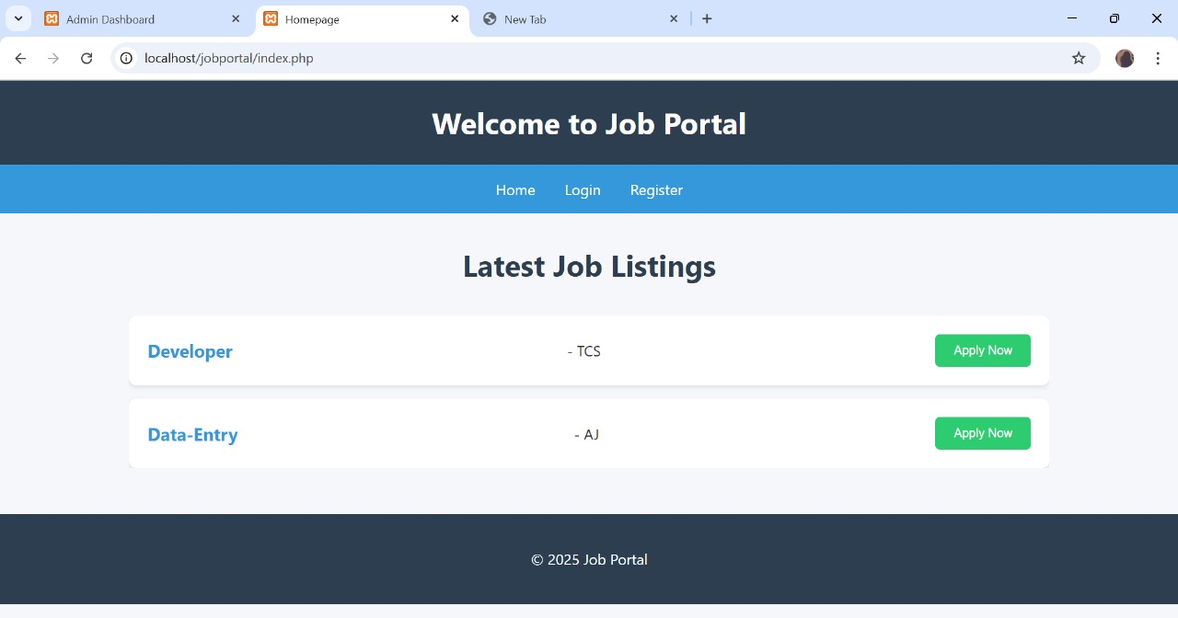

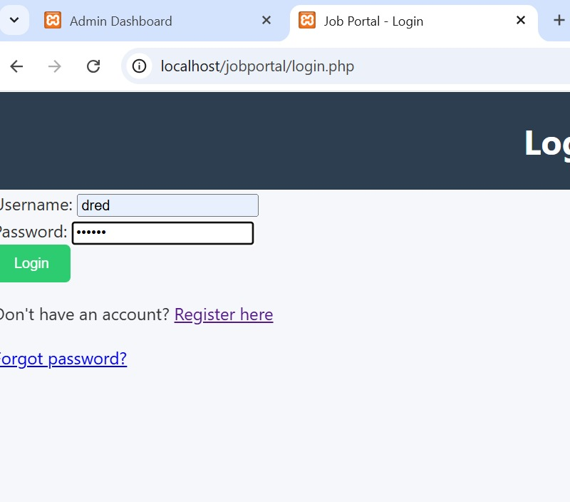

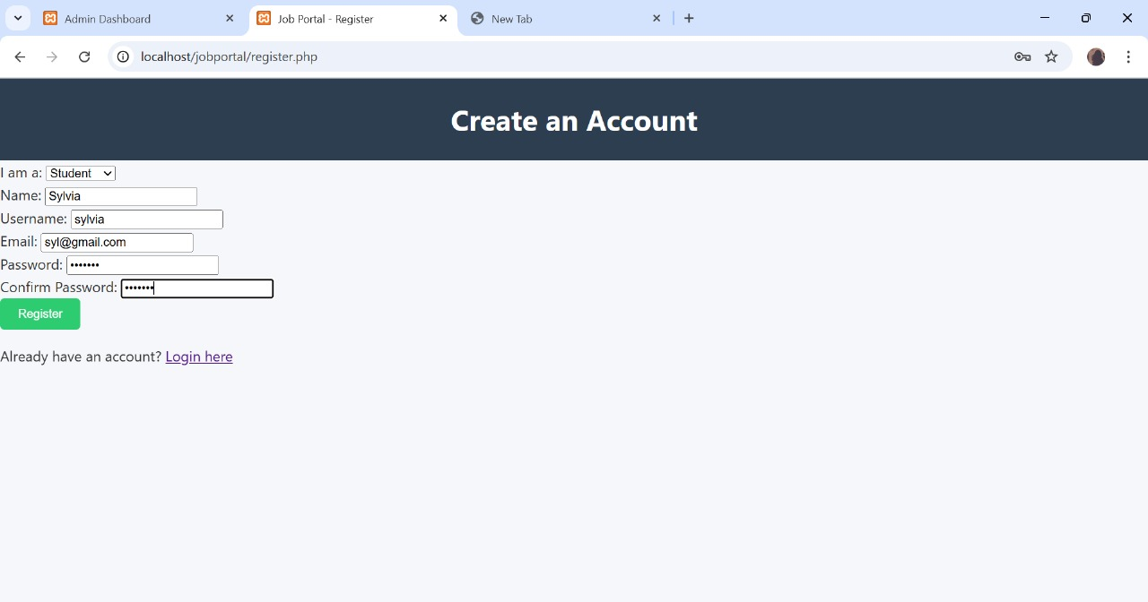

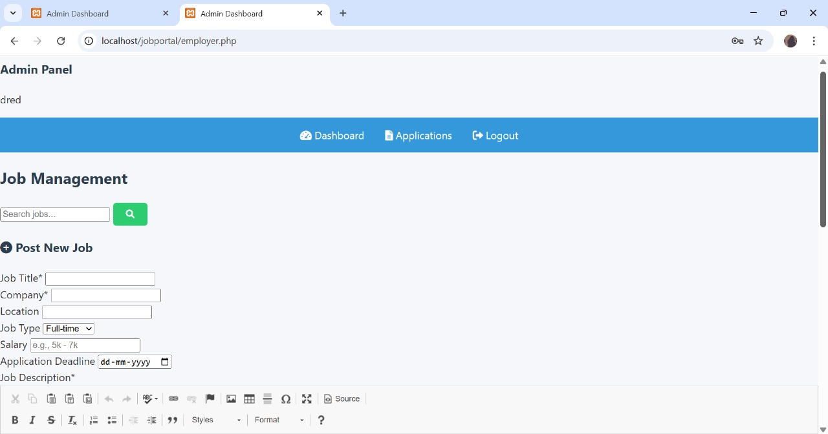

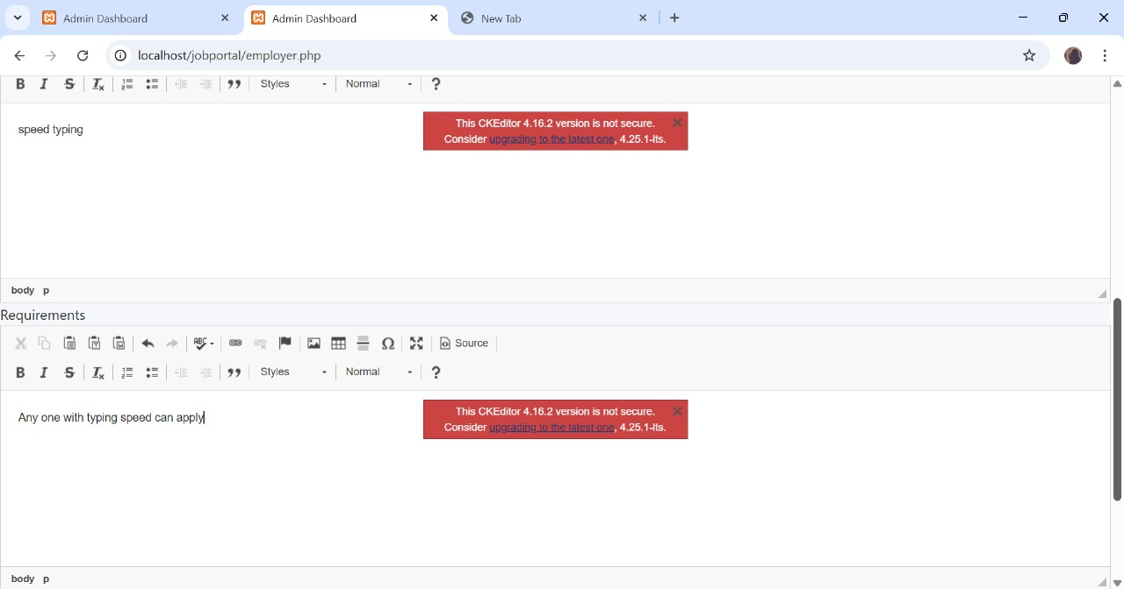

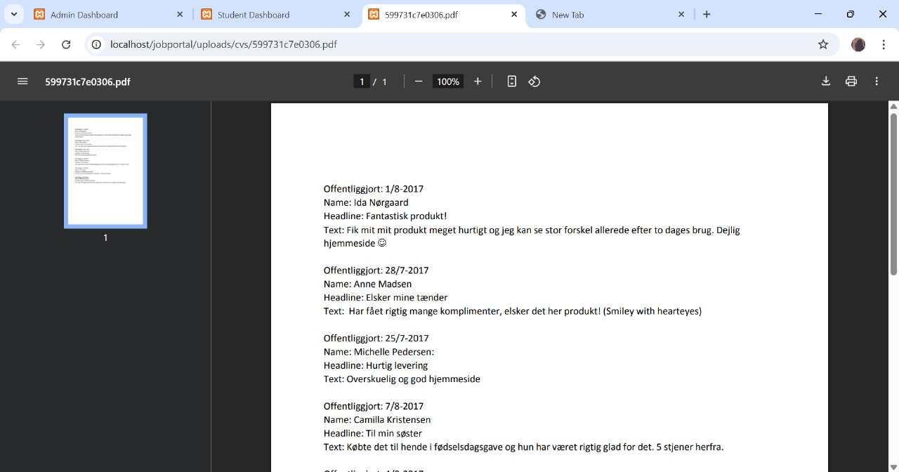

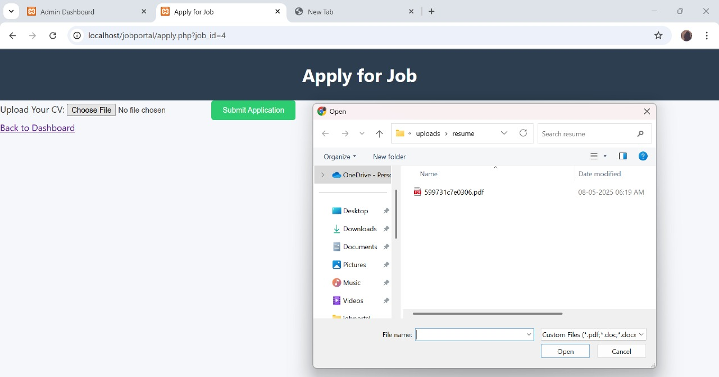

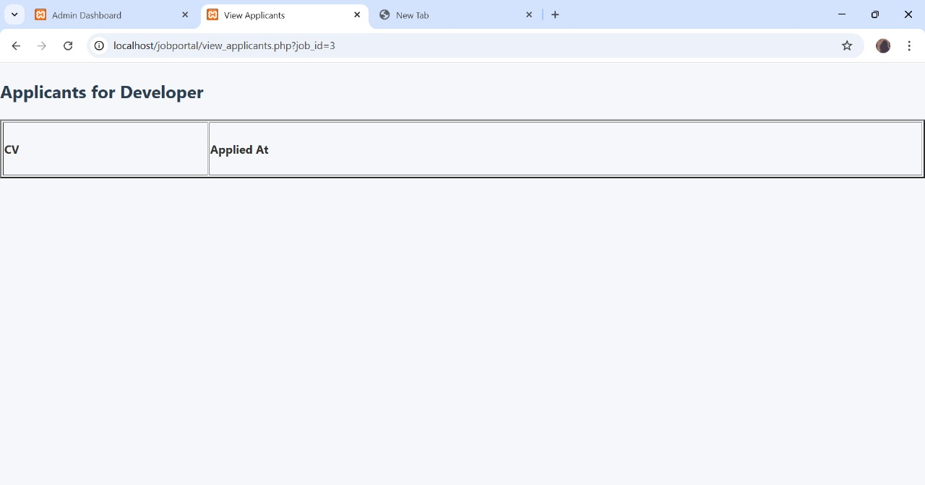

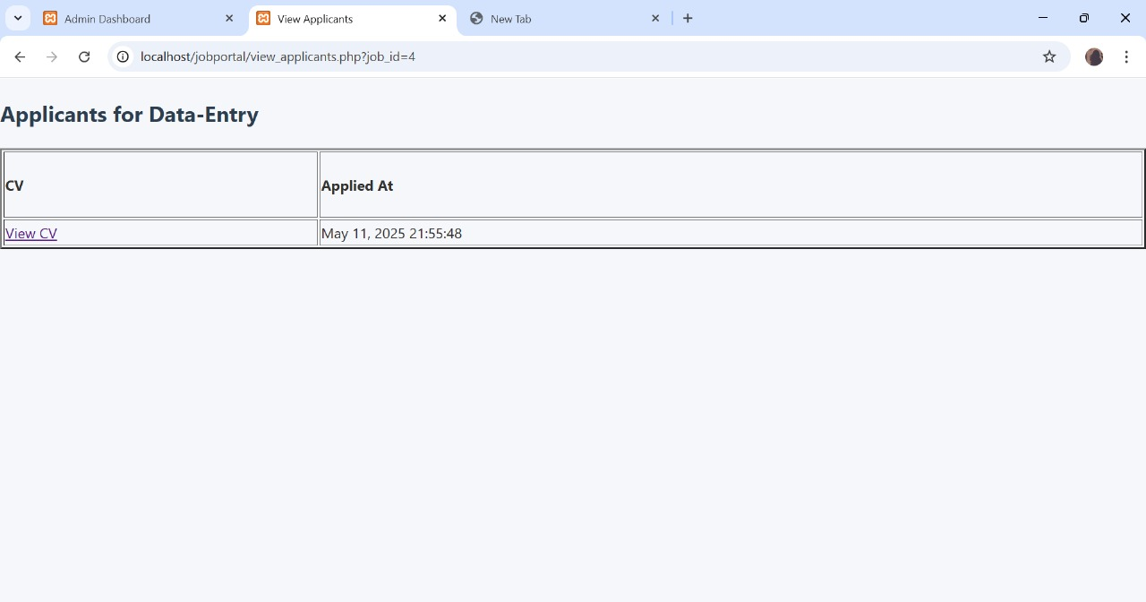

**Conclusion**

In conclusion, a dedicated part-time job board serves as a vital and efficient ecosystem connecting students with flexible employment opportunities. For students of Northeast Region, and beyond, such a platform offers a convenient pathway to gain valuable work experience, earn income, develop crucial skills, and explore career options, all while balancing their academic pursuits. Simultaneously, it provides local and remote employers with direct access to a motivated and adaptable talent pool. By streamlining the job search and hiring processes, a well-designed part-time job board ultimately empowers students and strengthens the local economy by fostering meaningful work opportunities.