整体上使用Struts 2

也使用了部分Spring框架

数据库的访问上用了：[**org**](eclipse-javadoc:%E2%98%82=SAES/D:%5C/Users%5C/Administrator%5C/workspace%5C/SAES%5C/WebContent%5C/WEB-INF%5C/lib%5C/spring-jdbc-3.2.3.RELEASE.jar%3Corg)**.**[**springframework**](eclipse-javadoc:%E2%98%82=SAES/D:%5C/Users%5C/Administrator%5C/workspace%5C/SAES%5C/WebContent%5C/WEB-INF%5C/lib%5C/spring-jdbc-3.2.3.RELEASE.jar%3Corg.springframework)**.**[**jdbc**](eclipse-javadoc:%E2%98%82=SAES/D:%5C/Users%5C/Administrator%5C/workspace%5C/SAES%5C/WebContent%5C/WEB-INF%5C/lib%5C/spring-jdbc-3.2.3.RELEASE.jar%3Corg.springframework.jdbc)**.**[**core**](eclipse-javadoc:%E2%98%82=SAES/D:%5C/Users%5C/Administrator%5C/workspace%5C/SAES%5C/WebContent%5C/WEB-INF%5C/lib%5C/spring-jdbc-3.2.3.RELEASE.jar%3Corg.springframework.jdbc.core)**.JdbcTemplate**

**该系统无法兼容IE浏览器**

**院内项目仅一个编辑界面，没有后台代码支持**

**管理员页面的功能基本没做**

**申报管理页面的后四个分页没做**

**需要梳理一遍系统需求**

**SRC中有如下几个包：**

**edu.usst.action**

**edu.usst.core**

**edu.usst.dao**

**edu.usst.model**

**edu.usst.pojo**

**edu.usst.service**

**edu.usst.utils**

**config中有如下配置文件:**

**applicationContext.xml**

**config.properties**

**log4j.properties**

**struts_hxh.xml**

**struts_lj.xml**

**struts_wk.xml**

**struts_zbw.xml**

**struts_zc.xml**

**struts.xml**

**WEB-INF下有配置文件:**

**Web.xml**

**CSS文件夹下有：**

**lj_main.css**

**main.hxh.css**

**main.wk.css**

**main.css**

**school.css**

**smsb.css**

**xmsb.css**

**zTreeStyke.css**

**js文件夹下有：**

**多个手写的JS文件**

**JspPage文件夹下共有59个JSP视图文件**

**数据库的表：（该系统目前共33张表）**

**code_generation**

|  |  |  |
| --- | --- | --- |
| **列名** | **数据类型** | **含义** |
| **id** | **Int(1)** | **主键** |
| **declare_number** | **Int(4)** | **申报管理的编号统计** |
| **project_number** | **Int(4)** | **项目管理的编号统计** |

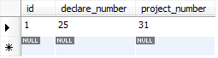

**项目唯一编号生成累计表**

**dm_edu_degree**

|  |  |  |
| --- | --- | --- |
| **列名** | **数据类型** | **含义** |
| **ID** | **Int(10)** | **主键** |
| **KEY_EDU_LEVEL_ID** | **Varchar(16)** | **学位编号** |
| **VALUE_EDU_LEVEL_NAME** | **Varchar(50)** | **学位名称** |
| **TYPE_LEVEL** | **Varchar(50)** | **等级** |
| **NOTE_CAPTION** | **Varchar(50)** | **备注** |

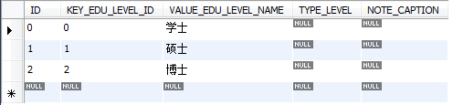

**学位表**

**dm_edu_level**

|  |  |  |
| --- | --- | --- |
| **列名** | **数据类型** | **含义** |
| **ID** | **Int(10)** | **\*主键** |
| **EDU_LEVEL_ID** | **Varchar(16)** | **学历编号** |
| **EDU_LEVEL_NAME** | **Varchar(50)** | **学历名称** |
| **CAPTION** | **Varchar(50)** | **备注** |

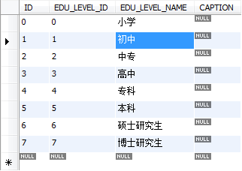

**学历表**

**dm_file_class**

|  |  |  |
| --- | --- | --- |
| **列名** | **数据类型** | **含义** |
| **ID** | **Int（10）** |  |
| **FILE_CLASS_ID** | **Varchar(32)** |  |
| **FILE_CLASS_NAME** | **Varchar(128)** |  |
| **NOTE** | **Varchar(256)** |  |



**未知表**

**dm_nation**

|  |  |  |
| --- | --- | --- |
| **列名** | **数据类型** | **含义** |
| ID | Int(10) | 主键 |
| NATION_ID | Varchar(16) | 民族编号 |
| NATION_NAME | Varchar(50) | 民族名称 |
| CAPTION | Varchar(50) | 备注 |



**民族表**

**dm_project_type**

|  |  |  |
| --- | --- | --- |
| **列名** | **数据类型** | **含义** |
| **ID** | **Varchar(32)** | **项目类别编号** |
| **PROJECT_TYPE_NAME** | **Varchar（255）** | **项目类别** |



**未知表**

**项目分类**

**dm_role**

|  |  |  |
| --- | --- | --- |
| **列名** | **数据类型** | **含义** |
| **ID** | **Varchar(32)** | **主键** |
| **GROUP_ID** | **Varchar(128)** | **用户组** |
| **NOTE** | **Varchar(255)** | **备注** |
| **ROLE_LEVEL** | **Varchar(64)** | **角色级别** |

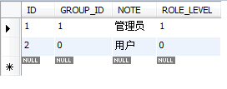

**角色表**

**dm_subject**

|  |  |  |
| --- | --- | --- |
| **列名** | **数据类型** | **含义** |
| **ID** | **Int（10）** | **主键** |
| **SUBJECT_CLASS_ID** | **Varchar(16)** | **学科分类编号** |
| **SUBJECT_CLASS_NAME** | **Varchar(50)** | **学科分类名称** |
| **CAPTION** | **Varchar(50)** | **备注** |



**学科分类**

**dm_title_define**

|  |  |  |
| --- | --- | --- |
| **列名** | **数据类型** | **含义** |
| **ID** | **int(10)** | **主键** |
| **TITLE_ID** | **Varchar(32)** | **国际码** |
| **NAME** | **Varchar(128)** | **职称名称** |
| **LEVEL_ID** | **Varchar(32)** | **职称级别** |
| **TYPE_ID** | **Varchar(32)** | **职称类别** |

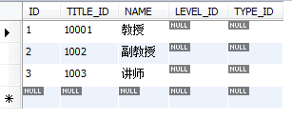

**职称表**

**s_achievement**

|  |  |  |
| --- | --- | --- |
| **列名** | **数据类型** | **含义** |
| **ID** | **int(10)** | **系统编号** |
| **Apply_ID** | **Varchar(32)** | **申报编号** |
| **AUTHOR_NAME** | **Varchar(32)** | **著作者** |
| **ACHIEVEMENT_NAME** | **Varchar(128)** | **成果名称** |
| **ACHIEVEMENT_MODE** | **Varchar(64)** | **成果形式** |
| **PUBLISH_UNIT** | **Varchar(128)** | **出版单位** |
| **PUBLISH_TIME** | **Date** | **出版时间** |



**近期主要研究成果**

**s_askreport**

|  |  |  |
| --- | --- | --- |
| **列名** | **数据类型** | **含义** |
| **ID** | **int(10)** | **主键** |
| **TITLE** | **Varchar(50)** | **公告标题** |
| **PERSON_ID** | **int(10)** | **发送人工号，关联person表** |
| **SENDE_NAME** | **Varchar(32)** | **发送人姓名** |
| **SEND_DATE** | **Datetime** | **发送时间** |
| **SENDER_DP** | **Varchar(32)** | **发送人部门（计算机学院）** |
| **ASK_DATE** | **Datetime** | **（可选）申请日期，默认当前时间** |
| **ASKREPORT_CONTENT** | **Varchar(50)** | **申请汇报内容** |
| **REC_ID** | **int(10)** | **收件人工号，关联person表** |
| **REC_NAME** | **Varchar(32)** | **收件人姓名** |
| **ACCEPT_DATE** | **Datetime** | **改成审核日期，接收日期，也就是查看日期** |
| **IS_VIEW** | **Int（2）unsigned** | **暂时无用，是审核，每人要查看；是否查看，0未读，1已读** |
| **STATE** | **Int（2）** | **状态，默认0未审批，1同意，2不同意** |
| **DELETEID** | **Int（2）unsigned** | **删除标记，0未删除，1已删除** |
| **FILE_ID** | **Int（10）** | **暂时没有，文件编号，关联file表** |

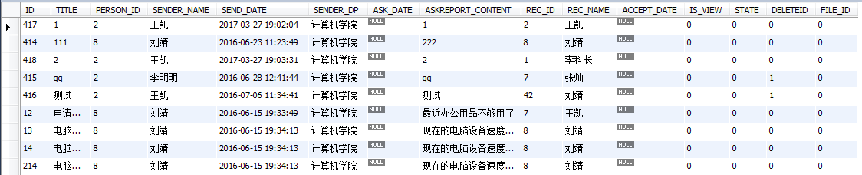

**未知表**

**s_book**

|  |  |  |
| --- | --- | --- |
| **列名** | **数据类型** | **含义** |
| **ID** | **Int(11)** | **系统编号** |
| **NAME** | **Varchar(256)** | **著作名称** |
| **FIRST_AUTHOR_NAME** | **Varchar(40)** | **第一作者名称** |
| **OTHER_AUTHOR_NAME** | **Varchar(300)** | **其他作者编号** |
| **PUBLISH_UNIT** | **Varchar(256)** | **出版单位** |
| **PUBLISH_DATE** | **Varchar(32)** | **出版日期** |
| **WORD_NUMBER** | **Varchar(32)** | **字数** |
| **REMARK** | **Varchar(400)** |  |
| **EDITOR** | **Varchar(40)** |  |
| **PROJECT_SOURCE_ID** | **Varchar(32)** | **项目来源代码** |
| **ISREAD** | **Varchar(32)** |  |

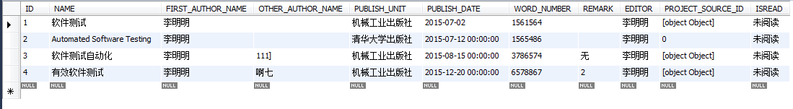

**未知表**

**s_division**

|  |  |  |
| --- | --- | --- |
| **列名** | **数据类型** | **含义** |
| **ID** | **Int(10)** | **主键** |
| **DIVISION_ID** | **Varchar(32)** | **部门编号** |
| **NAME** | **Varchar(128)** | **部门名称** |

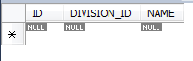

**未知表**

**s_duty**

|  |  |  |
| --- | --- | --- |
| **列名** | **数据类型** | **含义** |
| **ID** | **int(11)** | **主键** |
| **DUTY_ID** | **int(11)** | **服务编号** |
| **DUTY_NAME** | **Varchar(50)** | **职务名称** |

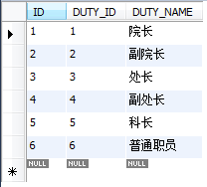

**职务表**

**s_file**

|  |  |  |
| --- | --- | --- |
| **列名** | **数据类型** | **含义** |
| **ID** | **int (10)** | **主键** |
| **NAME** | **Varchar(128)** | **文件名称** |
| **PUBLISH_DATE** | **Datetime** | **上传日期（修改时间）** |
| **FILE_ID** | **Varchar(200)** | **附件编号，hash出来的文件名，考虑加上路径** |
| **FILE_CLASS_ID** | **Int(32)** | **暂时不用，文件类别编号一一对应DM_FILE_CLASS** |
| **EXTRA_NAME** | **Varchar(10)** | **扩展名** |
| **NOTE** | **Varchar(500)** | **备注** |
| **CREATE_TIME** | **Datetime** | **记录创建时间** |
| **CREATOR_ID** | **Int(10)** | **创建者编号** |
| **CREATOR_NAME** | **Varchar(50)** | **创建者姓名** |
| **DOWNLOAD_TIMES** | **Int(10)** | **下载次数** |
| **UNIT_ID** | **Int(32)** | **暂时不用，所属单位编号** |
| **DELETEID** | **Int(2) unsigned** | **删除标记，0未删除，1已删除** |

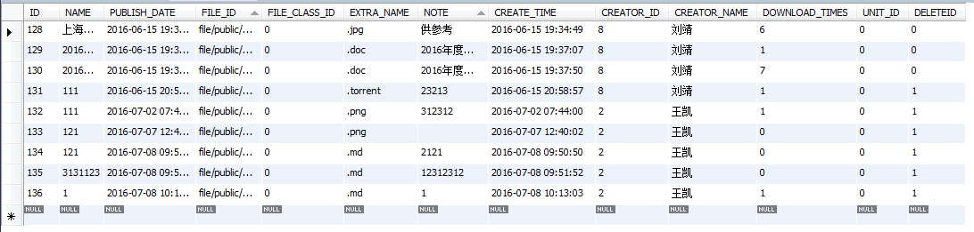

**文件表**

**s_magazine**

|  |  |  |
| --- | --- | --- |
| **列名** | **数据类型** | **含义** |
| **ID** | **int(11)** |  |
| **NAME** | **Varchar(128)** |  |
| **LEVEL** | **Varchar(32)** |  |
| **ISSN** | **Varchar(32)** |  |
| **CN** | **Varchar(32)** |  |
| **PAPER_TYPE_ID** | **Varchar(32)** |  |

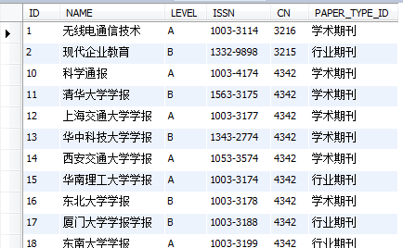

**未知表**

**s_notify**

|  |  |  |
| --- | --- | --- |
| **列名** | **数据类型** | **含义** |
| **ID** | **int(11)** | **主键** |
| **TITLE** | **Varchar(200)** | **公告标题** |
| **SENDER_ID** | **int(10)** | **发送人编号 – 对应S_PERSON表** |
| **SENDER_NAME** | **Varchar(50)** | **发送人姓名** |
| **SEND_DATE** | **Datetime** | **发送时间** |
| **CONTENT** | **Text** | **通知内容** |
| **VIEW_TIMES** | **int(10)** | **查阅次数** |
| **TITLE_TOP_FLAG** | **int(2)** | **是否置顶，默认0未置顶，1置顶，暂时没用** |
| **NOTIFY_TYPE** | **int(10)** | **公告类型，默认0，现在也不知道有什么类型** |
| **FILE_ID** | **int(10)** | **附件文件名编号** |
| **APPROVAL_ID** | **int(11)** | **审批人ID** |
| **DELETEID** | **int(2)** | **删除标记，0未删除，1已删除** |
| **APPROVAL_NAME** | **Varchar(50)** | **审批人姓名** |
| **APPROVAL_TIME** | **datetime** | **审批时间** |
| **STATE** | **int(2)** | **审批状态，0,1，2对应‘待审核‘’，‘’已通过‘’，‘’不通过‘’** |

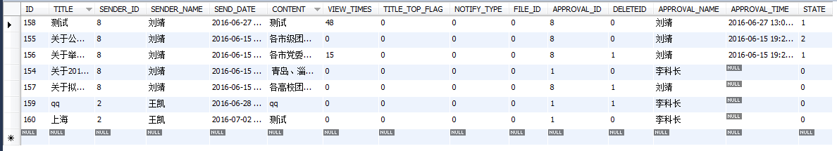

**存储通告信息**

**s_notify_view_info**

|  |  |  |
| --- | --- | --- |
| **列名** | **数据类型** | **含义** |
| **ID** | **int(11)** | **主键** |
| **REC_ID** | **int(11)** | **查看人编号-对应业务表，S_PERSON** |
| **REC_NAME** | **Varchar(20)** | **接收人姓名** |
| **NOTIFY_ID** | **int(11)** | **通知编号-对应业务表S_NOTIRY** |
| **TITLE** | **Varchar(100)** | **接收的信息标题** |
| **VIEW_DATE** | **Datetime** | **查看时间** |
| **IS_VIEW** | **Tinyint(1)** | **是否查看，0还没审核发出，1未查看，2已查看** |

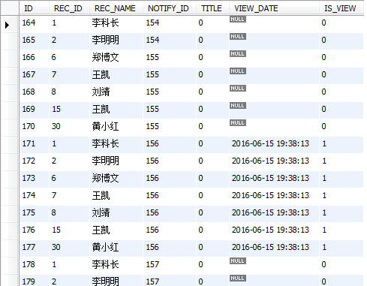

**个人接收公告信息表**

**s_paper**

|  |  |  |
| --- | --- | --- |
| **列名** | **数据类型** | **含义** |
| **id** | **Varchar()** |  |
| **UNIT_ID** | **Varchar()** |  |
| **NAME** | **Varchar()** |  |
| **PUBLISH_DATE** | **Varchar()** |  |
| **SUBJECT_CLASS_ID** | **Varchar()** |  |
| **SUBJECT_ID** | **Varchar()** |  |
| **PAPER_MODE_ID** | **Varchar()** |  |
| **PUBLISH_UNIT** | **Varchar()** |  |
| **PAPER_TYPE_ID** | **Varchar()** |  |
| **PUBLISH_YEAR** | **Varchar()** |  |
| **JUAN_NUMBER** | **Varchar()** |  |
| **QI_NUMBER** | **Varchar()** |  |
| **PAGE_SCOPE** | **Varchar()** |  |
| **WORD_NUMBER** | **Varchar()** |  |
| **AUTHOR_NUMBER** | **Varchar()** |  |
| **PUBLISH_RANGE_ID** | **Varchar()** |  |
| **PROJECT_SOURCE_ID** | **Varchar()** |  |
| **ISSN** | **Varchar()** |  |
| **KEYWORDS** | **Varchar()** |  |
| **CHECK_STATUS_ID** | **Varchar()** |  |
| **CREATOR_ID** | **Varchar()** |  |
| **CREATOR_NAME** | **Varchar()** |  |
| **CREATE_TIME** | **Varchar()** |  |
| **PAPER_PUBLISH_UNIT** | **Varchar()** |  |
| **PAGE_SPACE** | **Varchar()** |  |
| **IS_TRANSLATED** | **Varchar()** |  |
| **ENGLISH_NAME** | **Varchar()** |  |
| **CN** | **Varchar()** |  |
| **STANDBY10** | **Varchar()** |  |
| **FIRST_AUTHOR_NAME** | **Varchar()** |  |
| **OTHER_AUTHOR_NAME** | **Varchar()** |  |
| **FIRST_AUTHOR_CODE** | **Varchar()** |  |
| **OTHER_AUTHOR_CODE** | **Varchar()** |  |
| **OPERATE_TIME** | **Varchar()** |  |
| **PAPER_CLAIM_ID** | **Varchar()** |  |
| **TXZZ_ID** | **Varchar()** |  |
| **FILE_IDS** | **Varchar()** |  |
| **PAPER_SOURCE** | **Varchar()** |  |
| **PAPER_CONTRIBUTOR** | **Varchar()** |  |
| **TXZZ_NAME** | **Varchar()** |  |

**s_paper_publication_level**

|  |  |  |
| --- | --- | --- |
| **列名** | **数据类型** | **含义** |
| **ID** | **Varchar()** |  |
| **PAPER_ID** | **Varchar()** |  |
| **PAPER_TYPE_ID** | **Varchar()** |  |
| **PAPER_TYPE_NAME** | **Varchar()** |  |



**s_person**

|  |  |  |
| --- | --- | --- |
| **列名** | **数据类型** | **含义** |
| **ID** | **Varchar()** |  |
| **GROUP_ID** | **Varchar()** |  |
| **PERSON_ID** | **Varchar()** |  |
| **NAME** | **Varchar()** |  |
| **ACCOUNT** | **Varchar()** |  |
| **PASSWORD** | **Varchar()** |  |
| **UNIT_ID** | **Varchar()** |  |
| **SEXID** | **Varchar()** |  |
| **ID_CARD** | **Varchar()** |  |
| **BIRTHDAY** | **Varchar()** |  |
| **SUBJECT_CLASS_ID** | **Varchar()** |  |
| **SCHOOL** | **Varchar()** |  |
| **TITLE_ID** | **Varchar()** |  |
| **EDU_LEVEL_ID** | **Varchar()** |  |
| **EDU_DEGREE_ID** | **Varchar()** |  |
| **RESEARCH_FIELD** | **Varchar()** |  |
| **NATION_ID** | **Varchar()** |  |
| **DUTY_ID** | **Varchar()** |  |
| **DUTY** | **Varchar()** |  |
| **DUTY_DATE** | **Varchar()** |  |
| **TUTOR_TYPE_ID** | **Varchar()** |  |
| **MOBILE** | **Varchar()** |  |
| **EMAIL** | **Varchar()** |  |
| **ADDRESS** | **Varchar()** |  |
| **POSTAL_CODE** | **Varchar()** |  |
| **TEL_OFFICE** | **Varchar()** |  |
| **FAX_OFFICE** | **Varchar()** |  |
| **TEL_HOME** | **Varchar()** |  |
| **FAX_HOME** | **Varchar()** |  |
| **PERSONAL_WEB_SITE** | **Varchar()** |  |
| **PHOTO_ID** | **Varchar()** |  |
| **WORK_DATE** | **Varchar()** |  |
| **STANDBY1** | **Varchar()** |  |
| **STANDBY2** | **Varchar()** |  |
| **STANDBY3** | **Varchar()** |  |
| **HONOR_TITLE_ID** | **Varchar()** |  |
| **EXPERT_FLAG** | **Varchar()** |  |
| **QQ** | **Varchar()** |  |
| **GRADUATE_SCHOOL** | **Varchar()** |  |
| **STATUS** | **Varchar()** |  |
| **SELF_EVA** | **Varchar()** |  |
| **WORK_EXP** | **Varchar()** |  |
| **EDU-EXP** | **Varchar()** |  |
| **PRO_SKILL** | **Varchar()** |  |
| **EELSE** | **Varchar()** |  |
| **DAOSHINAME** | **Varchar()** |  |
| **DAOSHIZHICHENG** | **Varchar()** |  |
| **DAOSHIDANWEI** | **Varchar()** |  |

**s_personal_info**

|  |  |  |
| --- | --- | --- |
| **列名** | **数据类型** | **含义** |
| **sname** | **Varchar()** |  |
| **sno** | **Varchar()** |  |
| **ssex** | **Varchar()** |  |
| **sduty** | **Varchar()** |  |
| **srank** | **Varchar()** |  |
| **stele** | **Varchar()** |  |
| **szip** | **Varchar()** |  |
| **saddr** | **Varchar()** |  |
| **soff** | **Varchar()** |  |
| **slabor** | **Varchar()** |  |

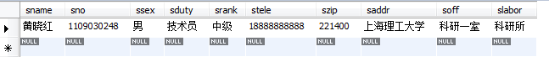

**s_prize**

|  |  |  |
| --- | --- | --- |
| **列名** | **数据类型** | **含义** |
| **ID** | **Varchar()** |  |
| **PROJECT_SOURCE_ID** | **Varchar()** |  |
| **NAME** | **Varchar()** |  |
| **FIRST_PRIZE_NAME** | **Varchar()** |  |
| **OTHER_PRIZE_NAME** | **Varchar()** |  |
| **UNIT** | **Varchar()** |  |
| **PRIZE_DATE** | **Varchar()** |  |
| **LEVEL** | **Varchar()** |  |
| **FILE_IDS** | **Varchar()** |  |

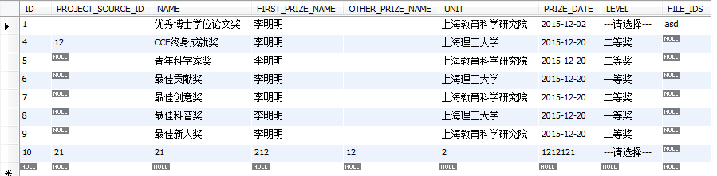

**s_project**

|  |  |  |
| --- | --- | --- |
| **列名** | **数据类型** | **含义** |
| **ID** | **Varchar()** |  |
| **NAME** | **Varchar()** |  |
| **UNIT** | **Varchar()** |  |
| **TYPE** | **Varchar()** |  |
| **FROMTO** | **Varchar()** |  |
| **ROLE** | **Varchar()** |  |
| **ACHIEVE** | **Varchar()** |  |
| **CHARGE** | **Varchar()** |  |
| **MONEY** | **Varchar()** |  |
| **DATEs** | **Varchar()** |  |

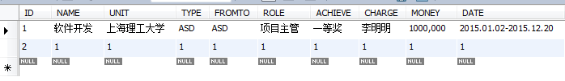

**s_project_actualize_info**

|  |  |  |
| --- | --- | --- |
| **列名** | **数据类型** | **含义** |
| **ID** | **Varchar()** |  |
| **UNIQUE_CODE** | **Varchar()** |  |
| **ACTUALIZE_STATUS** | **Varchar()** |  |
| **MIDEXAM_APPLY** | **Varchar()** |  |

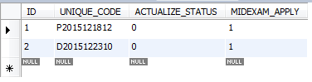

**s_project_apply_info**

|  |  |  |
| --- | --- | --- |
| **列名** | **数据类型** | **含义** |
| **APPLYID** | **Varchar()** |  |
| **NAME** | **Varchar()** |  |
| **PROJECT_LOCATION** | **Varchar()** |  |
| **KEYVALUE** | **Varchar()** |  |
| **SEARCH_AREAR** | **Varchar()** |  |
| **SUBJECT_CLASS** | **Varchar()** |  |
| **SEARCH_CLASS** | **Varchar()** |  |
| **PROJECT_CLASS** | **Varchar()** |  |
| **PROJECT_TYPE** | **Varchar()** |  |
| **PROJECT_SOURCE_UNIT** | **Varchar()** |  |
| **YUQI_PROJECT** | **Varchar()** |  |
| **YUQI_TIME** | **Varchar()** |  |
| **BEGIN_DATE** | **Varchar()** |  |
| **END_DATE** | **Varchar()** |  |
| **STATE** | **Varchar()** |  |
| **NOTE** | **Varchar()** |  |
| **CREATE_TIME** | **Varchar()** |  |
| **CREATOR_ID** | **Varchar()** |  |
| **CREATOR_NAME** | **Varchar()** |  |
| **REVIEWSTATE** | **Varchar()** |  |
| **REVIEWSTATE_NOTE** | **Varchar()** |  |
| **SUO_CHECK_STATE** | **Varchar()** |  |
| **SUO_CHECK_STATE_NOTE** | **Varchar()** |  |
| **YUAN_CHECK_STATE** | **Varchar()** |  |
| **YUAN_CHECK_STATE_NOTE** | **Varchar()** |  |
| **UNIT_ID** | **Varchar()** |  |
| **DIVISION_ID** | **Varchar()** |  |
| **APPLIER_ID** | **Varchar()** |  |
| **SUBJECT_ID** | **Varchar()** |  |
| **APPLY_FEE** | **Varchar()** |  |
| **APPLY_DATE** | **Varchar()** |  |
| **FILE_ID** | **Varchar()** |  |
| **IS_CONFIRM** | **Varchar()** |  |
| **BEFORE_RESEARCH_INFO** | **Varchar()** |  |
| **PROJECT_MODE** | **Varchar()** |  |
| **APPLY_CLASS** | **Varchar()** |  |
| **SHEJILUNZHENG** | **Varchar()** |  |
| **JINGFEIYUSUAN** | **Varchar()** |  |
| **DAOSHIYIJIAN** | **Varchar()** |  |
| **SUOSHUBUMENYIJIAN** | **Varchar()** |  |
| **GUANLIBUMENYIJIAN** | **Varchar()** |  |

**s_project_approval_info**

|  |  |  |
| --- | --- | --- |
| **列名** | **数据类型** | **含义** |
| **ID** | **Varchar()** |  |
| **UNIQUE_CODE** | **Varchar()** |  |
| **RESEARCH_CLASS_ID** | **Varchar()** |  |
| **APPROVAL_TIME** | **Varchar()** |  |
| **PLAN_END_DATE** | **Varchar()** |  |
| **PROJECT_FEE** | **Varchar()** |  |
| **EXPECT_RESULT** | **Varchar()** |  |

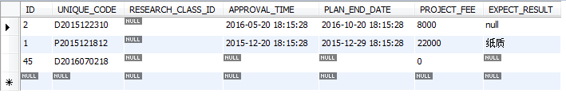

**s_project_basic_info**

|  |  |  |
| --- | --- | --- |
| **列名** | **数据类型** | **含义** |
| **ID** | **Varchar()** |  |
| **UNIQUE_CODE** | **Varchar()** |  |
| **PROJECT_CODE** | **Varchar()** |  |
| **PROJECT_TYPE** | **Varchar()** |  |
| **PROJECT_NAME** | **Varchar()** |  |
| **PERSON_ID** | **Varchar()** |  |
| **CHARGER_NAME** | **Varchar()** |  |
| **UNIT_ID** | **Varchar()** |  |
| **APPLIER_ID** | **Varchar()** |  |
| **CREATE_TIME** | **Varchar()** |  |
| **PROJECT_PROCESS** | **Varchar()** |  |
| **SUO_CHECK_STATE** | **Varchar()** |  |
| **SUO_SUGGEST** | **Varchar()** |  |
| **YUAN_CHECK_STATE** | **Varchar()** |  |
| **YUAN_SUGGEST** | **Varchar()** |  |
| **IF_DELETE** | **Varchar()** |  |

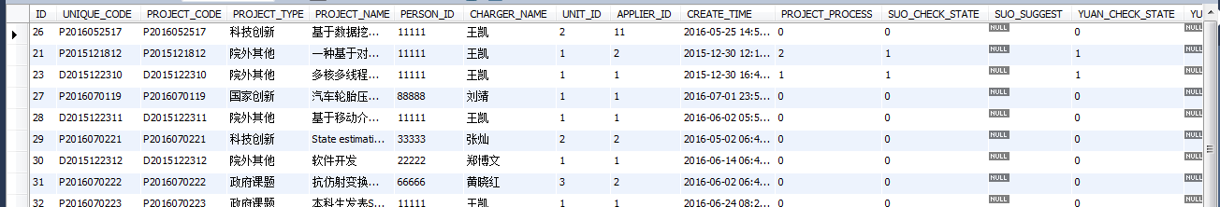

**s_project_enditem**

|  |  |  |
| --- | --- | --- |
| **列名** | **数据类型** | **含义** |
| **ID** | **Varchar()** |  |
| **UNIQUE_CODE** | **Varchar()** |  |
| **ENDITEM_TIME** | **Varchar()** |  |
| **FINISH_NOTE** | **Varchar()** |  |
| **SUO_CHECK_STATE** | **Varchar()** |  |
| **SUO_SUGGEST** | **Varchar()** |  |
| **YUAN_CHECK_STATE** | **Varchar()** |  |
| **YUAN_SUGGEST** | **Varchar()** |  |

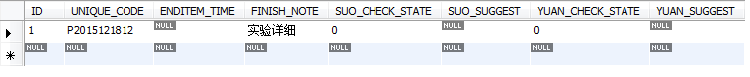

**s_project_midexam**

|  |  |  |
| --- | --- | --- |
| **列名** | **数据类型** | **含义** |
| **ID** | **Varchar()** |  |
| **UNIQUE_CODE** | **Varchar()** |  |
| **MIDEXAM_TIME** | **Varchar()** |  |
| **SUO_CHECK_STATE** | **Varchar()** |  |
| **SUO_SUGGEST** | **Varchar()** |  |
| **YUAN_CHECK_STATE** | **Varchar()** |  |
| **YUAN_SUGGEST** | **Varchar()** |  |

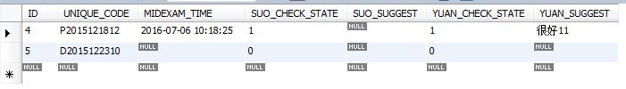

**s_schedule**

|  |  |  |
| --- | --- | --- |
| **列名** | **数据类型** | **含义** |
| **id** | **Varchar()** |  |
| **person_id** | **Varchar()** |  |
| **title** | **Varchar()** |  |
| **starttime** | **Varchar()** |  |
| **endtime** | **Varchar()** |  |
| **allday** | **Varchar()** |  |
| **color** | **Varchar()** |  |
| **url** | **Varchar()** |  |
| **type** | **Varchar()** |  |
| **priority** | **Varchar()** |  |
| **status** | **Varchar()** |  |

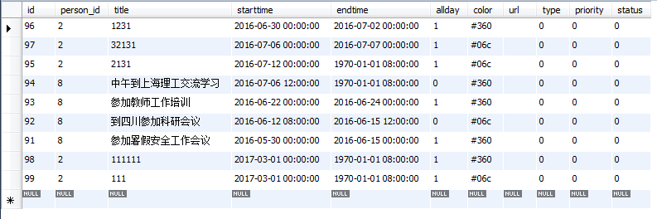

**s_train**

|  |  |  |
| --- | --- | --- |
| **列名** | **数据类型** | **含义** |
| **ID** | **Varchar()** |  |
| **NAME** | **Varchar()** |  |
| **UNIT** | **Varchar()** |  |
| **DATE** | **Varchar()** |  |
| **CONTENT** | **Varchar()** |  |
| **RAMARK** | **Varchar()** |  |

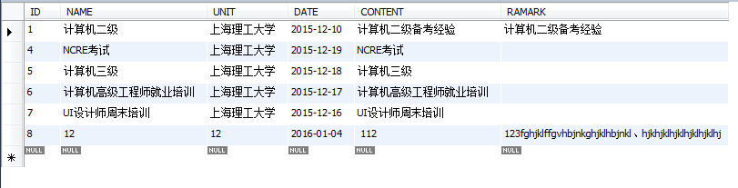

**s_unit**

|  |  |  |
| --- | --- | --- |
| **列名** | **数据类型** | **含义** |
| **ID** | **Varchar()** |  |
| **UNIT_ID** | **Varchar()** |  |
| **NAME** | **Varchar()** |  |
| **KJ_ID** | **Varchar()** |  |
| **STATUS** | **Varchar()** |  |

