# Beyond size: evolutionary patterns of non-allometric shape variation and divergence in a highly allometric clade of murine rodents

Ariel E. Marcy1,2*, Thomas Guillerme,3, Matthew J. Phillips4, and Vera Weisbecker2,5

**Affiliations:** 1University of Nebraska-Lincoln, School of Biological Sciences, Hall 402 1104 T St Lincoln, NE 68588-0118, USA; 2University of Queensland, School of Biological Sciences, St. Lucia, QLD 4072, Australia; 3University of Sheffield, Department of Animal and Plant Sciences, Alfred Denny Building S10 2TN, United Kingdom; 4Queensland University of Technology, School of Biology & Environmental Science, Brisbane, Queensland, 4000 Australia; 5Flinders University, College of Science and Engineering, Bedford Park SA 5042, Australia; *amarcy2@unl.edu

## Abstract (limit 350 words)

**Background:** Mammalian cranial diversity reflects its function in carrying a large brain while acquiring food and sensory information. As a result, selection on these traits appears to cause common evolutionary shape patterns. Craniofacial evolutionary allometry (CREA) is a well-known evolutionary pattern for mammals in which larger species have longer rostra and proportionally smaller braincases compared to related species. The mechanisms behind CREA are not yet established but hypotheses include stabilizing selection on function as cranial shapes scale at different proportions when body size changes (i.e. allometry). Australian murid rodents are known for exceedingly conserved CREA, even in specialist species, making them a model system for investigating mechanisms reinforcing CREA.

**Results:** We tested CREA in 37 species with 3D geometric morphometrics by quantifying cranial morphology, modularity, integration, and morphological distances between species in both allometric and allometry-free datasets. We assessed if the allometry-free datasets showed patterns that appeared independent of CREA, particularly in specialists. The positions of specialists in the allometry-free morphospace and a result for global integration suggest that stabilizing selection integrates posture with gnawing function. Carnivorous rodents, which have lost gnawing functionality, were the most anomalous while a species with the highest facial tilt consistent with bounding locomotion remained on the common evolutionary line. Unexpectedly, the second major allometry-free axis captured CREA-like shape patterns and separated species with allometries parallel to the common evolutionary line yet y-intercept shifted. These shifts correspond with more robust or gracile crania than expected for their body size, apparently facilitating divergent cranial shapes adapted to folivory and bipedal hopping, respectively, in an highly allometric clade.

**Conclusions:** The allometric and allometry-free datasets identify three main mechanisms appearing to produce cranial diversity in an allometrically constrained clade. First, allometric facilitation along the common evolutionary line which integrates most variations in cranial posture. Second, a release from stabilizing selection on gnawing function, supporting previous work finding exceptions to CREA among functional outliers. Third, and uniquely, we find a correlation between integration of non-allometric variation driving visible y-intercept shifts. The subsequent CREA-like patterns in the allometry-free dataset shows that CREA can be modified by mechanisms other than allometry.

**Keywords:** allometry, CREA, geometric morphometrics, integration, modularity, Muridae, stabilizing selection

## Background

The skull is arguably the most functionally diverse interface between a mammal and its environment. It is employed in the acquisition and mastication of food, receives the majority of sensory input, and carries the large and heavy brain. The evolution of mammalian cranial diversity is therefore assumed to be heavily influenced by the various requirements on the skull. Possibly for this reason, cranial morphology across mammals displays some common patterns of evolutionary variation. The most widely discussed of these is the tendency of larger mammals to display longer rostra and smaller braincases relative to smaller species, particularly in closely related species (Cardini et al. 2015). This pattern, termed craniofacial evolutionary allometry (CREA), has been found in a diverse range of vertebrates representing 11 different orders, especially those of placental mammals but also some marsupials (Cardini and Polly 2013, Bright et al. 2016, Cardini 2019). Mitchell et al. (2023x) challenged the assertion of a ubiquitous CREA pattern across mammals and reasoned that the frequently observed pattern is often a product of bite force allometry and phylogenetic niche conservatism. More closely related species tend to have more similar ecology and behaviour; however, larger species can also generate the same absolute bite force as smaller species with reduced relative bite force demand on their larger facial skeletons. Therefore, if related species share common dietary regimes or biting behaviours, larger species can sacrifice some capacity for bite force generation in their craniofacial architecture in favour of alternative selective pressures. Under this assumption, morphological shifts in cranial morphology are only predicted in association with substantial changes in dietary material properties, regardless of body size.

Among mammals, rodent skulls are one of the most striking cases of strong allometry coinciding with a CREA pattern of shape variation. A recent study (Marcy et al. 2020) showed that a sample of mostly Australian rodents, diverging as early as ten million years ago, have a highly conserved slope of allometry explaining over a third of their overall shape variation. The shape variation explained by allometry is also aligned with CREA, both in the definition adopted in Marcy et al. (2020; referring to a longer/elongated rostrum/muzzle/snout) and (Mitchell et al. 2023x; referring to hyperallometric gracilization more generally). This supports previous work suggesting that the strong allometry occurs as a result of stabilizing selection on the rodent gnawing apparatus, which is complex and highly adaptive for omnivory (Druzinsky 2015, Marcy et al. 2020). It might also explain the clade’s unique overall shape but slow-evolving morphological evolution through (Goswami et al. 2022). Support for this comes from developmental evidence suggesting that cranial growth – which is by definition allometric – varies substantially, such that similar specialisations can arise from different growth patterns (Wilson 2013, Segura et al. 2023). Moreover, Marcy et al. (2020) showed that species whose shape appeared most distinct from the common evolutionary allometric pattern tended to be ecological specialists with distinct diets and locomotor modes (Marcy et al. 2020). This is consistent with Mitchell et al. (2023x) hypothesis that CREA patterns disappear when dietary hardness changes, and also highlights that patterns of variation beyond allometric scaling are worth investigating on their own.

Assessing the impact and scope of cranial adaptation in situations where CREA appears to be the dominant pattern has the potential to clarify the origins of CREA, and also the conditions under which adaptations can be superimposed over CREA patterns of shape variation. The rodent sample assessed in Marcy et al. (2020) offers an ideal opportunity because it combines allometrically highly uniform species with specific deviations from the common pattern. These include the carnivorous rodents, but also a group of ecological specialists with a distinct non-diet related locomotor mode, the hopping mice *(Notomys*) and the rabbit-rat (*Conilurus penicillatus*). The latter group is of interest because of their conspicuous “facial tilt” of the anterior cranium, an adaptation resulting in an expansion of their field of view while hopping or bounding (Kraatz and Sherratt 2016). This makes hopping and bounding species intriguing cases to examine in the allometry-free morphospace as their rostral shapes may depend on the degree to which the facial tilt is independent from CREA.

Selection on functional shapes that are independent of CREA is expected to be most apparent in some parts of the skull but not others (e.g. the maxillary region of carnivorous species; the back of the skull in hopping or bounding species). A key question is therefore how different parts of the skull co-evolve, and whether there are size-independent different patterns alongside CREA which allow the evolution of skull parts away from the main allometric line. This is conceivable because allometry explained a large amount (36%), but not the majority, of cranial shape variation (Marcy et al. 2020), leaving substantial residual variation that might be attributable to non-CREA patterns. Understanding how the different parts of the cranium relate to each other in evolution can be investigated using assessments of variation within anatomical regions of the skull, known as modules, which are linked due to shared genetic or developmental mechanisms (Klingenberg 2009). This allows assessment of integration (covariation between modules; Klingenberg 2009) and modularity (the degree of independence of shape variation within a module relative to the others; Klingenberg 2009). These can be calculated in both the allometric morphospace and in the ‘allometry-free’ shape morphospace where the allometric component of shape has been removed from species mean shapes, leaving only the shape residuals. Strong allometry in the rodent sample means that we should expect all parts of the skull to evolve changes in shape as one structure, which corresponds with low modularity (i.e. no differences in evolutionary behavior across modules) and high integration between modules (i.e. all modules co-varying strongly, also known as global integration) (Klingenberg 2009, Bookstein 2015). Conversely, if the allometric pattern is paired with an underlying ability to change relative to CREA, we would expect higher modularity (where parts of the skull evolve independently of each other) and lower integration between modules (where modules co-vary less), particularly in the allometry-free space.

Another avenue for investigating the impact of allometry on rodent skull diversification is visualizing the evolution of cranial shape disparities through time in allometric and allometry-free contexts. In particular, if the shape residual variation relates to the capacity of the rodent skull to diverge independently of allometry, we would expect to see greater relative morphological distances involving species with non-CREA skull adaptations in the allometry-free dataset compared to the full shape dataset. In other words, we would expect to see the highest morphological distances between species that have ecological specializations with divergent functional requirements compared to those whose shapes follow the expected CREA pattern.

In this study, we test the above predictions based on Marcy et al. (2020)’s sample of 37 rodent species to assess the impact of non-allometric selection on an ecologically diverse sample of murid rodent species in an allometry-free morphospace. We ask if the removal of size from the dataset completely removes variation due to CREA; whether the allometry-free dataset confirms our prediction of higher modularity and lower integration of cranial modules; and whether size-independent shape variation should show maximum shape disparity occurring between distantly-related species and/or species with divergent functional requirements (as opposed to allometric shape spaces, where, maximum shape disparity should occur between species with divergent body sizes).

## Methods

We used a previously published dataset (n = 317; Marcy et al. 2020) of 37 Australian rodent species that were landmarked with a protocol of 60 fixed landmarks, 141 curve semi-landmarks, and 124 patch semi-landmarks. Ecological information on diet and locomotion for each species was taken from Breed and Ford (2007). For details, see Marcy et al. (2020). All analyses were performed in R (v.3.6.1) (R Core Team 2023) **[RUN UPDATE],** using the packages *geomorph* [VERSION] (Baken et al. 2021, Adams et al. 2022), LandvR [VERSION] (Guillerme and Weisbecker 2019)*,* and *vegan* [VERSION] (Oksanen et al. 2022)*.*

### Comparing distribution of species in morphospace through PCA scores

In order to visually assess the allometric and non-allometric morphospaces, we performed principal component analyses (PCA) on three different shape datasets of mean species shapes, and visualized each morphospace with plots of the first two principal components (PCs). The first, termed here ‘full shape dataset’ is based on a conventional generalized Procrustes analysis, and includes the allometric component of shape. Second, the ‘shape residual dataset’, includes the components of shape that remain once allometric shape is removed and it provides a ‘size-less’ or ‘allometry-free’ comparison of the mean species shapes. The shape residuals were obtained from a phylogenetically-informed linear generalized least squares model using random permutations implemented by the *RRPP* package (Collyer and Adams 2018, Collyer and Adams 2019). When residuals wereadded to the consensus shape derived from the GPA, the shape variationcould be compared visually to the full shape dataset. Third, we repeated the PCA for the shape residual dataset after removing the four hopping mice (genus *Notomys*). We did this because we expected their bipedal posture to exaggerate some features of shape variation in the PCA and the resulting morphospace plots.

To assess morphospace similarity between the full shape and shape residual datasets, we performed a Mantel test using the *vegan* function *mantel* (Oksanen et al. 2022) on the distance matrices of all PC scores in each dataset. We also use simple correlation to assess the relationships between allometric shape variation and individual morphospace axes, because the full shape PC1 is highly correlated with allometric shape variation in this dataset (r = 0.92; Marcy et al. 2020). Therefore, we calculated the same correlation for the full shape PC2 and the shape residual PCs to confirm that these morphospace axes capture shape variation independent of allometry and to confirm that the allometry-free dataset lacks allometric information.

### Assessment of allometric vs. allometry-free shape variation via heat maps

In order to visualize and assess allometric shape variation in the full shape dataset, we created heatmaps showing the magnitude of landmark displacements using *landvR* functions (Guillerme and Weisbecker 2019, Weisbecker et al. 2019). We compared three different visualizations of allometry. First, using fitted allometric shapes estimated by Procrustes linear models (also using random permutations as per RRPP) across the entire sample. However, variation characterized through ordination or allometric analysis provides summaries of parts of the variation, which do not always reflect actual specimens (Weisbecker et al. 2019). We therefore also visualized the mean configurations of the smallest native species (the delicate mouse, *Pseudomys delicatulus*) and the largest (the giant white-tailed rat, *Uromys caudimaculatus*), as determined by mean centroid size. Third, to illustrate the similarity in shape variation along PC1 to the two previous visualizations of allometric variation, we visualized the hypothetical shapes for PC1 minimum and maximum.

To compare the allometric shape change to the ‘isometry-free or ‘allometry-free’ shape variation, we produced heatmaps from the shape residual dataset visualizing the minimum and maximum hypothetical shapes for three different PC axes. First, we produced heatmaps for PC1 and PC2 to compare the allometry-free changes to the allometric cranial changes seen in the full shape dataset. We also visualized heatmaps for the shape residual PC2 without the four species of *Notomys* in order to assess the impact of their bipedal posture on the ordinated shape variation.

### Modularity and integration in allometric and allometry-free datasets

To compare the modularity patterns across our allometric and non-allometric datasets, we assumed a five-module framework that followed the six-module framework found across therian mammal crania (Goswami 2006) but excluding the zygomatic arch module, which was missing due to scanner limitations (Marcy et al. 2018). To quantify modularity, we used the *geomorph* function *phylo.modularity* (Adams 2016, Adams and Collyer 2019). This calculates the covariance ratio (CR) coefficient, with the numerator as covariation between modules and the denominator as covariation within modules (Adams 2016). Therefore, highly modular structures, with higher covariation within than between modules, will have small CR values within the unit interval (Adams 2016). By contrast, structures with low modularity will have CR values close to 1.0 because the two covariation values are very similar (Adams 2016). The modularity results were juxtaposed with analyses of integration, which use partial least squares (PLS) correlation coefficients between multiple modules to assess how much they co-vary, taking into account phylogeny (Adams and Felice 2014). In this case, values towards 1 indicate a higher PLS coefficient. In both modularity and integration analyses, the functions include a phylogenetic context by generating a matrix of partial least squares under a Brownian motion model of evolution (Adams and Felice 2014) that was informed by our time-calibrated ultrametric molecular phylogeny (Smissen and Rowe 2018, Marcy et al. 2020). The resulting evolutionary covariance matrix controls for similarities between closely related species, which is needed to study macro-evolutionary patterns of modularity (Klingenberg and Marugán-Lobón 2013, Adams and Felice 2014). Significance was determined by randomly resampling the modules 1,000 times and comparing the random distribution of CR coefficients to the observed value.

In order to assess whether the modularity and integration patterns are consistent with CREA or any other pattern, we used the *vegan* function *mantel* to perform pairwise Mantel tests on the distance matrices of PC scores within each module (Legendre and Legendre 2012). The resulting *r* statistics indicates the degree of correlation between each module pair, with values closer to one corresponding to higher integration (Hetherington et al. 2015). If a module consistently has *r* statistics closer to zero, this indicates higher modularity, i.e. greater independence in shape variation relative to the other cranial modules. The Bonferroni correction was used to adjust for multiple comparisons (Bonferroni 1936).

Finally, we tested for global integration of the crania in both the full shape and shape residual datasets using the *geomorph* function *globalIntegration* based on Bookstein (2015). This test distinguishes between integration and a null hypothesis for self-similarity, which is the absence of any interpretable change at any spatial scale. Self-similarity in a morphological dataset is the spatial equivalent of a temporal random walk based on Brownian motion (Bookstein 2015). The degree of integration versus self-similarity is quantified by the regression slope between the entire sample’s (n = 317) bending energy and its partial warp variance (Bookstein 2015, Evans et al. 2017, Young et al. 2017, Sansalone et al. 2019). The null expectation of self-similiarity would give a regression slope of -1 so if the slope is steeper – i.e. greater absolute value – this indicates global integration due to low independence in each cranial module relative to the other cranial modules.

### Phylo-morphological distance

Since the constraints on shape disparity from integration may differ in the allometric and allometry-free morphospaces, we visualized the relationship between pairwise phylogenetic and morphological distances for the full shape and shape residual datasets. We retrieved a matrix of pairwise phylogenetic distances using the *picante* function *cophenic* (Kembel et al. 2010) on our ultrametric time-calibrated phylogeny (Smissen and Rowe 2018, Marcy et al. 2020). Values were divided in half to give values in millions of years since last common ancestor. The pairwise Procrustes distances – i.e. morphological distances – derived from the GPA of shapes. We then plotted every pairwise combination of the phylogenetic and morphological distances between two species in our dataset for both the full shape and shape residual datasets. We expect this to provide a broad estimate of morphological divergences with and without allometry, but there are two caveats to this method: 1) pseudoreplication due to the high volume of pairwise comparisons within the sample and 2) non-uniform sampling of time due to the phylogeny’s structure, with most coverage occurring between 0.3-4.2 Ma. We therefore interpret the results with these caveats in mind.

## Results

### Principal component analyses

We visually assessed whether removing allometry emphasizes different morphological patterns in the rodent crania morphospace by comparing PC1/PC2 plots and an evolutionary allometry plot of the full shape dataset (with allometry, Fig. 1a-c) to PC1/PC2 plots of the shape residual dataset (allometry-free, Fig. 1d-f). As expected, the allometry-free shape residual dataset captured less shape variation along PC1: 26.8% compared to 52% in the full shape dataset (see also Fig. S1). The PC2 axes captured similar percentages of shape variation, 14.5% and 18.6%, within the full shape and shape residual datasets, respectively. As expected, the full shape PC1 orders species by size (correlation with centroid size is 0.92; Fig. 1a vs. b), whereas neither residual shape PC1 nor PC2 distinguishes between large-bodied and small-bodied species(Fig. 1c vs. d). The divergent bipedal posture of *Notomys* was not a main driver of residual shape variation: when *Notomys* was removed, the relative positioning of species and the shape variation associated with the first two PCs remain very similar (Fig. 1d vs. e).

The species distribution along the full shape PC2 resembles the pattern along the residual shape PC1 (Fig. 1a vs. f). Both axes show the carnivorous *Xeromys myoides* and *Hydromys chrysogaster* at one extreme and a quadrupedal bounding species (the brush-tailed rabbit rat, *Conilurus penicillatus*) at the other. A correlation of 0.97 confirms the similarity between the full shape PC2 and the residual shape PC1 axes while the Mantel correlation between the two morphospaces is comparatively lower at 0.58. However, removing the full shape PC1 – and the allometric variation it captures – from the full shape morphospace and then re-performing the Mantel correlation test raises the r statistic to 0.94. This confirms that PC1 mostly captures allometric variation while the other PCs preserve other shape patterns. Nevertheless, the relationship between the full shape and shape residual axes is not always PC(n) to PC(n-1). For example, the correlation between full shape PC3 and shape residual PC2 is 0.25. This supports our expectation of the ordinations summarising different dominant patterns of shape variation in the allometry-free shape residual dataset compared to the full shape dataset.

In the shape residual plot of PC1 and PC2, the majority of species cluster in the center, which is expected because the main differentiator of shape – size – is now removed. This includes the two large-bodied frugivores, which have high PC1 scores in the full shape plot and high regression scores in the evolutionary allometry plot. The allometry-free shape residual plots highlight other ecological specialists instead, such as the two semiaquatic carnivores along PC1 and the four hopping *Notomys* species along PC2 (Fig. 1f). The PC2 maximum highlights the Australian murid most specialized for folivory, the broad-toothed rat (*Mastacomys fuscus*). All of the specialists along these extremes are in the Pseudomys division (sensu; Smissen and Rowe 2018), a clade of five genera from the earliest radiation of extant Australian rodents (Aplin and Ford 2014), represented here by shades of blue (legend in Fig. 1c). In the full shape dataset, most of these specialists show a degree of deviation from the common allometric line (Fig. 1b,f). The two carnivores and a specialist folivore (*Mastacomys*) plot above the line while *Notomys* appears to have a lower y-intercept for their genus-wide evolutionary allometric trajectory compared to other murids.

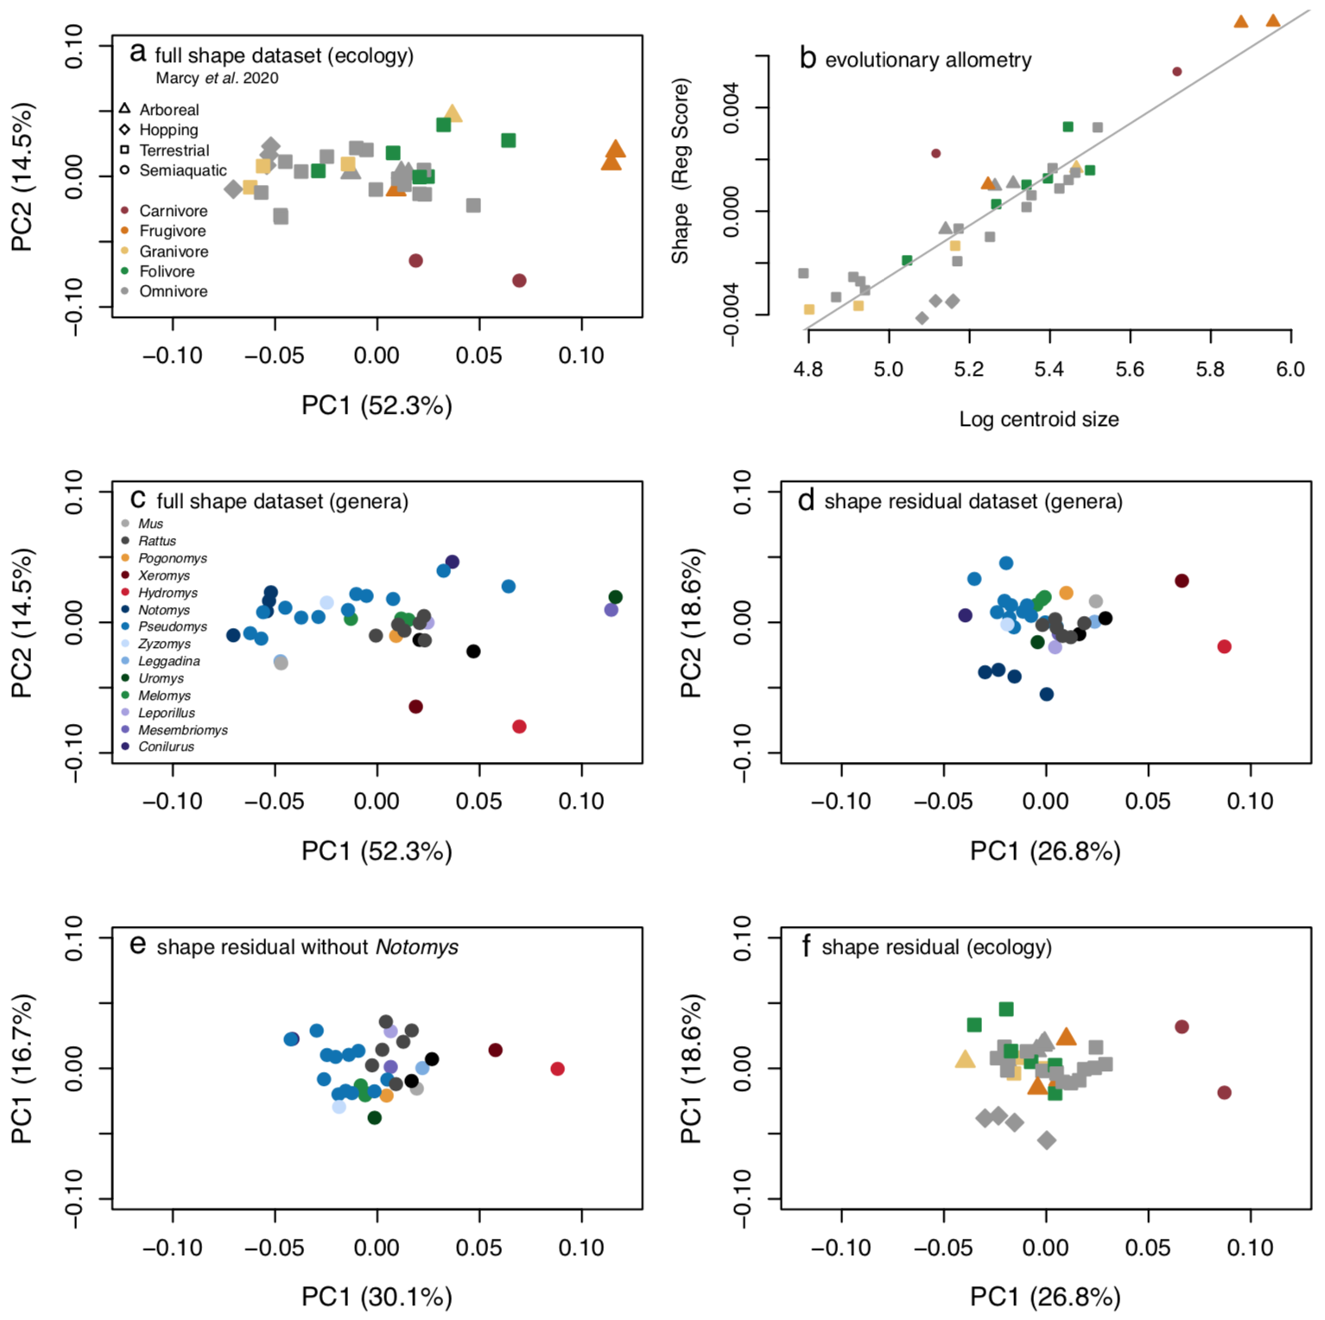

**Figure 1:** Differences between the hypothetical shapes captured between PC1 extremes.a, plot of PC1 and PC2 for the full shape dataset and b**,** plot of log centroid size versus the projected regression score with a gray regression line indicating the common evolutionary trajectory; data from Marcy et al. (2020) but with point shapes by locomotion and colors by diet. c,part a with point colors by genera (*Mastacomys* is within genus *Pseudomys*). d, ‘allometry-free’ shape residual dataset, e**,** shape residual dataset without *Notomys,* f, part d with point shapes by locomotion and colors by diet.

### Landmark heatmaps

As expected, pattern of gracilization with size is apparent in the visualization of shape variation that is associated with allometry: fitted minimum/maximum shapes, mean shapes of smallest/largest species, and shapes on the extremes of PC1 (Fig. 2a-c). Representations of larger species had lengthened rostra and smaller relative braincases compared to smaller species.

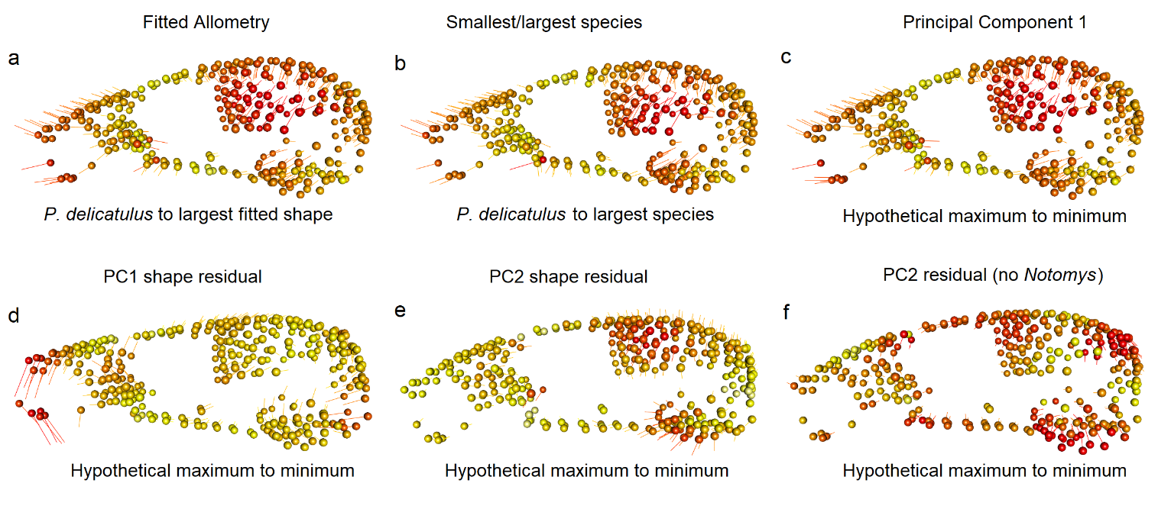

**Figure 2:** Landmark heatmaps shape variation. Spheres show the mean position of landmarks for the column’s dataset, vectors show landmark displacement. Colors and lengths are calculated from relative proportions of the minimum/maximum vector lengths for each comparison, and are not equivalent across columns. a, shape differences between the shape fitted for the smallest Australian native (*P. delicatulus)* to the largest species in the sample (*U. caudimaculatus)*; b, shape differences between the mean shapes of these previous species, showing high correspondence to differences between hypothetical allometric fitted shapes; c, differences between the hypothetical shapes captured between PC1 extremes; d, differences between the hypothetical shapes captured between PC1 extremes based on allometry-free data; e, differences between the hypothetical shapes captured between PC2 extremes on allometry-free data; f, differences between hypothetical shapes between PC1 extremes after removing *Notomys.*

Removing the shape patterns that covary with size (Fig. 2d-f) also removed this gracilization pattern. Species closer to the PC1 minimum then show ventral flexion of the rostrum and anteroventral movement of the foramen magnum (Fig. 2d). However, the allometry-free PC2 heatmaps with all species highlighted shape patterns resembling the allometric variation seen in the full shape PC1 even though this pattern is not allometric, i.e. not correlated with body size (correlation = 0.11). For example, the *Notomys* species at PC1 minimum show enlarged braincases and auditory bullae, but not shortened rostra as expected under CREA (Fig. 2e). To test whether these shape patterns are an artifact driven by the four bipedal hopping *Notomys* species, we removed these from the shape residual dataset and re-calculated the heatmaps. The result showed similar regions of variation (Fig. 2f) This indicates that the bipedal hopping species are not solely responsible for the braincase and auditory bulla shape variation seen in the shape residual dataset with all species.

### Modularity and integration

As expected, the full dataset had higher levels of integration (high PLS correlation coefficient) and lower modularity (CR coefficient closer to 1) than the shape residual dataset (Fig. 3). This confirms that size variation relates to an integrated response of modules across the whole cranium. As we also predicted, size-independent patterns of shape evolution exist in parallel with the size variation, with greater independence of the cranial modules suggested by the lower r-pls and Cr coefficients of the shape residual dataset. However, our Mantel tests of module PC score matrices did not confirm our expectation that the rostrum and vault module PCAs had higher correlations with each other than with others: rostrum and vault correlations in the full shape dataset had smaller r statistics (r=0.76) than that between the rostrum and the adjacent orbital region (0.81). The r statistics for the full shape dataset were all above 0.51 (Table 1, upper triangle), indicating medium-to-strong positive shape variation relationships between all modules. The molar module consistently had the lowest r statistics (r = 0.51-0.63) indicating that it is the most independent from the other modules. However, this could also be because this module has the fewest landmarks (n = 19). Results from the residual shape dataset gave similar ratios of r statistics between modules, indicating that pairwise patterns of integration between modules do not change when allometry is removed. As expected, the absolute values decreased relative to the full shape dataset (Table 1, lower triangle), which reflects an overall decrease in shape variation when one of the major variation determinants – allometry – is removed. However, intriguingly, the correlation between residual PCAs of the vault and the rostrum is substantially higher (0.7) compared to all the other correlations (0.37 – 0.65).

**Figure 3:** Modularity tests using the CR coefficient. **a** our five-module framework adapted from (Goswami 2006). Results from the b,d full shape and c,e shape residual datasets. Black curves are the density distribution of 1,000 permutations and the arrows point to the observed coefficients, which were all significant.

**Table 1:** Modularity tests using pairwise Mantel comparisons of PCA-based distance matrices of all modules, and Mantel r statistic. An r statistic of 1 indicates a strong correlation and 0 indicates no correlation. The upper triangle reports statistics for pairwise comparisons between cranial modules of the full dataset, the lower triangle reports r statistics for the lower dataset. The values in brackets are *p* values, adjusted by Bonferroni (1936) corrections for multiple comparisons.

|  |  |  |  |  |  |
| --- | --- | --- | --- | --- | --- |
|  | Basicran. | Molar | Orbital | Rostrum | Vault |
| Basicranium | **64** | 0.514 (0.01) | 0.601 (0.01) | 0.719 (0.01) | 0.753 (0.01) |
| Molar | 0.367 (0.03) | **19** | 0.55 (0.01) | 0.625 (0.01) | 0.564 (0.01) |
| Orbital | 0.283 (0.06) | 0.348 (0.02) | **32** | 0.807 (0.01) | 0.731 (0.01) |
| Rostrum | 0.524 (0.02) | 0.624 (0.01) | 0.626 (0.01) | **86** | 0.762 (0.01) |
| Vault | 0.652 (0.01) | 0.45 (0.03) | 0.629 (0.01) | 0.699 (0.01) | **124** |

Consistent with the overall high integration we found in both the full and size-free datasets, the test of global integration revealed a regression slope below -1.0 (Beval_full = -1.64; Beval_residual = -1.55; Fig. S2), which indicates global integration across all cranial modules (Bookstein 2015) in both datasets. This means integration or a high degree of covariation among all modules might obscure any potential modular structure (Klingenberg 2009).

### Phylo-morphological distance

Our phylo-morphological distance plots (Fig. 5) asked whether the relationship between phylogenetic distance and morphological distances (i.e. Procrustes distances between the mean shapes of a species pair) increases with increasing phylogenetic distance because, as integration patterns change over time, shape covariation patterns diverge (Voje et al. 2014). As expected, all of the points closest to the origin (i.e. low phylogenetic *and* low morphological distances) are within-genus pairs. In the full shape dataset, maxima in morphological distances tend to increase with phylogenetic distance until reaching an apparent asymptote around 4.2 Ma since the last common ancestor. However, the highest divergence values involve distances of all species with the two large-bodied frugivores: *U. caudimaculatus* and the black-footed tree rat *Mesembriomys gouldii* (Fig. 4a). If these are ignored, then the dataset’s maximum morphological distance appears earlier, around 2 Ma. Furthermore, all pairs involving *Rattus*, the most recent radiation of native rodents,fall below the maximum morphological distance reached around 2 Ma by pairwise comparisons of older endemics (Fig. 5a); in other words, shape distances between *Rattus* and other Australian murids, which have divergence dates of around ten million years[**CORRECT?**], fall well within the range of morphological distances within murids. However, as noted in the methods, these results are subject to pseudoreplication because they include all possible pairwise combinations, such that each of the 37 species accounts for 36 data points. This can be seen in the vertical clustering, which represent pairwise comparisons between one species and other species with the same divergence time.

The ‘allometry-free’ shape residual pairwise comparisons were similar to the full shape dataset, with overall lower morphological distances as expected from removing allometric shape variation. The removal of allometric differences between differently-sized species also has a marked effect on the spread of morphological distances at each divergence. Most conspicuously, removing allometry substantially reduces morphological distances between the large-bodied frugivores relative to other ecological specialists, so that the greatest distances between species is now at the time of divergence between the two semiaquatic, carnivorous species at 5.7 Ma (Fig. 5b). If the semiaquatic species are ignored, the remaining dataset’s maximum distances appear around 3.1 Ma, or pairwise comparisons between hopping *Notomys* species and close relatives in *Pseudomys*. Both plots show the greatest morphological divergences occurring within the old endemic species, not between more-distantly related species involving *Rattus* or *Mus*.

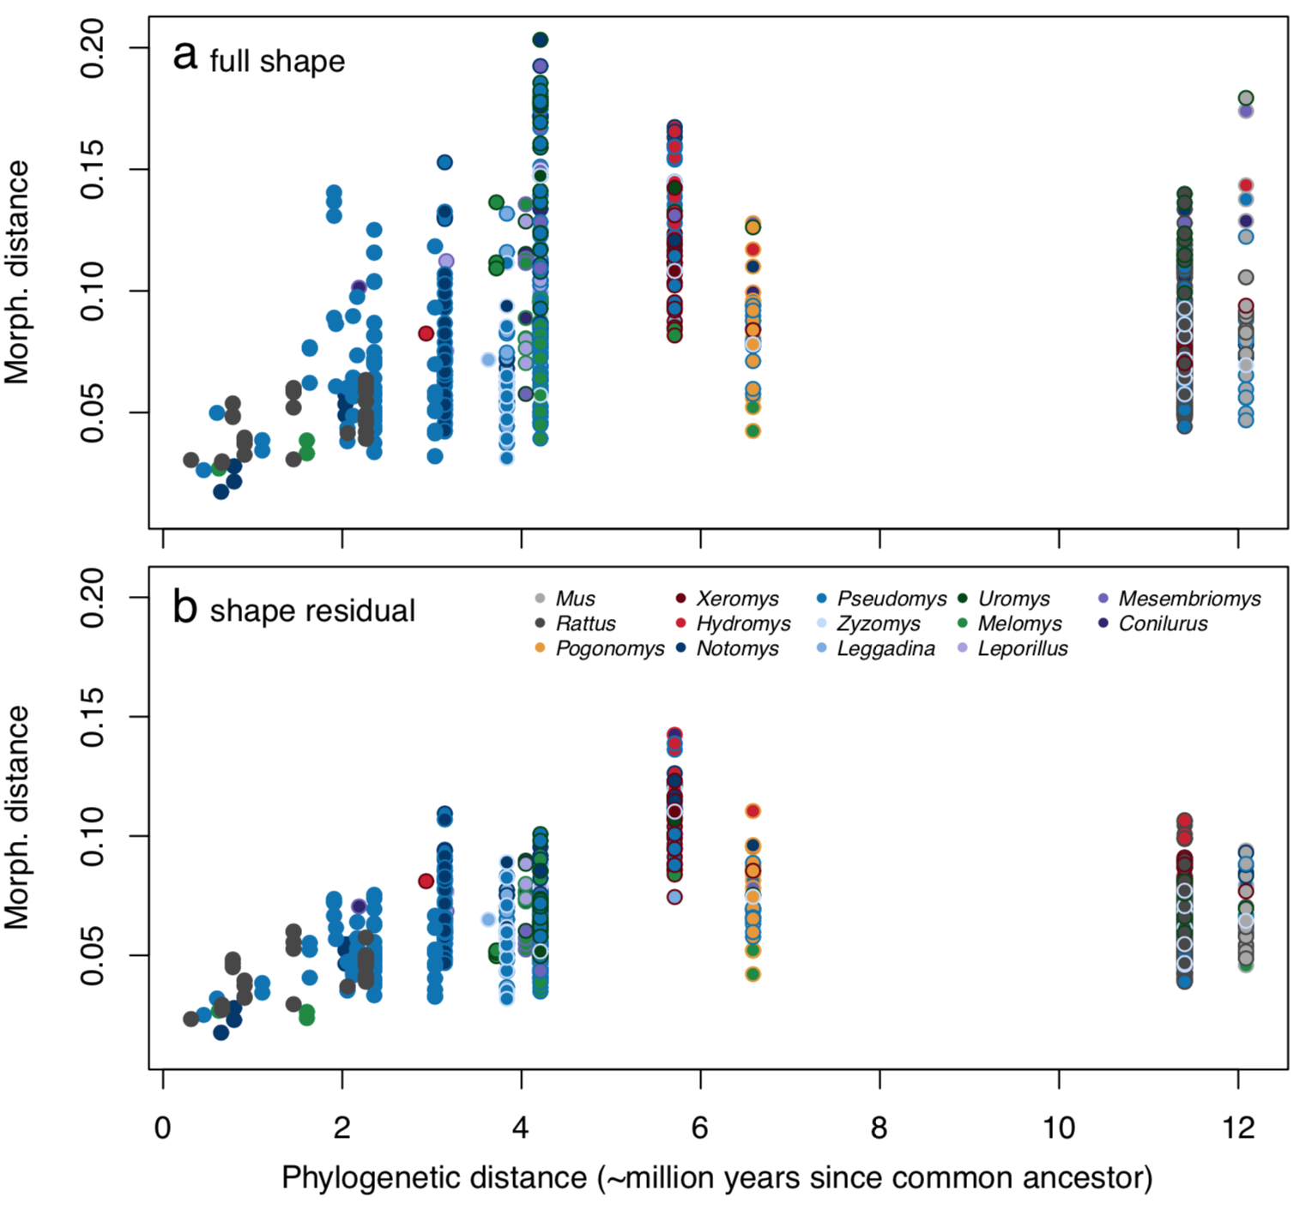

**Figure 5:** Phylo-morphological distance plots. Each point is a pairwise comparison with border and center colors corresponding to the two species’ genera. The x-axis is shared but the y-axes of morphological distances are not equivalent as they rely on different shape datasets: a full shape and b shape residual.

**Discussion**

In this study, we characterised the evolution of cranial shape beyond allometric patterns in a highly allometric clade of Australian murine rodents to understand the degree to which the facial gracilization that is part of the CREA pattern persists in the absence of size-related variation. As expected, removal of the allometric pattern indeed removes much of the shape variation of longer faces at larger sizes. However, a substantial part of the ordinated allometry-free shape variation – 18% - reflects differences in relative anterior braincase expansion, which are part of the CREA pattern but here appear independent of allometry. Thus, not unexpectedly (Mitchell et al. 2018, Weisbecker et al. 2019, Viacava et al. 2020), allometric patterning is not the only cause of shape variation that is commonly attributed to CREA. Removal of allometric effects thus can reveal other relevant patterns of shape variation. In the case of the murine pattern, it is possible that the brain of species with more expanded braincases along PC2 either have brain volumes that are larger than expected for their body mass – essentially reflecting the encephalization of these species (Smaers et al. 2021) – or have a different distribution of the brain tissue within the braincase (Weisbecker et al. 2021) compared to lower-scoring species. This effect serves as a reminder that comparisons of allometric and ‘allometry-free’ datasets can identify how different sources of shape variation interact to produce visible patterns of vertebrate shape diversity, even in clades with strong allometric constraints.

Allometry in mammalian crania, and the subsequent shape variation as predicted by CREA, has often been attributed to the integration of size with masticatory biomechanics (Marroig and Cheverud 2005, Singleton 2005, Mitchell et al. 2018, Weisbecker et al. 2019, Mitchell et al. 2023x). This is probably particularly true for rodents, where high levels of allometry likely reflect constraints imposed by their highly derived gnawing function (Lessa and Patton 1989, Cox et al. 2012, Druzinsky 2015, Marcy et al. 2016, Ginot et al. 2018, Marcy et al. 2020). However, the residual shape space also appears to have a biomechanical *and* allometry-independent source of shape variation: the second allometry-free axis captured CREA-like variation in relative basicranium dimensions, where the two most specialized folivore species showed shallower vaults than expected for their size. This pattern likely reflects the wider skulls and dorsally shifted temporalis muscles that increase the mechanical advantage for masticating fibrous foods, which has evolved in specialist folivores across several rodent families (Samuels 2009).

Under the assumptions of Mitchell et al. (2023x)’s framework, the CREA pattern represents a tradeoff between bite force and selective pressures that shift in importance with increasing size. Importantly, this includes variation among selective pressures are likely different for any given taxon of interest and can therefore lead to non-allometric biomechanical adaptation. In the case of rodents, there are potential benefits to increasing gape (Williams et al. 2009, Hennekam et al. 2020), which is possibly further evidenced by the carnivorous species with more elongate crania than expected for their size. By contrast, morphology related to biting biomechanics is also expected to be shaped over evolutionary time by toughest foods encountered (Van Valkenburgh 1989, Strait et al. 2009, Figueirido et al. 2014, Mitchell 2019), so that frequent consumption of desert seeds and insects by the hopping generalist species (Murray et al. 1999) might explain their more robust cranial dimensions than expected for their size.

Despite evidence that the allometric pattern in our sample is determined by stabilizing selection on mastication, the allometry-free morphospaces show that this appears not to constrain the evolution of adaptations such as postural variation coinciding with ecological specializations. For example, the rabbit rat (*Conilurus penicillatus*) has the highest facial tilt of the sample, consistent with its quadrupedally bounding locomotion (Kemper 1989, Kraatz and Sherratt 2016). However, despite its unusual shape, the rabbit rat still falls along the common allometric line, thus suggesting that any stabilizing selection on mastication also permits the evolution of specialist postures. A similar pattern is seen in the bipedally hopping genus *Notomys*, whichis second in facial tilt to *Conilurus*, and to a lesser degree in *Mastacomys*. *Notomys* species do not lie on the common allometric line, but this separation is because of their derived basicranium, not their facial tilt. The inclusion of a facial tilt in *Conilurus* and *Notomys* within the common allometric pattern therefore suggests a level of flexibility to adaptations that do not interfere with masticatory function.

Visual assessment of the non-allometric shape variation provides intriguing evidence that even apparently non-allometric variation may have its origins in an underlying allometric pattern. In particular, the allometry-free PC2 axis – capturing “partial” CREA-like variation of relative braincase size – differentiates species that are adapted for different masticatory functions. Specifically, specialized folivory for the broad-toothed rat *Mastacomys*, which lies above the common allometric line, and bipedal hopping for *Notomys*, which lies below this line. In terms of shape, *Mastacomys* displays a cranial shape like a larger murid, by having a relatively smaller braincase relative to the snout region; this is consistent with descriptions of its unusually robust skull (Breed and Ford 2007). By contrast, *Notomys* displays a larger braincase region relative to the snout, as would be expected for a smaller murid. Since the allometric slopes of *Notomys* and *Mastacomys* are not significantly different from the common allometric slope (Marcy et al. 2020), the changes in braincase dimension appear to reflect a “grade shift” of an otherwise identical allometric pattern. Thus, in a group with a constrained allometric slope, changing the multidimensional regression-score intercept of species- or genus-level trajectories might represent a pathway towards cranial diversity that remains consistent with a general allometric constraint (see also Mitchell et al. 2023x).

The modularity and integration results reinforce the impression that evolutionary size variation results in concerted changes across the cranium, as reflected in the higher integration values in the full dataset. This may well relate to stabilizing selection due to size-related biomechanical constraints. However, in the case of murines, such constraints appear to extend beyond the allometric pattern, due to the high levels of integration retained in the residual dataset. This agrees with the observation that rodents occupy a highly distinct, slowly-evolving area in the morphospace of placental crania (Goswami et al. 2022). In addition, however, the lower integration and higher modularity of the size-free dataset reinforces the impression from the morphospaces that discrete changes in particular regions of the skull occur alongside the allometry-related pattern of shape variation. This also agrees with previous interpretations that murine crania are under strong stabilizing selection related to their derived masticatory apparatus, of which allometric patterns are just one manifestation. More generally, it highlights the importance of interpreting allometric patterns in the context of other variation, even when allometry explains the majority of shape variation (Mitchell et al. 2023x).

Counter to our expectations, morphological distances between species species did not correspond with increases in phylogenetic distances. Instead, the asymptotic divergence pattern of shape reinforces the concept of rodent skulls evolving around an optimal shape unless a substantial change in either size or cranial function evolves. Consistent with this, the maximum divergences correspond with our three proposed mechanisms for the evolution of shape variation in Australian murids. First, the maximum divergence in the full shape dataset involves the large-bodied frugivores, whose cranial shapes were probably facilitated by an allometric line of least resistance honed by stabilizing selection (sensu Schluter 1996, Marcy et al. 2020). In contrast, the allometry-free maximum divergence highlights the shape distances we hypothesize occurred due to a carnivory-related release from this selection on masticatory function. Finally, the second-highest divergence in the allometry-free shape analysis involving the hopping *Notomys* likely reflects the aforementioned change in the genus-level allometric multidimensional intercept. Overall, the pattern of “spikes” of divergence in otherwise limited morphospace (as demonstrated by a plateau of diversification after 4.2-5.7 million years) suggests an evolutionary pattern most consistent with a mean-shift Ornstein-Uhlenbeck process of limited diversification around a local optimum (Harmon et al. 2010).

**Conclusions**

Characterising the allometric and allometry-free shape variation in the cranium of Australian muroid rodents has provided a useful context to recent suggestions that allometric shape variation is a biomechanics-driven process (Mitchell et al. 2023x). Our study supports the predictions of this framework in several ways. One, CREA emerges as just one out of several patterns that are well-explained by established biomechanical hypotheses, highlighting the overall strong signal of biomechanics on cranial shape. Two, size appears to be only a constraint where stabilizing selection for a particular cranial function – in our case, the highly specialized gnawing apparatus of rodents - is apparent, and disappears where changes in cranial function or diet are consistent with a change of selective regime; similar deviatins are seen in rodents with substantial change in mastication musculature (for example, hystricomorphs) or where extreme dietary shifts occur, such as in worm-specialists like *Paucidentomys* (Esselstyn et al. 2012).

One important insight is that some patterns of postural adaptation, in our case relating to facial tilt, appear to be integrated with a common allometric line, producing a shared evolutionary shape pattern for the majority of the diverse sample. This suggests that the CREA pattern, according to which rodent crania evolve, is a one-to-many pattern that can incorporate diverse cranial functionalities. [FINAL COMMENT: CREA ITSELF MAY BE A COMBINATION OF SEVERAL THINGS – E.G. BRAINCASE AND INCISORS; THE RODENT TILT IS A GOOD EXAMPLE; NEED TO BE EVEN MORE NUANCED.

**Declarations**

**Ethics approval and consent to participate:** Not applicable.

**Consent for publication:** Not applicable.

**Availability of data and materials:** The dataset of 3D specimen scans analyzed during the current study are available in the MorphoSource repository (https://www.morphosource.org/projects/00000C561). The dataset of landmark coordinates and the fully reproducible code for the analyses in the current study are available on GitHub (<https://github.com/miracleray/eco-rodents>).

**<CITATIONS NEEDED>**

**Competing interests:** The authors declare that they have no competing interests.

**Funding:** Discovery Grant DP170103227 to VW and MP, CE170100015

FT180100634 to VW. No funding sources were involved in the design of study; nor in the collection, analysis, and interpretation of data; nor in the writing of the manuscript.

**Authors’ contributions:** AEM and VW conceived the original idea. AEM collected the data. AEM analyzed the data with support from TG and VW. AEM wrote the manuscript with support from VW, TG, and MJP. VW and MJP provided supervision on the project.

**Acknowledgements:** We thank Dr Heather Janetzki for hosting AEM many times in the mammal collections at the Queensland Museum, Laura Cook for hosting at the Museum Victoria, Dr Sandy Ingleby for hosting at the Australian Museum, and Dr David Stemmer for loaning specimens from the South Australian Museum. Thanks to lab assistants Aubrey Keirnan and Lauren Thornton for help uploading 3D scans to Morphosource. Thanks to Dr Gabriele Sansalone for consulting on integration analysis. Thanks to Dr Gilbert Price for providing comments on an early draft.

**Authors’ information <DECIDE>**

**References**

Adams, D. C. 2016. Evaluating modularity in morphometric data: challenges with the RV coefficient and a new test measure. Methods in Ecology and Evolution **7**:565-572.

Adams, D. C., and M. L. Collyer. 2019. Comparing the strength of modular signal, and evaluating alternative modular hypotheses, using covariance ratio effect sizes with morphometric data. Evolution **73**:2352-2367.

Adams, D. C., M. L. Collyer, A. Kaliontzopoulou, and E. K. Baken. 2022. Geomorph: Software for geometric morphometric analyses. R package version 4.0.4. <https://cran.r-project.org/package=geomorph>.

Adams, D. C., and R. N. Felice. 2014. Assessing trait covariation and morphological integration on phylogenies using evolutionary covariance matrices. PLOS ONE **9**:e94335.

Aplin, K. P., and F. Ford. 2014. Murine rodents: late but highly successful invaders. Pages 196-240 *in* H. H. T. Prins and I. J. Gordon, editors. Invasion Biology and Ecological Theory: Insights from a Continent in Transformation. Cambridge University Press, Cambridge.

Baken, E. K., M. L. Collyer, A. Kaliontzopoulou, and D. C. Adams. 2021. geomorph v4.0 and gmShiny: enhanced analytics and a new graphical interface for a comprehensive morphometric experience. Methods in Ecology and Evolution **12**:2355-2363.

Bonferroni, C. 1936. Teoria statistica delle classi e calcolo delle probabilita. Pubblicazioni del R Istituto Superiore di Scienze Economiche e Commericiali di Firenze **8**:3-62.

Bookstein, F. L. 2015. Integration, disintegration, and self-similarity: characterizing the scales of shape variation in landmark data. Evolutionary Biology **42**:395-426.

Breed, B., and F. Ford. 2007. Native Mice and Rats.

Bright, J. A., J. Marugán-Lobón, S. N. Cobb, and E. J. Rayfield. 2016. The shapes of bird beaks are highly controlled by nondietary factors. Proceedings of the National Academy of Sciences **113**:5352-5357.

Cardini, A. 2019. Craniofacial allometry is a rule in evolutionary radiations of placentals. Evolutionary Biology **46**:239-248.

Cardini, A., D. Polly, R. Dawson, and N. Milne. 2015. Why the long face? Kangaroos and wallabies follow the same ‘rule’ of cranial evolutionary allometry (CREA) as placentals. Evolutionary Biology **42**:169-176.

Cardini, A., and P. D. Polly. 2013. Larger mammals have longer faces because of size-related constraints on skull form. Nature Communications **4**:2458.

Collyer, M. L., and D. C. Adams. 2018. RRPP: An R package for fitting linear models to high‐dimensional data using residual randomization. Methods in Ecology and Evolution **9**:1772-1779.

Collyer, M. L., and D. C. Adams. 2019. RRPP: Linear Model Evaluation with Randomized Residuals in a Permutation Procedure. <https://CRAN.R-project.org/package=RRPP>.

Cox, P. G., E. J. Rayfield, M. J. Fagan, A. Herrel, T. C. Pataky, and N. Jeffery. 2012. Functional evolution of the feeding system in rodents. PLOS ONE **7**:e36299.

Druzinsky, R. E. 2015. The oral apparatus of rodents: variations on the theme of a gnawing machine. Pages 323-349 *in* L. Hautier and P. G. Cox, editors. Evolution of the Rodents: Advances in Phylogeny, Functional Morphology and Development. Cambridge University Press, Cambridge.

Esselstyn, J. A., A. S. Achmadi, and K. C. Rowe. 2012. Evolutionary novelty in a rat with no molars. Biology Letters **8**:990-993.

Evans, K. M., B. Waltz, V. Tagliacollo, P. Chakrabarty, and J. S. Albert. 2017. Why the short face? Developmental disintegration of the neurocranium drives convergent evolution in neotropical electric fishes. Ecology and Evolution **7**:1783-1801.

Figueirido, B., Z. J. Tseng, F. J. Serrano-Alarcón, A. Martín-Serra, and J. F. Pastor. 2014. Three-dimensional computer simulations of feeding behaviour in red and giant pandas relate skull biomechanics with dietary niche partitioning. Biology Letters **10**:20140196.

Ginot, S., J. Claude, and L. Hautier. 2018. One skull to rule them all? Descriptive and comparative anatomy of the masticatory apparatus in five mouse species. Journal of Morphology **279**:1234-1255.

Goswami, A. 2006. Cranial modularity shifts during mammalian evolution. The American Naturalist **168**:270-280.

Goswami, A., E. Noirault, E. J. Coombs, J. Clavel, A.-C. Fabre, T. J. D. Halliday, M. Churchill, A. Curtis, A. Watanabe, N. B. Simmons, B. L. Beatty, J. H. Geisler, D. L. Fox, and R. N. Felice. 2022. Attenuated evolution of mammals through the Cenozoic. Science **378**:377-383.

Guillerme, T., and V. Weisbecker. 2019. LandvR: Tools for measuring landmark position variation. Zenodo.

Harmon, L. J., J. B. Losos, T. J. Davies, R. G. Gillespie, J. L. Gittleman, W. B. Jennings, K. H. Kozak, M. A. McPeek, F. Moreno-Roark, T. J. Near, A. Purvis, R. E. Ricklefs, D. Schluter, J. A. Schulte II, O. Seehausen, B. L. Sidlauskas, O. Torres-Carvajal, J. T. Weir, and A. Ø. Mooers. 2010. Early bursts of body size and shape evolution are rare in comparative data. Evolution **64**:2385-2396.

Hennekam, J. J., R. B. J. Benson, V. L. Herridge, N. Jeffery, E. Torres-Roig, J. A. Alcover, and P. G. Cox. 2020. Morphological divergence in giant fossil dormice. Proceedings of the Royal Society B: Biological Sciences **287**:20202085.

Hetherington, A. J., E. Sherratt, M. Ruta, M. Wilkinson, B. Deline, and P. C. J. Donoghue. 2015. Do cladistic and morphometric data capture common patterns of morphological disparity? Palaeontology **58**:393-399.

Kembel, S. W., P. D. Cowan, M. R. Helmus, W. K. Cornwell, H. Morlon, D. D. Ackerly, S. P. Blomberg, and C. O. Webb. 2010. *Picante*: R tools for integrating phylogenies and ecology. Bioinformatics **26**:1463-1464.

Kemper, C. M. 1989. Muridae. Page 35 *in* B. Richardson and D. Walton, editors. Fauna of Australia. Australian Government Publishing Service, Canberra.

Klingenberg, C. P. 2009. Morphometric integration and modularity in configurations of landmarks: tools for evaluating a priori hypotheses. Evolution & Development **11**:405-421.

Klingenberg, C. P., and J. Marugán-Lobón. 2013. Evolutionary covariation in geometric morphometric data: analyzing integration, modularity, and allometry in a phylogenetic context. Systematic Biology **62**:591-610.

Kraatz, B., and E. Sherratt. 2016. Evolutionary morphology of the rabbit skull. PeerJ **4**:e2453.

Legendre, P., and L. Legendre. 2012. Numerical ecology. 3rd English Edition edition. Elsevier.

Lessa, E. P., and J. L. Patton. 1989. Structural constraints, recurrent shapes, and allometry in pocket gophers (genus Thomomys). Biological Journal of the Linnean Society **36**:349-363.

Marcy, A. E., C. Fruciano, M. J. Phillips, K. Mardon, and V. Weisbecker. 2018. Low resolution scans can provide a sufficiently accurate, cost- and time-effective alternative to high resolution scans for 3D shape analyses. PeerJ **6**:e5032.

Marcy, A. E., T. Guillerme, E. Sherratt, K. C. Rowe, M. J. Phillips, and V. Weisbecker. 2020. Australian rodents reveal conserved cranial evolutionary allometry across 10 million years of Murid evolution. The American Naturalist **196**:755-768.

Marcy, A. E., E. A. Hadly, E. Sherratt, K. Garland, and V. Weisbecker. 2016. Getting a head in hard soils: Convergent skull evolution and divergent allometric patterns explain shape variation in a highly diverse genus of pocket gophers (*Thomomys*). BMC Evolutionary Biology **16**:207.

Marroig, G., and J. M. Cheverud. 2005. Size as a line of least evolutionary resistance: diet and adaptive morphological radiation in new world monkeys. Evolution **59**:1128-1142.

Mitchell, D. R. 2019. The anatomy of a crushing bite: The specialised cranial mechanics of a giant extinct kangaroo. PLOS ONE **14**:e0221287.

Mitchell, D. R., E. Sherratt, J. A. Ledogar, and S. Wroe. 2018. The biomechanics of foraging determines face length among kangaroos and their relatives. Proceedings of the Royal Society B: Biological Sciences **285**:20180845.

Mitchell, D. R., E. Sherratt, and V. Weisbecker. 2023x. Facing the facts: Adaptive trade-offs along body size ranges determine mammalian craniofacial scaling TBA **TBA**:TBA.

Murray, B. R., C. R. Dickman, C. H. S. Watts, and S. R. Morton. 1999. The dietary ecology of Australian rodents. Wildlife Research **26**:857-858.

Oksanen, J., G. Simpson, F. Blanchet, R. Kindt, P. Legendre, P. Minchin, R. O'Hara, P. Solymos, M. Stevens, E. Szoecs, H. Wagner, M. Barbour, M. Bedward, B. Bolker, D. Borcard, G. Carvalho, M. Chirico, M. De Caceres, S. Durand, H. Evangelista, R. FitzJohn, M. Friendly, B. Furneaux, G. Hannigan, M. Hill, L. Lahti, D. McGlinn, M. Ouellette, E. Ribeiro Cunha, T. Smith, A. Stier, C. Ter Braak, and J. Weedon. 2022. vegan: Community Ecology Package. R package version 2.6-4 <https://CRAN.R-project.org/package=vegan>.

R Core Team. 2023. R: A Language and Environment for Statistical Computing_. . R Foundation for Statistical Computing, Vienna, Austria. <https://www.R-project.org/>.

Samuels, J. X. 2009. Cranial morphology and dietary habits of rodents. Zoological Journal of the Linnean Society **156**:864-888.

Sansalone, G., P. Colangelo, A. Loy, P. Raia, S. Wroe, and P. Piras. 2019. Impact of transition to a subterranean lifestyle on morphological disparity and integration in talpid moles (Mammalia, Talpidae). BMC Evolutionary Biology **19**:179.

Schluter, D. 1996. Adaptive radiation along genetic lines of least resistance. Evolution **50**:1766-1774.

Segura, V., D. Flores, and G. Deferrari. 2023. Comparison of skull growth in two ecosystem modifiers: beavers Castor canadensis (Rodentia: Castoridae) and muskrats Ondatra zibethicus (Rodentia: Cricetidae). Zoologischer Anzeiger **304**:61-72.

Singleton, M. 2005. Functional shape variation in the Cercopithecine masticatory complex. Pages 319-348 *in* D. E. Slice, editor. Modern Morphometrics in Physical Anthropology. Springer US, Boston, MA.

Smaers, J. B., R. S. Rothman, D. R. Hudson, A. M. Balanoff, B. Beatty, D. K. N. Dechmann, D. de Vries, J. C. Dunn, J. G. Fleagle, C. C. Gilbert, A. Goswami, A. N. Iwaniuk, W. L. Jungers, M. Kerney, D. T. Ksepka, P. R. Manger, C. S. Mongle, F. J. Rohlf, N. A. Smith, C. Soligo, V. Weisbecker, and K. Safi. 2021. The evolution of mammalian brain size. Science Advances **7**:eabe2101.

Smissen, P. J., and K. C. Rowe. 2018. Repeated biome transitions in the evolution of Australian rodents. Molecular Phylogenetics and Evolution **128**:182-191.

Strait, D. S., G. W. Weber, S. Neubauer, J. Chalk, B. G. Richmond, P. W. Lucas, M. A. Spencer, C. Schrein, P. C. Dechow, C. F. Ross, I. R. Grosse, B. W. Wright, P. Constantino, B. A. Wood, B. Lawn, W. L. Hylander, Q. Wang, C. Byron, D. E. Slice, and A. L. Smith. 2009. The feeding biomechanics and dietary ecology of *Australopithecus africanus*. Proceedings of the National Academy of Sciences **106**:2124-2129.

Van Valkenburgh, B. 1989. Carnivore dental adaptations and diet: A study of trophic diversity within Guilds. Pages 410-436 *in* J. L. Gittleman, editor. Carnivore Behavior, Ecology, and Evolution. Springer US, Boston, MA.

Viacava, P., S. P. Blomberg, G. Sansalone, M. J. Phillips, T. Guillerme, S. F. Cameron, R. S. Wilson, and V. Weisbecker. 2020. Skull shape of a widely distributed, endangered marsupial reveals little evidence of local adaptation between fragmented populations. Ecology and Evolution **10**:9707-9720.

Voje, K. L., T. F. Hansen, C. K. Egset, G. H. Bolstad, and C. Pélabon. 2014. Allometric constraints and the evolution of allometry. Evolution **68**:866-885.

Weisbecker, V., T. Guillerme, C. Speck, E. Sherratt, H. M. Abraha, A. C. Sharp, C. E. Terhune, S. Collins, S. Johnston, and O. Panagiotopoulou. 2019. Individual variation of the masticatory system dominates 3D skull shape in the herbivory-adapted marsupial wombats. Frontiers in Zoology **16**:41.

Weisbecker, V., T. Rowe, S. Wroe, T. E. Macrini, K. L. S. Garland, K. J. Travouillon, K. Black, M. Archer, S. J. Hand, J. C. Berlin, R. M. D. Beck, S. Ladevèze, A. C. Sharp, K. Mardon, and E. Sherratt. 2021. Global elongation and high shape flexibility as an evolutionary hypothesis of accommodating mammalian brains into skulls. Evolution **75**:625-640.

Williams, S. H., E. Peiffer, and S. Ford. 2009. Gape and bite force in the rodents *Onychomys leucogaster* and *Peromyscus maniculatus*: Does jaw-muscle anatomy predict performance? Journal of Morphology **270**:1338-1347.

Wilson, L. A. B. 2013. Allometric disparity in rodent evolution. Ecology and Evolution **3**:971-984.

Young, N. M., M. Linde-Medina, J. W. Fondon, B. Hallgrímsson, and R. S. Marcucio. 2017. Craniofacial diversification in the domestic pigeon and the evolution of the avian skull. Nature Ecology & Evolution **1**:0095.

**Supporting Information**

**Figure0S1 Scree plots for PCAs on the three main datasets**

Scree plots show the proportion of variance explained by each individual PC. The pink line indicates 10%. The scree plot for (A) the full shape dataset with allometry, (B) the shape residual dataset (size-free or allometry-free), and (C) the shape residual dataset without *Notomys*.

**Figure0S2 Tests for global integration**

A plot of log bending energy (BEval) versus the log partial warp variance (PWvar) for our specimens, that using the method from Bookstein (2015), can distinguish global integration from self-similarity. The red line represents the null hypothesis for self-similarity with a regression slope of exactly -1 against the observed regression slopes for the (A) full shape and (B) shape residual datasets. The steeper observed slopes in both support hypotheses for global integration.