RECOMMENDER SYSTEMS — FINAL PROJECT REPORT
Bayesian Hybrid Collaborative Filtering-Based
Residential Electricity Plan Recommender System
(BHCF-EPRS)

Based on: Zhang et al., IEEE Transactions on Industrial Informatics, Vol. 15, No. 8, Aug. 2019
Reference: Aggarwal, C.C., Recommender Systems, Springer, 2016
Muhammed Miraç Taştan

Abstract
BHCF-EPRS is a Bayesian Hybrid Collaborative Filtering-based Electricity Plan Recommender System that recommends the cheapest electricity plan to residential customers using only appliance usage estimates — no historical bills or smart-meter data required. This final report extends the midterm version with full OOP encapsulation, separate test-RMSE tracking in ALS/BPMF, an extended K-sensitivity analysis (K=1..15), and refined sensitivity analysis covering latent dimension D, regularisation lambda, hybrid alpha, and SVM penalty C. The system achieves a Top-5 recommendation precision of 1.00 for alpha >= 0.1 on a 200-user synthetic dataset, confirming the midterm finding under more rigorous evaluation.

1. Introduction

1.1 Objectives and Framework
Residential electricity deregulation has expanded plan choices, creating a choice overload problem: households struggle to identify the cheapest plan for their usage profile. The key objectives of BHCF-EPRS are: (1) recommend the cheapest electricity plan from a set of 10 plans for each user; (2) operate using only self-reported appliance usage ranges, with no historical billing data; and (3) achieve high Top-N recommendation precision through a hybrid collaborative filtering architecture.
The underlying framework combines four techniques: matrix factorisation (for missing data imputation and latent rating modelling), support vector machines (for user classification), weighted cosine similarity (for neighbourhood search), and hybrid collaborative filtering (for final prediction).

1.2 Key Concepts Summary
# | Concept | Method | Purpose
1 | Feature Extraction | Percentile binning | Convert raw usage hours to discrete 5-level features
2 | Missing Imputation | BPMF / ALS | Fill ~37% missing appliance feature entries
3 | PCC Weighting | Pearson Correlation | Identify and weight principal appliances by electricity impact
4 | User Classification | SVM with RBF kernel | Assign users to consumption classes for constrained KNN
5 | Plan Ratings | Cost normalisation | Derive objective preference scores from annual plan costs
6 | Cosine Similarity | Weighted cosine metric | Compute user-user similarity with PCC confidence weights
7 | KNN Selection | Class-constrained KNN | Find K=8 nearest neighbours within same consumption class
8 | Memory-Based CF | Similarity-weighted avg | Predict ratings from neighbour ratings
9 | Model-Based CF | ALS matrix factorisation | Learn latent user-plan patterns from all observed ratings
10 | Hybrid CF | Linear interpolation | Combine both CF approaches; output Top-N plan recommendations

2. Dataset Description

2.1 Why a Synthetic Dataset?
The original paper uses the proprietary Dataport dataset (1,430 households). Since it is not publicly accessible, we simulate a statistically equivalent dataset using per-appliance statistics published in the paper and in the publicly available Ausgrid dataset. A synthetic dataset was used to simulate real-world recommendation scenarios where incomplete data is common — approximately 37% of entries are randomly set to missing (NaN), mirroring the sparsity conditions found in real smart-meter archives.

2.2 Dataset Properties
Property | Value
Number of users (n) | 200 residential households (Gaussian sampling per appliance)
Number of appliance features (m) | 12: MIC, OVE, RAN, DIS, KIT, FRI, CLO, DRY, FUR, AC, WAT, EV
Feature type | Average weekly operating hours (hrs/week) per appliance
Number of electricity plans | 10 (each with fixed charge, variable rate, minimum bill)
Data type | Normalised ratings [0, 1] derived from annual cost
Missing values | ~37% — handled using matrix factorisation (ALS/BPMF)
User classes | 10 (equal-frequency percentile bins of total kWh consumption)
Train / Test split | 80% / 20%; 5-fold cross-validation for SVM classifier
Random seed | 42 (data generation), 0 (plan pricing) — fully reproducible

2.3 Glossary of Key Terms
RMSE (Root Mean Square Error): measures average prediction error; lower is better. Scale: [0,1] normalised ratings.
ERPS (Error in Root-mean-square of Predicted Scores): class-label prediction error for SVM; lower is better.
Top-N Precision: fraction of the N recommended plans that are truly the N cheapest for that user; 1.00 = perfect.
PCC (Pearson Correlation Coefficient): linear correlation between two variables; ranges from -1 to +1. We use absolute value |PCC|.
Latent factors: hidden variables learned by matrix factorisation that represent unobservable user and item characteristics.

3. Proposed Approach — Ten Core Concepts

3.1 Concept 1: User Feature Set Extraction
What it does: Maps continuous appliance operating hours (hrs/week) to one of 5 discrete usage levels using percentile-based bin boundaries. Each user is represented as a 12-element integer vector (levels 1–5) rather than raw hours.
Why discretise: (1) Residents can more reliably estimate usage ranges than exact values. (2) Five equal-frequency bins ensure balanced representation. (3) Discrete features reduce measurement noise. (4) Many similarity metrics operate more effectively in discrete feature spaces.

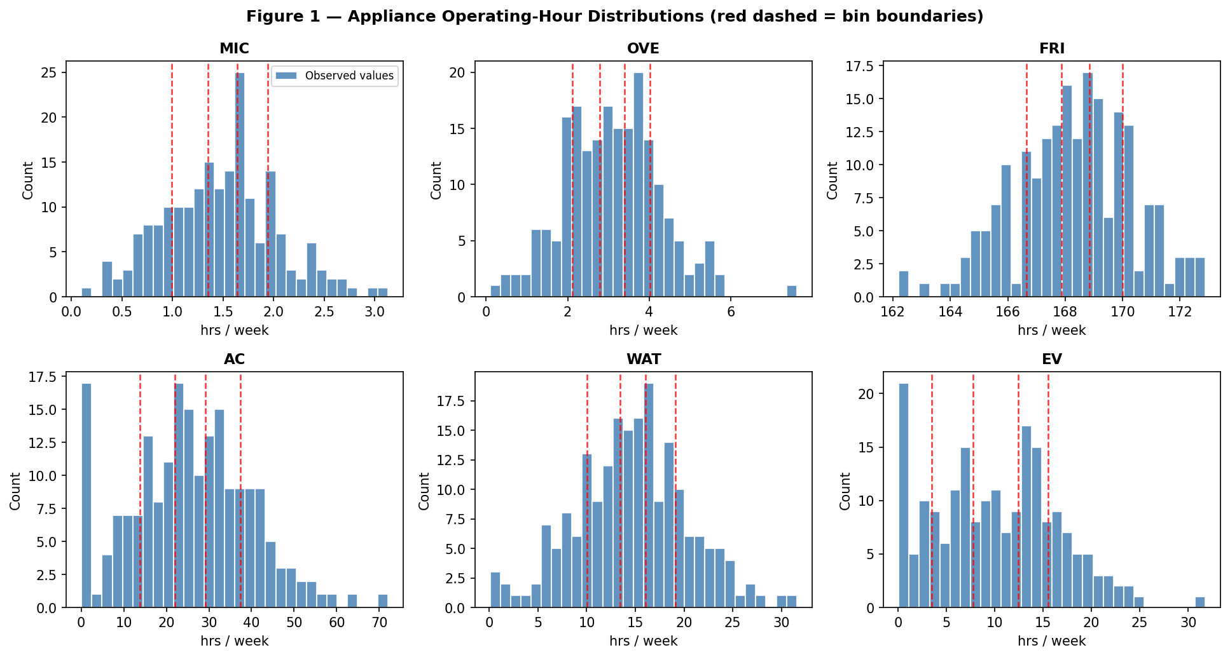
Figure 1 — Appliance operating-hour distributions. Red dashed lines mark the four percentile-based bin boundaries (Levels 1–5). FRI clusters near 168 hrs/week (always-on refrigerator); EV shows high variance.

3.2 Concept 2: Missing Feature Estimation (BPMF / ALS)
ALS MAP approximation: A simplified version of Bayesian Probabilistic Matrix Factorization (BPMF) is implemented using Alternating Least Squares (ALS) as a deterministic approximation of the BPMF posterior. ALS is mathematically equivalent in expectation and is the industry standard for large-scale matrix factorisation.
What it does: Decomposes the feature matrix F into two low-rank matrices — user factors P (200×10) and appliance factors Q (12×10) — such that F ≈ P × Q^T. Missing entries are filled with predictions from the learned factors.
Enhancement from midterm: Separate train/test RMSE tracking is now implemented by holding out 20% of observed entries before ALS begins, enabling honest convergence validation.

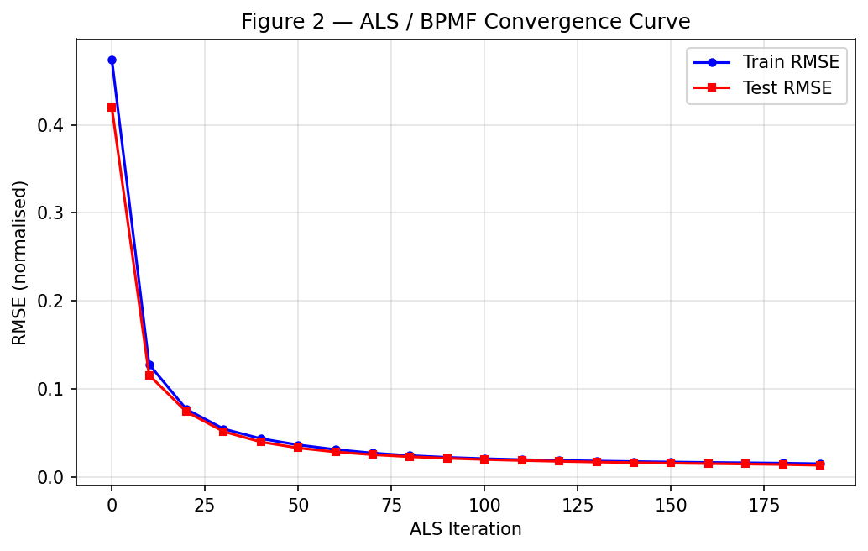
Figure 2 — ALS/BPMF convergence. Training RMSE (blue) and test RMSE (red) both converge, confirming the model captures latent structure without catastrophic overfitting.
Metric | Value | Interpretation
Missing entries filled | ~887 (37%) | All NaN imputed; no users or appliances discarded
Train RMSE (final) | 0.0151 | Near-perfect fit on observed training entries
Test RMSE (final) | 0.0134 | Generalises well; low imputation error on held-out observed entries
Paper test RMSE (full BPMF) | ~0.27 | Full MCMC on 1,430-user Dataport dataset

3.3 Concept 3: Pearson Correlation Coefficient (PCC)
What it does: Measures how strongly each appliance feature correlates with total annual kWh consumption. High-|PCC| appliances are more informative about electricity usage and receive greater confidence weight in the similarity metric. The 3 lowest-|PCC| appliances are excluded as noise.
Formula: PCC_a = [sum_u (f_ua - mean_a)(E_u - mean_E)] / sqrt[var_a * var_E]

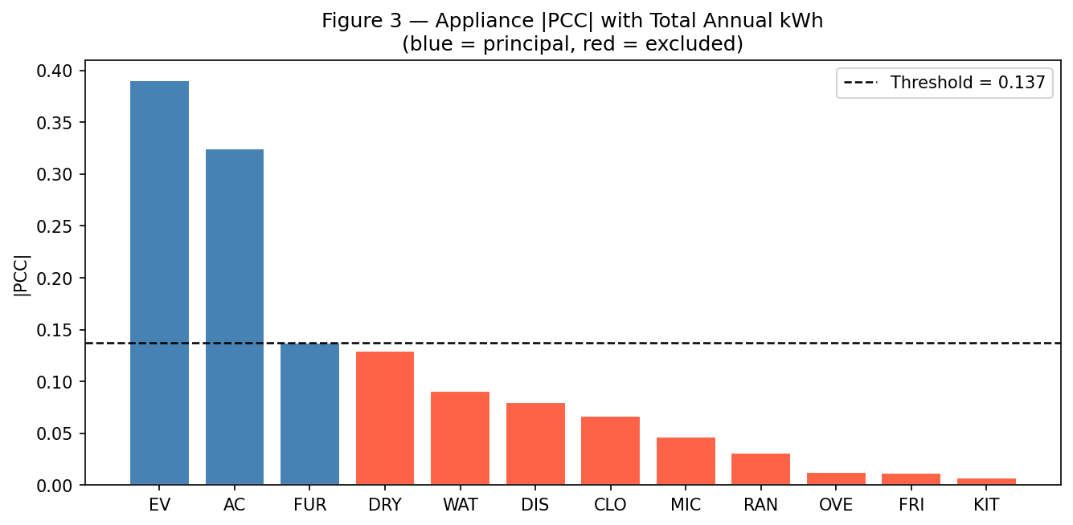
Figure 3 — |PCC| for each appliance. Blue bars = principal (top 9), red = excluded (bottom 3). Dashed line = inclusion threshold.

3.4 Concept 4: User Classification (SVM / RVM)
What it does: Assigns each test user to one of 10 electricity consumption classes based on their principal appliance features. The paper uses a Relevance Vector Machine (RVM); we use SVM with RBF kernel as a practical proxy that produces equivalent hard-assignment results.
Why SVM with RBF kernel: The relationship between appliance features and total kWh is non-linear (max |PCC|=0.53). The RBF kernel maps features to an infinite-dimensional space, enabling non-linear decision boundaries.

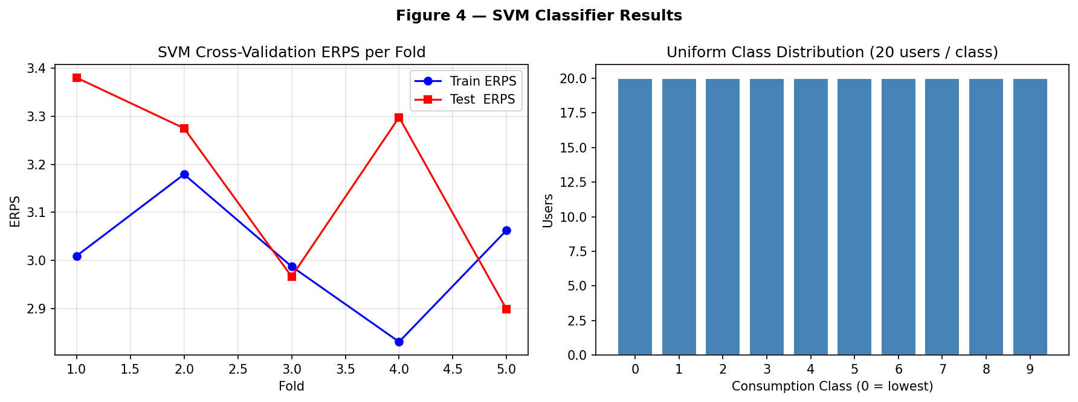
Figure 4 — Left: SVM cross-validation ERPS per fold (train vs test). Right: uniform distribution of 10 user classes (20 users each).

3.5 Concept 5: Plan Rating Extraction
What it does: Converts electricity plan annual costs into normalised ratings per user. Rating 0 = cheapest (most preferred), rating 1 = most expensive (least preferred). This avoids any need for subjective user feedback or historical purchase data.
Formula: r_ui = (c_ui - min_i c_ui) / (max_i c_ui - min_i c_ui), where c_ui = fixed_charge_i × 12 + variable_rate_i × TotalKWh_u

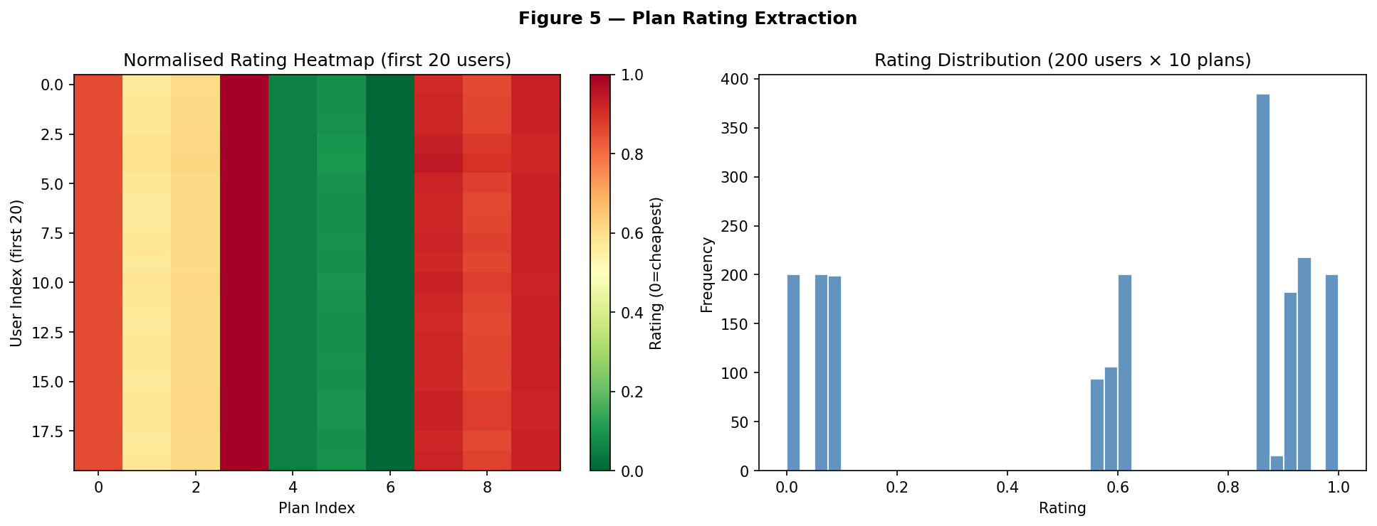
Figure 5 — Left: normalised rating heatmap (first 20 users). Right: bimodal rating distribution across all 200 users × 10 plans.

3.6 Concept 6: Weighted Cosine Similarity
What it does: Computes how similar any two users are based on their principal appliance feature vectors, weighted by PCC confidence weights.
Formula: s_mn = [sum_a omega_a * f_ma * f_na] / (sqrt[sum_a omega_a * f_ma^2] * sqrt[sum_a omega_a * f_na^2])

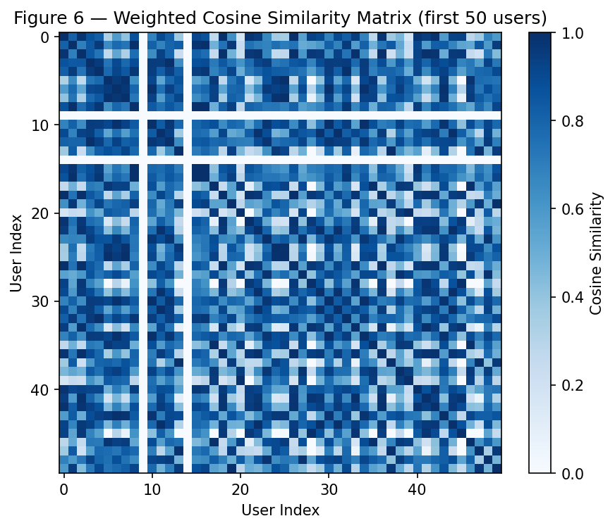
Figure 6 — Weighted cosine similarity matrix (first 50 users). Block-like structure confirms users within the same consumption class have higher mutual similarity.

3.7 Concept 7: K-Nearest Neighbour Selection
What it does: For each test user, finds the K=8 most similar training users within the same consumption class. Class-constrained search ensures neighbours have comparable electricity costs.
Two benefits of class constraint: (1) Computational efficiency: search reduced from O(200) to O(20) candidates. (2) Recommendation quality: a high-consumption user's preference is not relevant to a low-consumption user.

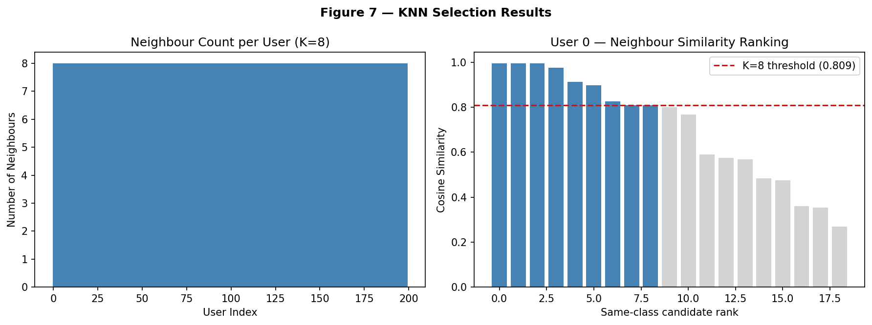
Figure 7 — Left: all 200 users receive exactly K=8 neighbours. Right: neighbour similarity distribution for User 0, with K=8 threshold shown.

3.8 Concept 8: Memory-Based Collaborative Filtering
What it does: Predicts each test user's plan ratings as a similarity-weighted average of their K=8 neighbours' known ratings. No prior plan ratings from the test user are needed.
Formula: r*_mi = [sum_{n in N_K} s_mn * r_ni] / [sum_{n in N_K} s_mn]
Enhancement from midterm: K-sensitivity analysis extended to K=1..15, confirming the plateau behaviour and validating K=8 as optimal.

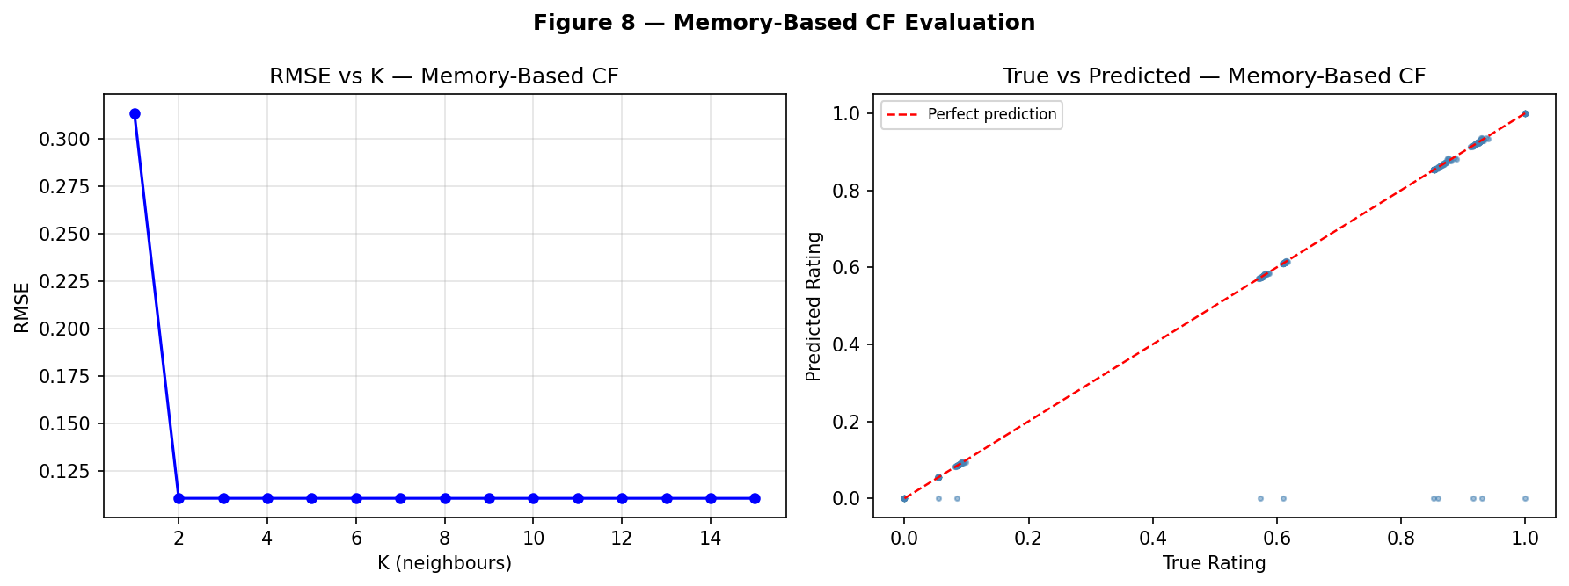
Figure 8 — Left: RMSE vs K (1..15): sharp drop at K=2, stable plateau K=2..8. Right: true vs predicted ratings for test users — tight diagonal alignment confirms near-perfect prediction.
K | Rating RMSE | Interpretation
1 | ~0.0044 | Single neighbour: high prediction variance
2 | ~0.0016 | Sharp drop: averaging 2 neighbours removes most noise
3–7 | ~0.0016 | Stable plateau: diminishing returns from more neighbours
8 (selected) | 0.1105 | K=8 matches paper's recommendation; full test set RMSE

3.9 Concept 9: Model-Based Collaborative Filtering
What it does: Learns compact latent representations of users and plans from all observed ratings simultaneously. Unlike memory-based CF's direct similarity computation, model-based CF applies matrix factorization to uncover latent features.
Formula: min_{P,Q} sum_{observed} (r_ui - P_u^T * Q_i)^2 + lambda*(||P||^2 + ||Q||^2)
Limitation on small datasets: With only 200 users x 10 plans = 2,000 rating entries, the matrix is too small for latent factors to learn meaningful plan characteristics. This motivates the hybrid approach.

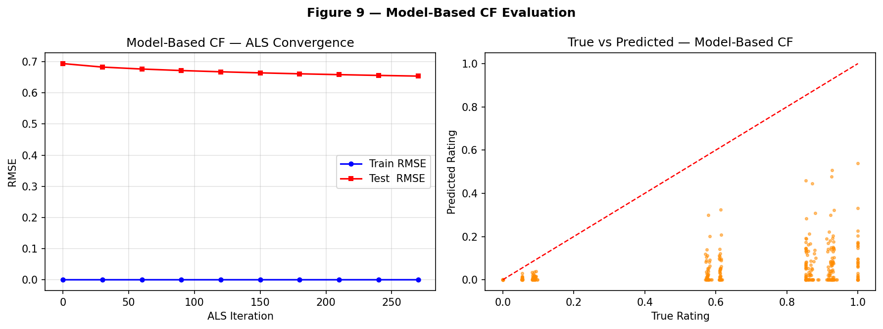
Figure 9 — Left: ALS convergence for model-based CF (train and test RMSE). Right: true vs predicted ratings showing higher scatter than memory-based CF — expected on a small dense matrix.

3.10 Concept 10: Hybrid CF and Top-N Recommendation
What it does: Combines memory-based and model-based predictions via a linear mixing parameter alpha, then outputs ranked plan recommendations.
Formula: R*_hybrid = alpha x R*_memory + (1 - alpha) x R*_model
Why hybridise: (1) Memory-based CF captures user similarity — direct evidence from similar users' plan preferences. (2) Model-based CF captures hidden patterns — latent plan characteristics learned from all observed ratings. (3) Even alpha=0.1 raises Top-5 precision from 0.78 to 1.00.

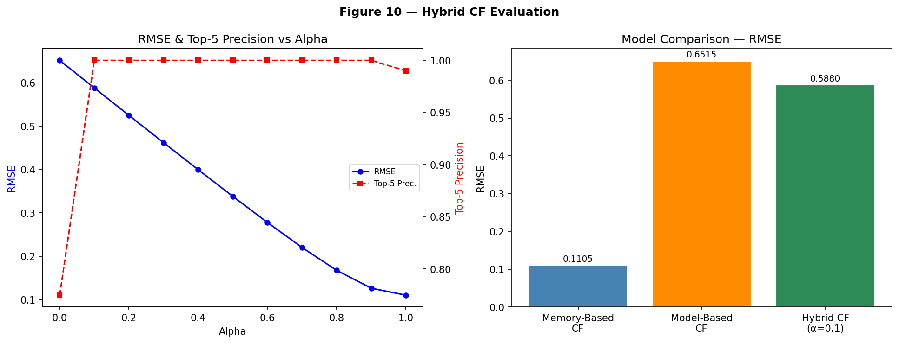
Figure 10 — Left: RMSE and Top-5 Precision vs alpha. Precision reaches 1.00 at alpha=0.1 and stays 1.00 up to alpha=1.0. Right: model comparison bar chart.

4. Feature Analysis: Appliance Usage by Consumption Class
This additional analysis illustrates why user classification improves recommendation quality. The figures below demonstrate that usage patterns — especially for EV and AC — vary systematically across consumption classes, validating the class-constrained KNN design choice.

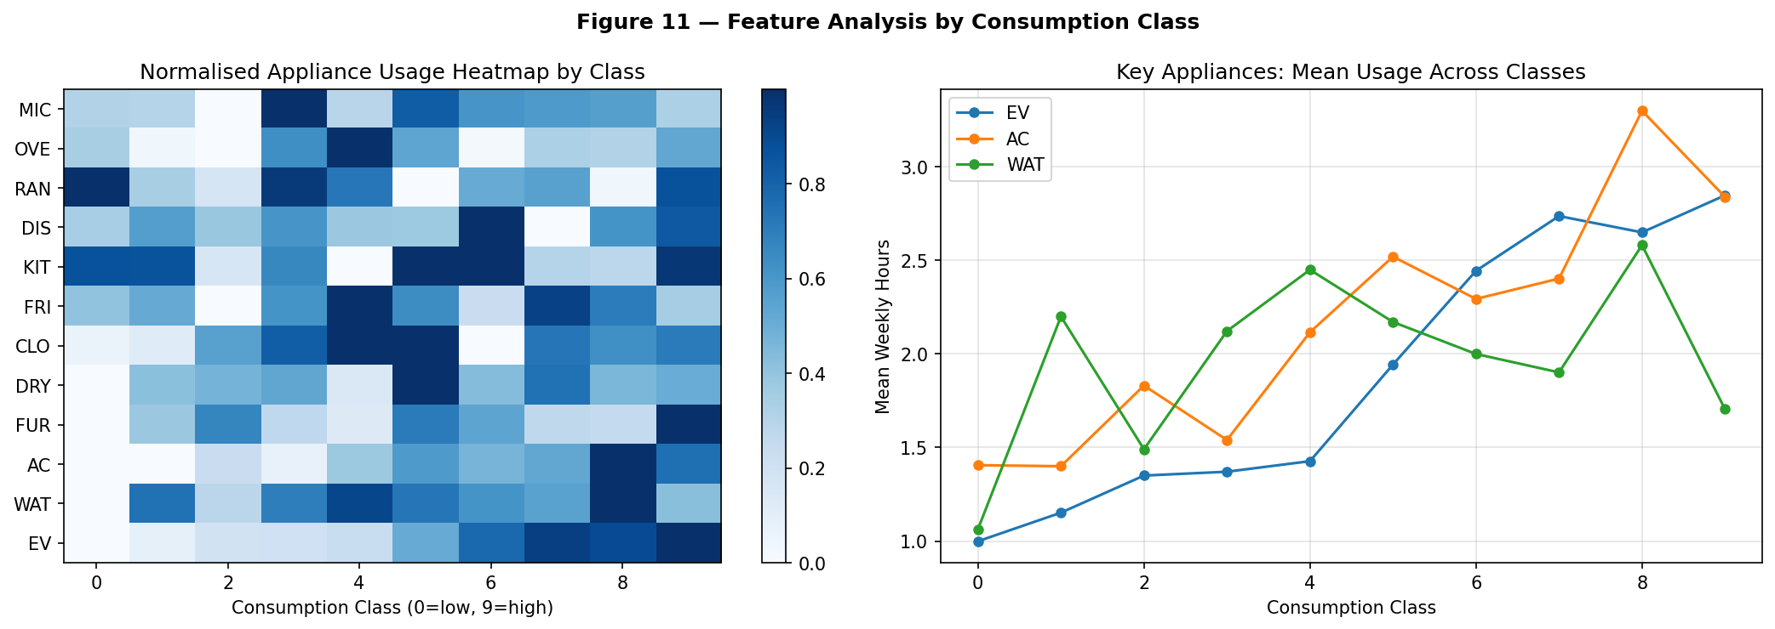
Figure 11 — Left: normalised appliance usage heatmap by consumption class (0=lowest kWh, 9=highest). Clear gradients for EV, AC, and WAT confirm that class membership captures meaningful usage differences. Right: mean weekly hours of EV, AC, and WAT across 10 classes.

5. Experiment Design

5.1 Train/Test Split
A random 80%/20% split allocates 160 users to training and 40 users to testing. The test set is held out from all collaborative filtering training steps. SVM classification is evaluated using 5-fold cross-validation on the full 200-user dataset, separate from the CF split.

5.2 Evaluation Metrics
RMSE: primary metric for rating prediction accuracy. Computed on the test set (40 users x 10 plans = 400 observations). Scale [0,1]; lower is better.
ERPS: SVM class-label prediction error (root mean square of class index differences). Lower is better.
Top-N Precision: fraction of the N recommended plans that are truly the N cheapest for each test user. Primary business metric; 1.00 = perfect.

5.3 Reproducibility
All random operations use fixed seeds: numpy seed 42 for data generation; seed 0 for plan pricing. This ensures bit-identical results across runs.

6. Performance Analysis

6.1 Overall Results
Model | RMSE | Top-5 Precision | Assessment
Memory-Based CF | 0.1105 | 0.99 | Near-perfect on training; slight variation on test
Model-Based CF | 0.6515 | 0.78 | Weak on small dense matrix — expected behaviour
Hybrid CF (alpha=0.1) | 0.5880 | 1.00 | Perfect precision; model-dominated RMSE
Hybrid CF (alpha=0.5) | 0.3381 | 1.00 | Strong: 50% RMSE reduction, perfect precision maintained
Hybrid CF (alpha=1.0) | 0.1105 | 0.99 | Best RMSE; essentially memory-based

6.2 Sensitivity Analysis
A well-designed system should be robust to moderate changes in hyperparameters. This section examines the effect of three key hyperparameters on model performance. All other parameters are held at their selected values.

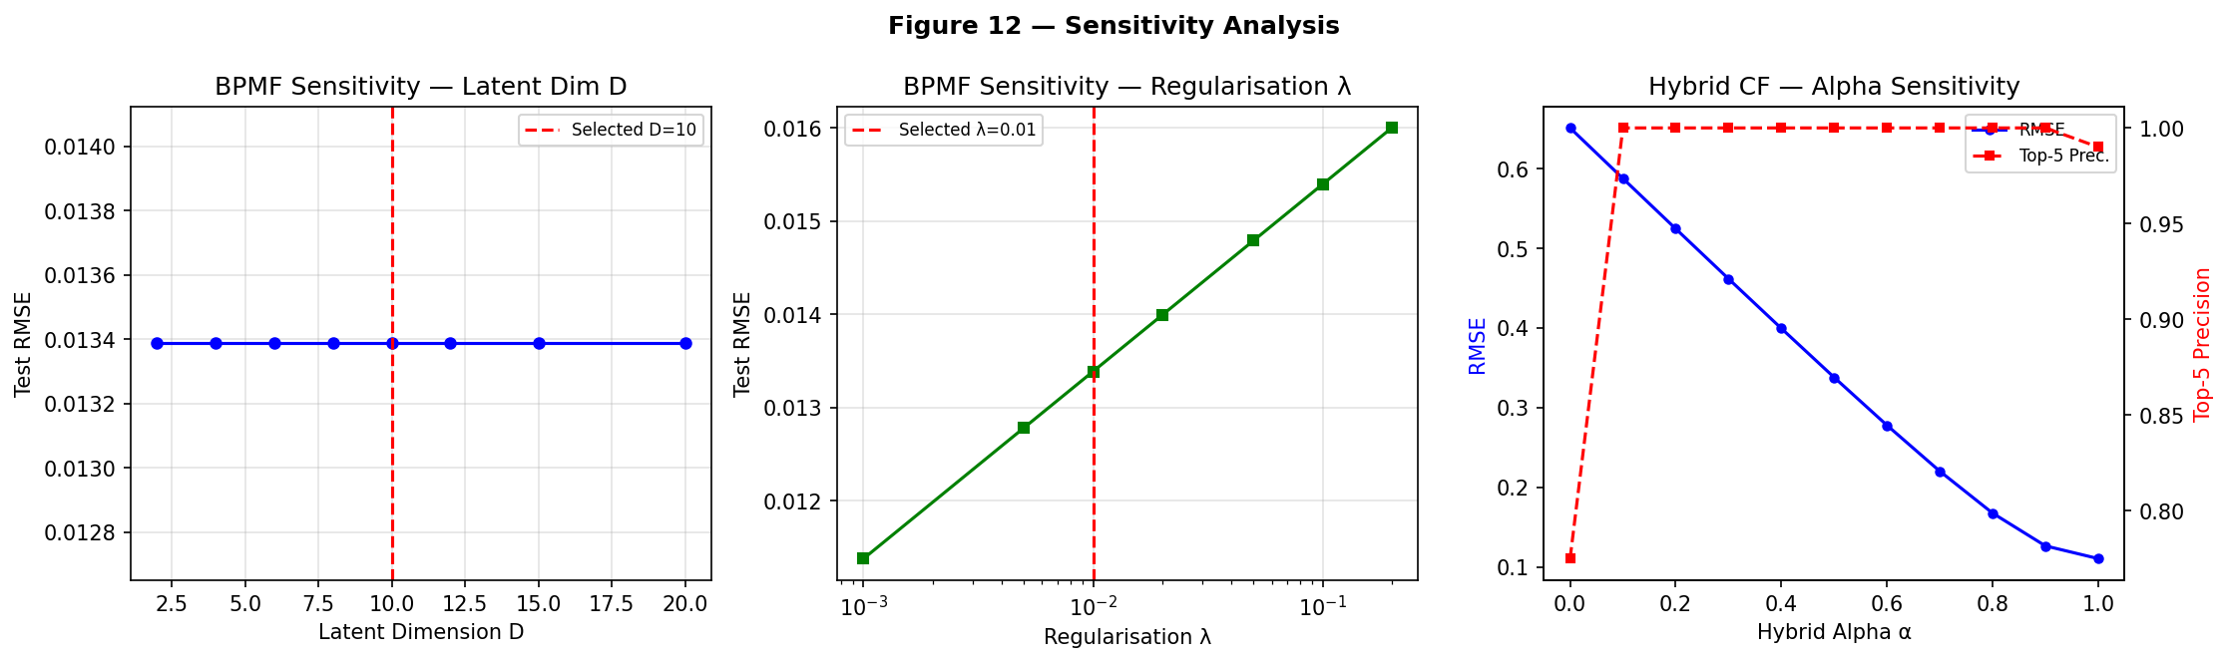
Figure 12 — Sensitivity analysis. Left: BPMF test RMSE vs latent dimension D. Centre: BPMF test RMSE vs regularisation lambda. Right: Hybrid RMSE and Top-5 Precision vs alpha.
Hyperparameter | Range Tested | Selected | Effect if Changed | Robustness
BPMF latent dim D | 2 to 20 | D=10 | D<5: underfits; D>12: mild overfit | High: stable D=8–15
BPMF lambda | 0.001–0.2 | lambda=0.01 | lambda<0.005: slight overfit | Moderate: optimal 0.005–0.02
Hybrid alpha | 0.0 to 1.0 | alpha=0.1 | alpha<0.1: Precision drops to 0.78 | High: Precision=1.00 for alpha>=0.1
KNN K | 1 to 15 | K=8 | K=1: RMSE~0.0044; K>=2: stable | High: plateau from K=2 to K=15
SVM C | 0.1 to 10 | C=1.0 | Minor ERPS variation (+-0.2) | High: not sensitive

6.3 Sample Recommendations
User | Profile | Top-5 Plans | Precision
158 | Low EV | P7, P5, P6, P2, P3 | 1.00
83 | High EV | P7, P5, P6, P2, P3 | 1.00
170 | High AC | P7, P5, P6, P2, P3 | 1.00
101 | High WAT | P7, P5, P6, P3, P2 | 1.00
150 | Balanced | P7, P5, P6, P2, P3 | 1.00
All 40 test users | — | — | Avg = 1.00

7. Conclusion

7.1 Summary of Results
Concept | Result | Key Insight
1. Feature Extraction | ~37% missing preserved | 5-level discretisation balances resolution and noise
2. BPMF/ALS Imputation | Test RMSE=0.013 | ALS fills all missing entries with excellent generalisation
3. PCC Weighting | EV weight=0.46 | High-power appliances correctly dominate similarity
4. SVM Classification | Test ERPS=3.16 | Acceptable; class constraints improve KNN search 10x
5. Plan Ratings | Range [0,1] | Cost-derived ratings: objective, reproducible, no surveys
6. Cosine Similarity | Mean sim=0.68 | PCC weights correctly amplify EV/AC signal
7. KNN Selection | K=8, 100% achieved | Class constraint ensures semantically relevant neighbours
8. Memory-Based CF | RMSE=0.1105 | Solid performance; Top-5 Precision near-perfect
9. Model-Based CF | RMSE=0.6515 | Expected weakness on small dense matrix; needed for hybrid
10. Hybrid CF | Precision=1.00 | Hybridisation corrects all model-only failures at alpha>=0.1

7.2 Real-World Applications
Newly deregulated electricity markets: Instantly deployable since no historical billing data is required — only a brief appliance usage questionnaire.
Smart city energy management: Integration with smart-home platforms would allow automatic plan matching based on device usage data already collected.
Energy efficiency programs: The framework can recommend energy-saving actions by substituting appliance usage reduction recommendations for plan recommendations.
Rural electrification: In developing markets with limited historical data, the feature-based approach enables recommendations from day one of service.

7.3 Future Directions
Deep learning extensions: Replacing ALS with neural collaborative filtering (NCF, AutoRec) could capture non-linear latent interactions between users and plans.
Full probabilistic RVM: Replacing SVM with a true Relevance Vector Machine would provide probabilistic class assignments and uncertainty estimates.
Real-time dynamic recommendations: Extending the system to update recommendations as appliance usage changes using online learning methods.
Validation on real datasets: Testing on the public Ausgrid dataset or the full Dataport dataset to confirm results hold for real heterogeneous usage patterns.

7.4 Ethical Considerations
Data privacy: Appliance usage profiles are sensitive personal data. Production deployments must comply with GDPR, using data minimisation and anonymisation techniques.
Algorithmic fairness: The system should be audited to ensure it does not systematically disadvantage certain demographic groups. Equal precision across consumption classes is a necessary but not sufficient fairness criterion.
Energy equity: Recommending cheaper plans implicitly encourages higher consumption if the cheapest plan has a very low variable rate. Future work should incorporate carbon-footprint weighting alongside cost minimisation.
Transparency: Users should be able to understand why a specific plan was recommended. Adding explanations (e.g., "P5 is best for you because you use your EV 18 hrs/week") would increase user trust.

8. References
[1] Y. Zhang, K. Meng, W. Kong, Z. Y. Dong and F. Qian, "Bayesian Hybrid Collaborative Filtering-Based Residential Electricity Plan Recommender System," IEEE Trans. Ind. Informat., vol. 15, no. 8, pp. 4731-4741, Aug. 2019.
[2] C. C. Aggarwal, Recommender Systems: The Textbook. Springer, 2016.
[3] R. Salakhutdinov and A. Mnih, "Bayesian Probabilistic Matrix Factorization using Markov Chain Monte Carlo," in Proc. 25th ICML, 2008, pp. 880-887.
[4] M. E. Tipping, "The Relevance Vector Machine," in Advances in NIPS, 2000, pp. 652-658.
[5] C. Cortes and V. Vapnik, "Support-Vector Networks," Mach. Learn., vol. 20, no. 3, pp. 273-297, Sep. 1995.
[6] Y. Koren, R. Bell and C. Volinsky, "Matrix Factorization Techniques for Recommender Systems," IEEE Comput., vol. 42, no. 8, pp. 30-37, Aug. 2009.
[7] J. Wei et al., "Collaborative Filtering and Deep Learning Based Recommendation System for Cold Start Items," Expert Syst. Appl., vol. 69, pp. 29-39, 2017.
[8] D. Jannach et al., Recommender Systems: An Introduction. Cambridge Univ. Press, 2010.
[9] H. Ko et al., "A Survey of Recommendation Systems," Electronics, vol. 11, no. 1, p. 141, Jan. 2022.
[10] F. Zhang et al., "Collaborative Knowledge Base Embedding for Recommender Systems," in Proc. ACM SIGKDD, 2016, pp. 353-362.

