Computational Intelligence

Revision (2025)

Lecture 15

**Frequency Domain Filters**

**Filtering** is an essential step in EEG signal processing since EEG signals are often contaminated by various sources of noise and artifacts that can distort or obscure the real brain activity.

**Main Reasons for Filtering:**

1. **Noise Reduction:** Noise is unwanted signals from external sources or random background activity, often continuous and non-biological.
   1. When a person blinks, moves their face, or tightens muscles, it creates **high-frequency noise** that mixes with the EEG signal.
   2. Electricaldevices and power lines give off signals at **50 or 60 Hz**, depending on the country. These signals can leak into EEG recordings and cause a **constant humming noise**.
2. **Artifact Removal:** Artifacts are unwanted signals from biological or physical movements that aren’t part of the brain’s activity, often sudden and predictable. These create large, fast changes in the signal, especially in the front of the scalp.
   1. The electrical signals from the heart can show up in EEG recordings, especially near the front of the head.
3. **Focusing on Specific Brainwave Frequencies:** The brain produces electrical signals at different **frequency ranges** depending on what you're doing or how you're feeling. These are called **brainwave bands**, such as:
   1. Delta (0.5–4 Hz): Deep sleep.
   2. Theta (4–8 Hz): Drowsiness or meditation.
   3. Alpha (8–13 Hz): Relaxed, calm state.
   4. Beta (13–30 Hz): Active thinking or concentration.
   5. Gamma (>30 Hz): High-level brain functions.

**Filtering** helps you isolate one of these bands so you can study specific mental states more accurately.

1. **Data Pre-processing:** When you record brain activity using EEG, the signal is not clean. It includes slow changes and unwanted noise. Filtering helps clean up the signal before you study it.
   1. Baseline Correction: Imagine your EEG signal is like a wavy line that is supposed to stay around the middle of the screen. But sometimes, due to: loose wires (electrode issues), body movement, or temperature changes, the whole signal starts slowly going up or down, even if the brain isn’t doing anything different. This is called a drift or baseline shift. Filtering removes these slow changes, so the signal stays stable and centered — making it easier to study real brain activity.
   2. EEG signals = brain waves = very **weak** signals. But factors like muscle movement, power line noise, and other sources can add **strong noise** on top of it. So we use **filters** to remove the parts of the signal that we don’t care about (like noise), and keep the parts we do want (like real brainwaves). This improves the **Signal to Noise Ratio (SNR).**

**Types of Filters**

1. **Low-Pass Filter (LPF):** It is a signal processing tool used to remove high-frequency noise and retain low-frequency brain activity. It allows frequencies below a specified **cutoff** to pass through while attenuating higher frequencies like muscle activity or electrical interference, preserves slow brain waves (e.g., delta, theta, and alpha waves), and smooths EEG signals for better interpretation. **Example:** Keep signals below **40 Hz**, block anything higher.

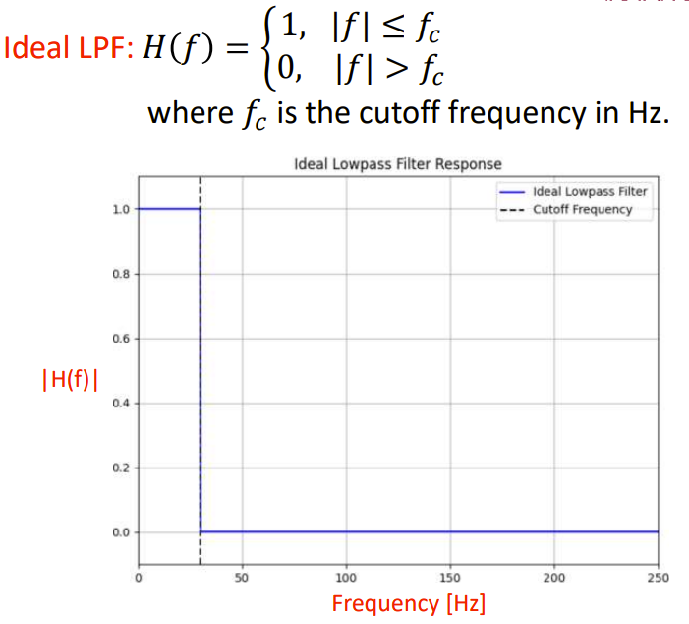

The LPF Butterworth Filter equation means:

* All frequencies below or equal to the cutoff frequency fC​ are kept (gain = 1).
* All frequencies above fC are completely blocked (gain = 0).

X-axis (Frequency [Hz]): This shows the range of frequencies from 0 to ~250 Hz.

Y-axis (|H(f)|): This shows the magnitude (gain) of the filter — how much of the signal at each frequency is allowed to pass.

The blue line shows the filter's response:

* Flat at 1 (100% passed) from 0 up to the cutoff frequency fC (~40 Hz).
* Drops instantly to 0 after fC, blocking all higher frequencies.

The dashed vertical line marks the cutoff frequency fC.

The **ideal** LPF has a **perfectly sharp cutoff** — it **immediately** drops from 1 to 0 at the cutoff frequency. This is not physically possible in real-world filters because it requires infinite precision and zero delay. Instead. Instead, we use **approximate filters** — they try to act like the ideal one, but with a **smooth** transition instead of a sharp drop. One popular real-world filter is called the **Butterworth filter**.

* + It provides a smooth transition from the passband to the stopband.
  + They are **stable**, **causal**, and **implementable** in both hardware and software.
  + It has a maximally **flat frequency response** in the passband (the frequencies that are allowed to pass through). This means that it does not introduce ripples or fluctuations, which is important for EEG signals where precise and consistent frequency representation is critical.
  + The Butterworth low-pass filter is frequently used in EEG processing to remove high-frequency artifacts such as muscle artifacts and power-line interference. By attenuating high-frequency noise, the filter helps preserve the brainwave signals (alpha, beta, theta) which are typically below 40 Hz.

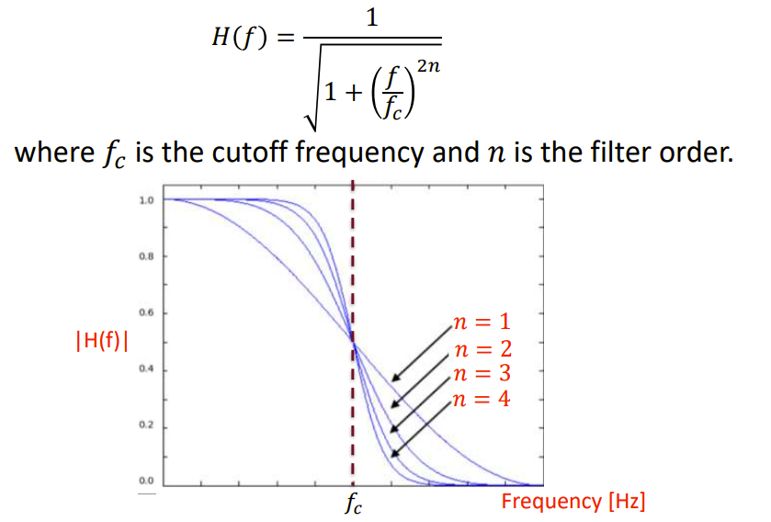

The LPF Butterworth Filter equation means:

* H(f): The output strength of a frequency F, (how much is passed).
* fC: The cutoff frequency — the point where the filter starts to reduce signal strength.
* n: The filter order — higher values mean sharper transitions from passband to stopband. The higher the filter order the closer it becomes to an ideal LPF (the sharper it drops).

1. **High-pass filter (HPF):** It is a signal processing tool used to allow high-frequency components of the brain’s electrical activity to pass through while attenuating or blocking lower-frequency components. It removes unwanted slow-wave activity, such as baseline drift or other low-frequency noise, which can be caused by movements, electrical interference, or other artifacts. It focuses on the brain’s faster electrical oscillations (e.g., alpha, beta, or gamma waves) and improves the signal-to-noise ratio by reducing low-frequency interference.

The HPF Butterworth Filter equation means:

* All frequencies above or equal to the cutoff frequency fC​ are kept (gain = 1).
* All frequencies below fC are completely blocked (gain = 0).

The ideal HPF has a sharp cutoff at fC, causing an instantaneous transition from 0 to 1. In practice, approximations like the Butterworth filter are used to approximate this ideal response in a realizable way just like in LPF.

1. **Band-pass filter (BPF):** It is a type of signal filter that allows frequencies within a specific range to pass through while attenuating frequencies outside that range. It is used to isolate relevant brainwave frequencies by filtering out unwanted noise and artifacts.
   1. **Lower Cutoff Frequency** – The lowest frequency that is allowed to pass through.
   2. **Upper Cutoff Frequency** – The highest frequency that is allowed to pass through.
   3. **Attenuation of Unwanted Frequencies** – Frequencies below the lower cutoff and above the upper cutoff are significantly reduced.

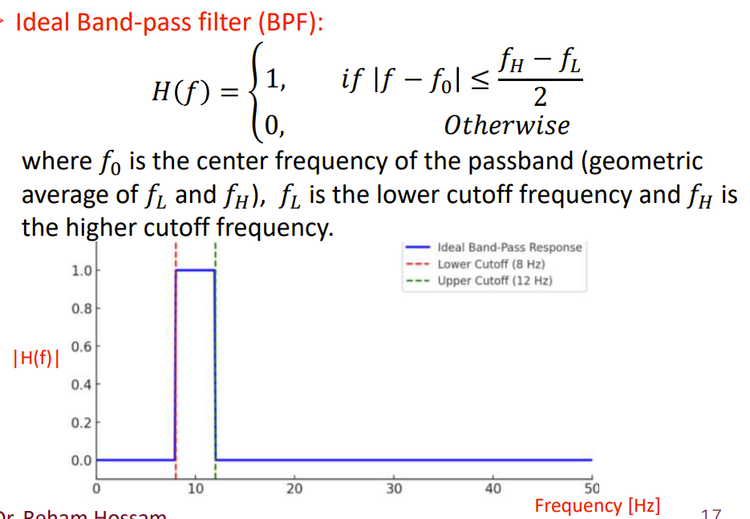

The BPF Butterworth Filter equation means:

* H(f): Frequency response of the band-pass filter.
* f: Input frequency.
* f0​: Center frequency of the band (geometric mean of fL and fH), where the filter’s response is maximum (maximum pass-through). In systems like filters, frequency components often vary logarithmically (e.g., octaves in audio), so, the **geometric mean** better represents the “true center” between two frequencies than the arithmetic mean.
* fL​: Lower cutoff frequency.
* fH​: Upper cutoff frequency.

The filter passes frequencies **between fL​ and fH​** and completely **attenuates** others.

The condition defines a symmetric range around the center frequency f0​, forming a **band**. For frequencies inside this band, the output of the filter is 1 (i.e., they are passed without attenuation). For frequencies outside this band, the output is 0 (i.e., they are completely rejected). To calculate the geometric mean of fL and fH:

The center frequency 𝑓0 in an ideal BPF is where the filter passes the signal with minimal attenuation, meaning…

* The signal at f0​ passes through **without any attenuation**.
* Frequencies close to f0 (within the bandwidth) also pass through.
* Frequencies far from f0​ are **completely blocked**.

B = fH−fL: Bandwidth of the filter (range of frequencies passed).

1. **Band-stop filter (BSF):** Also known as Notch filter, it is used to attenuate (block) a specific range of frequencies while allowing frequencies outside this range to pass. It removes specific noise since the most common use is to eliminate powerline interference noise (50 Hz in Europe or 60 Hz in USA) caused by electrical equipment. It is used to suppress muscle artifacts or other unwanted frequency components and to improve signal quality before further analysis.

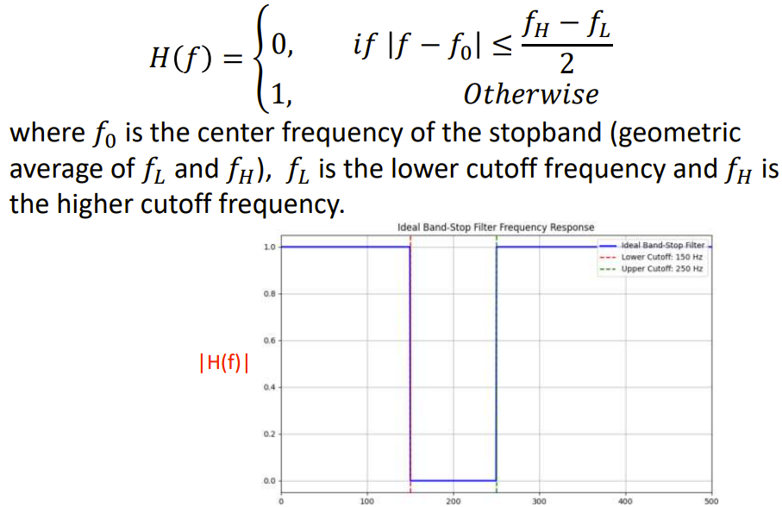

The condition defines a symmetric range around the center frequency f0​, forming a **band**. For frequencies inside this band, the output of the filter is 0 (i.e., they are passed without attenuation). For frequencies outside this band, the output is 1 (i.e., they are completely rejected).

The center frequency f0 in an ideal BSF is where the filter attenuates the signal the most (i.e., maximum attenuation).

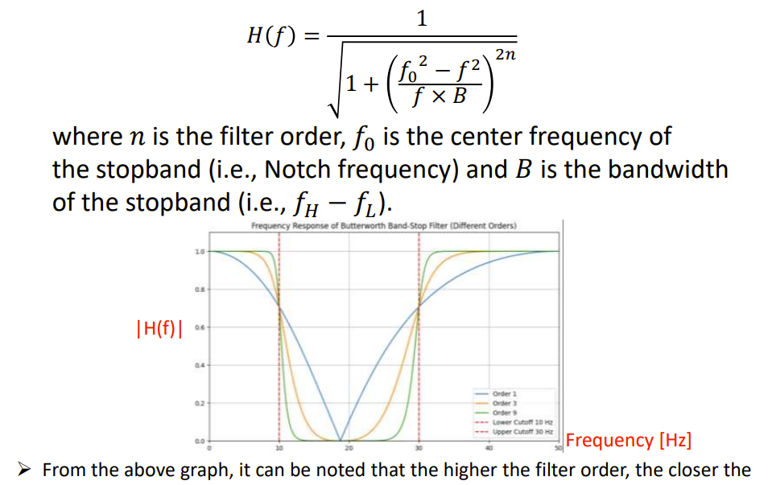

* **𝐺𝑎𝑖𝑛 𝑑𝐵** = 20 𝑙𝑜𝑔10(|𝐻𝑓|), where the 𝐺𝑎𝑖𝑛 means how much a signal at frequency 𝑓 is amplified or passed by a filter.
  + **H(f)** The frequency response of the system (how it behaves at a specific frequency f).
  + **∣H(f)∣**: The magnitude of the frequency response (how much the amplitude of the signal is changed).
* **Attenuation 𝑑𝐵** = −20 𝑙𝑜𝑔10 𝐻f, where attenuation defines how much the signal is reduced by a filter.
* Therefore, 𝐴𝑡𝑡𝑒𝑛𝑢𝑎𝑡𝑖𝑜𝑛 𝑑𝐵 = −𝐺𝑎𝑖𝑛 (𝑑𝐵)

*LECTURE 16*

**Spatial-Domain Filtering**

Spatial-domain filtering in EEG involves using the locations of the electrodes placed on the scalp to process and interpret EEG signals. EEG signals recorded from multiple electrodes carry not only brain activity but also unwanted noise from sources like eye blinks or muscle movements. Spatial filtering techniques help to distinguish meaningful brain activity by considering how signals at different electrode **locations relate** to each other.

**SUMMARY + KEY POINTS**

**Why Filtering is Needed in EEG**

| **Reason** | **What’s the Problem?** | **How Filtering Helps** |
| --- | --- | --- |
| **1. Noise Reduction** | Unwanted signals from outside sources (like power lines or muscle movement) | Removes high-frequency or power-line noise to clean the EEG signal |
| **2. Artifact Removal** | Signals from the body (like eye blinks or heartbeats) that interfere with brain data | Filters out these non-brain signals to focus on actual brain activity |
| **3. Focus on Brainwave Frequencies** | Brain has different wave types (alpha, beta, etc.) for different mental states | Allows you to isolate and study specific frequency bands (like alpha or delta waves) |
| **4. Data Preprocessing** | Signal may drift slowly or be hard to read due to low signal-to-noise ratio | Removes slow drifts and unwanted frequencies, making the signal cleaner and clearer |

**Types of Filters**

1. **Low-Pass Filter (LPF):** Passes **low-frequency** signals, blocks **high-frequency** noise (e.g., muscle activity, electrical interference). Useful for **preserving slow brainwaves**: delta, theta, alpha.
   1. **Cutoff Frequency (fC)**:
      1. Frequencies **≤ fC**: allowed (gain = 1)
      2. Frequencies **> fC**: attenuated or blocked (gain drops to 0)
   2. **Butterworth LPF**:
      1. **Smooth transition** between passband and stopband (not sharp).
      2. **Maximally flat** response in the passband (no ripples).
      3. **Stable, causal**, and implementable in hardware/software.
      4. Commonly used in EEG to clean signals **below 40 Hz**.
2. **High-Pass Filter (HPF):** Passes **high-frequency** signals, removes **low-frequency noise** (e.g., baseline drift, movement artifacts). Enhances visibility of **faster brainwaves**: alpha, beta, gamma.
   1. **Cutoff Frequency (fC)**:
      1. Frequencies **≥ fC**: allowed (gain = 1)
      2. Frequencies **< fC**: blocked (gain drops to 0)
   2. **Butterworth HPF**:
      1. Smooth transition (not ideal sharp).
      2. Preserves high-frequency components for better **signal-to-noise ratio**.
3. **Band-Pass Filter (BPF):** Allows only a **specific range of frequencies** to pass (band of interest). Filters out both low and high-frequency noise.
   1. **Key Parameters**:
      1. fL: Lower cutoff frequency
      2. fH: Upper cutoff frequency
      3. f0: Center frequency = √(fL × fH) (geometric mean)
      4. B = fH - fL: Bandwidth
   2. **Butterworth BPF**:
      1. Passes frequencies **within [fL, fH]**
      2. Attenuates signals **outside the band**
      3. Useful for isolating specific brainwave bands (e.g., beta: 13–30 Hz)
   3. **Frequency Response**:
      1. Max gain (1) at f0
      2. Tapering off toward fL and fH
      3. Gain = 0 outside the band
4. **Band-Stop Filter (BSF) / Notch Filter: Blocks a specific frequency range**, passes all others. Commonly used to **remove electrical noise** (e.g., 50/60 Hz powerline).
   1. **Key Parameters**:
      1. fL: Lower stopband edge
      2. fH: Upper stopband edge
      3. f0: Center of the stopband = √(fL × fH)
      4. B = fH - fL: Width of blocked band
   2. **Butterworth BSF**:
      1. Gain = 0 in the stopband ([fL, fH])
      2. Gain = 1 outside the stopband
      3. Ideal for **eliminating specific interference** (e.g., muscle artifacts)
   3. **Example**: Notch filter at **60 Hz** to remove **powerline interference** in EEG.

* **𝐺𝑎𝑖𝑛 𝑑𝐵** = 20 𝑙𝑜𝑔10(|𝐻𝑓|), where the 𝐺𝑎𝑖𝑛 means how much a signal at frequency 𝑓 is amplified or passed by a filter.
  + **H(f)** The frequency response of the system (how it behaves at a specific frequency f).
  + **∣H(f)∣**: The magnitude of the frequency response (how much the amplitude of the signal is changed).
* **Attenuation 𝑑𝐵** = −20 𝑙𝑜𝑔10 𝐻f, where attenuation defines how much the signal is reduced by a filter.
* Therefore, 𝐴𝑡𝑡𝑒𝑛𝑢𝑎𝑡𝑖𝑜𝑛 𝑑𝐵 = −𝐺𝑎𝑖𝑛 (𝑑𝐵)

*LECTURE 9*

**Spatial-domain filtering in EEG**

* Processes signals recorded by analyzing their spatial arrangement (i.e., their physical positions on the scalp). It is used to…
  + Reduce noise such as eye blinks or muscle activity.
  + Focus on activity from specific brain regions.
  + Improve signal quality for BCIs.

**Types of Spatial-Domain Filtering**

1. **Common Average Reference (CAR):** A spatial filtering technique used to reduce noise and improve the signal-to-noise ratio (SNR) by referencing each electrode to the average of all electrodes. Instead of using a single reference electrode, we calculate the average signal from all electrodes and use that as the reference. This helps us reduce noise that’s common across all electrodes — like power line interference or general muscle noise — and enhances signals that are more localized to a specific brain region. But CAR isn’t perfect. It assumes that all electrodes are equally affected by noise, which isn’t always the case. If some electrodes are noisy or disconnected, they can distort the average and affect the filtered signals. That’s why CAR works best when you have many electrodes — ideally 64 or more. The math is pretty straightforward. You calculate the average signal across all electrodes at a given time and subtract that from each individual electrode’s signal. The result? You get a clearer, more focused look at localized brain activity — perfect for brain-computer interface systems.
2. **Surface Laplacian Filter**: A method used to make the brain signals clearer by focusing on activity right under each electrode and ignoring widespread noise. The Surface Laplacian helps you focus on your **neighbors** only, not the whole head like CAR does. It reduces volume conduction and reliance on reference electrode choice. Useful in motor imagery tasks, ERP analysis, and BCI. Ideal for detecting activity from specific cortical sources, like the motor cortex. In sparse setups, the “neighbors” may be too far to reflect true local activity, leading to inaccurate spatial filtering. Electrodes on the edges of the montage (e.g., near ears or forehead) have fewer neighbors. Laplacian filters at the edges will be less accurate or not applicable at all.
3. **Independent Component Analysis (ICA):** It is a powerful mathematical method used to separate mixed brain (alpha waves) and non-brain signals (eye blinks, muscle movements) recorded from scalp electrodes into their original, statistically independent source components. s