Congrats on installing extendedInterface !


Performance
Disable efficiency cores. The effect has been as much as a ~3x difference in the latency from beginning a large bash script to completion.
Disabling HyperThreading can result in a significant performance improvement as well, especially for such very heavy single-threading tasks as flight sim.

If you are a developer of hardware/software design scripts…
You mostly just want:
C:\_bash.bat.lnk
Pin to Start .
Includes sshf/vncf/_vnchost , git , sane defaults , and the extra powerful scripting capabilities of ubiquitous_bash . YubiKey/SSH , symlinks , end-of-line , are properly supported.

Dependencies…
Install all of these dependencies if possible – the ‘ubcp’ prompt will start faster and the functionality is useful.
'ykman' 'Yubico/YubiKey Manager'
'nmap' 'Nmap'
'qalc' 'Qalculate'
'vncviewer' 'TigerVNC'
'kate' 'Kate/bin'
'VBoxManage' 'Oracle/VirtualBox'

If you are a legacy gamer...

You now have:

C:\core\infrastructure\extendedInterface\README-installer.pdf

C:\core\infrastructure\extendedInterface\support\joystickgremlin
C:\core\infrastructure\extendedInterface\support\voiceattack

C:\core\infrastructure\extendedInterface\app

Dependencies
C:\core\infrastructure\extendedInterface\_local\ops.sh
Add your own Bash scripting here, or overload functions provided to change functionality .
One common use case will be to configure shell variables corresponding to your own joystick/throttle USB UIDs .
JoystickGremlin
The USB UIDs are configured for a particular MS SWFFB2 joystick and a Thrustmaster TWCS throttle. You will need to change these. Scripts have done this automatically before, and a general purpose converter will be added.
HidGuardian can be configured through JoystickGremlin -> Tools -> Options -> HidGuardian .
vJoy
Configuring vJoy is particularly difficult. Please attempt to match the following screenshots – four devices, 32buttons for first device, 31buttons for second device, 30buttons for third device, 29buttons for fourth device, POV Hat Switch continuous, POVs 1, Force Feedback – All .

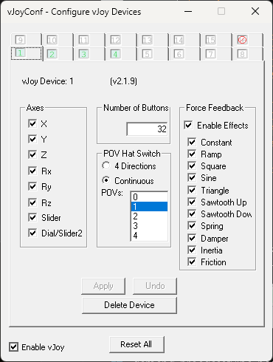
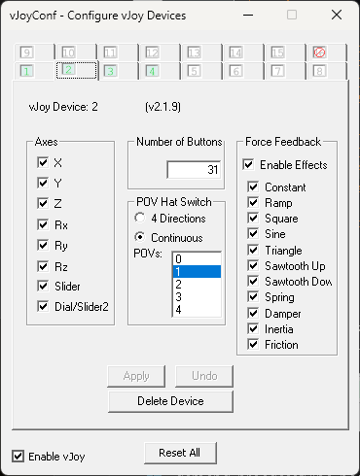
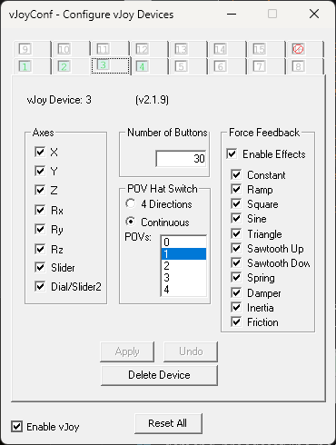
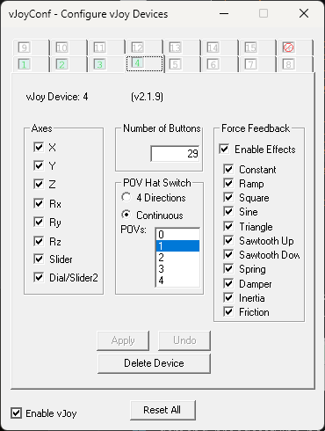

If you are a legacy VR gamer…

You now have:

C:\core\infrastructure\extendedInterface\param.ods

Use this spreadsheet as a calculator and a checklist to ensure an optimum resolution at the best clarity available with your VR heatset at a minimal number of pixels for your high-end PC to render.

Configure your In-App/In-Game, SteamVR, and NVIDIA Control Panel settings to match.

If you are a legacy VR flight sim enthusiast...

Then you have a lot of learning to do.

All of ‘C:\core\infrastructure\extendedInfrastructure’ is a template of:
* Documentation. Begin with ‘README.md’ and ‘commonControlScheme.pdf’ .
* Startup sequences to run supporting applications (eg. SIMFFB, DCS SRS) .
* Configuration files (eg. for JoystickGremlin, VoiceAttack) .
* Batch scripts .
* Bash scripts integrated with MSW through ‘ubcp’ .
* Python scripts (at least eventually, maybe) integrated with MSW through ‘ubcp’ .

ResizeBar has a large performance benefit (which can be directly put into higher resolutions for better VR visual clarity). Enable this for your application (eg. DCS World) if possible.

Consider whether Hardware GPU Scheduler may be helpful or harmful to performance.

https://www.majorgeeks.com/content/page/hardware_accelerated_gpu_scheduling.html

PanelBoard is a part of any ‘ubdist’ dist/OS, and uses scripting to cause a Virtual Machine Linux Desktop (at least KDE Plasma), to arrange and switch to windows as an IDE-like interface to rapidly interact with a standardized set of files/folders (eg. approach plates, checklists, waypoints lists, notes, etc). Specifically intended for use with OVRDrop .

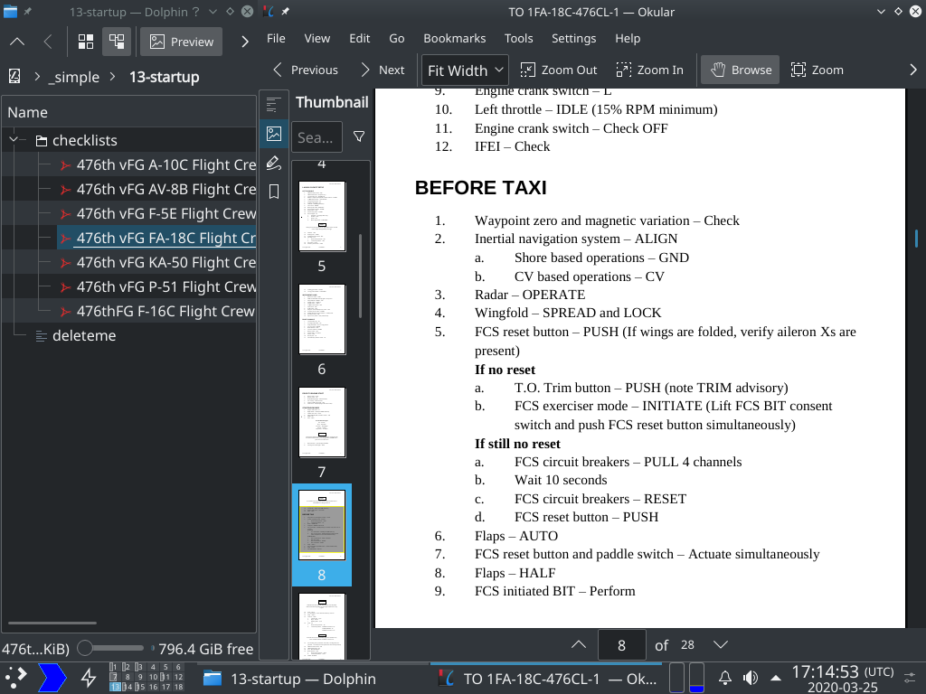

If you are a CARDinal user or gamer… or a native ‘ubdist’ dist/OS user… or an MSW user of ‘ubiquitous_bash’ compatible software (eg. ‘BOM_designer’)...
Then welcome to the future, you will not have needed to install ‘extendedInterface’ .
If you are using CARDinal, ‘ubcp’ would already be included, and user interface hardware would be used more directly without vJoy, etc. Voice commands would be directly sent to VirtualMachines through the CARDinal ‘queue’ (ie. ad-hoc shared wires) IPC bus, rather than translated to obscure reserved key combinations through VoiceAttack.
If you are using ‘ubdist’ natively, the legacy keyboard/mouse emulation provided by such hacks as vJoy, VoiceAttack, etc, would be better managed by relevant less constrained open-source software (eg. ‘wmctrl’), or by CARDinal (eg. for Virtual Machine use in VR, for joystick inputs, etc).
If ‘ubcp’ was needed for MSW compatibility, it would have been included with the installer for that software (eg. ‘BOM_designer’).

Limitations
Installation directory is hardcoded to C:\core\infrastructure . Installation is for all users (other users of ‘ubcp’ will be ‘root’ within the ‘Cygwin’ shell).
Eventually, it should be possible to edit configuration files used by software created for the MSW platform (eg. JoystickGremlin, VoiceAttack), and call these programs, thus enabling relative paths through Bash scripting through ‘ubcp’ .
For now however, changing these locations is officially unsupported (though some provisions may already be in place for some dynamic path finding).

