AO-Hex Hotend-Subassembly

Required Tools: Torque wrench with 7mm crows foot adaptor, 18mm open end wrench, 4.5mm open end wrench, 1.5mm hex screwdriver, 2mm hex screwdriver, high temperature thread-locking compound

- Unscrew heatsink and nozzle – reinstall nozzle using a 7mm torque wrench and holding the heater block with a 18mm wrench. Tighten to 30 in*lbs

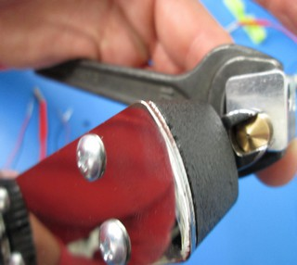
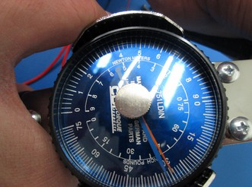

- Apply thin coat of high temperature threadlock to the entire threaded portion and re-install in the heater block. Install tightly using a 4.5mm wrench and holding the heater block with a 18mm wrench
  - If possible, rotate the heatsink so that one of the points of the heatsink faces the front and the set screw hole is somewhere in the back.
- Lock the threaded extension into the heatsink using an M2x6 SCHS with a small amount of high temperature thread lock.
- Take thermistor and pull back both pieces of the black shielding 1/2”
  - Make sure that the inner clear plastic tubing is all the way down to the bead of the thermistor

- Slide ONE of the pieces of black shielding down to the bead of the thermistor and insert into the heater block
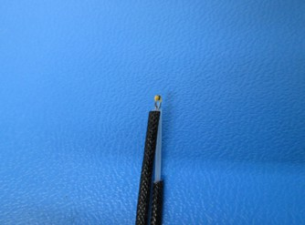
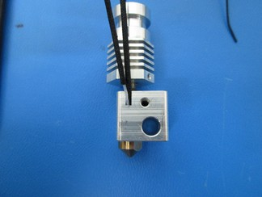
- Holding the thermistor leads in place, install the heater cartridge, but do not lock in place yet
- Secure heater cartridge and thermistor into the side of the heat block with a retention plate and an M3x6 BHCS.
  - Be sure that the retention plate is tightened seated completely flush against the block
  - Make sure that the front edge of the plate is parallel to the front face of the heater block.
  - Make sure that the retention plate is covering part of the heater cartridge
  - Make sure that both leads of the thermistor are in the channel in the side of the heater block and not pinched against the flat face. One of the 2 black shield bits should be secured by the retention plate, the other should rest flush with the top of it.
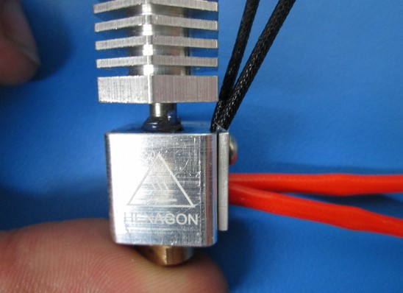

- Pull heater cartridge up against the retention plate and lock into place with am M3x6 set screw from the rear of the heater cartridge.
- Attach ground lug to the left side of the heater block using an M3x6 BHCS and star lock washer between the ground lug and the heater block.
  - make sure that the wire is facing toward the heatsink so it can be routed with the other leads

