Cartesian style CNC machines (ie. X/Y/Z 3D printers) are often required to precisely maintain the vertical position of heavy tools moving along their X-axis. Additionally, this load may be cantilevered some distance away from the axis, allowing significant twisting.

For the TazMega, loads are in the range of 2-10lbs, cantilevered as much as 150mm, and may be positioned across an 875mm length.

As simulations show, twisting is the dominant mode of displacement/deformation. Maximum deflection is on the order of 0.64mm when a single 20x60mm aluminum extrusion is used as the linear bearing rail. Moreover, as the positioning error is nonlinear and dependent on tool position, physical compensation is difficult.

Physical positioning errors beyond 0.35mm are likely to lead to tooling crashes, breaking milling bits or degrading nozzles. Errors beyond 0.1mm may complicate use of precision tools.

Adding a 1.125”x3.5” (true dimension) select pine board as reinforcement may improve rigidity. Simulations indicate a single board can cost-effectively reduce deflection to a maximum of 0.25mm. Nonlinear positioning errors in operation may be somewhat more or less, depending on travel range, deformation at the edges of travel range, and surrounding hardware.

Here, a variety of simulation results are presented, starting with the bare (unreinforced) condition, and a configuration balancing costs with benefits.

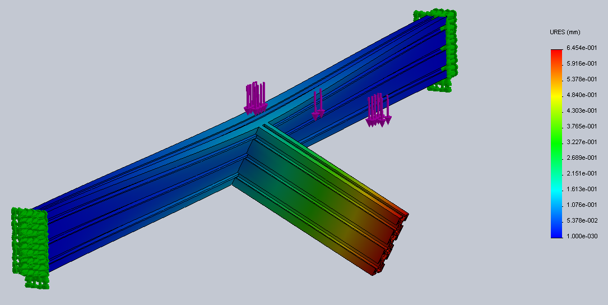
Bare configuration.
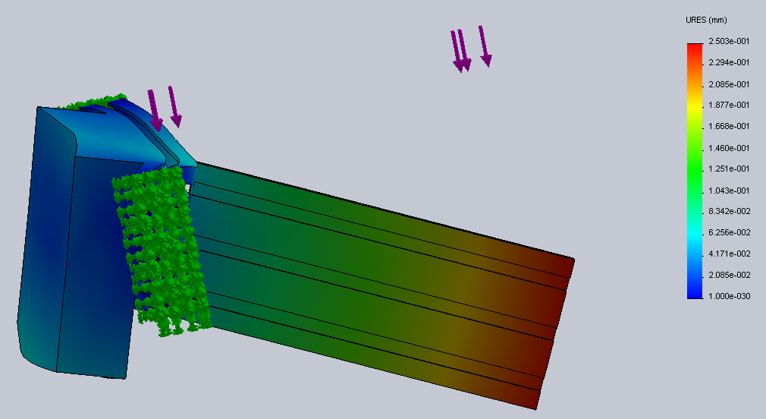
Top slab. Balanced approach achieves near optimum rigidity improvement, while leaving top aluminum extrusion slot accessible.

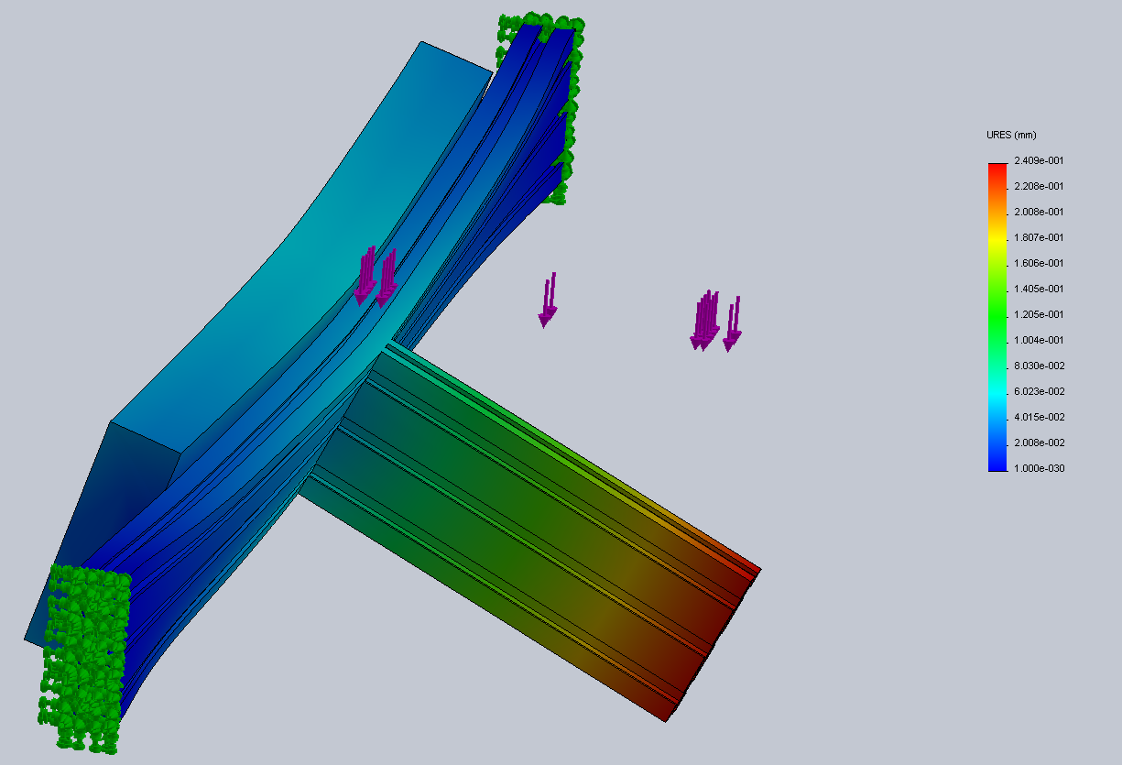
Optimum configuration, mid slab.
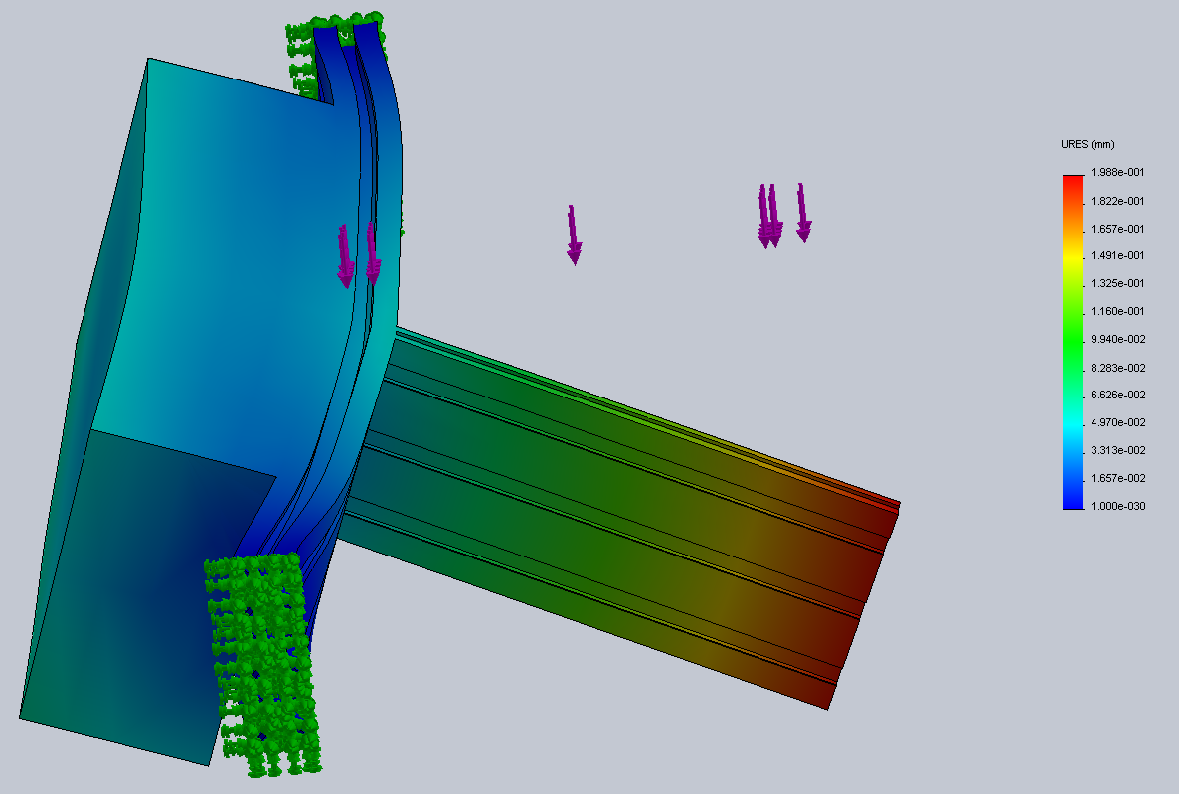
Better configuration. Double slab. Minor improvement (~0.04mm) for doubling of cost and weight indicates diminishing returns.
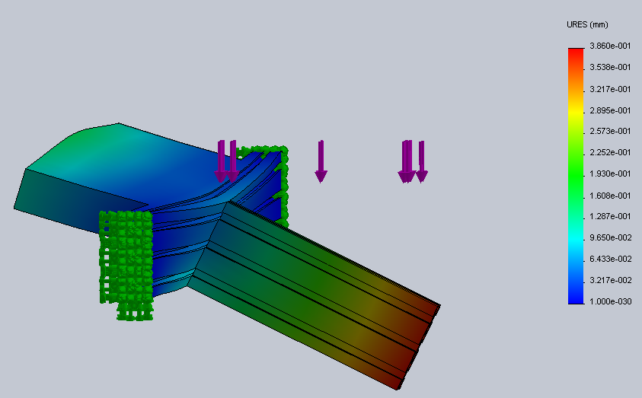
Right-angle configuration. At 0.38mm, this is by far the least effective configuration, though accessiblity to extrusion slots is maximized, and extra weight is conveniently positioned to counterbalance the primary load.

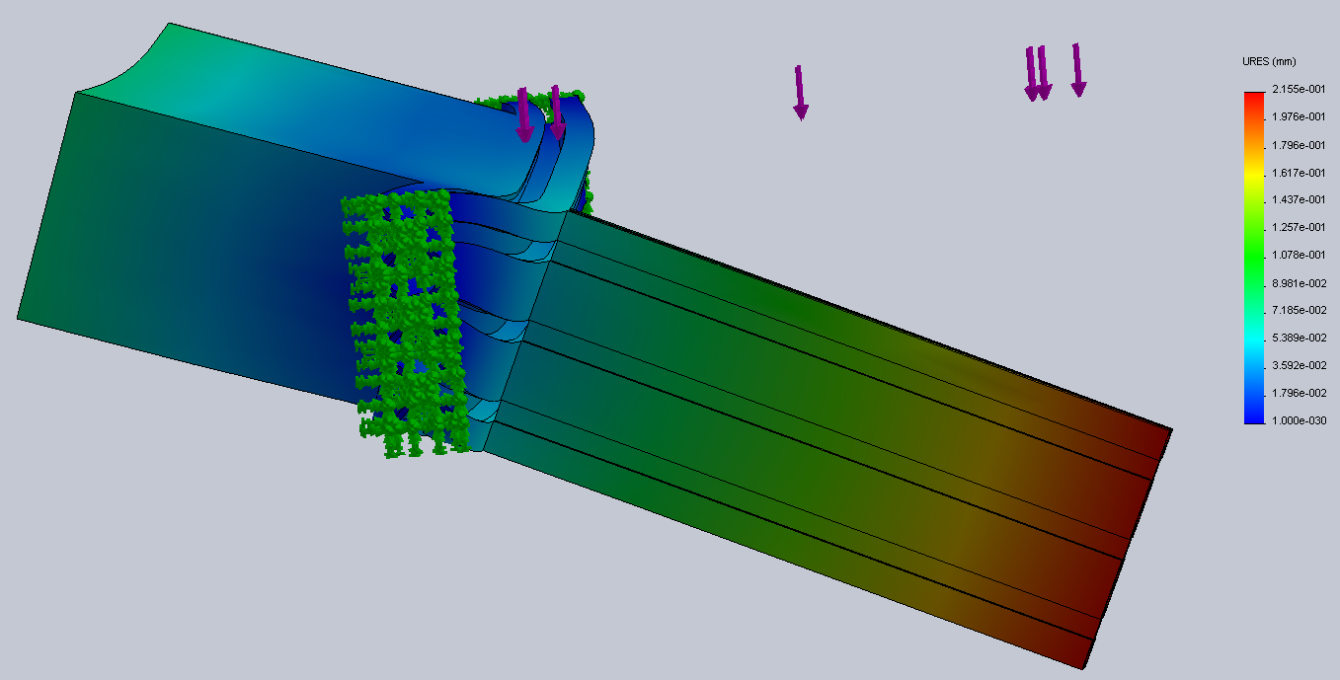
Double right-angle configuration. Performance still not in line with desired results. Also, fastners between the boards may be subject to shear displacements in this configuration, not modeled here.

