Electronics enclosure v0.2

- (21X) 6.0mm Thru, 21X 10.0X90deg countersink
  - 5 on back, 4 top, 4 bottom, 4 left side, 4 right side

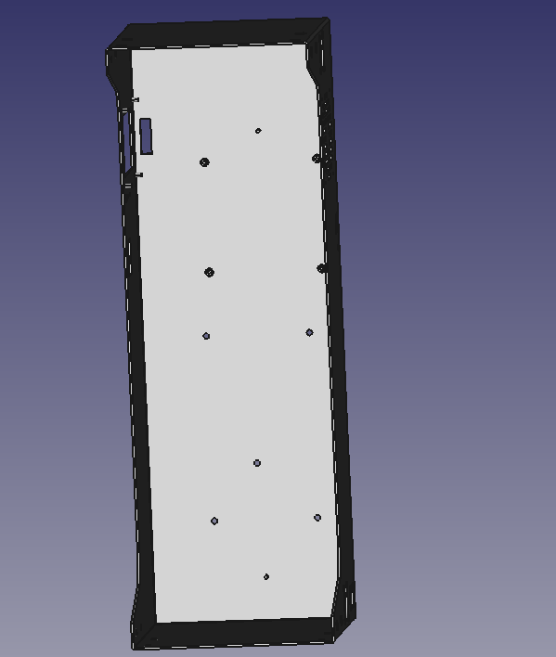
(4X) TSO-M25-600Z3

(4x) SOG-3.5M3-6

(2X) FH-M3-10Z1

