


aftermarket_8kX_hinge
Production and Development associated with...
3D Connected Printing, Soaring Industries LLC, "mirage335"
Aftermarket hinges to attach Pimax Vision 8kX to Modular Audio Strap, at angles different from those supplied by the original manufacturer Pimax. As a '3D printable' aftermarket modification, including derived third-party work under apparent GNU GPL v2 license, these alternative hinges are an independent offering.
Tools
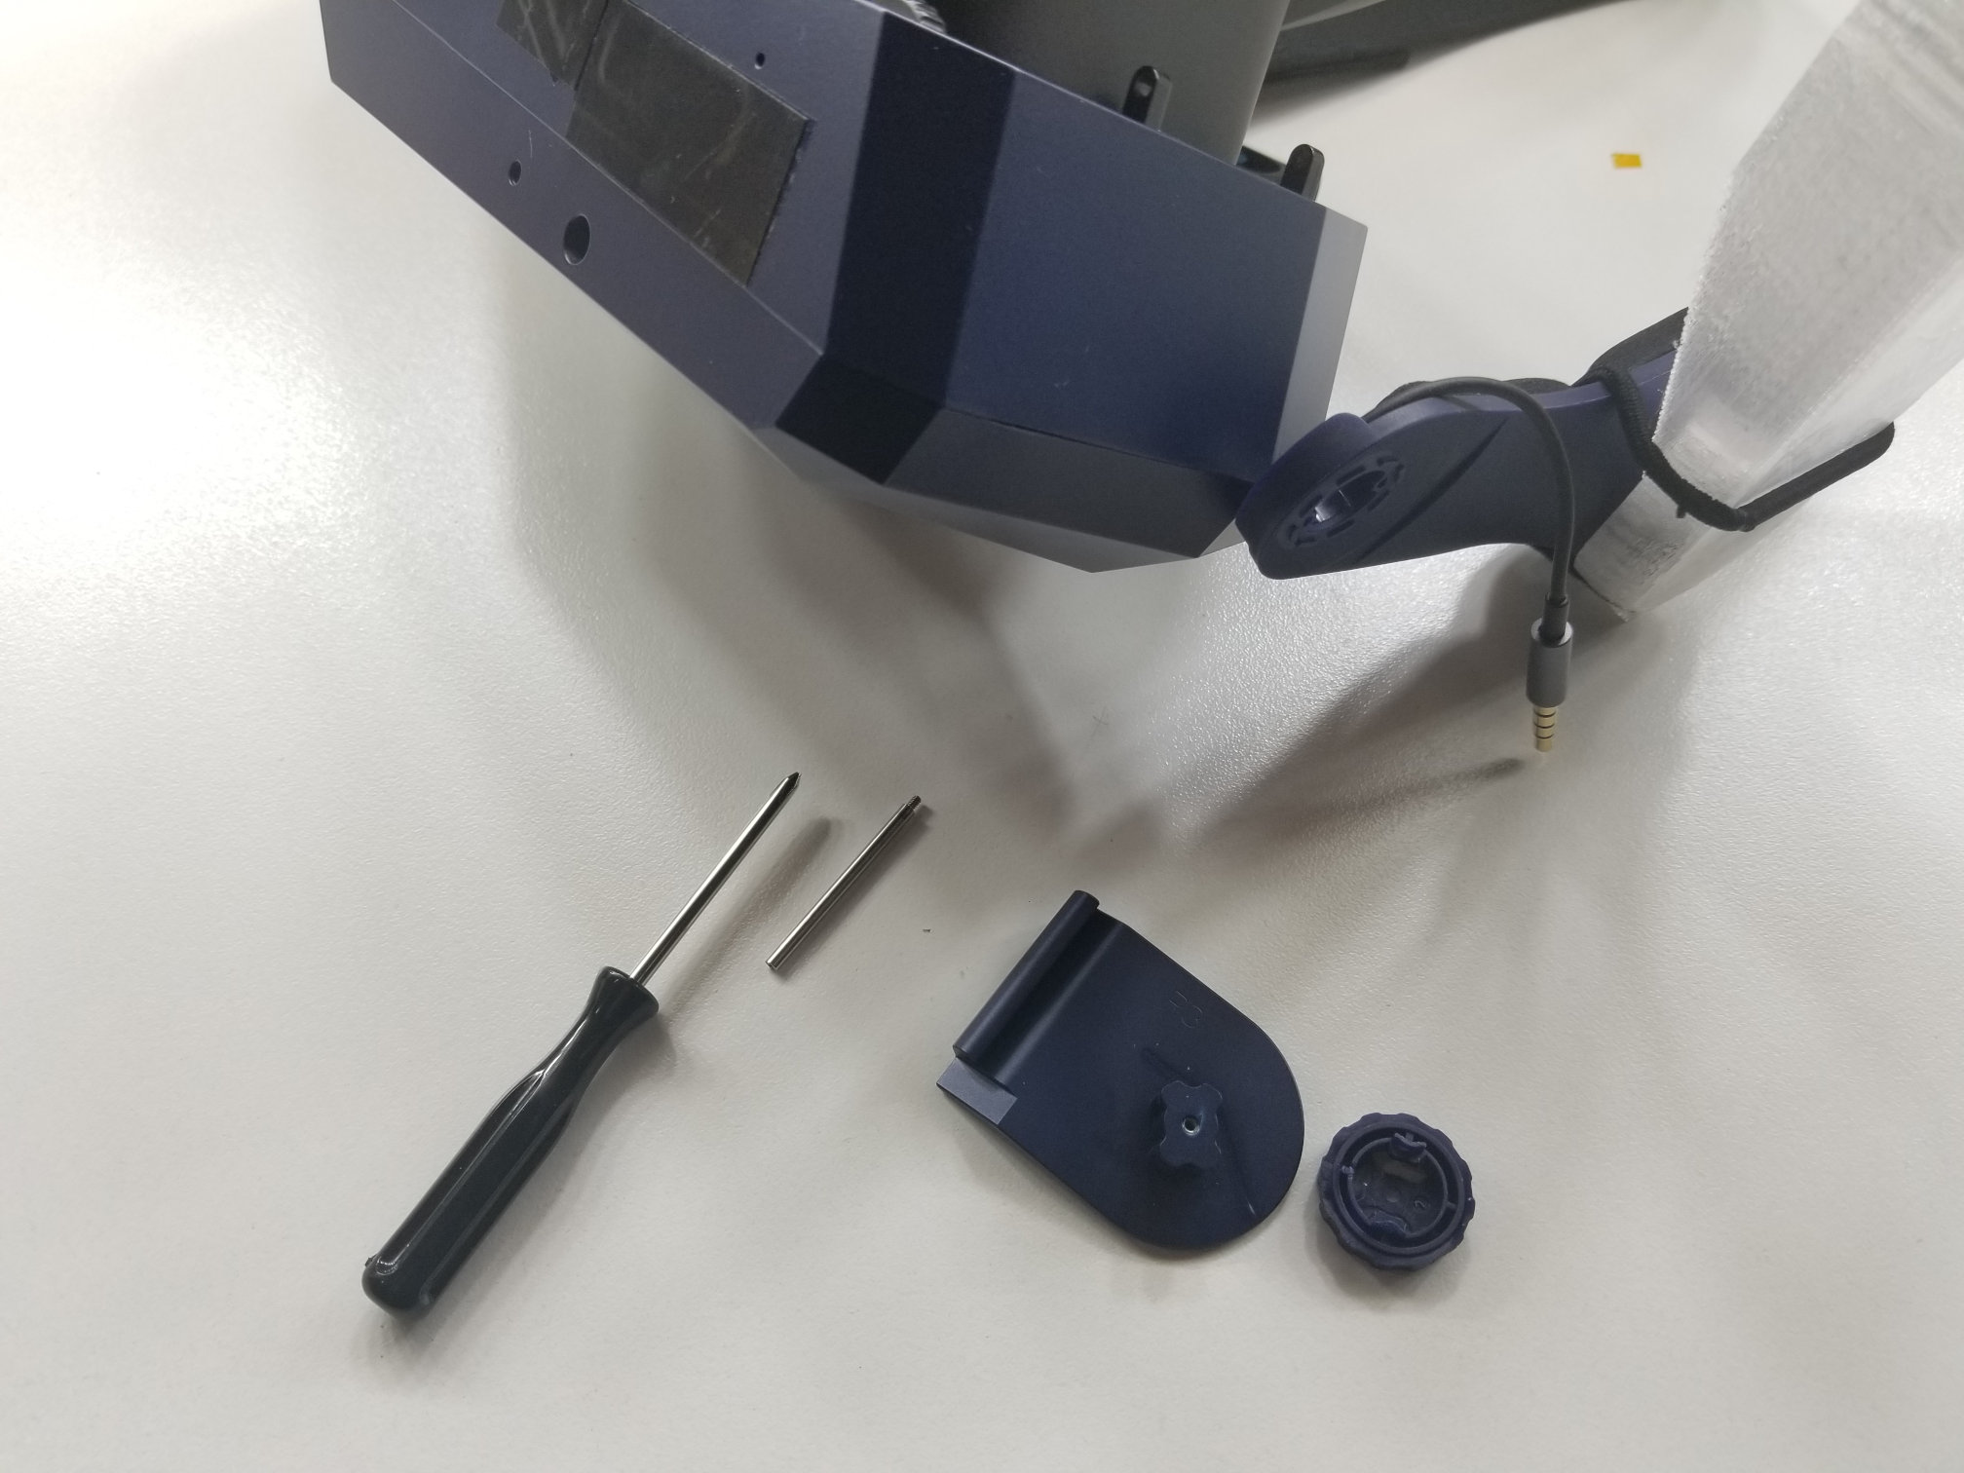
A small Phillips screwdriver, and possibly a small standard (flat) screwdriver, will be required. Typical, widely available, multi-tip 'precision' screwdriver kits, include appropriately sized bits. Please be careful not to allow the Phillips driver/screw to 'cam out', as this may make the screw difficult to remove in the future.
Installation
To remove old hinge, gently unscrew metal hinge pins, and gently twist off locking plastic cap. Attach new hinge using same metal hinge pins and locking plastic cap. Carefully avoid pinching wires.
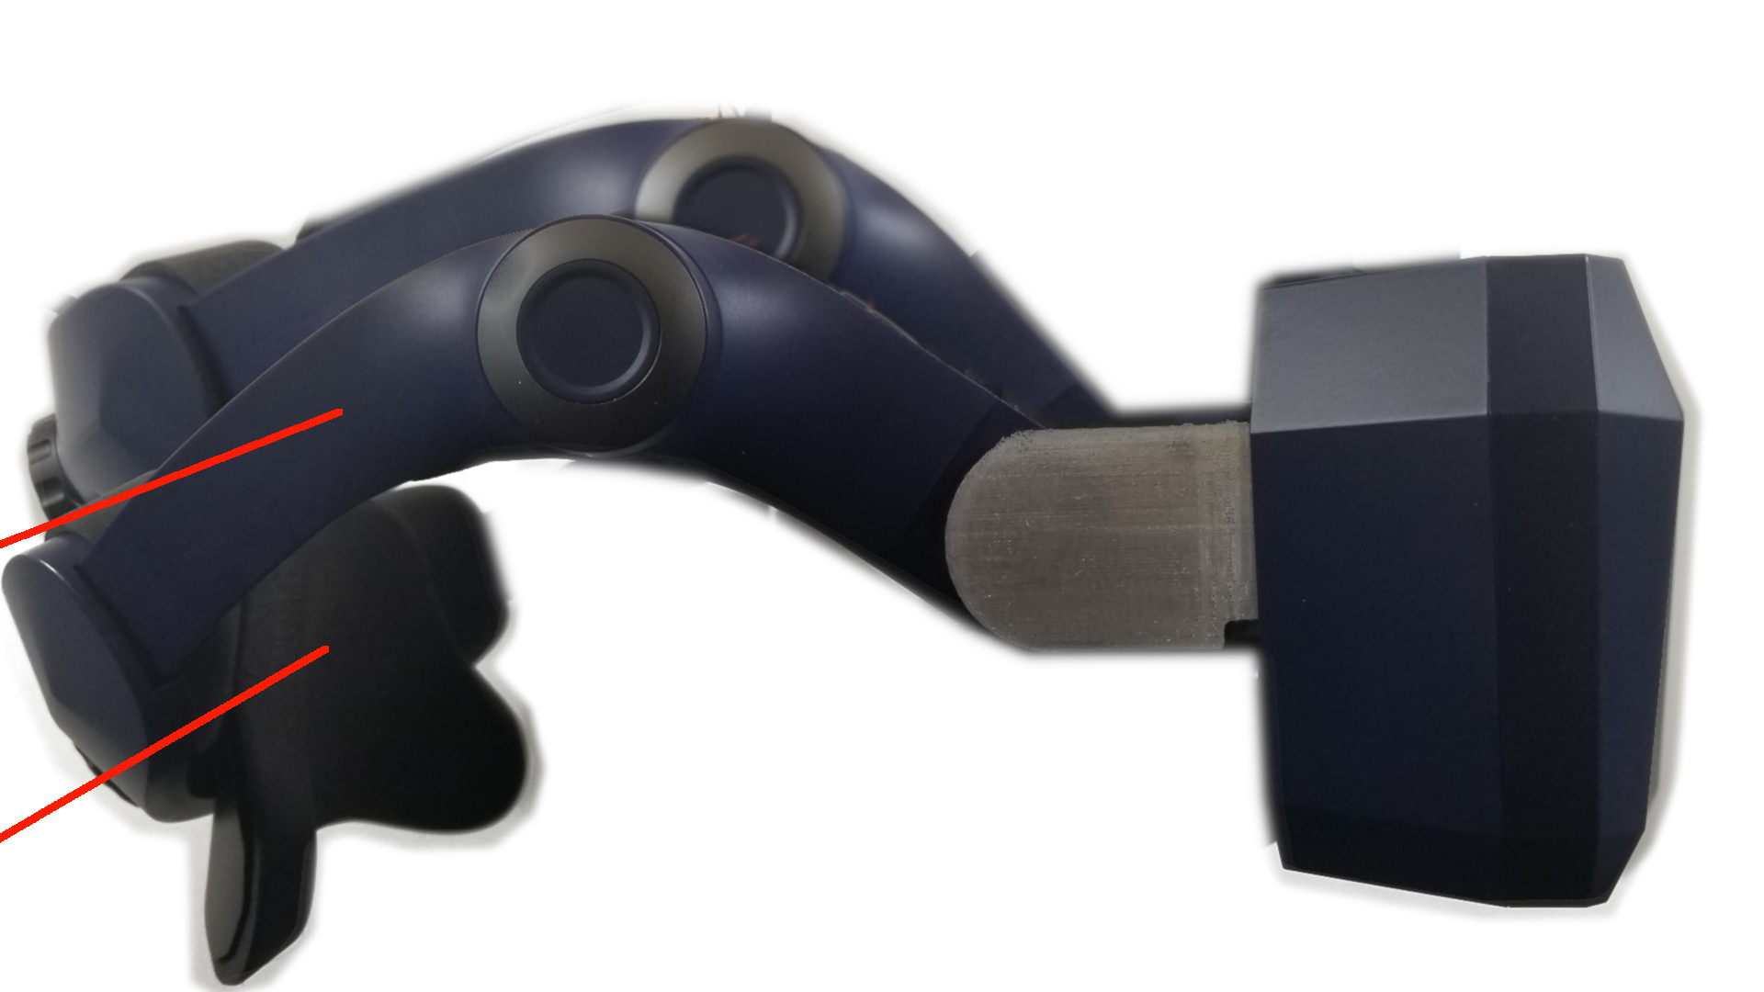
Angle
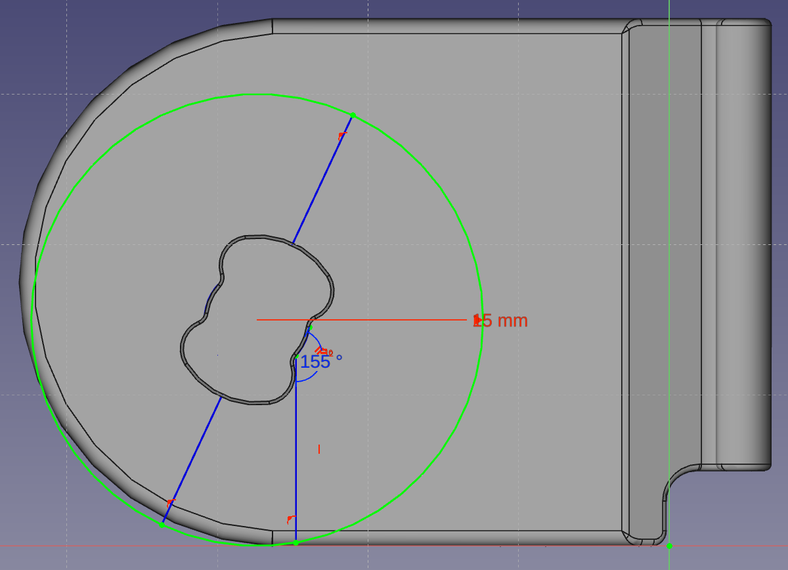
How far the strap can bend down before tilting the headset up is determined by the angle of the 'pillar base' on the hinge.
An angle of 161deg is recommended as a starting point. Lower numbers of degrees will reduce pressure on cheekbones, higher numbers will spread pressure more evenly across the entire face. Plastic hinges shipped by Pimax have been known to use an approximately 155deg angle.
Immovable vs Adjustable vs Flexible
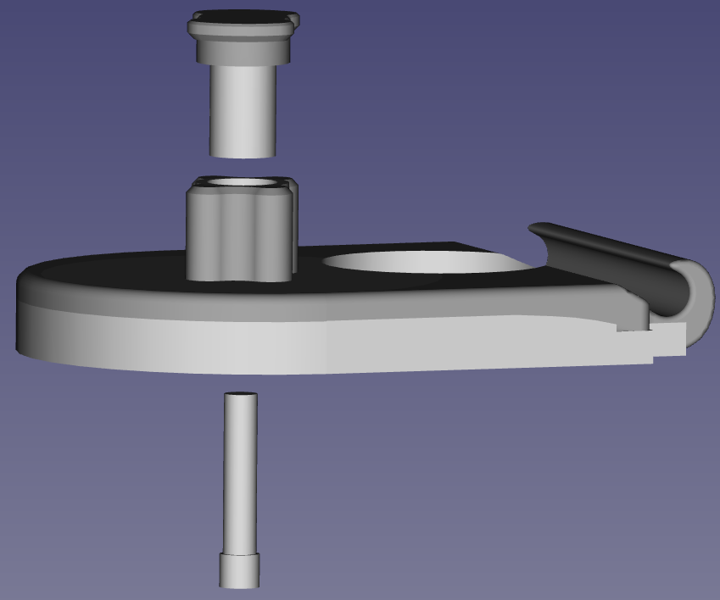Immovable
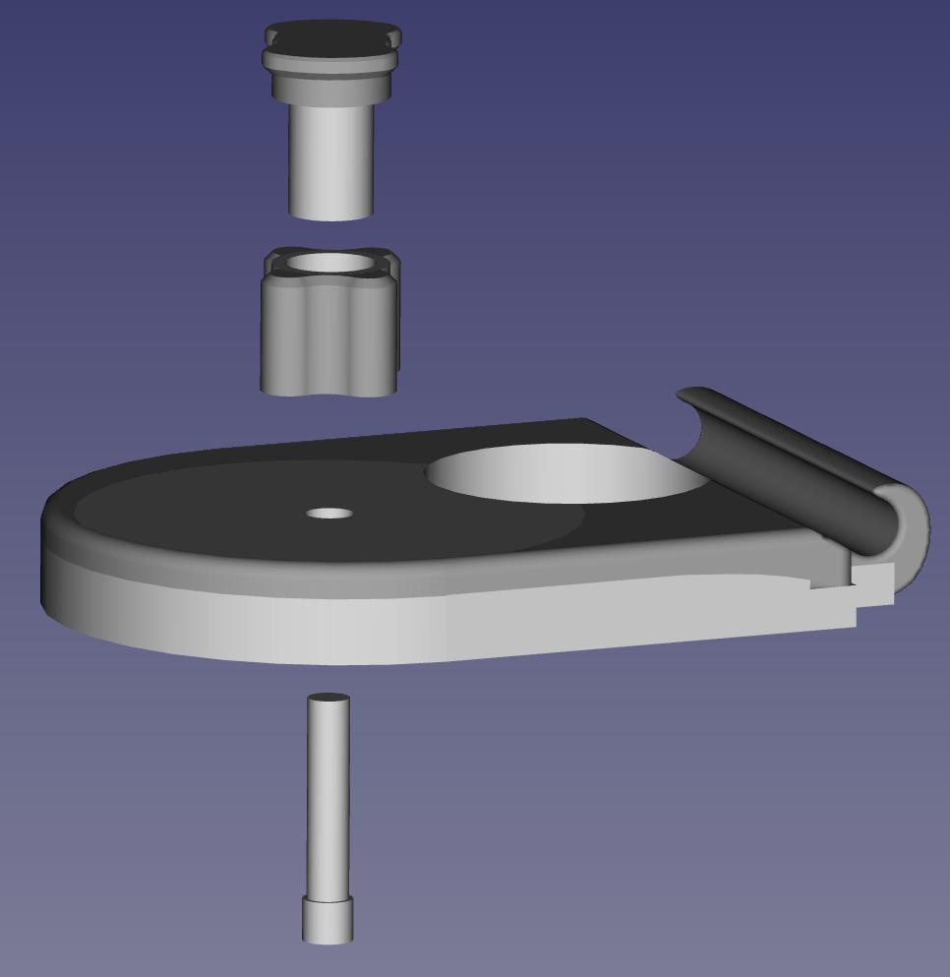Adjustable
Immovable hinges have pillar bases permanently attached to the hinges at manufacturing. Hinges are swapped (removed and replaced completely by new hinge) to change angle.
Adjustable hinges are manufactured as separate parts, allowing the pillar base angle to be changed while loosened. Adjustable hinges may require epoxy and careful measurements to prevent undesired rotation or tilt.
Flexible hinges are usually immovable hinges made of flexible material.
Third-Party Copyright Notices - Particularly important CAD models in this 'aftermarket_8kX_hinge' are derived from dimensionally accurate CAD models provided by 'OpenMR' forum participant 'Teigue'.
https://www.thingiverse.com/thing:4590303/files
http://www.gnu.org/licenses/old-licenses/gpl-2.0.html
https://github.com/pavel-ruban/Pimax
https://cad.onshape.com/documents/fc37eacb99e7b11e2a322105/w/a07aab2718f48f7bca448c96/e/941ae8a6d26472d6f4b638b7
https://github.com/mirage335/aftermarket_8kX_hinge/tree/main/_ref/8kX_SMAS%20Hinge-thirdParty
While other files in the 'aftermarket_8kX_hinge' may, as stated, be redistributed under GNU GPL license versions later than version 2, all files derived from (or otherwise including) third party files obtained under apparent GNU GPL v2 license, must retain that license.
Copyright - Copyright (C) 2020- mirage335
This file is part of aftermarket_8kX_hinge.
aftermarket_8kX_hinge is free software: you can redistribute it and/or modify it under the terms of the GNU General Public License as published by the Free Software Foundation, either version 2 of the License, or (at your option) any later version.
aftermarket_8kX_hinge is distributed in the hope that it will be useful, but WITHOUT ANY WARRANTY; without even the implied warranty of MERCHANTABILITY or FITNESS FOR A PARTICULAR PURPOSE. See the GNU General Public License for more details.
You should have received a copy of the GNU General Public License along with aftermarket_8kX_hinge. If not, see <http://www.gnu.org/licenses/>.
https://github.com/mirage335/aftermarket_8kX_hinge
https://3dconnectedprinting.com https://www.etsy.com/shop/3DConnectedPrinting https://community.openmr.ai/

