


aftermarket_8kX_hinge
Production and Development associated with...
3D Connected Printing, Soaring Industries LLC, "mirage335"
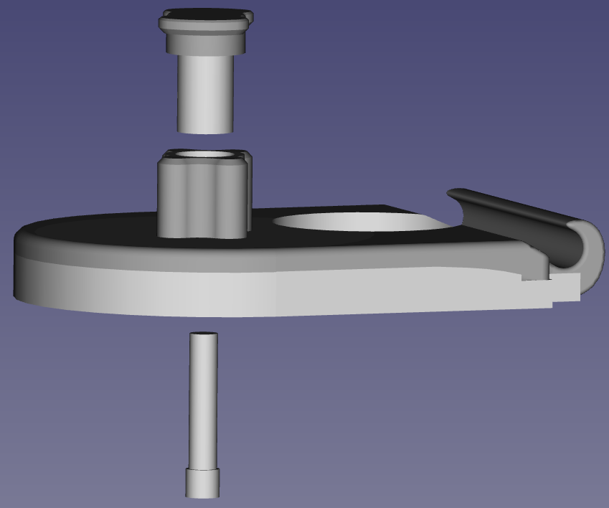
Aftermarket hinges to attach Pimax Vision 8kX to Modular Audio Strap, at angles different from those supplied by the original manufacturer Pimax. As a '3D printable' aftermarket modification, including derived third-party work under apparent GNU GPL v2 license, these alternative hinges are an independent offering.
Copyright (C) 2020- mirage335
See the end of the file for license conditions.
See license.txt for aftermarket_8kX_hinge license conditions.
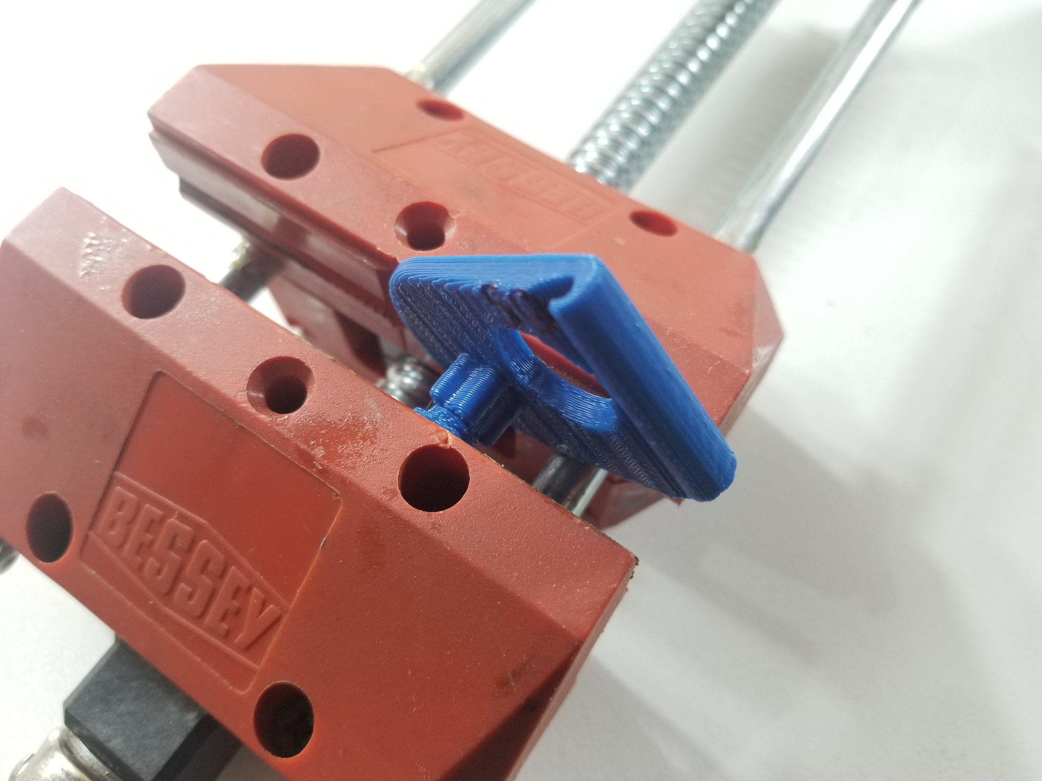
Pillar to Base
If 'XY compensation' is used, the pillar may loosely fit in the base. Otherwise, these parts are likely to fit together tightly enough to require a vise to completely push together. Carefully avoid any off-axis force to prevent damage. Reject any parts that noticeably crack during this process.
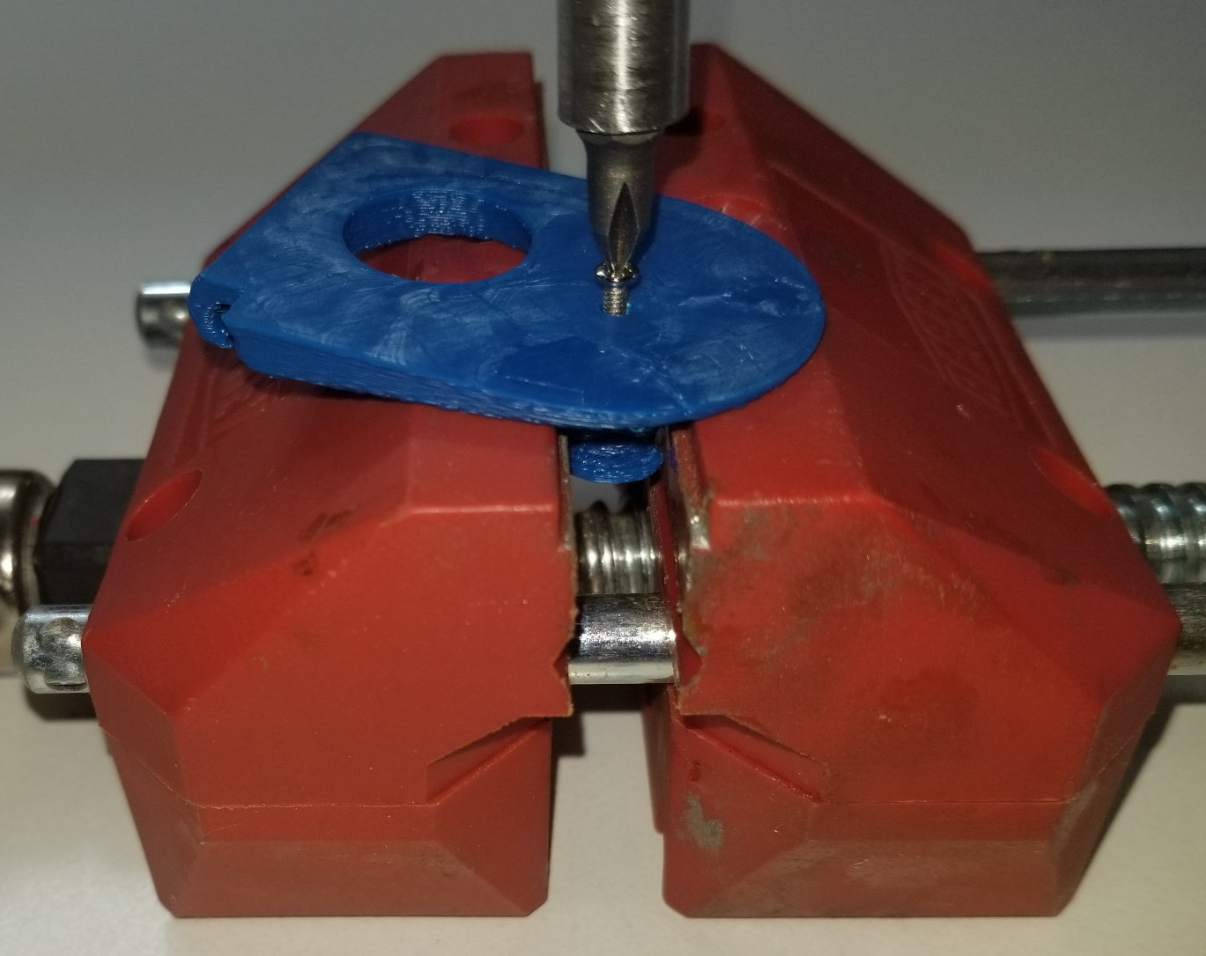
Pillar Rotational Alignment
While turning the screw to fasten the pillar to the base, the pillar may rotate. A vise may be used to constrain this undesired movement, preventing misalignment.
Only tighten the screw as necessary to completely pull together the pillar to base, or for the screw head to meet the plastic surface. Do not attempt to overdrive.
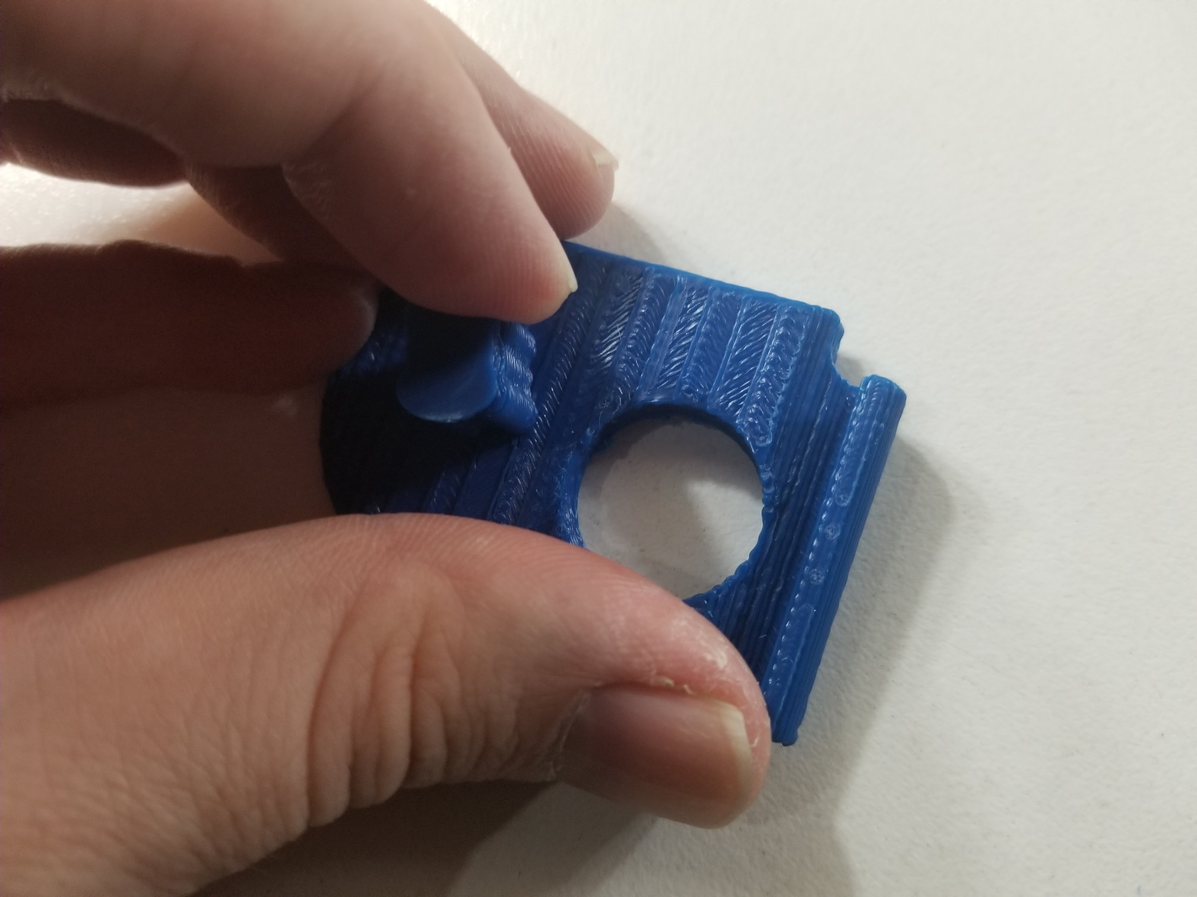
Pillar Must Be Finger Tight
Once Pillar is fastened to the base with a screw, the pillar must not rotate under the amount of pressure that could reasonably be applied by a typical human finger. That is to say it must be 'finger tight'.
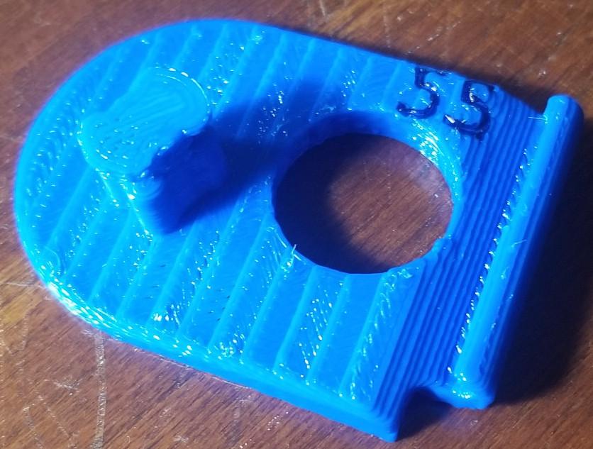
Matching Hinges and Number Readability
Identical angle hinges must be used for both left and right - if a 155deg hinge is used for the left, then a 155deg hinge must be used for the right. Mismatching these hinges will result in a subtle cause of discomfort for the end-user.
To minimize the risk of such mismatch, models may include numeric labels. These labels need not be clearly readable, but it is useful if they appear somewhat unique. Particularly important labels likely to be a starting point for most users - 155deg (shown here) or 161deg - may be further marked by running a permanent marker or perhaps paint along the resulting channel.
In addition, it may be helpful to place each pair of hinges in clear plastic bags.

Third-Party Copyright Notices - Particularly important CAD models in this 'aftermarket_8kX_hinge' are derived from dimensionally accurate CAD models provided by 'OpenMR' forum participant 'Teigue'.
https://www.thingiverse.com/thing:4590303/files
http://www.gnu.org/licenses/old-licenses/gpl-2.0.html
https://github.com/pavel-ruban/Pimax
https://cad.onshape.com/documents/fc37eacb99e7b11e2a322105/w/a07aab2718f48f7bca448c96/e/941ae8a6d26472d6f4b638b7
https://github.com/mirage335/aftermarket_8kX_hinge/tree/main/_ref/8kX_SMAS%20Hinge-thirdParty
While other files in the 'aftermarket_8kX_hinge' may, as stated, be redistributed under GNU GPL license versions later than version 2, all files derived from (or otherwise including) third party files obtained under apparent GNU GPL v2 license, must retain that license.
Copyright - Copyright (C) 2020- mirage335
This file is part of aftermarket_8kX_hinge.
aftermarket_8kX_hinge is free software: you can redistribute it and/or modify it under the terms of the GNU General Public License as published by the Free Software Foundation, either version 2 of the License, or (at your option) any later version.
aftermarket_8kX_hinge is distributed in the hope that it will be useful, but WITHOUT ANY WARRANTY; without even the implied warranty of MERCHANTABILITY or FITNESS FOR A PARTICULAR PURPOSE. See the GNU General Public License for more details.
You should have received a copy of the GNU General Public License along with aftermarket_8kX_hinge. If not, see <http://www.gnu.org/licenses/>.
https://github.com/mirage335/aftermarket_8kX_hinge
https://3dconnectedprinting.com https://www.etsy.com/shop/3DConnectedPrinting

