


aftermarket_8kX_hinge
Production and Development associated with...
3D Connected Printing, Soaring Industries LLC, "mirage335"
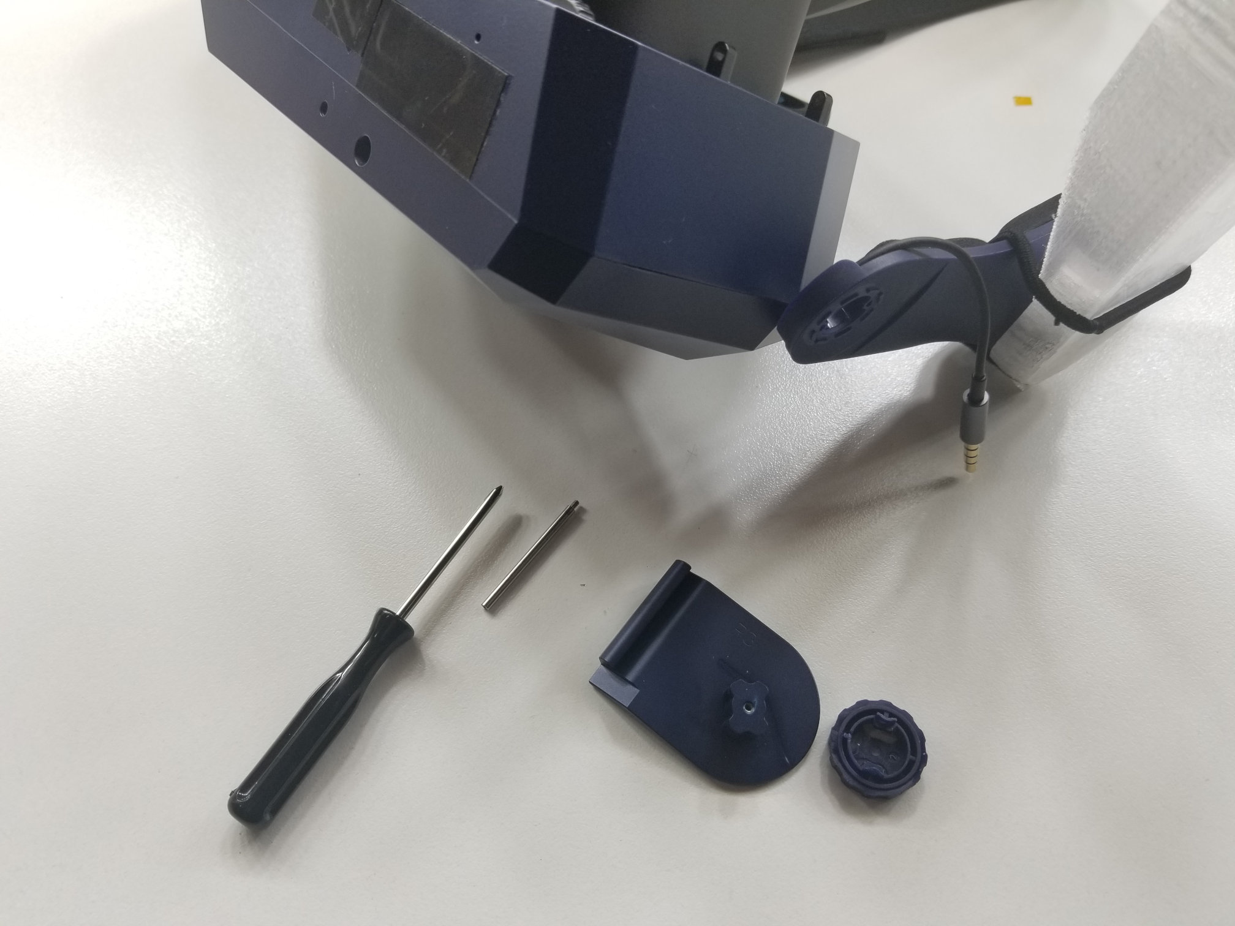
Aftermarket hinges to attach Pimax Vision 8kX to Modular Audio Strap, at angles different from those supplied by the original manufacturer Pimax. As a '3D printable' aftermarket modification, including derived third-party work under apparent GNU GPL v2 license, these alternative hinges are an independent offering.
Alternate Installation Technique
Physically pulling out the large rubber black cowling may allow the hinges to be gently rotated onto the hinge pins without removing them. Reportedly, this may be much easier than trying to slide the hinge pins into the hinges later as would otherwise be necessary.
We appreciate your patience as we continue investigating and documenting.
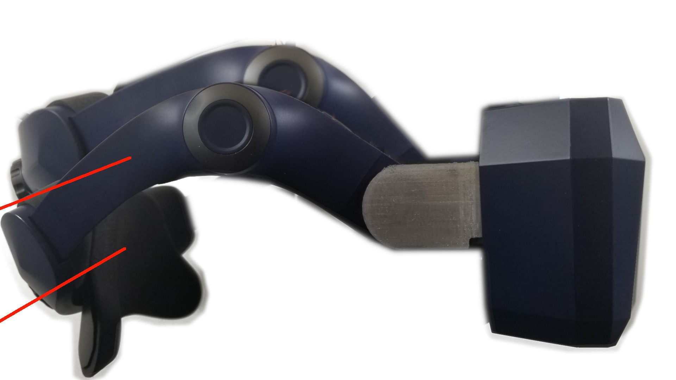
Do NOT Pick Up from Side
Please do NOT grab headset from just one side of strap. Always grab from top strap, headset itself, or any other balanced location.
Lifting the headset from the side strap will apply a torsion mechanical load which stresses the hinges far beyond any forces encountered in normal use. Although some hinges may show soldering iron wedge tip marks made to improve adhesion, the confined space does NOT allow us to add sufficient material to prevent such breakage. Also, spare 161deg hinge pairs may be shipped with larger orders to ensure customer success.
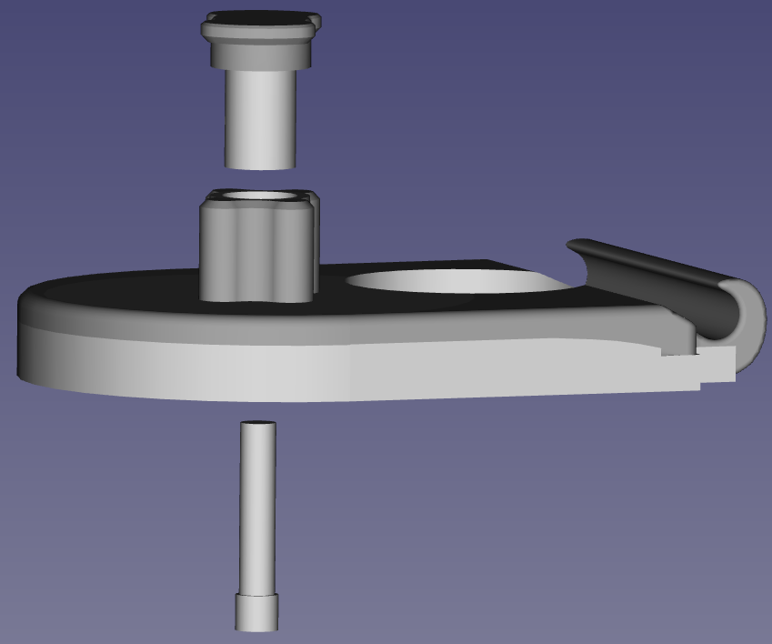
Please be aware of this limitation.
We appreciate your patience as we continue investigating and documenting.

Third-Party Copyright Notices - Particularly important CAD models in this 'aftermarket_8kX_hinge' are derived from dimensionally accurate CAD models provided by 'OpenMR' forum participant 'Teigue'.
https://www.thingiverse.com/thing:4590303/files
http://www.gnu.org/licenses/old-licenses/gpl-2.0.html
https://github.com/pavel-ruban/Pimax
https://cad.onshape.com/documents/fc37eacb99e7b11e2a322105/w/a07aab2718f48f7bca448c96/e/941ae8a6d26472d6f4b638b7
https://github.com/mirage335/aftermarket_8kX_hinge/tree/main/_ref/8kX_SMAS%20Hinge-thirdParty
While other files in the 'aftermarket_8kX_hinge' may, as stated, be redistributed under GNU GPL license versions later than version 2, all files derived from (or otherwise including) third party files obtained under apparent GNU GPL v2 license, must retain that license.
Copyright - Copyright (C) 2020- mirage335
This file is part of aftermarket_8kX_hinge.
aftermarket_8kX_hinge is free software: you can redistribute it and/or modify it under the terms of the GNU General Public License as published by the Free Software Foundation, either version 2 of the License, or (at your option) any later version.
aftermarket_8kX_hinge is distributed in the hope that it will be useful, but WITHOUT ANY WARRANTY; without even the implied warranty of MERCHANTABILITY or FITNESS FOR A PARTICULAR PURPOSE. See the GNU General Public License for more details.
You should have received a copy of the GNU General Public License along with aftermarket_8kX_hinge. If not, see <http://www.gnu.org/licenses/>.
VIDEO TUTORIAL https://www.youtube.com/watch?v=DQY9Z6OXVtY https://github.com/mirage335/aftermarket_8kX_hinge
https://3dconnectedprinting.com https://www.etsy.com/shop/3DConnectedPrinting https://community.openmr.ai/

