


zipTiePanel
Production and Development associated with...
3D Connected Printing, Soaring Industries LLC, "mirage335"
Compact, robust, rapid, and maintainable panel with enclosure, designed to mechanically anchor and separate wires, using zip ties. Supplants bundles of shrink tubing and similarly slow or unmaintainable splicing techniques. Accepts a wider variety of wire sizes than common connectors, and may join multiple wires at a single point.
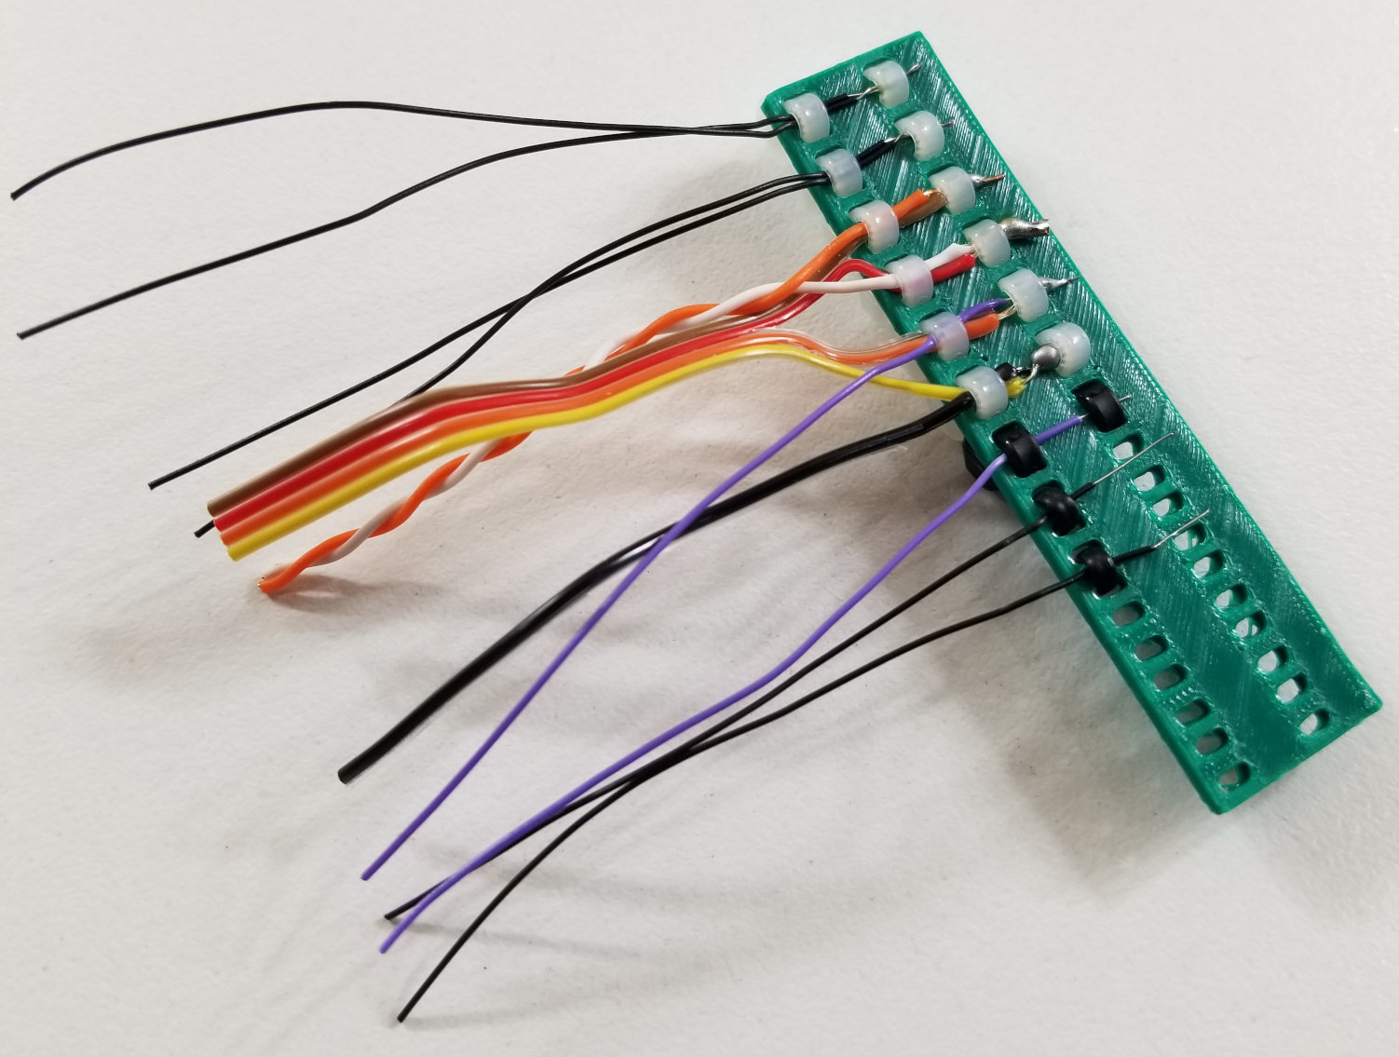
Step 1
Twist and solder wires together. Reputable 63/37 rosin core leaded solder ~0.05in/~1mm strongly recommended if permitted.
Step 2
Thread zip tie through panel and insert spliced wires as shown.
Step 3
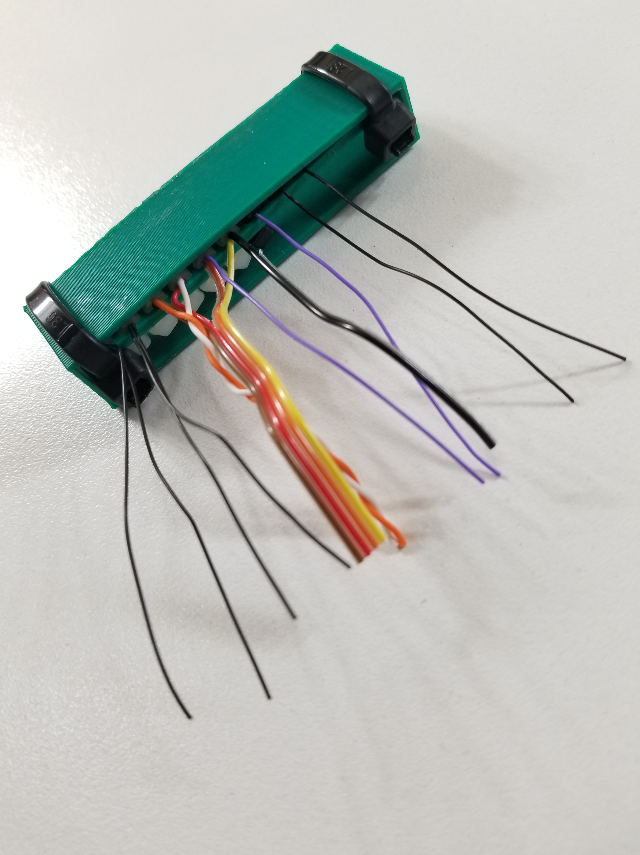
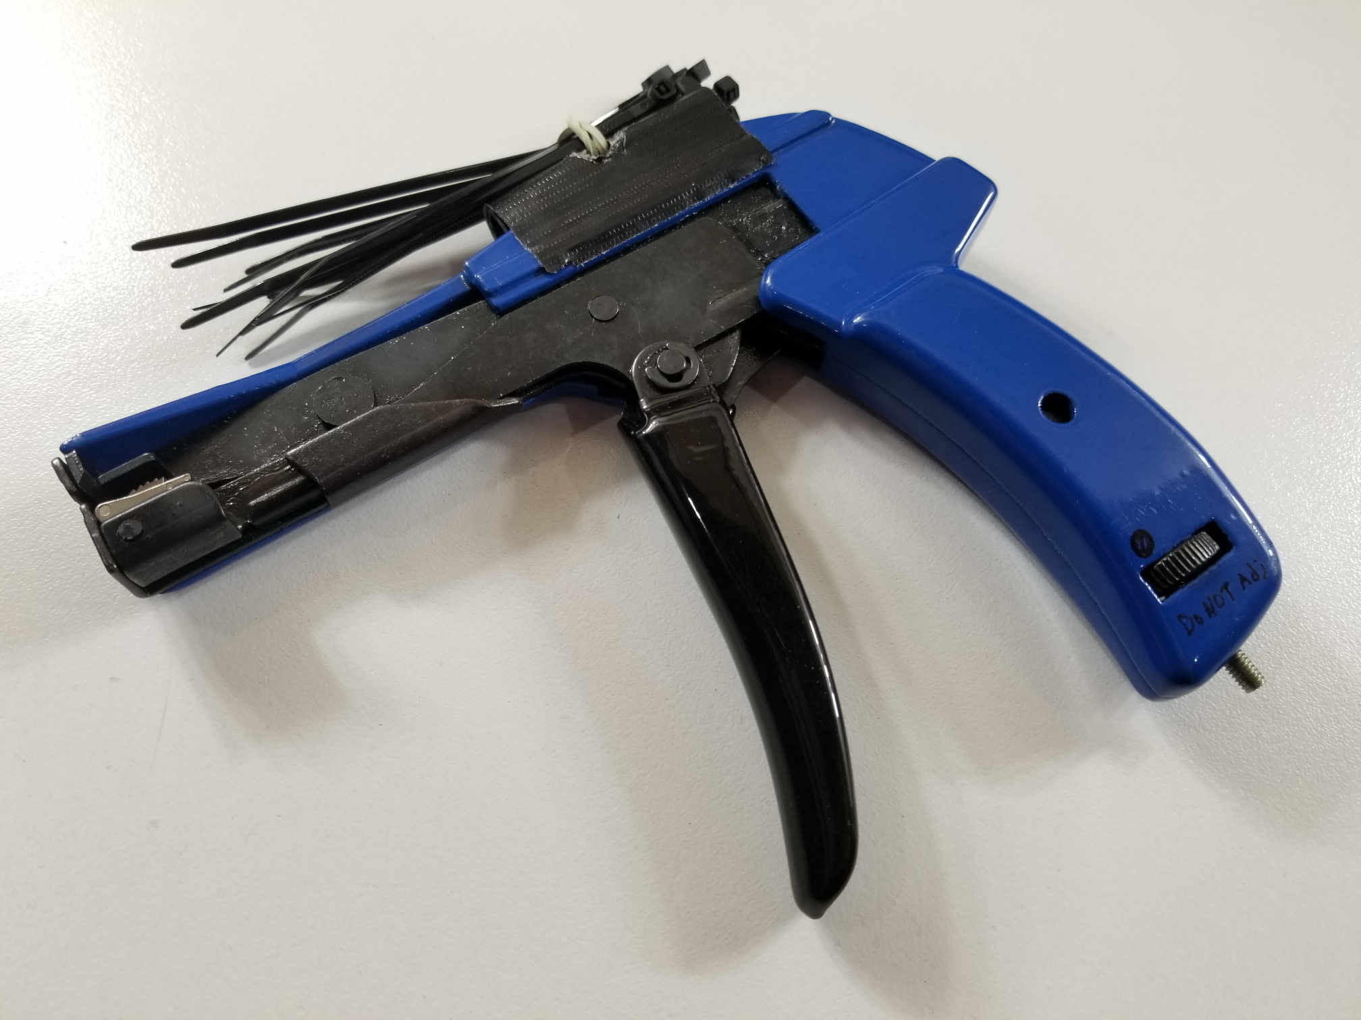
Tighten zip tie to maximum tension. Inexpensive tightening tools (~$10) have proven highly efficient - complete stub removal is not necessary.
Repeat steps 1-3 for all splices.

Step 4 (Optional)
Fasten to protective box with two zip ties. Splice side of panel should be pulled toward box wall as shown. Other insulative protective materials may be used instead as appropriate, such as clear heat-shrink.

Safety - Please keep in mind the designs here are intended as OEM parts to be used by knowledgeable individuals, are intended NOT as any kind of consumer products, and are specifically intended NOT for building/residential wiring. Any consumer products, services, or other applications using these parts will require appropriate due diligence to ensure safety and compliance with relevant best practices. No claim of liability is made by anyone. Your accident is your accident. Use common sense, and follow all regulations. If you don't understand the safety features and limitations, don't use this circuitry or anything similar.
Lead-free solder is often too hazardous to use even with extensive due diligence and/or the best factory assembly practices, particularly if ever under -13degC, vacuum, mechanical stress, or other factors which may not be scientifically known. Lead-free solder requirements cause failures that can simultaneously overwhelm all redundancy. Tin whiskers and tin pest can cause fire, exposed high-voltage, uncontrolled motion, complete data loss, and total capital equipment loss, among other hazards. No known additives (eg. antimony, bismuth) other than large percentages (>60%) of lead offer significant improvement. Soldering itself may carry some risks, particularly from lead (if not 'lead-free'), or various flux compounds.
Copyright - Copyright (C) 2020- mirage335
This file is part of zipTiePanel.
zipTiePanel is free software: you can redistribute it and/or modify it under the terms of the GNU General Public License as published by the Free Software Foundation, either version 3 of the License, or (at your option) any later version.
zipTiePanel is distributed in the hope that it will be useful, but WITHOUT ANY WARRANTY; without even the implied warranty of MERCHANTABILITY or FITNESS FOR A PARTICULAR PURPOSE. See the GNU General Public License for more details.
You should have received a copy of the GNU General Public License along with zipTiePanel. If not, see <http://www.gnu.org/licenses/>.
https://github.com/mirage335/zipTiePanel
https://3dconnectedprinting.com https://www.etsy.com/shop/3DConnectedPrinting
Applications
- Desktop computer internal accessory wiring.
- Extruders for 3D printers (and other machine tools).
- Audio connections.
- VR headset accessory power.
- Any typical use for 'hook up wire'.
- Strings, belts, pulleys, bowden cables, etc.
Recommendations
Zip tie tightening tool is *strongly recommended*. Set *tightening tension to maximum*. An expensive tool is not necessary for these panels, and this (~$10) tool in particular has been found to be highly productive.
https://amazon.com/dp/B01B1EFM1U
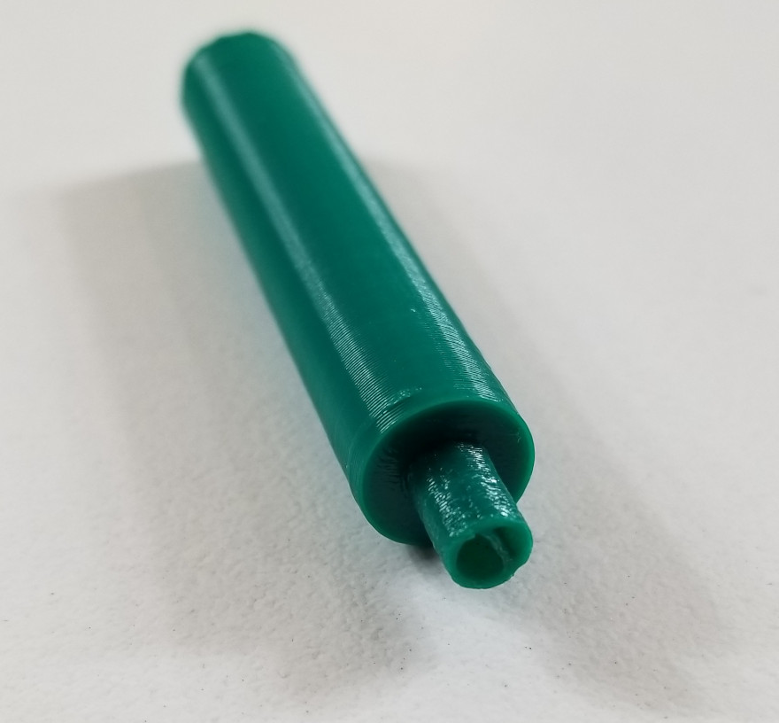
Wire wrap tools are a highly productive means to connect wires to pins provided by 'motherboards' as used by 3D printers among other electronics. Standard wire wrap tools are widely available for standard 2.5mm/2.54mm/100mil pitch header pins. Powered wire wrap tools can be used to make at least tens of connections per minute. Larger pins (as may be used for extruder heater connections) may be wrapped by this simple 3D printable tool.
https://github.com/mirage335/wirewrap_huge
Wire may be chosen for quality, shielding, twisting, impedance, bundling, or cost. Large diameter (eg. 14AWG) may require an additional zip tie, or independent splicing with clear heat shrink tubing.
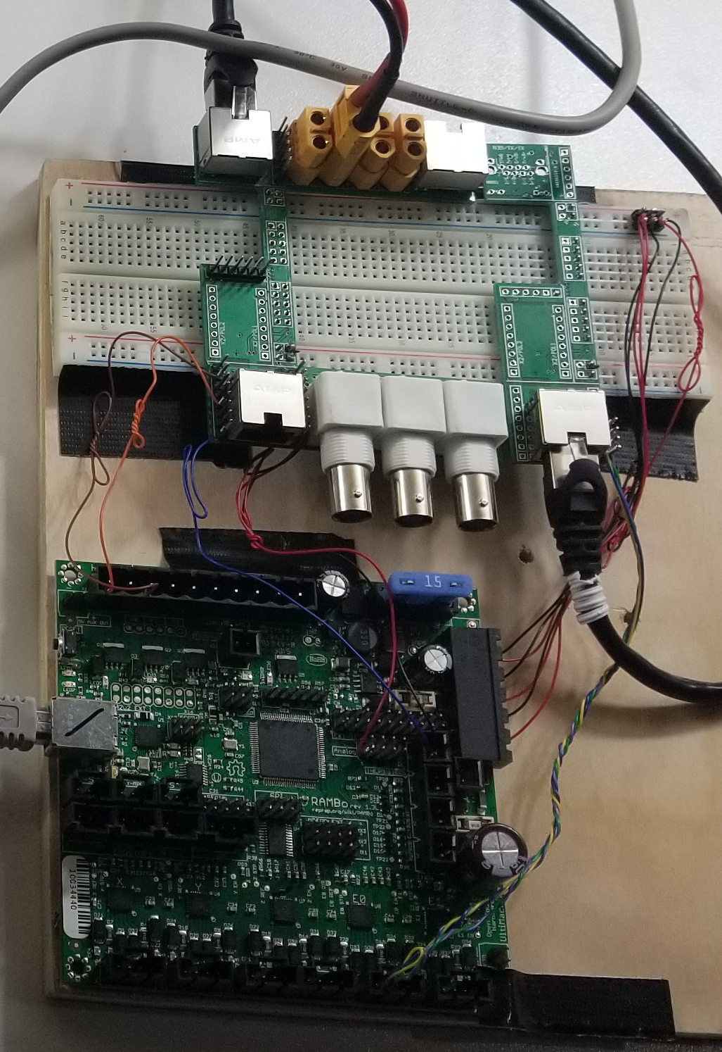
- Cat 6A S/FTP cabling.
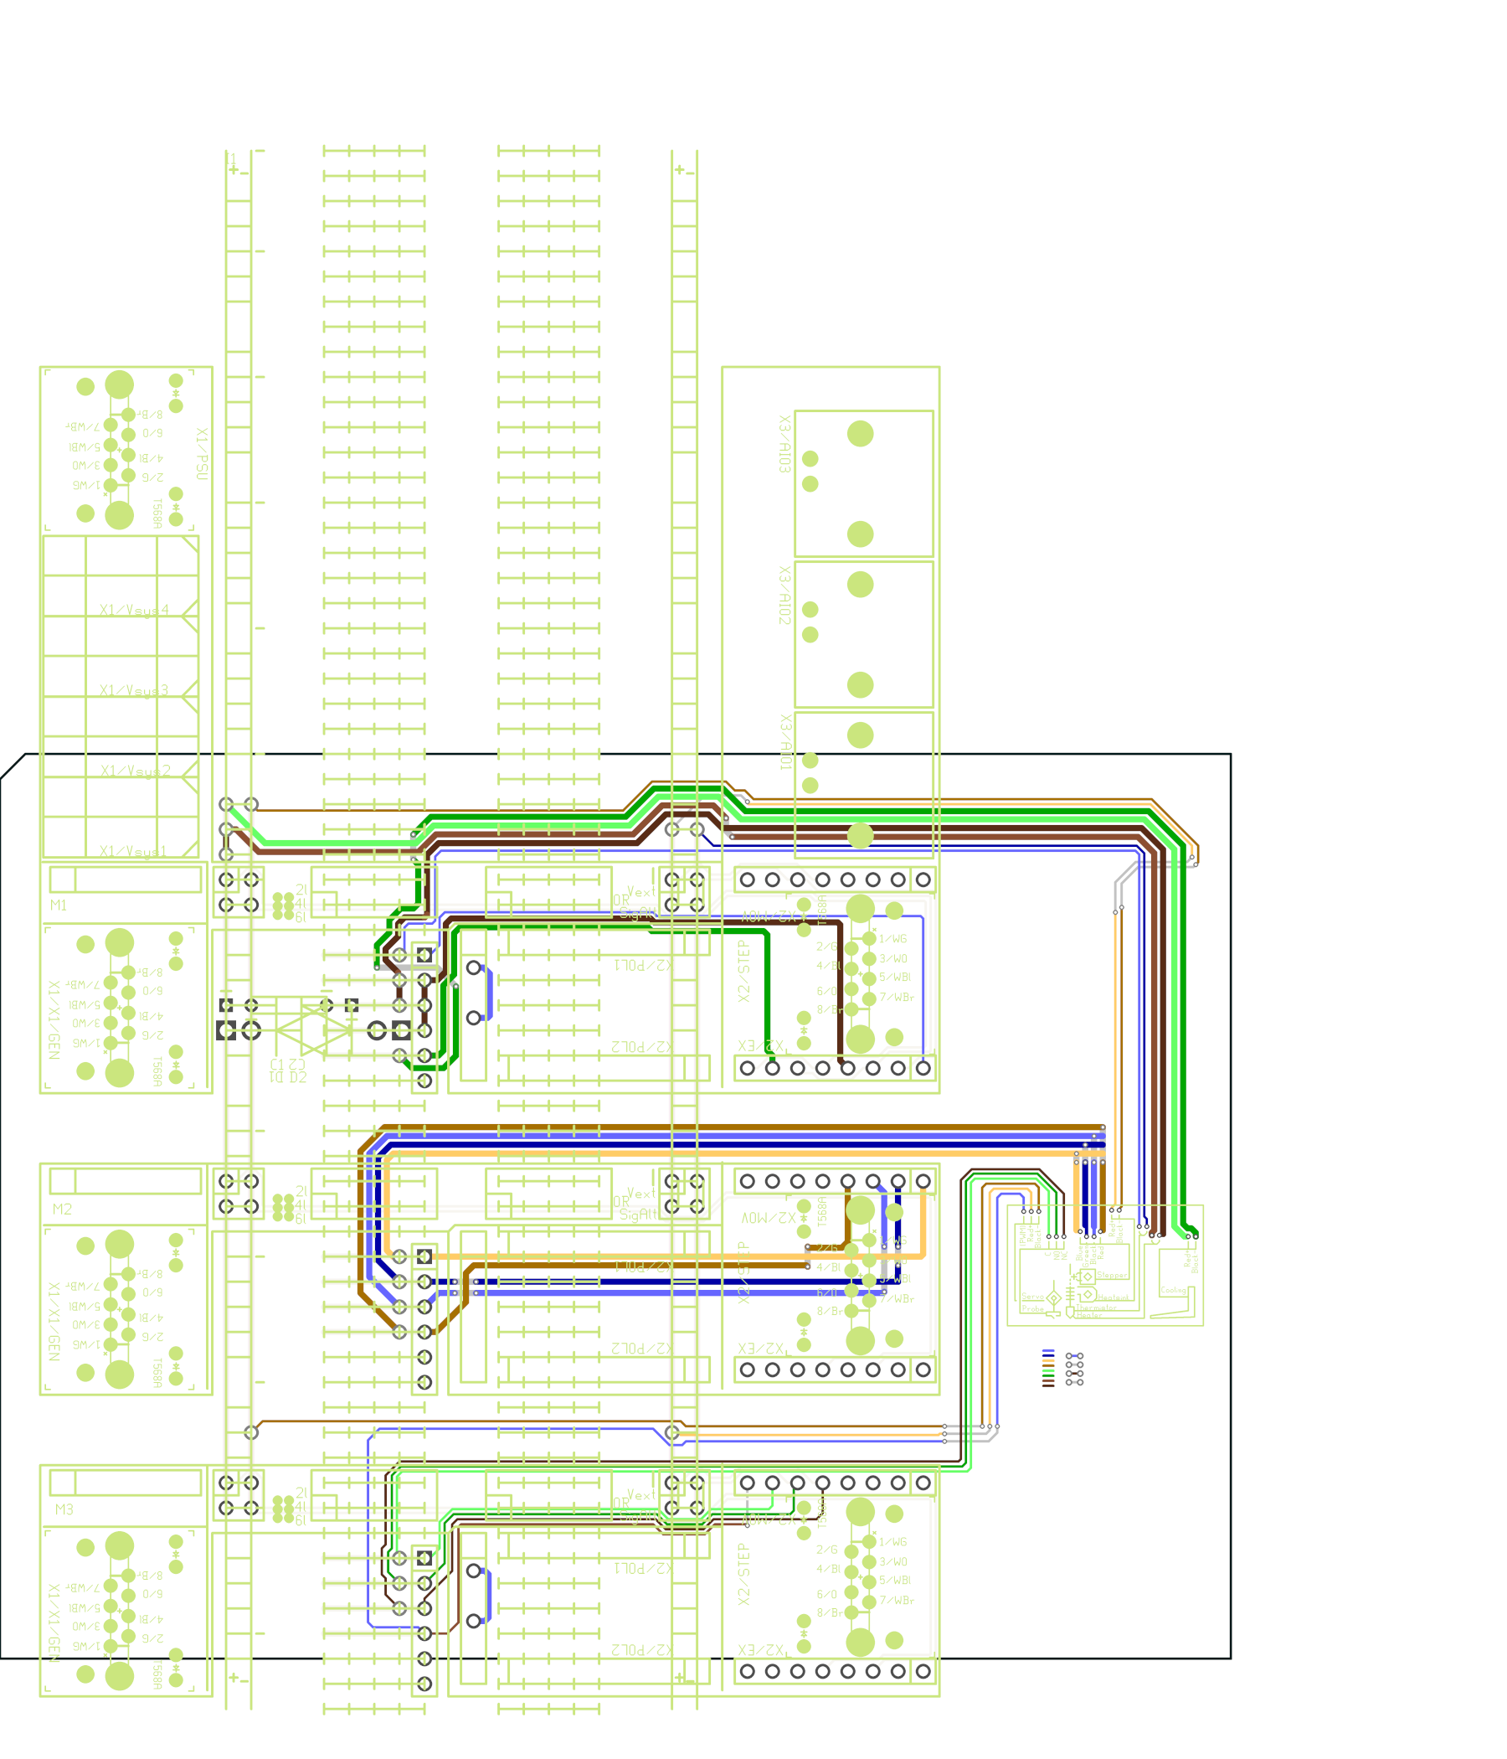
- Wrapping Wire (Kynar insulation, silver plated, 30AWG).
- Silicone insulated wire (14AWG, 30AWG).
PatchRap standard is intended to achieve similar goals - compact, robust, rapid, maintainable. RJ45 connectors used by PatchRap are ideal for use with Cat 6A S/FTP cabling to be subsequently spliced with a zipTiePanel .
https://github.com/mirage335/PatchRap
https://github.com/mirage335/PatchRap_to_CNC
https://github.com/mirage335/PatchRap_LulzBot


