
邯 郸 学 院
信 息 工 程 学 院

实 验 报 告

编制部门：信息工程学院 编制人：王煜哲 实验日期： 2018 年 11 月16 日
学号 | 20150410103004 | 姓名 | 马博韬 | 专业 | 计算机  科学与技术 | 年级 | 2015
课程名称 | JavaEE项目实训 |  |  | 实验名称 | 小米网站商品展示及购物车模块
实验目的 | - 了解网站购物流程的设计与实现过程。  - 数量掌握JSTL及EL表达式的使用  - 掌握利用Session实现购物车
实验内容（写明操作步骤和结果）

一、实验要求：
- 实现如图所示的商品展示界面。
- 注意界面的友好性，该提示的部分注意提示。
- 项目目录部分注意分层(dao,model,db,controller)。
- 项目关键代码和程序运行截图。
二、实现效果：

商品展示页面：
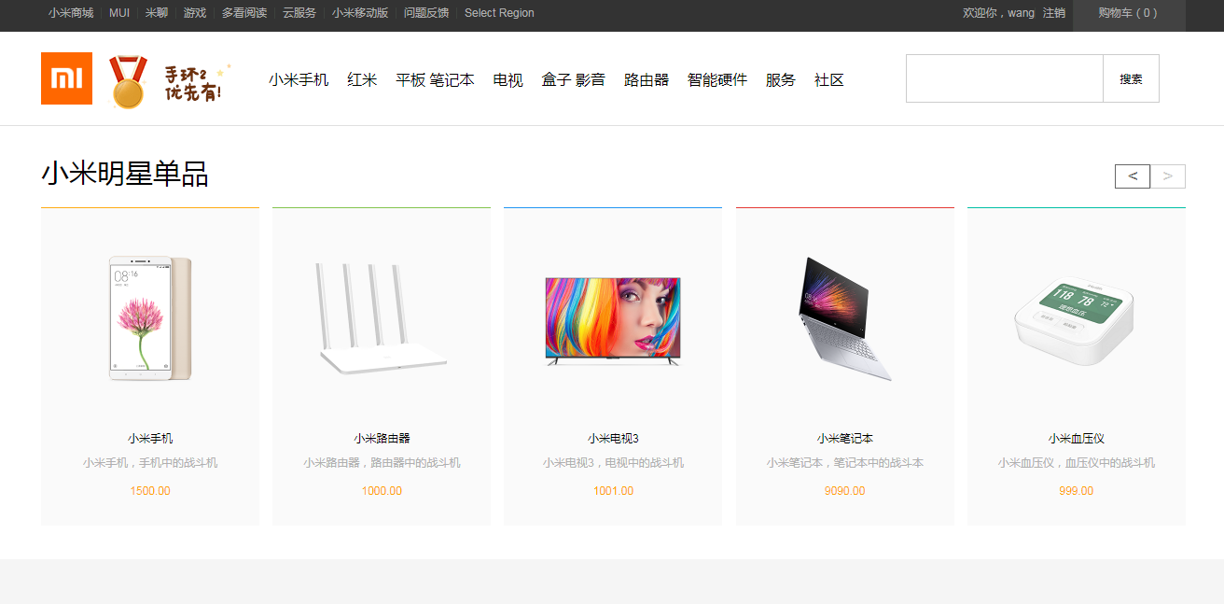
注意登录成功后页面右上方提示：欢迎您，xx
点击商品，跳转到商品展示页面。
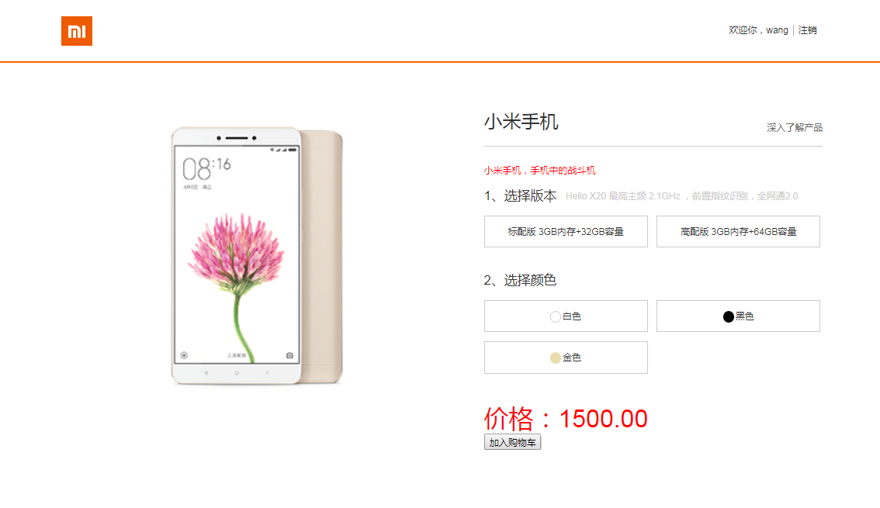
点击加入购物车，将商品添加到购物车，页面右上方提示购物车内商品数量
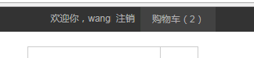
查看购物车
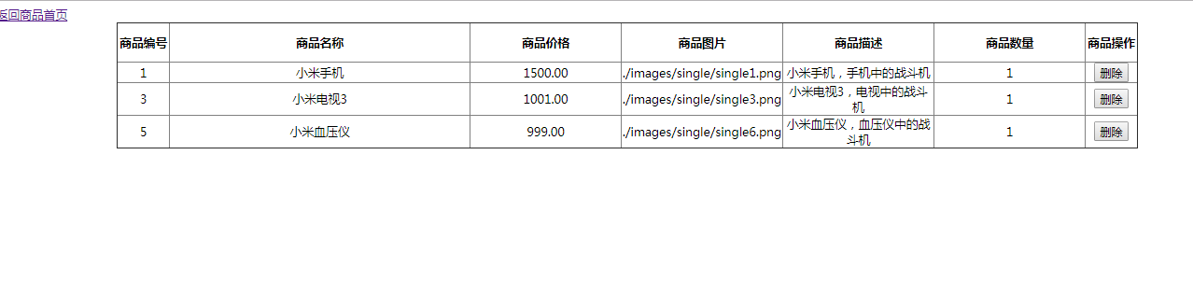
删除购物车内商品
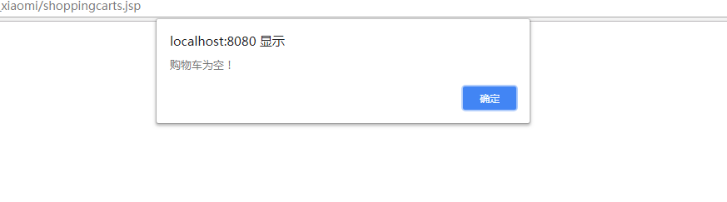

数据库表设计：

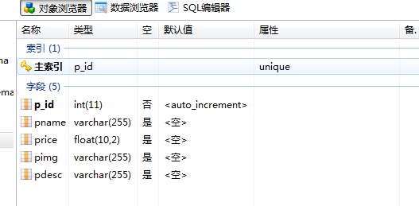

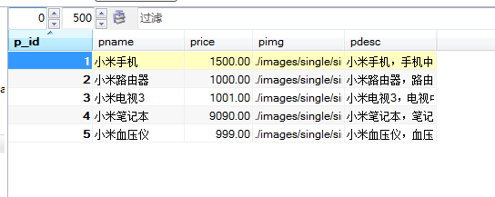

三、运行截图及关键代码
商品展示页面：
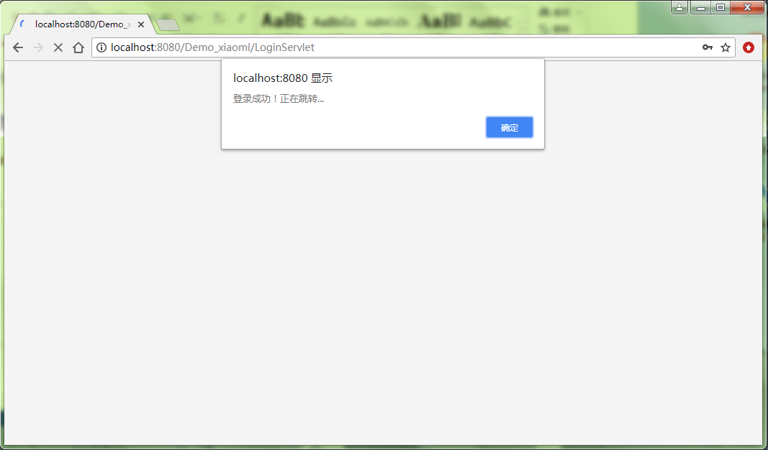
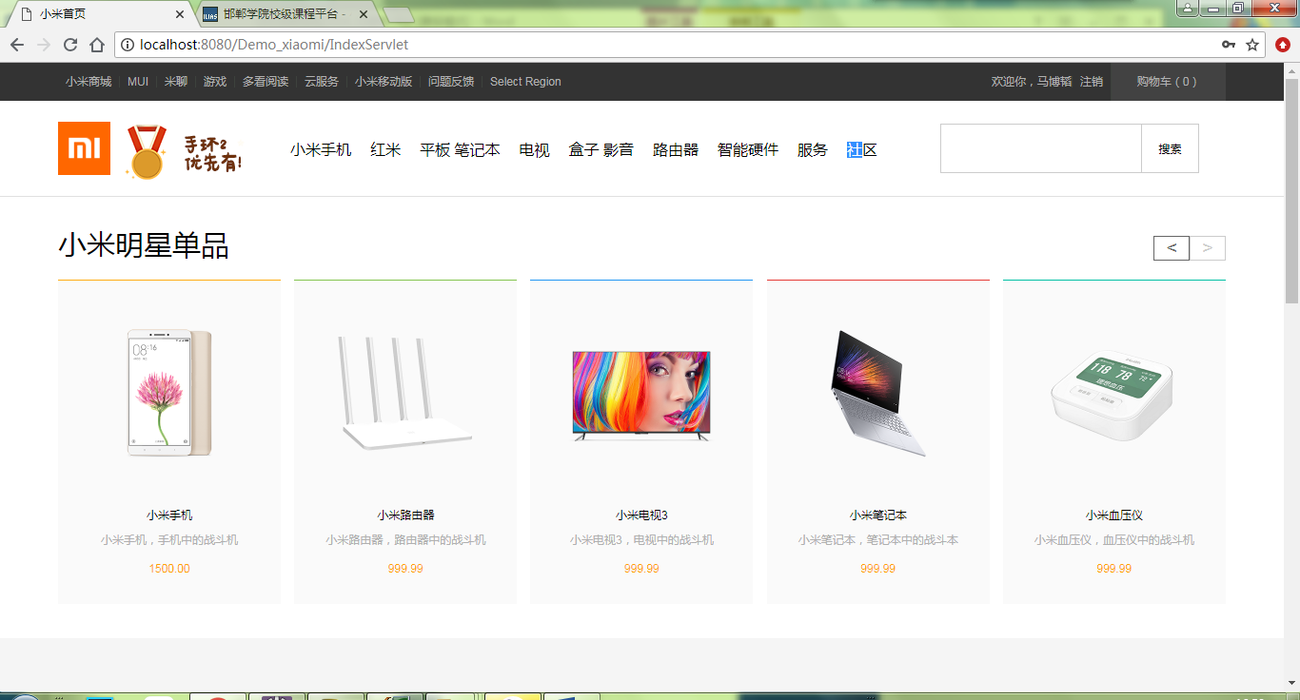
关键代码：
- LonginServlet.java

/**
* Servlet implementation class loginServlet
*/
@WebServlet("/LoginServlet")
public class LoginServlet extends HttpServlet {
private static final long serialVersionUID = 1L;

/**
* @see HttpServlet#HttpServlet()
*/
public LoginServlet() {
super();
// TODO Auto-generated constructor stub
}

/**
* @see HttpServlet#doGet(HttpServletRequest request, HttpServletResponse response)
*/
protected void doGet(HttpServletRequest request, HttpServletResponse response) throws ServletException, IOException {
// TODO Auto-generated method stub
//response.getWriter().append("Served at: ").append(request.getContextPath());
}
/**
* @see HttpServlet#doPost(HttpServletRequest request, HttpServletResponse response)
*/
protected void doPost(HttpServletRequest request, HttpServletResponse response) throws ServletException, IOException {
// TODO Auto-generated method stub
doGet(request, response);
response.setContentType("text/html;charset=utf-8");
PrintWriter out = response.getWriter();
HttpSession session = request.getSession();
request.setCharacterEncoding("UTF-8");
String username = request.getParameter("username");
String password = request.getParameter("password");
User user = new User();
user.setPassword(password);
user.setUsername(username);
if(new UserDao().checkUser(user))
{
session.setAttribute("username", user.getUsername());
out.print("<script>alert('登录成功！正在跳转...');location.href='IndexServlet';</script>");
}
else
{
out.print("<script>alert('用户名或密码错误！');location.href='login.jsp';</script>");
}
}

}
2. IndexServlet.java
/**
* Servlet implementation class IndexServlet
*/
@WebServlet("/IndexServlet")
public class IndexServlet extends HttpServlet {
private static final long serialVersionUID = 1L;

/**
* @see HttpServlet#HttpServlet()
*/
public IndexServlet() {
super();
// TODO Auto-generated constructor stub
}

/**
* @see HttpServlet#doGet(HttpServletRequest request, HttpServletResponse response)
*/
protected void doGet(HttpServletRequest request, HttpServletResponse response) throws ServletException, IOException {
// TODO Auto-generated method stub
//sresponse.getWriter().append("Served at: ").append(request.getContextPath());
List<Product> list = new ProductDao().getAllProduct();
request.setAttribute("list", list);
request.getRequestDispatcher("index.jsp").forward(request, response);
}

/**
* @see HttpServlet#doPost(HttpServletRequest request, HttpServletResponse response)
*/
protected void doPost(HttpServletRequest request, HttpServletResponse response) throws ServletException, IOException {
// TODO Auto-generated method stub
doGet(request, response);
}
}
3.index.jsp
<%@page import="java.util.Map.Entry"%>
<%@page import="com.hdc.mbt.domin.CartItem"%>
<%@page import="java.util.Map"%>
<%@page import="com.hdc.mbt.dao.ProductDao"%>
<%@page import="java.util.List"%>
<%@page import="com.hdc.mbt.domin.Product"%>
<%@page import="java.util.ArrayList"%>
<%@ page language="java" contentType="text/html; charset=UTF-8"
pageEncoding="UTF-8"%>
<%@taglib prefix="c" uri="http://java.sun.com/jsp/jstl/core"%>
<!DOCTYPE html>
<html>
<head>
<meta charset="UTF-8">
<title>小米首页</title>
<link rel="stylesheet" type="text/css" href="css/base.css">
<link rel="stylesheet" type="text/css" href="css/style.css">
<link rel="stylesheet" type="text/css" href="css/media_index.css">
<link rel="stylesheet" type="text/css" href="css/mod.css">
</head>
<body>
<% int num=0; %>
<section><nav id="nav" class="site-topbar">
<div class="wraper"><ul class="nav-left">
<li><a href="#">小米商城</a></li>
<li><a href="#">MUI</a></li>
<li><a href="#">米聊</a></li>
<li><a href="#">游戏</a></li>
<li><a href="#">多看阅读</a></li>
<li><a href="#">云服务</a></li>
<li><a href="#">小米移动版</a></li>
<li><a href="#">问题反馈</a></li>
<li><a href="#">Select Region</a></li></ul>
<ul class="nav-right">
<% if(session.getAttribute("username") != null)
{out.print("<li>欢迎你，" + session.getAttribute("username") +"</li>");
out.print("<li><a href='CancelServlet'>注销</a></li>");
}else{out.print("<li><a href='login.jsp'>登录</a></li><li><a href='register.jsp'>注册</a></li>");}
if(session.getAttribute("cart") != null) {Map<Integer,CartItem> cart = (Map<Integer,CartItem>)session.getAttribute("cart");
for (Entry<Integer, CartItem> entry : cart.entrySet()) {
num += entry.getValue().getNum();}}%>
<li class="buyCar"><a class="i_car" href="shoppingcarts.jsp">购物车（<%=num %>）
</a><div class="content"></div></li></ul></div></nav>
<header id="header" class="site-header"><div class="wraper">
<hgroup class="header-left"><h1>小米</h1><h2></h2></hgroup>
<ul class="header-middle header-menu">
<li><a href="#">小米手机</a><div class="content">
<ul class="goods-list"><li class="item">
<div class="prod-img"><img src="./images/index_drop_prod1.jpg">
</div><p class="name">小米Max</p> <span class="price">1299元起</span>
</li></ul></div></li><li><a href="#">红米</a>
<div class="content"><ul class="goods-list"><li class="item">
<div class="prod-img"><img src="./images/index_drop_red1.jpg">
</div><p class="name">红米Note 3</p> <span class="price">899元
起</span></li></ul></div></li><li><a href="#">平板 笔记本</a>
<div class="content"><ul class="goods-list"><li class="item">
<div class="prod-img"><img src="./images/index_drop_pad1.jpg">
</div><p class="name">小米平板2 64GB</p> <span class="price">1299
元</span></li></ul></div></li><li><a href="#">电视</a><div class="content"><ul class="goods-list"><li class="item">
<div class="prod-img"><img src="./images/index_drop_tv1.jpg">
</div><p class="name">小米电视3S 48英寸</p> <span class="price">1999元</span></li></ul></div></li><li><a href="#">盒子 影音</a>
<div class="content"><ul class="goods-list"><li class="item">
<div class="prod-img"><img src="./images/index_drop_box1.jpg">
</div><p class="name">小米盒子3</p> <span class="price">249元</span>
</li></ul></div></li><li><a href="#">路由器</a><div class="content">
<ul class="goods-list"><li class="item">
<div class="prod-img"><img src="./images/index_drop_router1.jpg">
</div><p class="name">小米路由器 3</p> <span class="price">149元</span></li></ul></div></li><li><a href="#">智能硬件</a>
<div class="content"><ul class="goods-list"><li class="item">
<div class="prod-img"><img src="./images/index_drop_hard1.jpg">
</div><p class="name">小米净水器</p> <span class="price">1299元起</span></li></ul></div></li><li><a href="#">服务</a><div class="content">
<ul class="good-list"><li class="item"><div class="prod-img">
</div><p class="name"></p> <span class="price"></span>
</li></ul></div></li><li><a href="#">社区</a><div class="content">
<ul class="good-list"><li class="item"><div class="prod-img"><!--<img src="">--></div><p class="name"></p> <span class="price"></span></li></ul>
</div></li></ul><div class="header-right"><input type="text" class="search" list="search-record"name="search"><button class="btn">搜索</button><ul><li>小米手机5<span>约有11件</span></li>
<li>小米手机5<span>约有11件</span></li>
<li>小米手机5<span>约有11件</span></li>
<li>小米手机5<span>约有11件</span></li>
<li>小米手机5<span>约有11件</span></li>
<li>小米手机5<span>约有11件</span></li>
<li>小米手机5<span>约有11件</span></li></ul></div></div>
</header>
<footer id="footer" class="">
<section class="wraper footer-middle">
<aside class="footer-right connect">
<p class="tel">400-100-5678</p>
<p class="detail">周一至周日 8:00-18:00 （仅收市话费）</p>
<a href="#" class="btn"><span></span>24小时在线客服</a>
</aside>
<section class="footer-left menu-columns">
<ul class="menu"><li><dl><dt>帮助中心</dt>
<dd>账户管理</dd><dd>购物指南</dd><dd>订单操作</dd>
</dl></li></ul></section></section>
<footer class="footer-bottom">
<div class="wraper"><div class="info"><div class="links">
<a href="#">小米商城</a><a href="#">小米商城</a><a href="#">小米商城</a>
<a href="#">小米商城</a><a href="#">小米商城</a><a href="#">小米商城</a>
<a href="#">小米商城</a><a href="#">小米商城</a>
<a href="#">小米商城</a><a href="#">小米商城</a><a href="#">小米商城</a><a href="#">小米商城</a></div><p class="desc">©mi.com 京ICP证110507号 京ICP备10046444号京公网安备11010802020134号 京网文[2014]0059-0009号违法和不良信息举报电话：185-0130-1238，本网站所列数据，除特殊说明，所有数据均出自我司实验室测试</p></div>
<ul class="img-list">
<li><a href="#"><img src="./images/i_trust.png"></a></li>
<li><a href="#"><img src="./images/i_company.png"></a></li>
<li><a href="#"><img src="./images/i_cmt.png"></a></li>
<li><a href="#"><img src="./images/i_protect.png"></a></li>
</ul><h3>探索黑科技，小米为发烧而生</h3></div>
</footer></footer></section></body></html>
点击商品，跳转到商品展示页面。
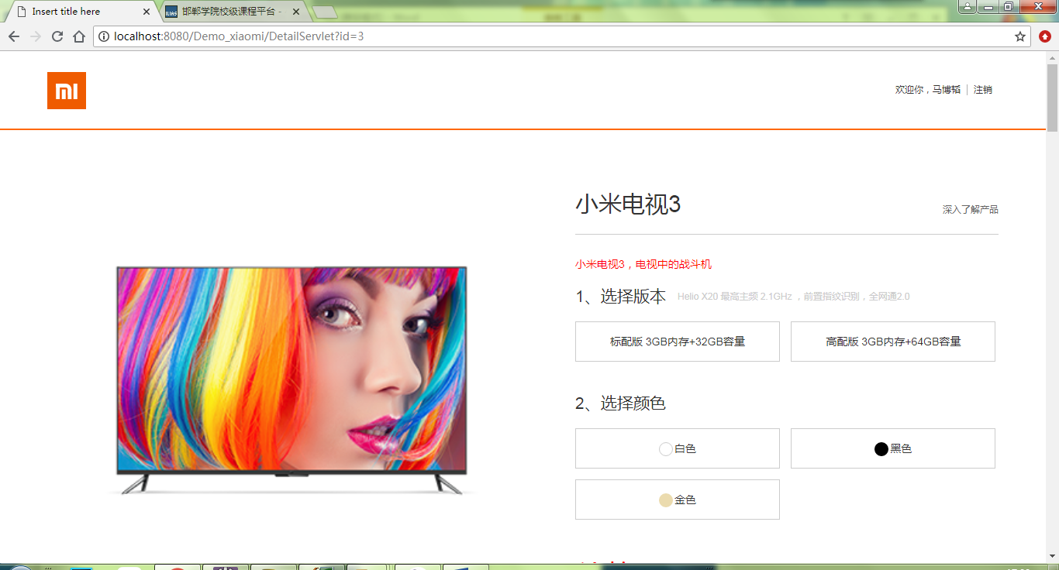
关键代码：
- DetailServlet.java
/**
* Servlet implementation class DetailServlet
*/
@WebServlet("/DetailServlet")
public class DetailServlet extends HttpServlet {
private static final long serialVersionUID = 1L;
/**
* @see HttpServlet#HttpServlet()
*/
public DetailServlet() {
super();
// TODO Auto-generated constructor stub
}
/**
* @see HttpServlet#doGet(HttpServletRequest request, HttpServletResponse response)
*/
protected void doGet(HttpServletRequest request, HttpServletResponse response) throws ServletException, IOException {
// TODO Auto-generated method stub
//response.getWriter().append("Served at: ").append(request.getContextPath());
int id = Integer.valueOf(request.getParameter("id"));
Product product = new ProductDao().getProduct(id);
request.setAttribute("product", product);
request.getRequestDispatcher("detail.jsp").forward(request, response);
}
/**
* @see HttpServlet#doPost(HttpServletRequest request, HttpServletResponse response)
*/
protected void doPost(HttpServletRequest request, HttpServletResponse response) throws ServletException, IOException {
// TODO Auto-generated method stub
doGet(request, response);
}
}
- detail.jsp
<main id="main" class="site-main">
<section id="prod-intro" class="wraper prod-intro">
<aside class="main-left intro-left">
<img src="${product.pimg}" class="prod-pic"
style="width: 500px; height: 500px">
</aside><section class="main-right intro-right">
<header class="prod-title">
<h2 class="name">${product.pname}</h2>
<span class="price"></span> <a href="" class="link">深入了解产品</a>
</header><p class="tip">${product.pdesc}</p>
<section class="options">
<hgroup class="opt-title"><h3>1、选择版本</h3>
<h4 class="desc">Helio X20 最高主频 2.1GHz ，前置指纹识别，全网通2.0</h4>
</hgroup><ul class="opt-ul">
<li><input class="option-btns" type="radio" name="version"
id="version1" hidden><label class="opt-item"
for="version1">标配版 3GB内存+32GB容量</label></li>
<li><input class="option-btns" type="radio" name="version"
id="version2" hidden><label class="opt-item"
for="version2">高配版 3GB内存+64GB容量</label></li>
</ul></section>
<section class="options">
<hgroup class="opt-title"><h3>2、选择颜色</h3></hgroup>
<ul class="opt-ul">
<li><input class="option-btns" type="radio" name="color"
id="color1" hidden><label class="opt-item" for="color1"><div
class="i_color i_white"></div>白色</label></li>
<li><input class="option-btns" type="radio" name="color"
id="color2" hidden><label class="opt-item" for="color2"><div
class="i_color i_black"></div>黑色</label></li>
<li><input class="option-btns" type="radio" name="color"
id="color3" hidden><label class="opt-item" for="color3"><div
class="i_color i_gold"></div>金色</label></li>
</ul></section><article>
<h3 class="notice" style="font-size: 40px; color: red">
价格：${product.price}</h3>
<a href="AddCartServlet?id=${product.pid}" class="btn"><button>加入购物车</button></a>
</article></section></section></main>
点击加入购物车，将商品添加到购物车，页面右上方提示购物车内商品数量
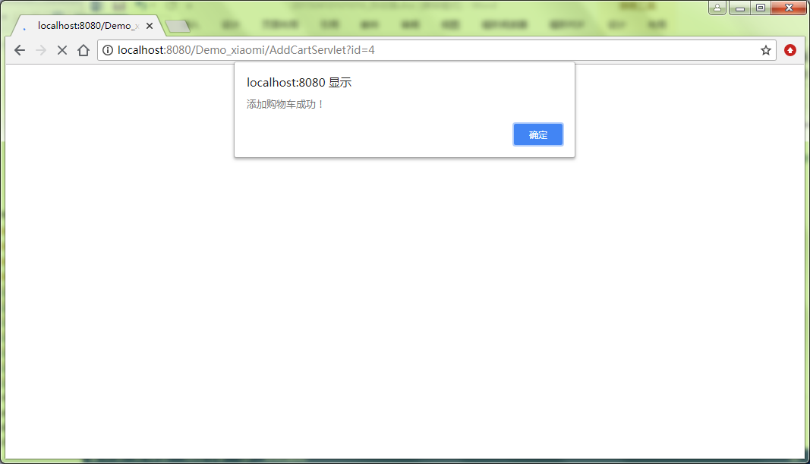
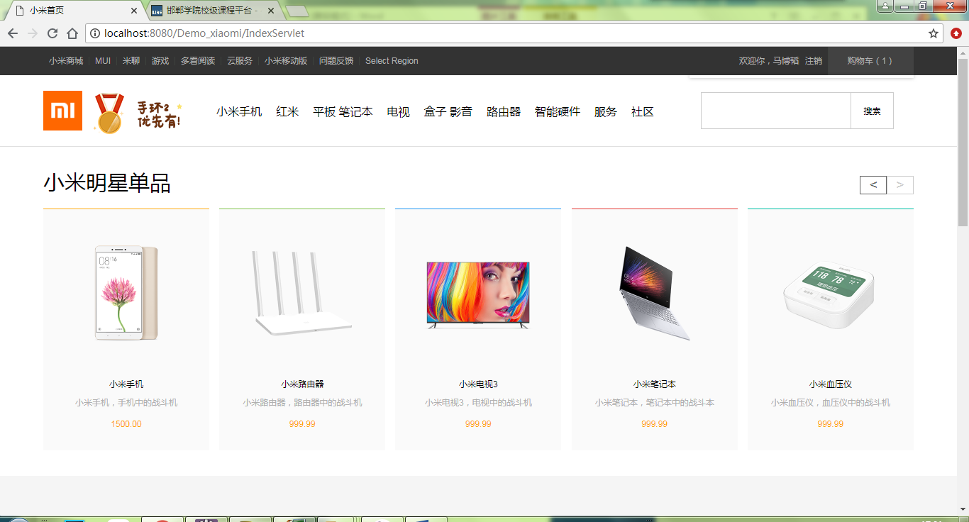
关键代码：
- AddCartServlet.java
/**
* Servlet implementation class AddCartServlet
*/
@WebServlet("/AddCartServlet")
public class AddCartServlet extends HttpServlet {
private static final long serialVersionUID = 1L;
/**
* @see HttpServlet#HttpServlet()
*/
public AddCartServlet() {
super();
// TODO Auto-generated constructor stub
}
/**
* @see HttpServlet#doGet(HttpServletRequest request, HttpServletResponse response)
*/
protected void doGet(HttpServletRequest request, HttpServletResponse response) throws ServletException, IOException {
// TODO Auto-generated method stub
//response.getWriter().append("Served at: ").append(request.getContextPath());
response.setContentType("text/html;charset=utf-8");
PrintWriter out = response.getWriter();
int id = Integer.valueOf(request.getParameter("id"));
HttpSession session = request.getSession();
//将购物车从session中取出
Map<Integer, CartItem> cart = (Map<Integer, CartItem>) session.getAttribute("cart");
//如果购物车为空，创建购物车
if(cart == null)
{cart = new HashMap<Integer,CartItem>();}
//判断商品是否在购物车里
CartItem cartItem = cart.get(id);
//商品不在购物车
if(cartItem == null)
{//将商品取出添加到购物车
cartItem = new CartItem();
cartItem.setNum(1);
cartItem.setProduct(new ProductDao().getProduct(id)); ;
cart.put(id, cartItem); }
else
{cartItem.setNum(cartItem.getNum()+1); }
session.setAttribute("cart", cart);
out.print("<script type='text/javascript'> alert('添加购物车成功！');location.href='IndexServlet'</script>");}
/**
* @see HttpServlet#doPost(HttpServletRequest request, HttpServletResponse response)
*/
protected void doPost(HttpServletRequest request, HttpServletResponse response) throws ServletException, IOException {
// TODO Auto-generated method stub
doGet(request, response); }}
查看购物车
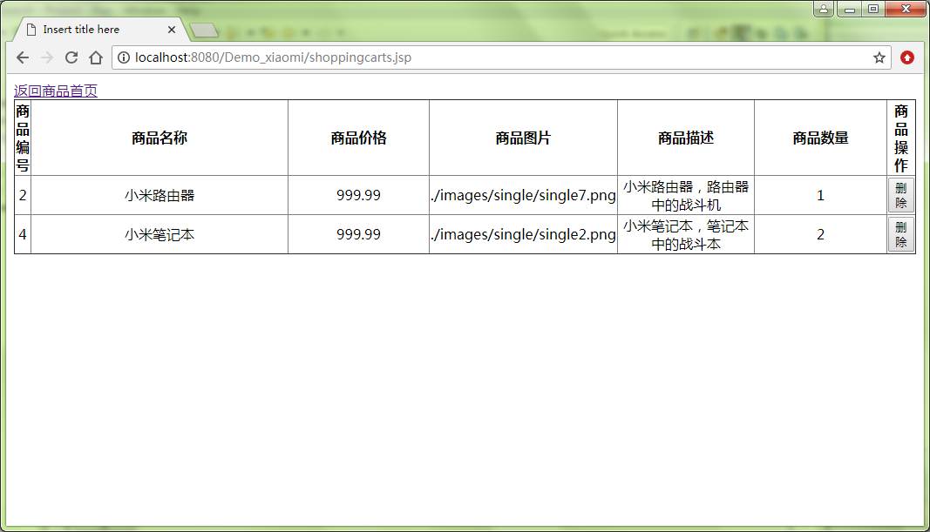
关键代码：
- shoppingcarts.jsp
<%@page import="com.hdc.mbt.domin.CartItem"%>
<%@page import="java.util.Map"%>
<%@page import="java.util.ArrayList"%>
<%@page import="java.util.List"%>
<%@ page language="java" contentType="text/html; charset=UTF-8"
pageEncoding="UTF-8"%>
<%@taglib prefix="c" uri="http://java.sun.com/jsp/jstl/core"%>
<!DOCTYPE html>
<html>
<head>
<meta charset="UTF-8">
<title>Insert title here</title>
</head>
<body>
<% Map<Integer,CartItem> cart = (Map<Integer,CartItem>)session.getAttribute("cart");
if (cart.isEmpty()) { %>
<script type="text/javascript">alert("购物车为空！");
location.href = "IndexServlet";
</script><% }%>
<a href="IndexServlet">返回商品首页</a>
<table border="1"
style="text-align: center; margin: 0px auto; border-collapse: collapse;">
<tr><th>商品编号</th><th>商品名称</th>
<th>商品价格</th><th>商品图片</th>
<th>商品描述</th><th>商品数量</th>
<th>商品操作</th></tr>
<c:forEach items="${cart}" var="item">
<tr>
<td class="td1">${item.value.product.pid}</td>
<td class="td2">${item.value.product.pname}</td>
<td class="td3">${item.value.product.price}</td>
<td class="td3">${item.value.product.pimg}</td>
<td class="td3">${item.value.product.pdesc}</td>
<td class="td3">${item.value.num}</td>
<td class="td4"><a href="DeleteCartServlet?id=${item.key}"><button>删除</button></a></td>
</tr></c:forEach></table></body></html>
删除购物车内商品
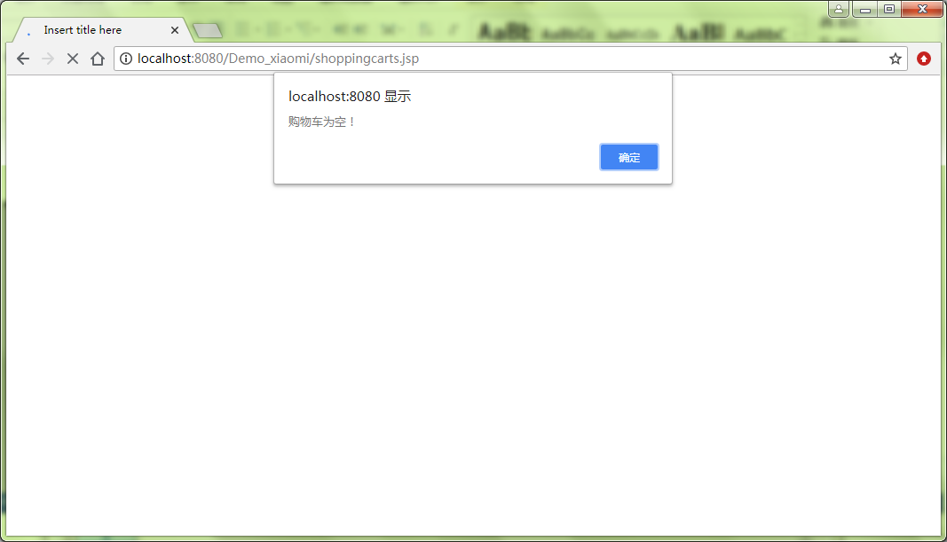
关键代码：
- DeleteCartServlet.java
/**
* Servlet implementation class DeleteCartServlet
*/
@WebServlet("/DeleteCartServlet")
public class DeleteCartServlet extends HttpServlet {
private static final long serialVersionUID = 1L;
/**
* @see HttpServlet#HttpServlet()
*/
public DeleteCartServlet() {
super();
// TODO Auto-generated constructor stub
}
/**
* @see HttpServlet#doGet(HttpServletRequest request, HttpServletResponse response)
*/
protected void doGet(HttpServletRequest request, HttpServletResponse response) throws ServletException, IOException {
// TODO Auto-generated method stub
//response.getWriter().append("Served at: ").append(request.getContextPath());
int id = Integer.valueOf(request.getParameter("id"));
HttpSession session = request.getSession();
//将购物车从session中取出
Map<Integer, CartItem> cart = (Map<Integer, CartItem>) session.getAttribute("cart");
cart.remove(id);
session.setAttribute("cart", cart);
response.sendRedirect("shoppingcarts.jsp");
}
/**
* @see HttpServlet#doPost(HttpServletRequest request, HttpServletResponse response)
*/
protected void doPost(HttpServletRequest request, HttpServletResponse response) throws ServletException, IOException {
// TODO Auto-generated method stub
doGet(request, response);
}
}
注销账号
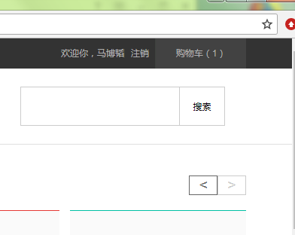
关键代码：
- CancelServlet.java
/**
* Servlet implementation class CancelServlet
*/
@WebServlet("/CancelServlet")
public class CancelServlet extends HttpServlet {
private static final long serialVersionUID = 1L;
/**
* @see HttpServlet#HttpServlet()
*/
public CancelServlet() {
super();
// TODO Auto-generated constructor stub
}
/**
* @see HttpServlet#doGet(HttpServletRequest request, HttpServletResponse response)
*/
protected void doGet(HttpServletRequest request, HttpServletResponse response) throws ServletException, IOException {
// TODO Auto-generated method stub
//response.getWriter().append("Served at: ").append(request.getContextPath());
HttpSession session = request.getSession();
session.removeAttribute("username");
response.sendRedirect("IndexServlet");
}
/**
* @see HttpServlet#doPost(HttpServletRequest request, HttpServletResponse response)
*/
protected void doPost(HttpServletRequest request, HttpServletResponse response) throws ServletException, IOException {
// TODO Auto-generated method stub
doGet(request, response);}}
数据库表设计：
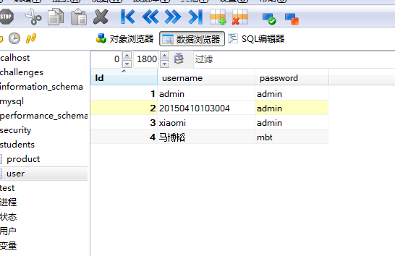

四、实验反思
在这周的培训课程中，我们学习了购物车模块的设计与实现，掌握JSTL及EL表达式的使用，掌握利用Session实现购物车JavaWeb项目中的登录和注册页面如何实现。虽从一开始的无处下手，到后来的逐渐完成，是通老师和同学的帮助,让我加快了实验的进程。这次实验使我受益匪浅。。这也为自己写毕业设计打下了很好的基础，但离我们自己设计出好的网站还很遥远，在之后阶段的学习要更加努力，为以后自己设计网站做好铺垫。

