R Notebook

This is an [R Markdown](http://rmarkdown.rstudio.com) Notebook. When you execute code within the notebook, the results appear beneath the code.

Try executing this chunk by clicking the *Run* button within the chunk or by placing your cursor inside it and pressing *Ctrl+Shift+Enter*.

Add a new chunk by clicking the *Insert Chunk* button on the toolbar or by pressing *Ctrl+Alt+I*.

When you save the notebook, an HTML file containing the code and output will be saved alongside it (click the *Preview* button or press *Ctrl+Shift+K* to preview the HTML file).

The preview shows you a rendered HTML copy of the contents of the editor. Consequently, unlike *Knit*, *Preview* does not run any R code chunks. Instead, the output of the chunk when it was last run in the editor is displayed.

library(plotrix)

# Problem 1.169

# A) Solution:

# EAR  
mean = 60  
# percent of RDA (p-value)  
pz = .9772  
# RDA  
A = 75  
  
# find z-value from p-value  
z= round(qnorm(pz, lower.tail = TRUE),2)  
print(paste("z score for RDA is", z))

## [1] "z score for RDA is 2"

sd = (A-mean)/z  
print(paste("Standard deviation of the requirement distribution is",sd))

## [1] "Standard deviation of the requirement distribution is 7.5"

# B) Solution:

ul = 2000  
xmin = mean-sd*3  
xmax = mean+sd*3  
# Create a sequence of numbers between xmin and 2000 incrementing by 0.1  
x <- seq(xmin, ul, by = .1)  
xgap <- ifelse(x>xmax,2000, x)  
# Choose the mean as 60 and standard deviation as 7.5.  
y <- dnorm(x, mean, sd)  
par(bty="n") # deleting the box  
gap.plot(xgap,y, gap=c(120,1970), gap.axis="x", pch=16,  
 col="blue", ylim=range(y),  
 xtics=c(seq(30, 120, by = 10),seq(1970, 2010, by = 10)),   
 xticlab=c(seq(30, 120, by = 10),seq(1970, 2010, by = 10)), xlab = 'mg/d',   
 ylab ='', main="Distribution of Vitamin C Consumption for Female")  
abline(v=mean, col="red") #add EAR line  
abline(v=A, col="purple") # add RDA line  
abline(v=seq(120,1970,100), col="white") # hiding vertical lines  
axis.break(1,120,style="slash") # plotting slashes for breakpoints  
legend(90, .04, legend=c("EAR", "RDA"),  
 col=c("red", "purple"), lty=1:1, cex=0.8)

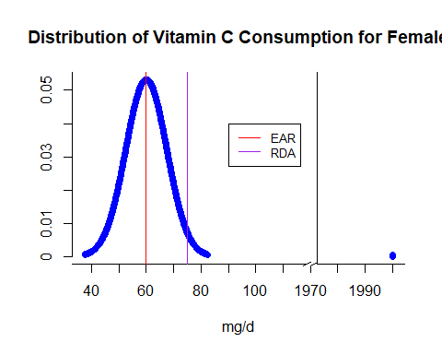

# Problem 1.170

# A) Solution:

#EAR  
mean = 75  
# percent of RDA (p-value)  
pz = .9772  
# RDA  
A = 90  
  
#find z-value from p-value  
z= round(qnorm(pz, lower.tail = TRUE),2)  
print(paste("z score for RDA is", z))

## [1] "z score for RDA is 2"

sd = (A-mean)/z  
print(paste("Standard deviation of the requirement distribution is",sd))

## [1] "Standard deviation of the requirement distribution is 7.5"

# B) Solution:

ul = 2000  
xmin = mean-sd*3  
xmax = mean+sd*3  
# Create a sequence of numbers between xmin and 2000 incrementing by 0.1  
x <- seq(xmin, ul, by = .1)  
xgap <- ifelse(x>xmax,2000, x)  
# Choose the mean as 60 and standard deviation as 7.5.  
y <- dnorm(x, mean, sd)  
par(bty="n") # deleting the box  
gap.plot(xgap,y, gap=c(120,1970), gap.axis="x", pch=16,  
 col="blue", ylim=range(y),  
 xtics=c(seq(30, 120, by = 10),seq(1970, 2010, by = 10)),   
 xticlab=c(seq(30, 120, by = 10),seq(1970, 2010, by = 10)), xlab = 'mg/d',   
 ylab ='', main="Distribution of Vitamin C Consumption for Male")  
abline(v=mean, col="red") #add EAR line  
abline(v=A, col="purple") # add RDA line  
abline(v=seq(120,1970,100), col="white") # hiding vertical lines  
axis.break(1,120,style="slash") # plotting slashes for breakpoints  
legend(100, .04, legend=c("EAR", "RDA"),  
 col=c("red", "purple"), lty=1:1, cex=0.8)

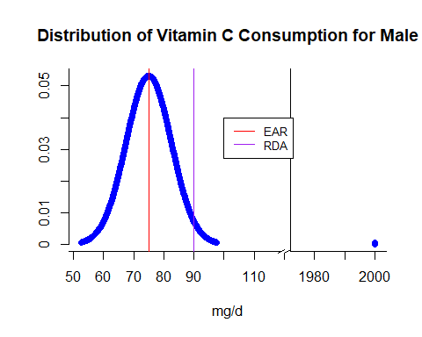

# Problem 1.171

# A) Solution:

# percent of RDA (p-value)  
pz5 = 0.05  
  
  
# find z-value from p-value  
z5= round(qnorm(pz5),2)  
print(paste("z score for 5th percentile is", z5))

## [1] "z score for 5th percentile is -1.64"

# percent of RDA (p-value)  
pz50 = 0.50  
# RDA  
A50 = 79  
# find z-value from p-value  
z50= round(qnorm(pz50, lower.tail = TRUE),2)  
print(paste("z score for 50th percentile is", z50))

## [1] "z score for 50th percentile is 0"

# percent of RDA (p-value)  
pz95 = 0.95  
  
# find z-value from p-value  
z95= round(qnorm(pz95, lower.tail = TRUE),2)  
print(paste("z score for 95th percentile is", z95))

## [1] "z score for 95th percentile is 1.64"

We know z = (x-mean)/sd

So, mean = x-(sd*z)

But, for 50th percentile, z is 0 as p(z<=0.00) = .50

So, mean = A50-(sd*0)

Finally, mean = A50

mean = A50  
print(paste("The value of mean is",mean))

## [1] "The value of mean is 79"

A95 = 142  
sd = (A95-mean)/z95  
print(paste("The value of standard deviation is",sd))

## [1] "The value of standard deviation is 38.4146341463415"

# B) Solution:

ul = 2000  
xmin = mean-sd*3  
xmax = mean+sd*3  
# Create a sequence of numbers between xmin and 2000 incrementing by 0.1  
x <- seq(xmin, ul, by = .1)  
xgap <- ifelse(x>xmax,2000, x)  
# Choose the mean as 60 and standard deviation as 7.5.  
y <- dnorm(x, mean, sd)  
par(bty="n") # deleting the box  
gap.plot(xgap,y, gap=c(200,1970), gap.axis="x", pch=16,  
 col="blue", ylim=range(y),  
 xtics=c(seq(-40, 200, by = 10),seq(1970, 2010, by = 10)),   
 xticlab=c(seq(-40, 200, by = 10),seq(1970, 2010, by = 10)), xlab = 'mg/d',   
 ylab ='', main="Distribution of Vitamin C Consumption for Female")  
abline(v=mean, col="red") #add new mean line  
abline(v=60, col="purple") # add old mean line  
abline(v=75, col="violet") # add RDA line  
abline(v=seq(200,1970,100), col="white") # hiding vertical lines  
axis.break(1,200,style="slash") # plotting slashes for breakpoints  
legend(140, .01, legend=c("New mean", "Old mean", "RDA"),  
 col=c("red", "purple", "violet"), lty=1:1, cex=0.8)

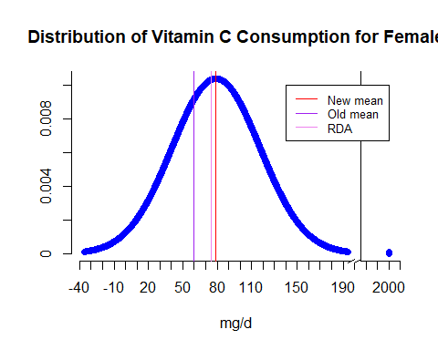

# C) Solution:

*As per the new graph, we can see that the new mean (79) is more than the previously estimated mean (60) and the new mean (79) which is at 50th percentile is also more than the RDA (75). So we can confidently say that majority of the female population consumes more vitamin C than the RDA on a daily basis.*

# Problem 1.172

# A) Solution:

# percent of RDA (p-value)  
pz5 = 0.05  
  
  
# find z-value from p-value  
z5= round(qnorm(pz5),2)  
print(paste("z score for 5th percentile is", z5))

## [1] "z score for 5th percentile is -1.64"

# percent of RDA (p-value)  
pz50 = 0.50  
# RDA  
A50 = 114  
# find z-value from p-value  
z50= round(qnorm(pz50, lower.tail = TRUE),2)  
print(paste("z score for 50th percentile is", z50))

## [1] "z score for 50th percentile is 0"

# percent of RDA (p-value)  
pz95 = 0.95  
  
# find z-value from p-value  
z95= round(qnorm(pz95, lower.tail = TRUE),2)  
print(paste("z score for 95th percentile is", z95))

## [1] "z score for 95th percentile is 1.64"

We know z = (x-mean)/sd

So, mean = x - (sd*z)

But, for 50th percentile, z is 0 as p(z<=0.00) = .50

So, mean = A50-(sd*0)

Finally, mean = A50

mean = A50   
print(paste("The value of mean is",mean))

## [1] "The value of mean is 114"

A95 = 217  
sd = (A95-mean)/z95  
print(paste("The value of standard deviation is",sd))

## [1] "The value of standard deviation is 62.8048780487805"

# B) Solution:

ul = 2000  
xmin = mean-sd*3  
xmax = mean+sd*3  
# Create a sequence of numbers between xmin and 2000 incrementing by 0.1  
x <- seq(xmin, ul, by = .1)  
xgap <- ifelse(x>xmax,2000, x)  
# Choose the mean as 60 and standard deviation as 7.5.  
y <- dnorm(x, mean, sd)  
par(bty="n") # deleting the box  
gap.plot(xgap,y, gap=c(330,1970), gap.axis="x", pch=16,  
 col="blue", ylim=range(y),  
 xtics=c(seq(-80, 330, by = 10),seq(1970, 2010, by = 10)),   
 xticlab=c(seq(-80, 330, by = 10),seq(1970, 2010, by = 10)), xlab = 'mg/d',   
 ylab ='', main="Distribution of Vitamin C Consumption for Male")  
abline(v=mean, col="red") #add new mean line  
abline(v=75, col="purple") # add old mean line  
abline(v=90, col="violet") # add RDA line  
abline(v=seq(330,1970,100), col="white") # hiding vertical lines  
axis.break(1,330,style="slash") # plotting slashes for breakpoints  
legend(240, .005, legend=c("New mean", "Old mean", "RDA"),  
 col=c("red", "purple", "violet"), lty=1:1, cex=0.8)

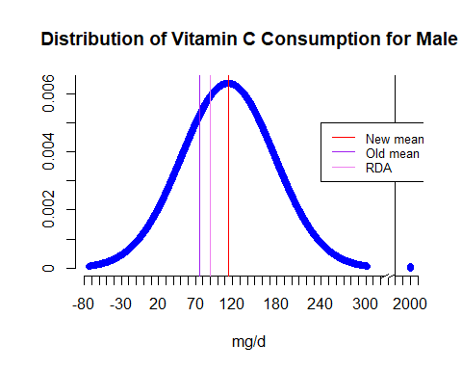

# C) Solution:

*As per the new graph, we can see that the new mean (114) is more than the previously estimated mean (75) and the new mean (114) which is at 50th percentile is also more than the RDA (90). So we can confidently say that majority of the male population consumes more vitamin C than the RDA on a daily basis.*

# Problem 1.176

# A) Solution:

For third graders’ current scores:

μ=70

σ=10

z = (x-μ)/σ

=>z = (x-70)/10 …..(1)

For desired score

μ=100

σ=20

so X-new =z*σ +μ

=[(x-70)/10]*20 +100 ......(from 1)  
  
 =2x-140+100  
  
 =2x-40

So, a=-40 and b=2

# B) Solution:

For six graders’ current scores:

μ=80

σ=11

z = (x-μ)/σ

=>z = (x-80)/11 …..(1)

For desired score

μ=100

σ=20

so X-new =z*σ +μ

=[(x-80)/11]*20 +100 ......(from 1)  
  
 =(20x-1600+1100)/11  
   
 =(20x-500)/11  
  
 =1.82x-45.45

So, a=-45.45 and b=1.82

# C) Solution:

David’s transformed score =-40+2*72=104

Nancy’s transformed score = -45.45+1.82*78=96.51

David Scores higher as his standardized transformed score is higher.

# D) Solution:

For both third and six graders standardized scoring less than 75 as they have the same distribution:

mean = 100  
sd = 20  
x = 75  
z = (x-mean)/sd  
z

## [1] -1.25

pz = pnorm(z, lower.tail = TRUE)  
print(paste("Percent value is", round(pz*100,2),"%"))

## [1] "Percent value is 10.56 %"

For non-standardized scoring:

# for third graders  
mean = 70  
sd = 10  
x = 75  
z = (x-mean)/sd  
z

## [1] 0.5

pz = pnorm(z, lower.tail = TRUE)  
print(paste("Percent value of third graders is", round(pz*100,2),"%"))

## [1] "Percent value of third graders is 69.15 %"

# for sixth graders  
mean = 80  
sd = 11  
x = 75  
z = (x-mean)/sd  
z

## [1] -0.4545455

pz = pnorm(z, lower.tail = TRUE)  
print(paste("Percent value of sixth graders is", round(pz*100,2),"%"))

## [1] "Percent value of sixth graders is 32.47 %"