DS - 670 –Capstione Big Data & Business Analytics

Mir Ahmed, Kaushik Raj Devarashetty, Madhuri koganti, leonsteen sterling

Project Proposal: Predicting House Prices and Identifying Ideal Locations in NJ

Saint Peter’s University | 2641 John F. Kennedy Blvd, Jersey City, NJ 07306

2023

# Project Proposal: Predicting House Prices and Identifying Ideal Locations in NJ

# Introduction

In this project, we aim to build two types of predictive models using various machine learning algorithms to predict the house price for purchase and identify ideal locations for purchase or rent in New Jersey. The project will use publicly available datasets from various sources such as Zillow, Freddie Mac, NJ Department of Education, and the Census Bureau. The project's primary goal is to help real estate investors and buyers as well as new residents and potential movers make informed decisions based on the models’ predictions.

# Project Group

Kaushik Raj Devarashetty

Madhuri Koganti

Mir Ahmed

Leonsteen Sterling

# Problem Statement

Moving to a new state can be a challenging task, especially when trying to determine the ideal location to live. People who are planning to move to New Jersey may not have enough knowledge about the state and its counties, which can make it difficult to determine where to live. Additionally, there are various factors to consider, such as the cost of living, crime rate, schools, and accessibility to amenities, which can be overwhelming to evaluate.

To tackle this challenge, we aim to develop a recommendation system that will assist people who are moving to NJ from other states in finding the appropriate county to rent or own a home using predictive modeling. The system will collect and analyze data from various sources such as real estate listings, census data, and public records to identify key factors that influence the quality of life in each county. We will use machine learning algorithms to predict the best counties that match an individual's preferences and needs, such as number of bedrooms, quality of schools, crime rate, and cost of living.

For this project, we would like our problem statement to be as follows:

**What type of crime has the most impact on house prices for a specific county?**

# Data Sources

## Zillow Home Value Index Data:

The dataset provides information on the Zillow Home Value Index by county, city, or ZIP code, which would be used as the target variable for building regression and/or classification models.

<https://www.zillow.com/research/data/>

## Mortgage Value Data:

This dataset provides information on the average mortgage rates for different regions in NJ, which could be used as a predictor variable in the regression and/or classification models.

[http://www.freddiemac.com/pmms/#](http://www.freddiemac.com/pmms/)

## Tax Rate Data:

This dataset provides information on the tax rates for different regions in NJ, which could be used as a predictor variable in the regression and/or classification models.

<https://www.state.nj.us/treasury/taxation/lpt/statdata.shtml>

## County Lines and Shape Data (GeoJSON):

This dataset provides geographic boundaries for different counties in NJ and could be used to visualize location-based features.

<http://data.ci.newark.nj.us/dataset/new-jersey-counties-polygon/resource/95db8cad-3a8c-41a4-b8b1-4991990f07f3>

## NJ Department of Education Data for School Performance:

This dataset provides information on school ratings for different regions in NJ, which could be used as a predictor variable in the classification and/or regression models.

<https://www.schooldigger.com/go/NJ/schoolrank.aspx>

## Crime Data:

These datasets provide information on crime rates for different regions in NJ, which could be used as a predictor variable in the classification and/or regression models.

For 2017: <https://ucr.fbi.gov/crime-in-the-u.s>

For 2018,2019,2020: <https://www.njsp.org/ucr/current-crime-data.shtml>

## Poverty and Median Income Data:

This dataset provides information on poverty and median income rates for different regions in NJ, which could be used as predictor variables in both the regression and classification models.

<https://www.census.gov/programs-surveys/saipe/data/api.html>

## NJ Population History by County

These datasets will give us historical population counts (estimated) from 2010 till 2021.

<https://www.nj.gov/labor/labormarketinformation/demographics/population-household-estimates/>

## NJ Municipalities by County

These datasets will give us all municipalities by county for NJ.

<https://data.nj.gov/Reference-Data/Municipalities-of-New-Jersey/k9xb-zgh4>

## NJ Food Desert – USDA Foot Atlas

This dataset will provide us flags for low access areas (food deserts) by county, which could be used as a predictor variable in the classification and/or regression models.

<https://www.ers.usda.gov/data-products/food-access-research-atlas/>

## NJ Area Deprivation Index – Neighborhood Atlas

The Area Deprivation Index (ADI) is based on a measure created by the Health Resources & Services Administration (HRSA) over three decades ago, and has since been refined, adapted, and validated to the Census Block Group neighborhood level by Amy Kind, MD, PhD and her research team at the University of Wisconsin-Madison. It allows for rankings of neighborhoods by socioeconomic disadvantage in a region of interest (e.g., at the state or national level). It includes factors for the theoretical domains of income, education, employment, and housing quality. It can be used to inform health delivery and policy, especially for the most disadvantaged neighborhood groups. "Neighborhood" is defined as a Census Block Group.

<https://www.neighborhoodatlas.medicine.wisc.edu/download>

# Methodology

## Regression Model:

For the regression model, we will use the Zillow Home Value Index as the target variable and use different algorithms such as Linear Regression, Random Forest, K-Nearest Neighbor, and Support Vector Machines to predict the house prices for different regions in NJ. The regression model will use predictor variables such as mortgage rates, tax rates, poverty rates, and median income rates. We will use the Root Mean Squared Error (RMSE) to evaluate the performance of the regression models.

## Classification Model:

For the classification model, we will use various algorithms such as Logistic Regression, Random Forest, K-Nearest Neighbor, Support Vector Machines, and Neural Networks to identify ideal locations for purchase or rent in NJ. The classification model will use predictor variables such as school performance metrics, crime rates, poverty rates, and median income rates. We will use accuracy, precision, recall, and F1-score to evaluate the performance of the classification models.

# Expected Outcome

The expected outcome of this project is to develop an app with most possible accurate predictive models for real estate investment/ rentals in New Jersey. These models will provide insights and recommendations to potential investors/ new residents to make informed decisions about property investments/ rentals in the state. This project will also provide an opportunity to understand the impact of various factors such as school performance, crime rates, and poverty levels on housing prices and rental values in New Jersey.

# Exploratory Data Analysis

Below are the packages we have used on Jupyter notebook to create these visualizations:

* matplotlib
* seaborn
* plotly

Besides these packages specific to visualization, we have also used the following packages for our exploratory data analysis:

* Pandas
* Numpy
* Pandas Profiling

First, we looked at each dataset separately and observed the trends. Below are the trend analyses of our datasets:

## Crime

Crime rates are going down in most of the counties across time, except Cape May.

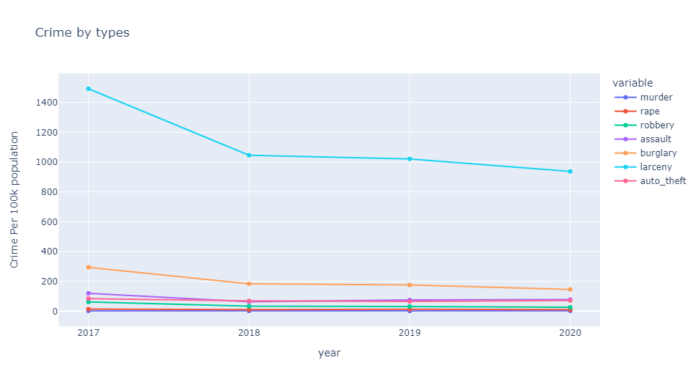

Most frequent violent crime in NJ is larceny which is also going down along with all other violent crimes over time.

## Poverty

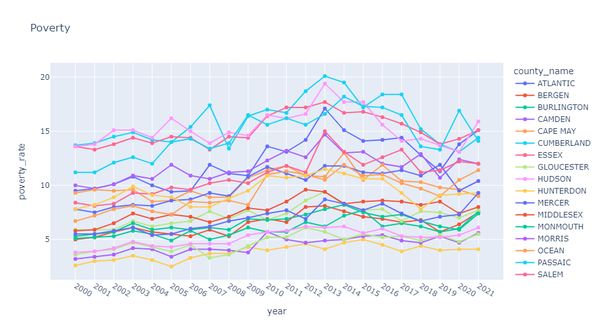

Poverty rates of counties are going up and down (zagged) from 2000 through 2021. But ultimately poverty rates in 2021 are more than what they were back in 2000.

## Median household income

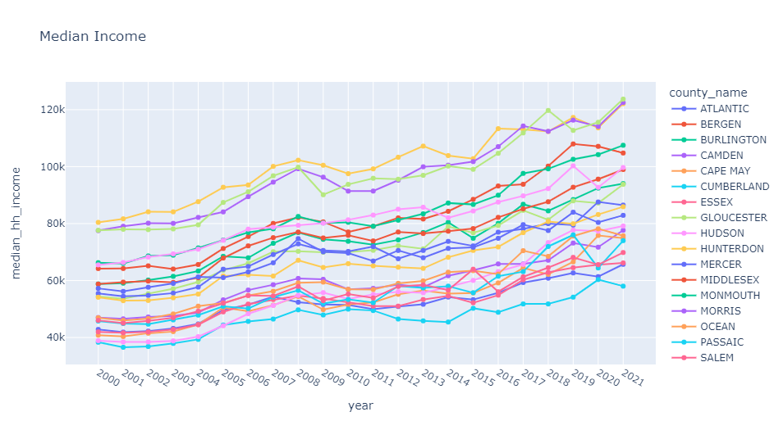

Median income is steadily going up across time.

## School performance

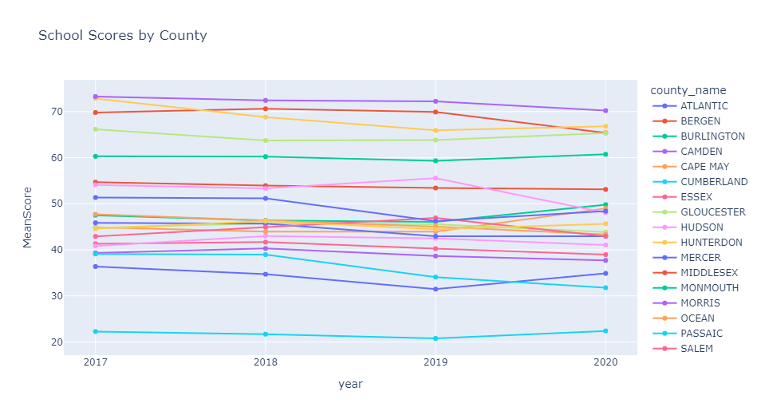

On average, NJ schools maintained their quality/ranking over time with a couple of exceptions like Passaic, Sussex, and Bergen.

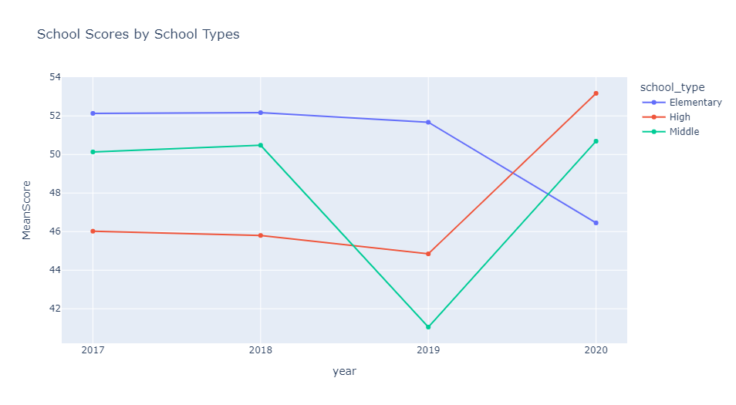

Mean scores for elementary schools went down. Middle schools saw a steep decline from 2018-2019 then got back up in 2020. High school scores went up by a lot from 2019 onwards.

## Zillow House Value Index

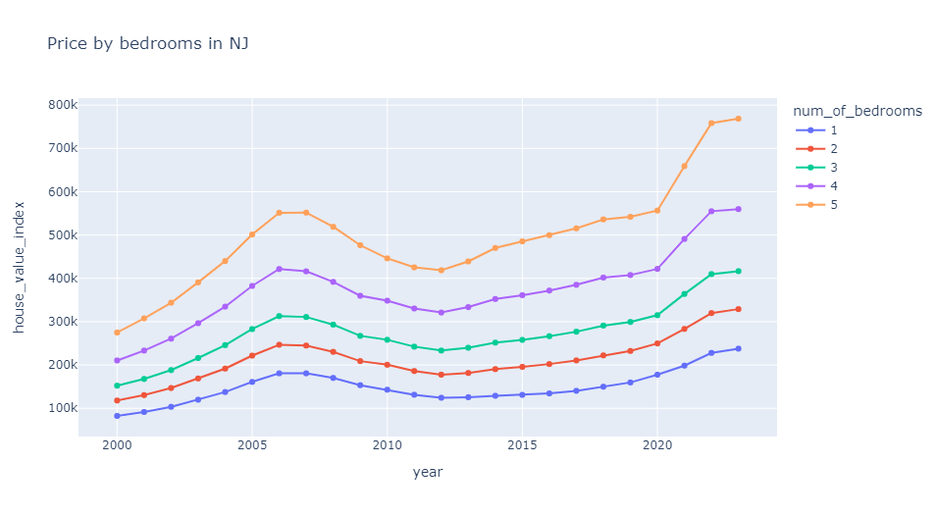

House prices for all bedrooms are going up over time except for a short decline from 2007 to 2012.

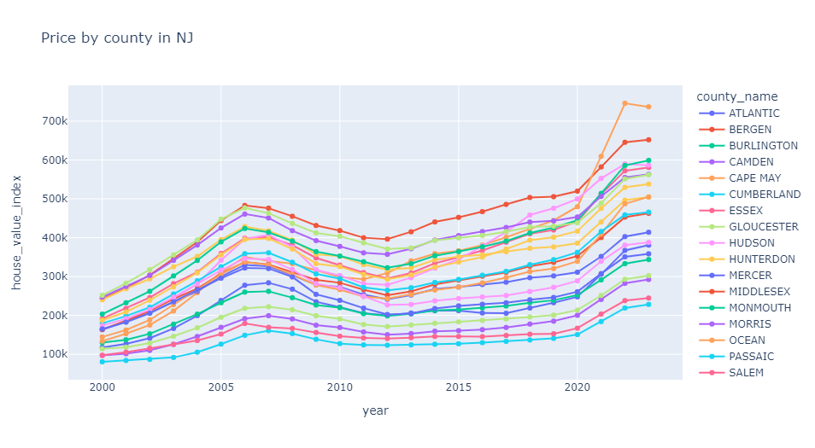

House prices for all counties are going up over time except for a short decline from 2007 to 2012.

## Zillow Observed Rent Index

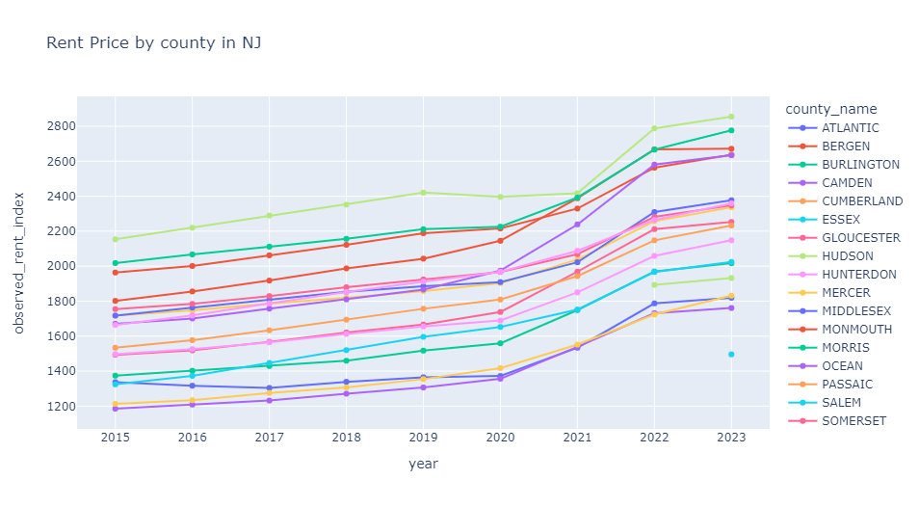

Rental prices for all counties are going up over time.

## Property Tax

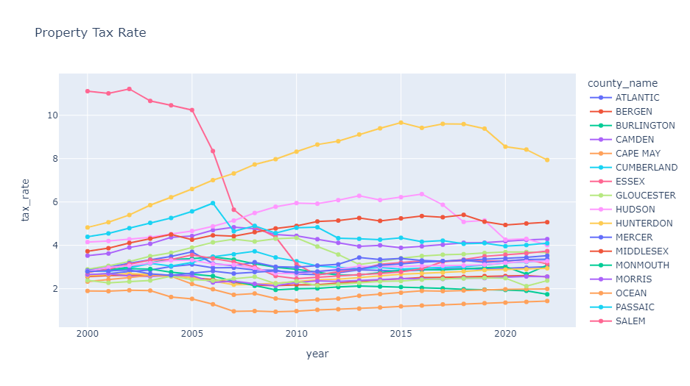

Essex property tax saw a huge decline from 2005 through 2011. Union property tax was on the rise from 2000 till 2015 and then it started to decline. Hudson also saw an increase in property tax up until 2016 and then it went down. The rest of the counties kind of maintained the same property tax across time.

## Population

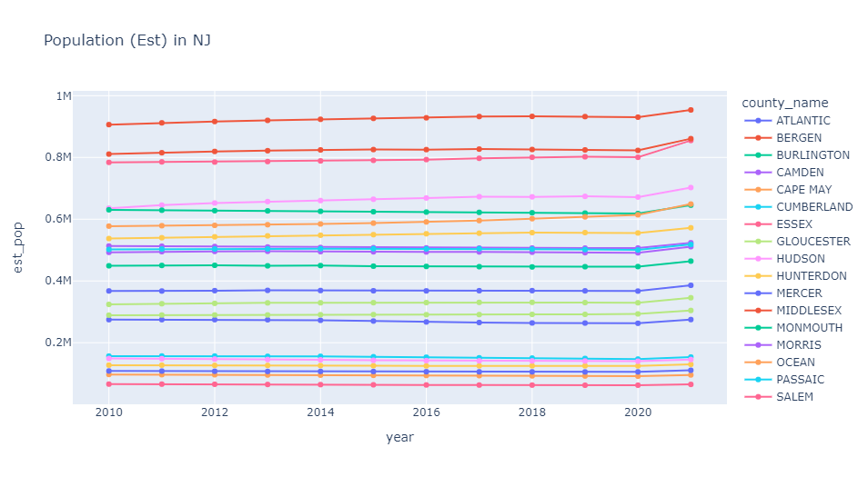

Population counts (estimated) are increasing very slightly over the years for all the counties.

## Food Desert

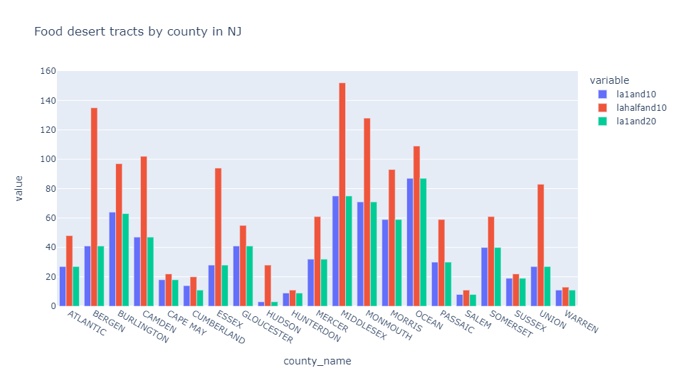

Food desert counts are mostly the same for both 1 mile radius in urban areas and 10 mile radius in rural areas and 1 mile radius in urban areas and 20 mile radius in rural areas. Counts are high for half mile radius in urban areas and 10 mile radius for rural areas for Middlesex, Bergen, and Monmouth.

## Area Deprivation Index

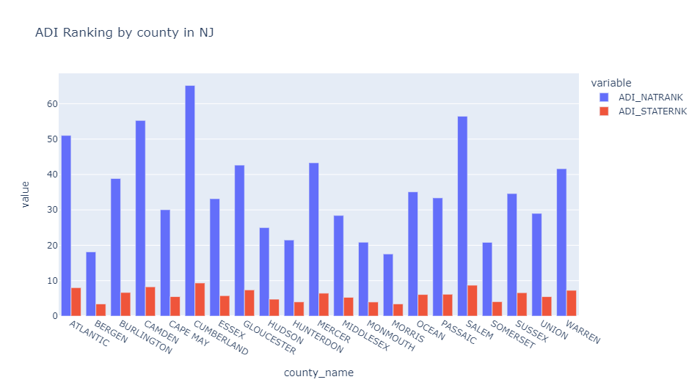

Counties like Cumberland, Salem, Camden and Atlantic are ranked pretty far down the list of counties nationwide in terms of area deprivation index, which translates low socio economic and educational opportunities.

## Correlation heatmap for historical data

We merged all the data sets using county names and created a correlation heatmap which shows the correlations between all variables.

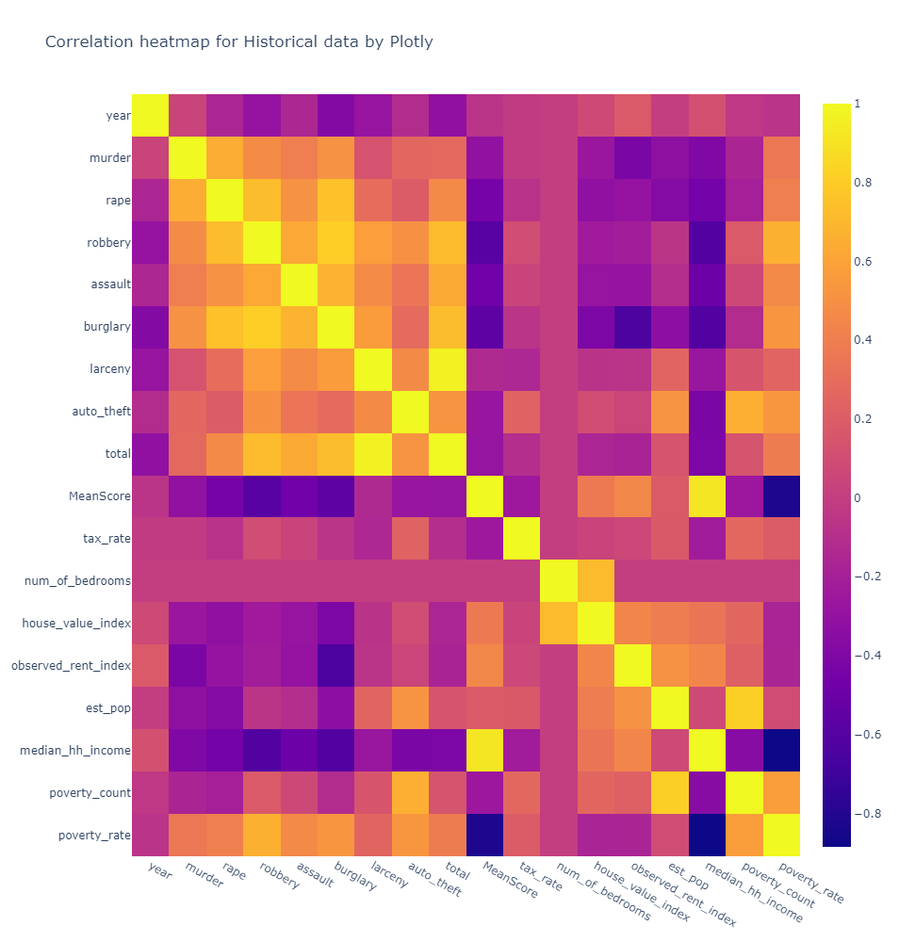

House value index has strong positive correlation with number of bedrooms and has weak positive correlation with school score, rent index, population, and median household income. It has a weak negative correlation with poverty rate but weak positive correlation with poverty count.

## Correlation heatmap for historical data

Then we just focused on data from 2020 as we had the most amount of data points as well as the latest for that year.

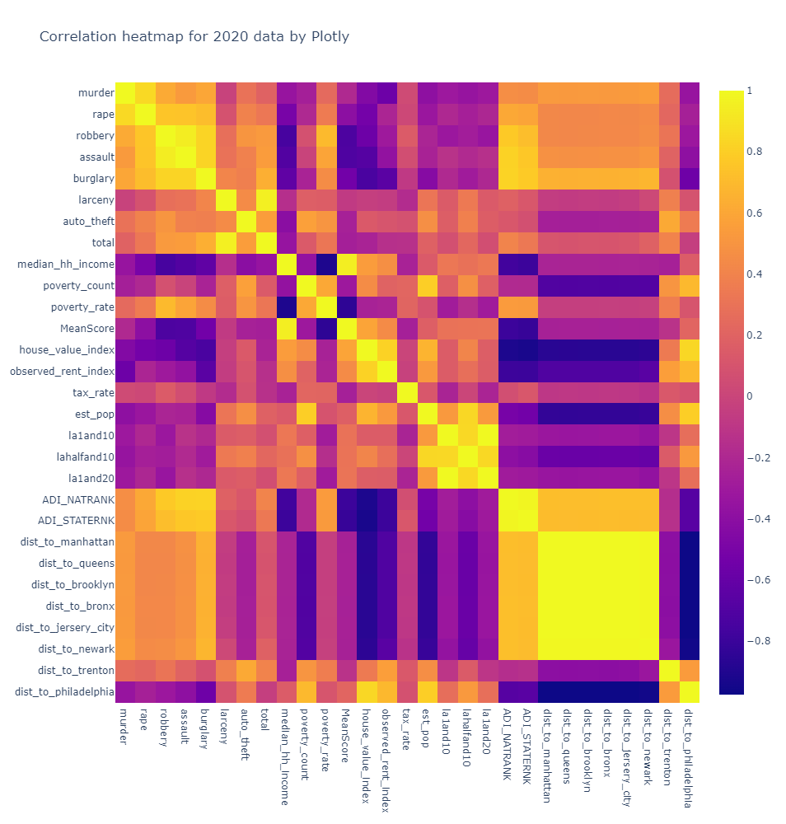

The House Price index has a strong negative correlation with distance to all major cities except Trenton and Philadelphia as well as Area Deprivation Index (ADI) - both national and state rankings and burglary. The House Price Index has a strong positive correlation with the Observed Rent Index and moderately strong positive correlation with population, median household income, school scores. The House Price Index also have somewhat of a weak to moderate positive correlation to food desert count at half mile radius.

The poverty rate has a strong negative correlation with school score and median household income and moderately strong positive correlation between different violent crimes. Out of those violent crimes, burglary has the biggest correlation with house price index. Next, we have assault which also has a moderate negative correlation with house prices.

# Conclusion

Based on our exploratory analysis, we came to the following conclusion:

**The number of burglaries in a county has the most adverse effect on Zillow house price index.**

So, we should avoid counties for house purchase as well as rentals where the number of burglaries is high.

**References**

“Moving to New Jersey - A Complete Guide 2023.” *Movingist*, 2023, Retrieved March 10, 2023. <https://movingist.com/moving-to-new-jersey/>

“Moving to New Jersey.” *Moving to New Jersey - A Complete Relocation Guide 2023*, Retrieved March 10, 2023. <https://www.moverjunction.com/moving-to-new-jersey>