Cascade Classifiers

Haar Cascade

* Machine learning object detection algorithm used to identify objects in an image or video

Four stages of the algorithm:

1. Haar Feature Selection
2. Creating Integral Images
3. Adaboost Training
4. Cascading Classifiers

Example: Face Detection

1. Collect the Haar features
   1. Look at a specific location of an image
   2. Look at the adjacent rectangular regions
   3. Sum the pixel intensities of each region
   4. Calculate the difference between these sums
2. Integral Images
   1. Also known as Summed Area Table
   2. Quick and effective way of calculating the sum of values (pixel values) in a given image
3. Adaboost Training

* Most features that are calculated can be considered irrelevant, look at image below.

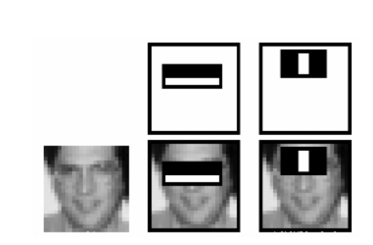

* The far left image is the image that is being calculates
* The rectangles represent the “feature”
* The “feature” is focusing on how to detect/break down the eyes
* The first feature (middle two images) focus on the region of the eyes where the eyes are darker than the nose and the cheeks
* The second feature (right two images) focus on the region of the eyes are darker than the bridge of the nose
  1. Adaboost selects the best features and trains the classifiers that use them
  2. This algorithm constructs a strong classifier as a linear combination of weighted simple “weak” classifiers
  3. During the detection stage, a window of the target size is moved over the input image and for each subsection of the image, a Haar feature(s) are(is) calculated
  4. Each Haar feature is a “weak” classifier (detection quality is slightly better than random) and a large number of Haar features are needed to describe an object with sufficient accuracy and then becomes a cascade classifier to form strong classifier

1. Cascade Classifier
   1. The cascade classifier consists of a collection of stages where each stage is an ensemble of weak learners (simple classifiers)
   2. Each stage is trained using the “boosting” technique
   3. The boosting provides the ability to train a highly accurate classifier by taking a weighted average of decisions made by weak learners
   4. Each stage of classifier labels the region as either a positive or a negative
   5. Positive indicates that an object was found
   6. Negative indicates an object was not found
   7. If label is negative, the classification of the region is complete and the detector slides the window to the next location
   8. The detector reports an object found at the current window location when the final stage classifies the region is positive

<http://www.willberger.org/cascade-haar-explained/>