HSV

**What is HSV?**

H = Hue

S = Saturation

V = Value

**Hue**

Hue is the shade of a color rather than using primary colors to describe it. It’s value is between 0 to 360 degrees.

* Red: 0 to 60 degrees
* Yellow: 61 to 120 degrees
* Green: 121 to 180 degrees
* Cyan: 181 to 240 degrees
* Blue: 241 to 300 degrees
* Magenta: 301 to 360 degrees

**Saturation**

Saturation is the intensity of a color. It’s value is between 0 to 100%. The closer it is to 0, more grey it looks.

**Value**

Value is the brightness or intensity of the color. The value is between 0% to 100%. The closer it is to 0, the darker and more black it is. The closer it is to 100%, the brighter and the more it reveals the most of the color.

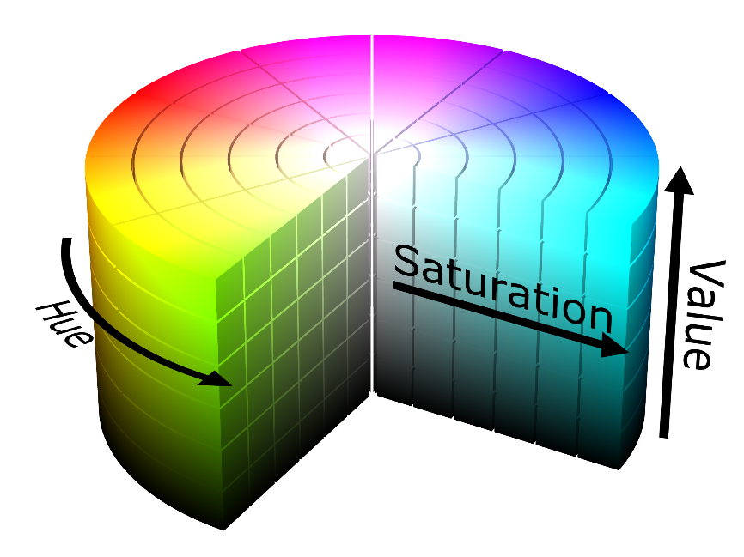

HSV is represented in a cylindrical shape.

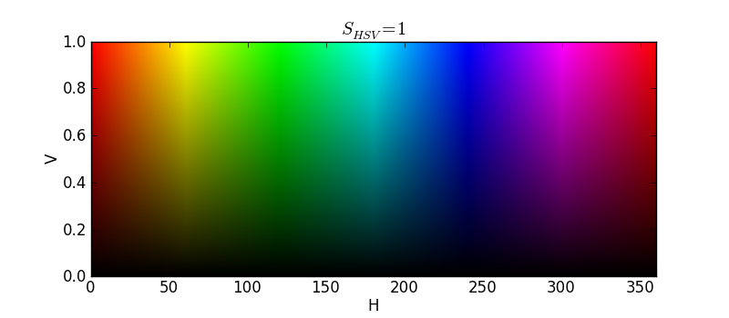

When represented in a flat surface, red is on both sides of the spectrum, which is why to detect the color red, there are two ranges (refer back to the code). But when detecting other colors, there is only one range.

**Why use HSV instead of RGB/BGR?**

RGB colorspace is represented dependent on how much of the primary colors R, G, and B (Red, blue and green). It is not easily converted through code also is not how humans perceive color. HSV is more closely how color is perceived through the eyes as well as easier to use within code.