WEEK 1 REPORT
Data Acquisition, Cleaning, and Preprocessing
Case study: Titanic passenger dataset (891 records, 12 features)
Prepared by: SK Miraj Ahamed
Tools: Python 3, pandas, NumPy, Matplotlib, Seaborn, scikit-learn
Data source: Public Titanic dataset (DataScienceDojo GitHub repository, CSV format)
Deliverables: This report, the cleaning script pipeline.py, and the cleaned file titanic_cleaned.csv

1. Introduction and Objectives
Real-world data is rarely ready for analysis. It arrives with missing values, inconsistent entries, extreme values and columns that a model cannot use directly. If these problems are ignored, every later step (visualisation, statistics, machine learning) inherits them, which is why data preparation usually takes most of a data science project.
The goal of this task is to acquire a public dataset, assess its quality, clean it, preprocess it for modelling, and document every decision with code and reasoning. The specific objectives are:
- Select a reliable public dataset and describe how it was collected.
- Explore the structure and quality of the data.
- Detect and treat missing values, inconsistencies and outliers.
- Prepare the data for analysis through feature engineering, encoding and scaling.
- Explain the rationale behind each choice and discuss its effect on later analyses.

2. Data Acquisition

2.1 Dataset selection
The Titanic passenger dataset was chosen. It is a widely used public dataset, so its context is well documented and results can be cross-checked against other work. It also contains all three classes of problem this task asks about: a large amount of missing data (Age, Cabin, Embarked), outlier-prone numeric columns (Fare, family counts) and text columns hiding useful information (Name, Cabin).

2.2 Collection method
The data was downloaded programmatically as a CSV file from a public GitHub repository, rather than by manual copy, so that the whole workflow is reproducible by running a single script.
Python code
import pandas as pd, numpy as np
import matplotlib.pyplot as plt
import seaborn as sns

URL = ("https://raw.githubusercontent.com/datasciencedojo/"
"datasets/master/titanic.csv")
df = pd.read_csv(URL) # acquisition
raw = df.copy() # untouched backup for before/after comparisons
print(df.shape)

Output
(891, 12)

2.3 Data dictionary
Column | Type | Description
PassengerId | int | Unique row identifier
Survived | int (0/1) | Target variable: 1 = survived, 0 = did not
Pclass | int (1-3) | Ticket class, a proxy for socio-economic status
Name | text | Passenger name including title (Mr, Mrs, Miss...)
Sex | text | male / female
Age | float | Age in years (fractional for infants)
SibSp | int | Number of siblings or spouses aboard
Parch | int | Number of parents or children aboard
Ticket | text | Ticket number
Fare | float | Ticket price paid
Cabin | text | Cabin number (deck letter + number)
Embarked | text | Port of embarkation: C, Q or S

3. Initial Data Exploration
Before changing anything, the structure and quality of the raw data were inspected: shape, data types, summary statistics, missing values and duplicates.
Python code
print(df.dtypes)
print(df.describe().round(2))
print(df.isnull().sum())
print("Duplicate rows:", df.duplicated().sum())
print("Duplicate IDs :", df.PassengerId.duplicated().sum())

Output
Summary statistics (numeric columns)
Survived Pclass Age SibSp Parch Fare
count 891.00 891.00 714.00 891.00 891.00 891.00
mean 0.38 2.31 29.70 0.52 0.38 32.20
std 0.49 0.84 14.53 1.10 0.81 49.69
min 0.00 1.00 0.42 0.00 0.00 0.00
50% 0.00 3.00 28.00 0.00 0.00 14.45
max 1.00 3.00 80.00 8.00 6.00 512.33

Duplicate rows: 0
Duplicate IDs : 0

3.1 Key observations
- The dataset has 891 rows and 12 columns, with no duplicate rows or duplicate passenger IDs.
- Only 38% of passengers survived, so the target is moderately imbalanced.
- Fare has a mean (32.20) far above its median (14.45) and a maximum of 512.33, which signals a strongly right-skewed distribution with extreme values.
- Age has a count of 714, so values are missing. Its minimum of 0.42 is a legitimate infant age expressed in years.

3.2 Missing values
Column | Missing | % of rows | Initial assessment
Cabin | 687 | 77.10% | Mostly absent; the absence itself may be informative
Age | 177 | 19.87% | Important predictor; too many rows to drop
Embarked | 2 | 0.22% | Negligible; simple fill is enough

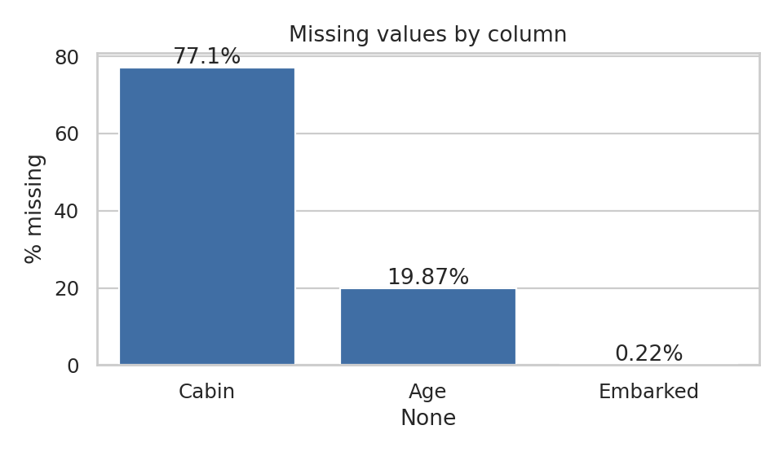
Figure 1: Percentage of missing values per column

4. Data Quality Issues Identified
Beyond missing values, consistency checks were run on categorical labels, value ranges, text fields and numeric extremes.
Python code
print(df.Sex.unique(), df.Embarked.unique())
print("Names with stray whitespace:", (df.Name != df.Name.str.strip()).sum())
print("Fare == 0 :", (df.Fare == 0).sum())
print("Age < 1 :", (df.Age < 1).sum())
print("Negative Age / Fare :", (df.Age < 0).sum(), (df.Fare < 0).sum())
print("Rows sharing ticket :", df.Ticket.duplicated(keep=False).sum())

Output
['male' 'female'] ['S' 'C' 'Q' nan]
Names with stray whitespace: 2
Fare == 0 : 15
Age < 1 : 7
Negative Age / Fare : 0 0
Rows sharing ticket : 344

# | Issue | Evidence | Verdict
1 | Missing Age | 177 rows (19.87%) | Genuine missing data; impute
2 | Missing Cabin | 687 rows (77.10%) | Too sparse to impute; engineer features
3 | Missing Embarked | 2 rows (both 1st class, Fare 80) | Impute with mode
4 | Stray whitespace in Name | 2 rows | Real inconsistency; strip
5 | Fare = 0 | 15 rows | Plausible (staff, free tickets); keep but flag
6 | Fare outliers | 116 rows above IQR fence of 65.63 | Real, but distorts models; treat
7 | Age < 1 | 7 rows (e.g. 0.42, 0.75) | Valid infants; keep
8 | SibSp = 8 | Sage family, same ticket | Valid; keep
9 | Shared tickets | 344 rows share a ticket | Families and groups; not duplicates
10 | Invalid labels or negatives | None found | No action needed

Important lesson: not every unusual value is an error. Age 0.42 and SibSp 8 look suspicious but are historically correct. Verifying before deleting prevented the loss of valid information.

5. Data Cleaning

5.1 Fixing text inconsistencies
Leading and trailing spaces in the Name column would break the title extraction used later, so they were removed first.
Python code
df["Name"] = df["Name"].str.strip()
print("Whitespace after:", (df.Name != df.Name.str.strip()).sum())

Output
Whitespace after: 0

5.2 Missing values in Embarked
Only two passengers (Miss Amelie Icard and Mrs George Nelson Stone) have no port. Both are 1st-class passengers who paid a fare of 80. With just 0.22% of rows affected, filling with the most frequent port (the mode) is simple and has negligible impact on the distribution.
Python code
emb_mode = df["Embarked"].mode()[0] # 'S' (Southampton)
df["Embarked"] = df["Embarked"].fillna(emb_mode)

5.3 Missing values in Cabin
With 77% of cabins missing, imputing a specific cabin would be pure invention. Instead, the missingness was converted into information. A binary flag records whether a cabin is known, and the deck letter is extracted where available.
Python code
df["HasCabin"] = df["Cabin"].notnull().astype(int)
df["Deck"] = df["Cabin"].str[0].fillna("Unknown")
print(df.groupby("HasCabin")["Survived"].mean().round(3))

Output
HasCabin
0 0.300
1 0.667

Passengers with a recorded cabin survived at 66.7% versus 30.0% for those without. Missing Cabin is therefore not random; it is strongly tied to class and survival. Dropping the column outright would have thrown this signal away. The raw Cabin column itself is removed from the final export because of its sparsity.

5.4 Missing values in Age (group-based imputation)
Age is a meaningful predictor and 177 rows is too many to delete. Filling with one global mean would flatten the distribution and ignore obvious patterns, such as 'Master' being a title for young boys. A smarter approach was used: extract the title from each name, group rare titles together, and fill each missing Age with the median age of passengers sharing the same title and class.
Python code
# Extract title (Mr, Mrs, Miss, Master, Dr, ...)
df["Title"] = df["Name"].str.extract(r",\s*([^\.]+)\.", expand=False).str.strip()

# Merge synonyms and rare titles
title_map = {"Mlle": "Miss", "Ms": "Miss", "Mme": "Mrs"}
rare = ["Lady", "the Countess", "Capt", "Col", "Don", "Dr",
"Jonkheer", "Major", "Rev", "Sir"]
title_map.update({t: "Rare" for t in rare})
df["Title"] = df["Title"].replace(title_map)

# Keep a flag, then impute with group median (fallback: overall median)
df["Age_Missing"] = df["Age"].isnull().astype(int)
group_median = df.groupby(["Title", "Pclass"])["Age"].transform("median")
df["Age"] = df["Age"].fillna(group_median)
df["Age"] = df["Age"].fillna(df["Age"].median())
print("Missing Age left:", df["Age"].isnull().sum())

Output
Title groups: Mr 517 | Miss 185 | Mrs 126 | Master 40 | Rare 23
Missing Age left: 0

The group medians confirm the idea works. The table below shows how strongly age depends on title and class.
Title | 1st class | 2nd class | 3rd class
Master | 4.0 | 1.0 | 4.0
Miss | 30.0 | 24.0 | 18.0
Mr | 40.0 | 31.0 | 26.0
Mrs | 40.0 | 32.0 | 31.0
Rare | 48.5 | 46.5 | no data (global median used)

A global median of 28 would have given a boy titled 'Master' an age of 28, which is clearly wrong. The group approach gives him 4. The Age_Missing flag was also kept so a model can learn if missingness itself matters.
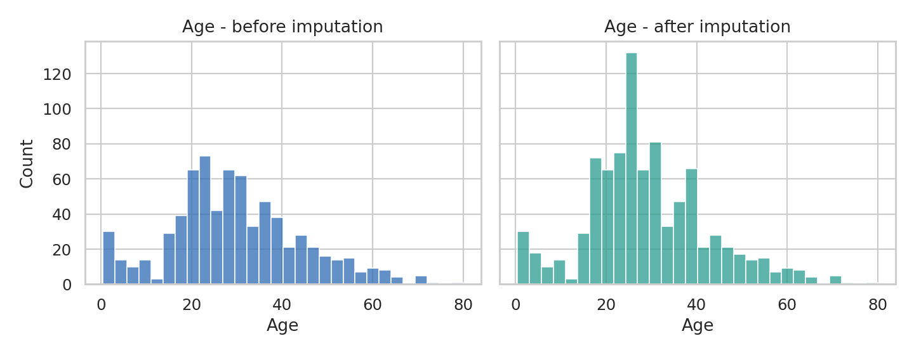
Figure 2: Age distribution before and after imputation
Statistic | Before (714 rows) | After (891 rows)
Mean | 29.70 | 29.14
Median | 28.0 | 26.0
Std. deviation | 14.53 | 13.49

The mean barely moves and the overall shape is preserved. The standard deviation falls slightly (14.53 to 13.49), which is the known side effect of imputation: filled values sit near the centre of their group and so reduce variance. This is discussed in Section 8.

6. Outlier Detection and Treatment

6.1 Detection with the IQR rule
Outliers were detected using the interquartile-range rule: a value is flagged if it lies below Q1 - 1.5 x IQR or above Q3 + 1.5 x IQR.
Python code
def iqr_bounds(s):
q1, q3 = s.quantile([.25, .75])
iqr = q3 - q1
return q1 - 1.5*iqr, q3 + 1.5*iqr

for col in ["Age", "Fare", "SibSp", "Parch"]:
lo, hi = iqr_bounds(df[col])
n = ((df[col] < lo) | (df[col] > hi)).sum()
print(f"{col}: lower={lo:.2f} upper={hi:.2f} outliers={n}")

Output
Age : lower=-2.62 upper=60.38 outliers=22
Fare : lower=-26.72 upper=65.63 outliers=116
SibSp: lower=-1.50 upper=2.50 outliers=46
Parch: lower=0.00 upper=0.00 outliers=213

6.2 Decision for each column
Column | Outliers | Decision | Reason
Age | 22 | Keep | Elderly passengers (up to 80) are real, valid values
SibSp / Parch | 46 / 213 | Keep | IQR is misleading for sparse counts where most values are 0; large families exist
Fare | 116 | Cap + log transform | Strong skew (4.79); a few values up to 512 dominate the scale

6.3 Treating Fare
The highest fares (512.33) belong to genuine 1st-class suites, so deleting them would remove real passengers. Two complementary treatments were used instead. The raw fare was winsorised (capped) at the 99th percentile, 249.01, and a log(1 + x) version was created to pull the long right tail in. The original value is preserved in Fare_Raw, and the 15 zero-fare rows are marked with a flag rather than altered.
Python code
cap = df["Fare"].quantile(0.99) # 249.01
df["Fare_Raw"] = df["Fare"] # keep original
df["Fare_Zero"] = (df["Fare"] == 0).astype(int) # flag free tickets
df["Fare"] = df["Fare"].clip(upper=cap) # winsorise
df["Fare_Log"] = np.log1p(df["Fare_Raw"]) # log transform

print("Skew raw :", round(df["Fare_Raw"].skew(), 2))
print("Skew capped :", round(df["Fare"].skew(), 2))
print("Skew log :", round(df["Fare_Log"].skew(), 2))

Output
Skew raw : 4.79
Skew capped : 3.11
Skew log : 0.39

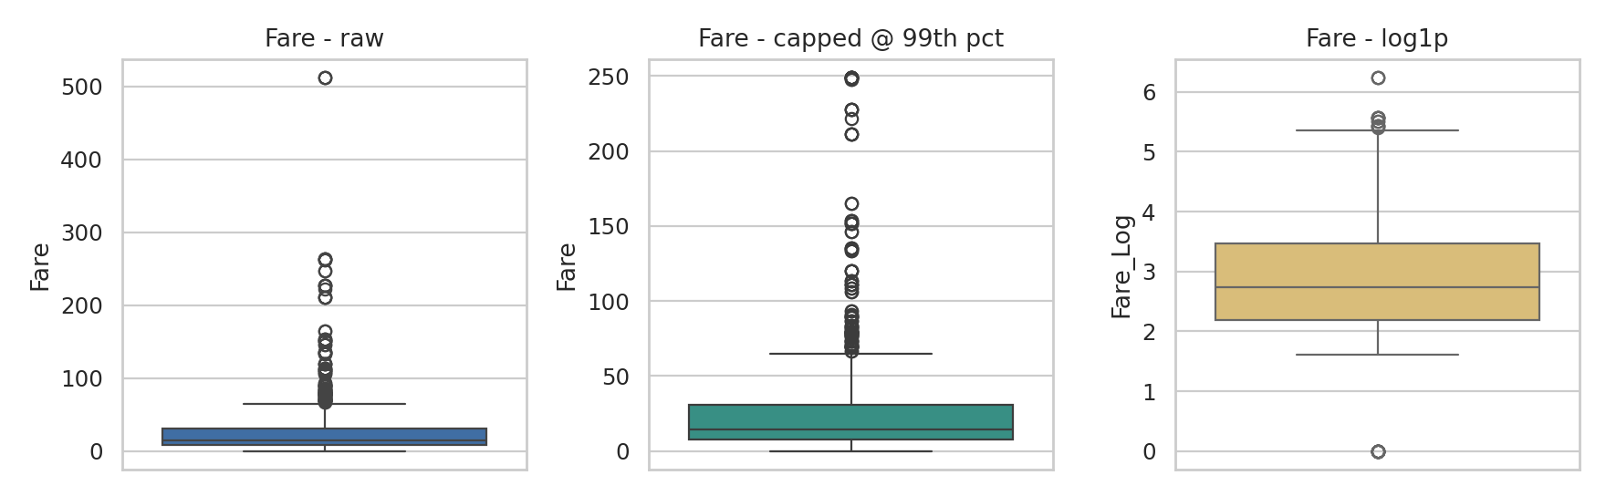
Figure 3: Fare box plots: raw, capped at the 99th percentile, and log-transformed
Capping alone reduced skewness from 4.79 to 3.11, and the log transform brought it to 0.39, which is close to symmetric. The log version is the one used for modelling.

7. Preprocessing and Feature Engineering

7.1 New features
- FamilySize = SibSp + Parch + 1, which combines two weak columns into one clearer signal.
- IsAlone = 1 when FamilySize is 1; travelling alone may affect survival differently.
- Title, HasCabin, Deck, Age_Missing and Fare_Zero, all built during cleaning.

7.2 Encoding categorical variables
Machine learning models need numbers. Sex is binary so it was label-encoded. Embarked and Title have no natural order, so one-hot encoding was used, which avoids implying that, for example, port S is 'greater than' port C.

7.3 Scaling
Age (roughly 0 to 80) and log-fare (roughly 0 to 6) live on different scales. Standardisation (zero mean, unit variance) was applied so that distance-based and gradient-based models are not dominated by whichever feature has larger numbers.
Python code
from sklearn.preprocessing import StandardScaler

df["FamilySize"] = df["SibSp"] + df["Parch"] + 1
df["IsAlone"] = (df["FamilySize"] == 1).astype(int)
df["Sex_Code"] = df["Sex"].map({"male": 0, "female": 1})

df = pd.get_dummies(df, columns=["Embarked", "Title"],
prefix=["Emb", "Title"], dtype=int)

scaler = StandardScaler()
df[["Age_Scaled", "Fare_Scaled"]] = scaler.fit_transform(df[["Age", "Fare_Log"]])

df.drop(columns=["Cabin"]).to_csv("titanic_cleaned.csv", index=False)
print("Final shape:", df.shape)

Output
Scaled means: [0.0, -0.0] Scaled std: [1.001, 1.001]
Final shape: (891, 30)

The final dataset keeps all 891 rows and has 30 columns, with no missing values left in the modelling columns.

7.4 Validation of the cleaned dataset
Check | Raw data | Cleaned data
Rows | 891 | 891 (nothing deleted)
Missing Age | 177 | 0
Missing Embarked | 2 | 0
Cabin information | 77% missing | Converted to HasCabin and Deck
Fare skewness | 4.79 | 0.39 (log version)
Categorical columns | Text | Numeric (encoded)
Original values preserved | n/a | Yes (Fare_Raw, Age_Missing flags)

8. Impact of Preprocessing on Subsequent Analyses

8.1 Effect on relationships with survival
Correlation with the target (Survived) was compared before and after cleaning.
Feature | Correlation with Survived
Fare (raw) | 0.257
Fare_Log (after transform) | 0.330
Age (raw, NaNs ignored) | -0.077
Age (after imputation) | -0.063
HasCabin (new) | 0.317
Sex_Code | 0.543
Pclass | -0.338

The log transform lifted the Fare relationship from 0.257 to 0.330, and the engineered HasCabin feature (0.317) captures a signal that was invisible while Cabin was a mostly empty text column. The correlation of Age changed only slightly, which suggests that imputation did not distort its relationship with survival.
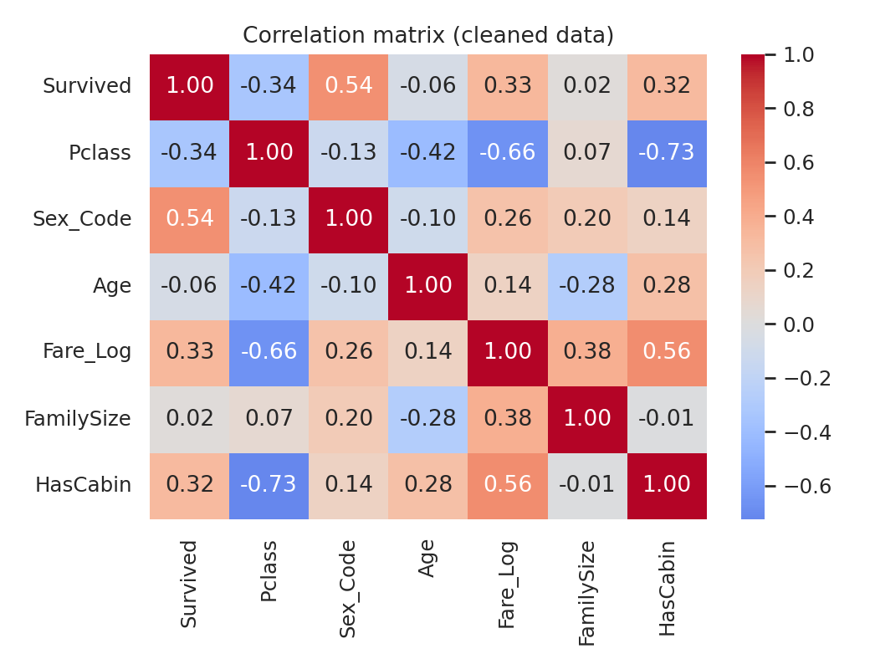
Figure 4: Correlation matrix of key features in the cleaned dataset

8.2 Effect on a simple model
To illustrate the practical effect, a logistic regression was evaluated with 5-fold cross-validation on two versions of the data.
Approach | Rows used | CV accuracy
Naive: drop rows with missing Age, raw features | 714 | 79.0%
Cleaned and preprocessed data | 891 | 82.7%

Honest caveat: this is an illustration, not a controlled experiment. The two models differ in both the rows they see and the features they use (the cleaned version also has Title, HasCabin, FamilySize and so on), so the 3.7-point gain reflects the whole pipeline rather than any single step. It is still a useful sign that the preprocessing helped rather than hurt.

8.3 Trade-offs and risks
- Reduced variance: imputation shrinks the spread of Age (std 14.53 to 13.49). Standard errors and confidence intervals computed on the filled data will be slightly too optimistic.
- Imputation is an assumption: it assumes missing ages resemble those of passengers with the same title and class. If ages are missing for systematic reasons, some bias remains. Keeping Age_Missing lets analysts test this.
- Winsorising loses extreme-value information: this is why the original fare was kept in Fare_Raw.
- Data leakage risk: the scaler and the group medians here were fitted on the whole dataset. In a real prediction project they should be fitted on the training split only and then applied to the test split.
- Interpretability: log-transformed and scaled values are harder to read, so original columns were retained for reporting.

9. Challenges Faced and How They Were Overcome
Challenge | How it was handled
Deciding what counts as an error versus a real extreme value (Age 0.42, SibSp 8, Fare 512) | Inspected the actual rows. The Sage family shared one ticket and the fare values belonged to 1st-class suites, so these were kept and treated by transformation rather than deletion.
77% of Cabin missing | Rather than dropping or inventing values, converted the absence into a HasCabin flag and found it linked to a 30% vs 67% survival gap.
A global average would give wrong ages for children | Used title and class group medians; 'Master' now receives a child age of about 4 rather than 28.
Rare titles had too few rows for stable medians | Merged Mlle, Ms, Mme into Miss/Mrs and grouped uncommon titles into 'Rare'. Added a global-median fallback for the empty Rare/3rd-class group.
IQR rule flagged 213 'outliers' in Parch | Recognised that IQR is unreliable for sparse count data where most values are 0, and kept these values.
Hidden whitespace broke title extraction | Stripped the Name column before running the regular expression.
Keeping the work reproducible | Wrote the whole workflow as one script that downloads, cleans and exports the data, and saved original values alongside transformed ones.

10. Conclusion and Reflection
The raw Titanic data had three missing-value problems, one set of text inconsistencies and a heavily skewed fare column. Each was handled with a documented, justified method, and no rows were deleted. The main reflections from this task are:
- Always inspect before you clean. Several values that looked wrong were actually valid.
- Missingness can carry information. The Cabin column was mostly empty, yet the fact that it was empty was a strong predictor.
- Context-aware imputation beats global averages. Using title and class gave far more believable ages.
- Every cleaning step is a modelling assumption. Keeping flags and original columns keeps those assumptions visible and reversible.
The cleaned dataset (titanic_cleaned.csv) is now ready for the next stage: exploratory data analysis and predictive modelling.

References
- Titanic dataset, DataScienceDojo public datasets repository (GitHub), CSV file titanic.csv.
- pandas documentation: https://pandas.pydata.org/docs/
- scikit-learn documentation (StandardScaler, LogisticRegression, cross_val_score): https://scikit-learn.org/stable/
- Seaborn and Matplotlib documentation for the visualisations.

