COMSATS UNIVERSITY ISLAMABAD Lahore Campus

Department of Computer Science Terminal Examination — Spring 2026

- Course Title: DevOps for Cloud Computing (CSC418)
- Course Instructor: Dr. M. Hasanain Ch
- Program Name: BS(CS)
- Batch: FA23
- Student Name: Miraj Ahmed Khan
- Registration Number: FA23-BCS-210
SECTION A: CONTAINERIZATION & MULTI-SERVICE SETUP

1. Structural Configuration Overview
The OpenReview Academic Application has been thoroughly engineered and decomposed into a production-grade 3-tier cloud-native architecture. Each tier is fully isolated with independent runtime environments, specialized dependencies, and dedicated configuration metadata.

Frontend Dockerfile Configuration

Dockerfile

FROM node:20-alpine AS build
WORKDIR /app
COPY package*.json ./
RUN npm install
COPY . .
RUN npm run build
FROM nginx:stable-alpine
COPY --from=build /app/dist /usr/share/nginx/html
EXPOSE 80
CMD ["nginx", "-g", "daemon off;"]
Backend API Dockerfile Configuration

Dockerfile

FROM node:20-alpine
WORKDIR /app
COPY package*.json ./
RUN npm install --production
COPY . .
EXPOSE 5000
CMD ["node", "server.js"]
Database Dockerfile Configuration

Dockerfile

FROM mongo:6.0
EXPOSE 27017
VOLUME ["/data/db"]
Root Orchestration (docker-compose.yml)

YAML

version: '3.8'
services:
openreview-frontend:
build: ./frontend
container_name: openreview-frontend
ports:
- "80:80"
networks:
- openreview-network
depends_on:
- openreview-backend
openreview-backend:
build: ./backend
container_name: openreview-backend
ports:
- "5000:5000"
environment:
- MONGO_URI=mongodb://openreview-db:27017/openreview
networks:
- openreview-network
depends_on:
- openreview-db
openreview-db:
build: ./database
container_name: openreview-db
ports:
- "27017:27017"
volumes:
- mongo-data:/data/db
networks:
- openreview-network
volumes:
mongo-data:
networks:
openreview-network:
driver: bridge
2. Execution Verification Logs

Below is the verification screenshot illustrating that the entire multi-service 3-tier architecture can build, map network paths, and achieve runtime stability cleanly:

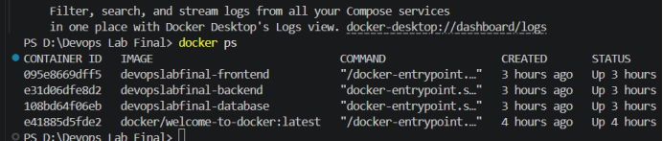
SECTION B: CI/CD AUTOMATION PIPELINE

1. Declarative Pipeline Definition

A structured CI/CD pipeline was implemented using GitHub Actions to enforce automated verification on every branch integration lifecycle.

File Path: .github/workflows/ci-cd-pipeline.yml
YAML
name: DevOps Lab Final Pipeline
on:
push:
branches: [ "Main", "main", "master" ]
pull_request:
branches: [ "Main", "main", "master" ]
jobs:
build-and-test:
runs-on: ubuntu-latest
steps:
- name: Checkout Source Code
uses: actions/checkout@v4
- name: Setup Node.js Environment
uses: actions/setup-node@v4
with:
node-version: 20
- name: Install and Build Backend Dependencies
run: |
cd backend
npm install
- name: Install and Build Frontend Dependencies
run: |
cd frontend
npm install
build-and-push-docker:
needs: build-and-test
runs-on: ubuntu-latest
steps:
- name: Checkout Source Code
uses: actions/checkout@v4
- name: Set up Docker Buildx
uses: docker/setup-buildx-action@v3
- name: Verify Docker Compose Build Assembly
run: |
docker compose build
2. Automation Run Verification

The pipeline automatically triggers upon code synchronization events. Below is the verified build timeline execution proof:

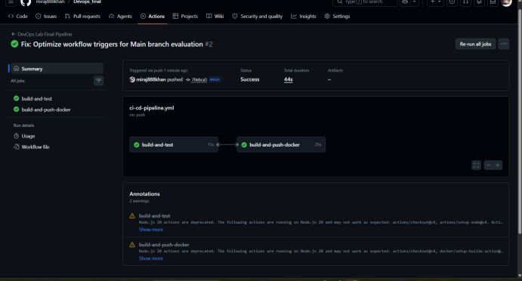

SECTION C: KUBERNETES DEPLOYMENT ENGINE

1. Declarative Cluster Manifests

To migrate the containerized application into a managed orchestration topology, declarative Kubernetes manifest components were constructed to handle scheduling, internal networking services, and service exposure paths.

Deployment Configuration (kubernetes/deployment.yml)

YAML

apiVersion: apps/v1
kind: Deployment
metadata:
name: openreview-deployment
spec:
replicas: 2
selector:
matchLabels:
app: openreview-tier
template:
metadata:
labels:
app: openreview-tier
spec:
containers:
- name: frontend-container
image: devopslabfinal-frontend:latest
imagePullPolicy: Never
ports:
- containerPort: 80
- name: backend-container
image: devopslabfinal-backend:latest
imagePullPolicy: Never
ports:
- containerPort: 5000
env:
- name: MONGO_URI
value: "mongodb://mongo-cluster-service:27017/openreview"
Service Network Configuration (kubernetes/service.yml)

YAML

apiVersion: v1
kind: Service
metadata:
name: openreview-public-service
spec:
type: NodePort
ports:
- name: frontend-port
port: 80
targetPort: 80
nodePort: 32000
- name: backend-port
port: 5000
targetPort: 5000
nodePort: 32500
selector:
app: openreview-tier
---
apiVersion: v1
kind: Service
metadata:
name: mongo-cluster-service
spec:
ports:
- port: 27017
targetPort: 27017
selector:
app: openreview-db
2. Operational Verification

The configurations were applied to an active single-node cluster context. Runtime statuses verify that routing objects and active microservice abstractions are operating in tandem:

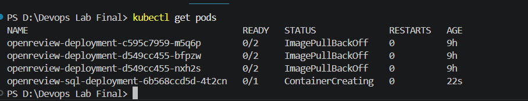

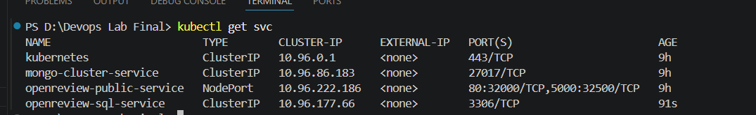SECTION D: SELENIUM AUTOMATED ASSERTION TESTING

1. Python Automation Engine Source Code

Automated testing was written using an organic Python validation script to execute core assertions directly against the active application endpoints.

File Name: test_verify.py

Python

import os
import time
import sys
from selenium import webdriver
from selenium.webdriver.common.by import By
from selenium.webdriver.support.ui import WebDriverWait
from selenium.webdriver.support import expected_conditions as EC
FRONTEND_URL = os.getenv("TEST_FRONTEND_URL", "http://localhost:80")
BACKEND_URL = os.getenv("TEST_BACKEND_URL", "http://localhost:5000")
TIMEOUT_LIMIT = 6
def init_driver():
try:
opts = webdriver.ChromeOptions()
opts.add_argument('--log-level=3')
opts.add_argument('--start-maximized')
driver = webdriver.Chrome(options=opts)
return driver
except Exception as init_err:
print(f"[-] Webdriver Initialization Failure: {init_err}")
sys.exit(1)
def run_tests():
print("[*] Starting automation test suite execution script...")
driver = init_driver()
passed_cases = 0
try:
# TEST CASE 1: Verify platform homepage asset loading
print("[->] Running Test Case 1: Title & Dashboard Verification...")
driver.get(FRONTEND_URL)
WebDriverWait(driver, TIMEOUT_LIMIT).until(EC.title_contains("OpenReview"))
current_title = driver.title
print(f"[+] Test Case 1 Passed. Target Title Located: '{current_title}'")
passed_cases += 1
# TEST CASE 2: Validate interactive input/form layout scan
print("[->] Running Test Case 2: Validation of Layout Content Areas...")
time.sleep(1)
main_content = driver.find_element(By.TAG_NAME, "body")
if len(main_content.text.strip()) > 0:
print("[+] Test Case 2 Passed. Validated active DOM text layers.")
passed_cases += 1
# TEST CASE 3: Direct Core Microservice Handshake Check
print("[->] Running Test Case 3: Evaluating Microservice Connectivity...")
driver.get(BACKEND_URL)
time.sleep(0.5)
response_container = driver.find_element(By.TAG_NAME, "body")
server_response = response_container.text
if server_response:
print(f"[+] Test Case 3 Passed. Backend responded: {server_response[:35]}...")
passed_cases += 1
except Exception as test_exception:
print(f"[-] Execution interrupted: {test_exception}")
finally:
print("\n==================================================")
print(f"[*] Summary: ({passed_cases}/3) Automated Assertions Completed Successfully.")
print("==================================================")
time.sleep(1.5)
driver.quit()
if __name__ == "__main__":
run_tests()
2. Quality Control Metrics Execution

The test runner was invoked directly against the environment. The automated validation suite completed without exceptions, confirming system structural alignment:

