

A Report On
AI: Balancing Innovation with Ethical Integrity – Large Language Models (LLMs) and Education

Name: Mirajan Shrestha
Group: L5CG12
University Id: 2462263
Tutor: Raju Karki
Submitted on: 17/01/2026

Table of Contents

1. Abstract………………………………………………………………………………………………....3
2. Introduction………………………………………………………………………………………….….4
3. Thematic Review - Key Ethical Challenges and Emerging Debates in AI…………………………….5
3.1 Bias and Accuracy in LLM-Generated Educational Content………………………………………5
3.2 Transparency and Accountability in the modules of LLM…………………………………………5
3.3 Privacy and Data Governance in Educational Contents…….……………………...………………5
3.4 Initiatives of AI……………………………….…………………………………………………….6
3.5 Proposed Ethical AI Framework……………………………………………………………………6
4. Discussion / Personal Reflection……………………………………………………………………..…7
5. References………………………………………………………………………………………………8
6. Appendix………………………………………………………………………………………………..9

Abstract

The swift progress in Artificial Intelligence (AI), especially in the Large Language Models(LLMs) has made a profund yet remarkable impact on the modern education system (UNESCO, 2021). The AI tools are increasingly being used in these fields to create and curate learning observations as well as evaluation of vaious learning materials and subjects of study. This report is a testament of study of Ethical AI that examines the ethical consideration of using LLMs in education along with focusing on three key areas: bias and accuracy in the data, responsibility and accountability in LLM and privacy and data governance in AI. Further aided attention is also given to transparency, fairness and redundancy of the data widespread in the datasets and how actions have been taken to mitigate the problems occuring in this field.
[Keywords: Atificial Intelligence, Large Language Models, inclusivity, Automated Assessment, bias, data governance, AI Risk Management]

Introduction
Aritifcial Intelligence has accelerated in numerous fields encountered by humans in daily lives, more definitively in the fields of Education. Large Language Models are widely used digital tools operated for the purpose of teaching-learning such as generating educational materials, providing feedbacks and viewpoints on several topcis, grading research papers, rectifying mistakes and promptly giving feedbacks and reviews on the relevant fields of study. AI has been nothing but helpful in the fields of education and the criteria keeps on expanding quite literally as well as topographically where the access of quality education could barely exist due to lack of human resources.
On the contrary, education has been recognized as a high-risk domain on AI deployment due to its direct impact on the primary learners’ cognitive development, debated answers, unclear explanantions and outputs. There arise different concerns and issue on ethics that might affect on fairness, transparency and trust within the bounds of the education and the system in itself. Unlike other sectors, the damage caused in the education field is not rudimentary. It can have long-term consequences on the lives of learners in an academic journey and and self-perception.
On the retropect there are so many ways of defying the point of AI being used in the field of education with the establishment of numerous ethcial principles that embody that fulfill the embodiment of transparency and trust to be maintained in the fields along with the integrity of the basic principles and norms a learner must inherit while learning from an AI-based platform.
Responsible implementation of AI in education is regarded to be extremely useful and essential. Without ethical safeguards, the spread of LLMs in education might create certain inequalities and obstruction in cognitive learning and understanding. Conversely, ethically curated systems adhere to sustainable development and long-term societal development.

3. Thematic Review - Large Language Models (LLMs) and Education
3.1 Bias and Accuracy in LLM-Generated Educational Content
LLMs are generally trained rigorously on large-scaled datasets to clear the confusion on several methods of study. However, these trained sets of modeled data often tend to represent cultural, linguistic and academic biases prevalant in the community often prioritizing to the Western-centered datasets (Zawacki-Richter et al., 2019). Evidently, the materials shown upon the screeen may cause conflict of interest in accordance to the contemporary statistics of the real-world data.
Accuracy is another major ethical concern in which the LLM models may create a credible output data but is in fact incorrect often outdated and provides misleading prospects of the model often termed as hallucinations in the dataset (Holmes et ak., 2022). Such atrocious outcomes create widespread of misinformation of the analysed data and probable havoc if published in the market without proper verification.
3.2 Transparency and Accountability in the modules of LLM
The LLM models need to comprehend the dataset taken into consideration and then further to be analyzed in a directive such that the output is user-friendly and easy to comprehend. The data in the dataset must be impartial enough to cause any opacity in the explanation of a certain problem statement. While using the modules of inference or tutor-based feedbacks, it can be easily shown on what input data might have cuase the curve to deviate from the esired output factor. It can be taken from a simple example of usage of a regression function or tuning of a hyperparameter that might give the concrete explanation on the accountability of the data on imposing the output on a different direction than desired. This helps the learners critically evaluate the AI powered explanations (Holmes et al., 2022; NIST, 2023).
3.3 Privacy and Data Governance in Educational Contents
AI-based assessment system grading is in increasing demand in today’s education system where the contents are approved on an automated basis of learning, where the technical and literative interpretation and reasoning of the contents are empahsized in order to improve the level of perfection and efficiency on an academic and ergonomic basis. On the other side, while the automated verification of graphs and answers improve efficiency, it struggles to analyse the open-ended answers, solutions in an alternative method or analysation of conceptual data and algorithm done by a non-native speaker or even neurodivergent learners (OECD, 2019).
There are data provided by AI to the learners in the form of responses where the feedbacks and factual evidences of the data recorded are unclear, sometimes flawed. The ambiguity in the output of that data raises various ethical concerns about the governance and oversight, often discovered when the AI-generated contents influence the academic peformance in the course of events. (NIST, 2023). Therefore, a balanced system of good governance must be impemented to action for maintaining balance in the education system where the educators would be aided by AI rather than replaced and learners would benefit more than harm.
3.4 Initiaves on Ethical AI
International initiatives have been taken into action and consideration in order to provide a systemic guidance for ethical AI usage in technical education. UNESCO’s Recommendation of Ethics on Artificial Intelligence emphasizes the design of AI learning modules to be based on human-centered design and causes inclusivity in the technology of education. Organization of Economic Co-operation and Development (OECD) has formulated OECD AI principles hat stress on the agenda of transparency and accountability particularly in the systems that influence learning outcomes. Principle growth on initiatives have been observed globally in different countries across the regions (OECD, 2019).
Similarly, the National Institute of Standards and Technology (NIST) launches AI Risk Management Framework (RMF) that plans to suppport responsible AI deployment with continuous observation and monitorization of technical and social risks. GOVERN function is infused in the RMF to prevent to override false data and ensure pure data in the outcome of the LLM models (NIST, 2023).
3.5 Proposed Ethical AI Framework
An ethical framework for LLMs is quite necessary approach not just to minimize bias and show transparency and accountability but the frameworks must also be inclusive of all kinds of data to be taken under consideration. Therefore, it will help to promote sustainable ethical long term system design aligned with the educational goals.

Personal Reflection
Ethical AI in retrospection has always been a topic of discussion in terms of responsibility and accountability. Nevertheless, it has also been a matter of research on the grounds of superficial to deep level understanding of the models and their responses. During this research, I was startled by the acceptance of the students taken from the AI responses on simpler to complex topics with barely questioning about the aunthenticity or even accuracy of the data and their respective sources. This causes the risk of surface-level learning to long-term establishment of the misconceptions to exist.
I also see very strong prospects in the future days where an integrated education system adheres to LLMs that will make the subject matters more simplified and accurate to the learners that will help to build a better and inclusive education system where the outliers are managed carefully and all kinds of data and responses are handled in a user-friendly environment to promote sustainanble growth of an individual, society, country and the globe as a whole.

References
Holmes, W., Bialik, M., & Fadel, C. (2022). Artificial intelligence in education: Promise and implications for teaching and learning. Curriculum Redesign. https://curriculumredesign.org/wp-content/uploads/AIED-Book.pdf
National Institute of Standards and Technology. (NIST). (2023). AI risk management framework. https://nvlpubs.nist.gov/nistpubs/ai/NIST.AI.100-1.pdf
Organisation for Economic Co-operation and Development. (OECD). (2019). OECD principles on artificial intelligence. https://www.oecd.org/going-digital/ai/principles/
European Union. (2024). Artificial Intelligence Act. https://artificialintelligenceact.eu/the-act/
UNESCO. (2021). Recommendation on the ethics of artificial intelligence. https://unesdoc.unesco.org/ark:/48223/pf0000380455
Zawacki-Richter, O., Marín, V. I., Bond, M., & Gouverneur, F. (2019). Systematic review of research on artificial intelligence applications in higher education. Educational Technology Research and Development, 67(4), 935–958. https://educationaltechnologyjournal.springeropen.com/articles/10.1186/s41239-019-0171-0

Appendix
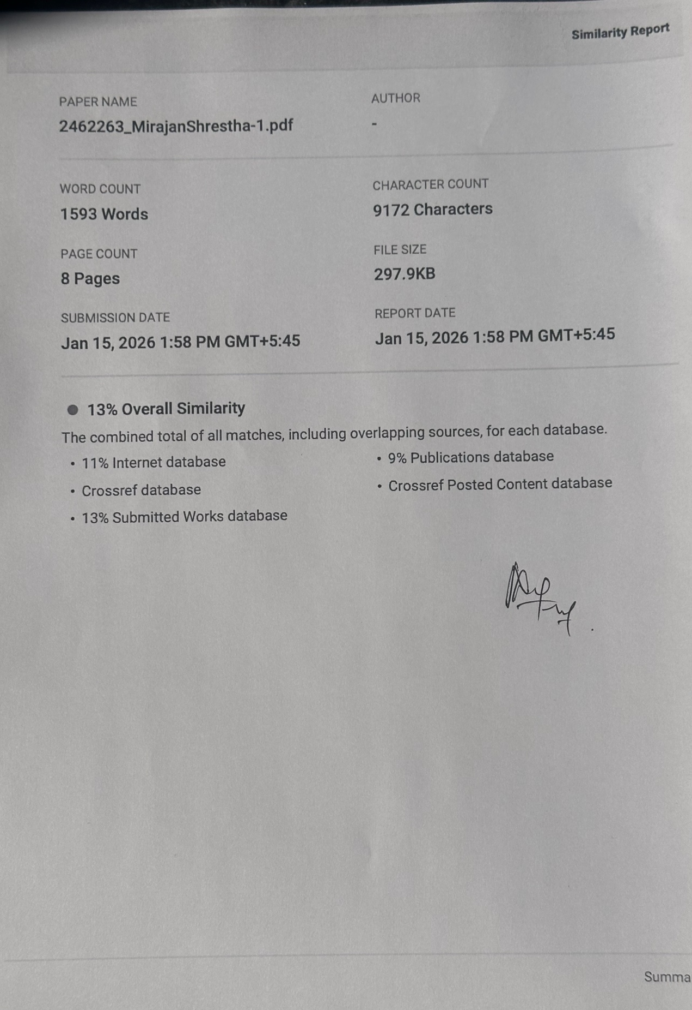
Similarity Index Report signed by Sunita Parajuli ma’am.

