DNA Databases: Genomic Context
Hands-On Workbook
Day 2 - Bioinformatics Internship 2026

Learning Objectives
- Access and navigate Ensembl genome browser
- Retrieve gene structure information (exons, introns, UTRs)
- Use UCSC Genome Browser to visualize genomic context
- Find and interpret variants in ClinVar
- Connect genomic data to biological function

Exercise 1: Navigating Ensembl
Objective: Retrieve insulin gene from Ensembl and document its genomic features.

Part A: Access Ensembl and Search for Insulin Gene
- Go to https://www.ensembl.org
- Select 'Human' under 'Search for a species'
- Search for 'insulin' in the search box
- Click on 'INS' (Insulin gene) to open the gene page
Q1: What is the Ensembl gene ID for insulin?
Answer: ENSG00000254647(should start with ENSG)

Part B: Retrieve Genomic Coordinates
On the insulin gene page, look for 'Location' section. Fill in the following:
Chromosome | ______11__________
Start Position | _____2,159,779___________
End Position | _____2,161,221___________
Strand | __-____ (+ or -)

Calculate: Gene length = End Position - Start Position = ___1442___ bp

Part C: Understanding Gene Structure
Click on 'Transcripts' or 'Exons' to view the gene structure. Complete the table:
Exon # | Start | End | Length | Contains 5' UTR?
1  ENSE00001938789 | 2,161,209 | 2,161,168 | 42 | Y
2 ENSE00003494357 | 2,160,988 | 2,160,785 | 204 | Y
3  ENSE00003901829 | 2,159,997 | 2,159,779 | 219 | Y
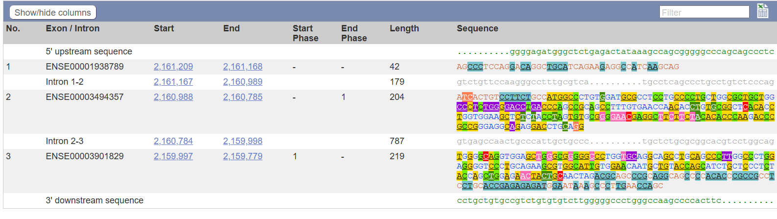
Above table is for transcript
ENST00000381330.5
Which is INS-202 out of the 4 protein coding transcripts of INS or insulin gene.
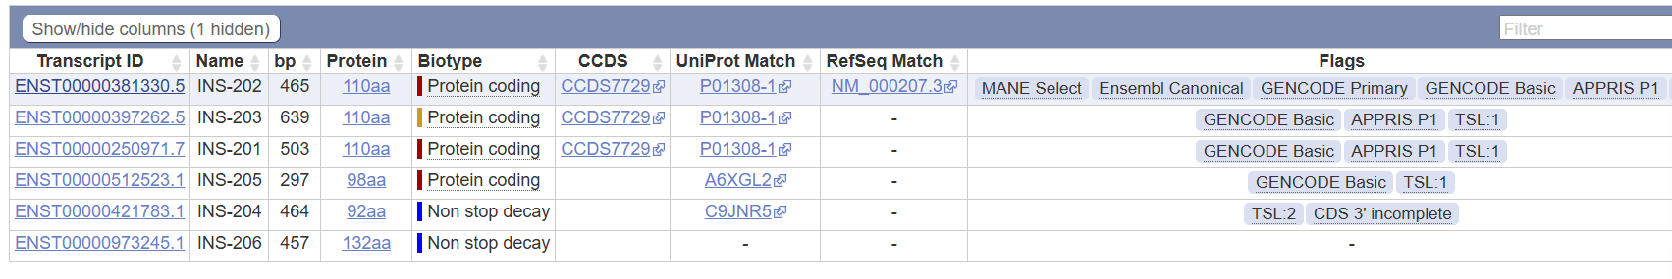

Exercise 2: UCSC Genome Browser Visualization
Objective: Visualize insulin gene in genomic context and identify neighboring genes.

Part A: Access UCSC and Locate Insulin Gene
- Go to https://genome.ucsc.edu
- Confirm genome is set to 'Human' and assembly is 'GRCh38/hg38'
- In the search box, type your insulin coordinates from Ensembl: chr11:5246517-5249250
- Click 'Go' or press Enter
Q1: What gene is located immediately upstream (left) of insulin? (Use the gene name or symbol)
Answer: INS-IGF2
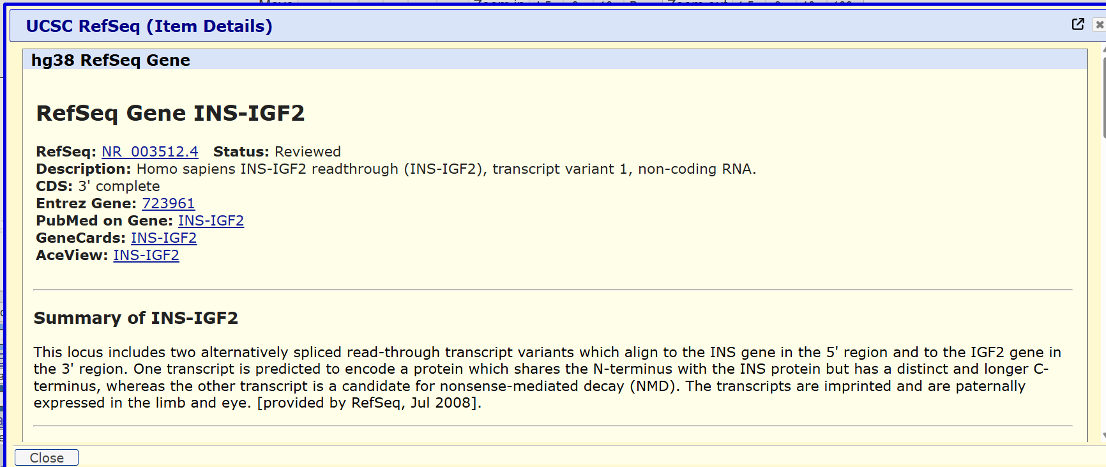

Q2: What gene is located immediately downstream (right) of insulin?
Answer: TH gene
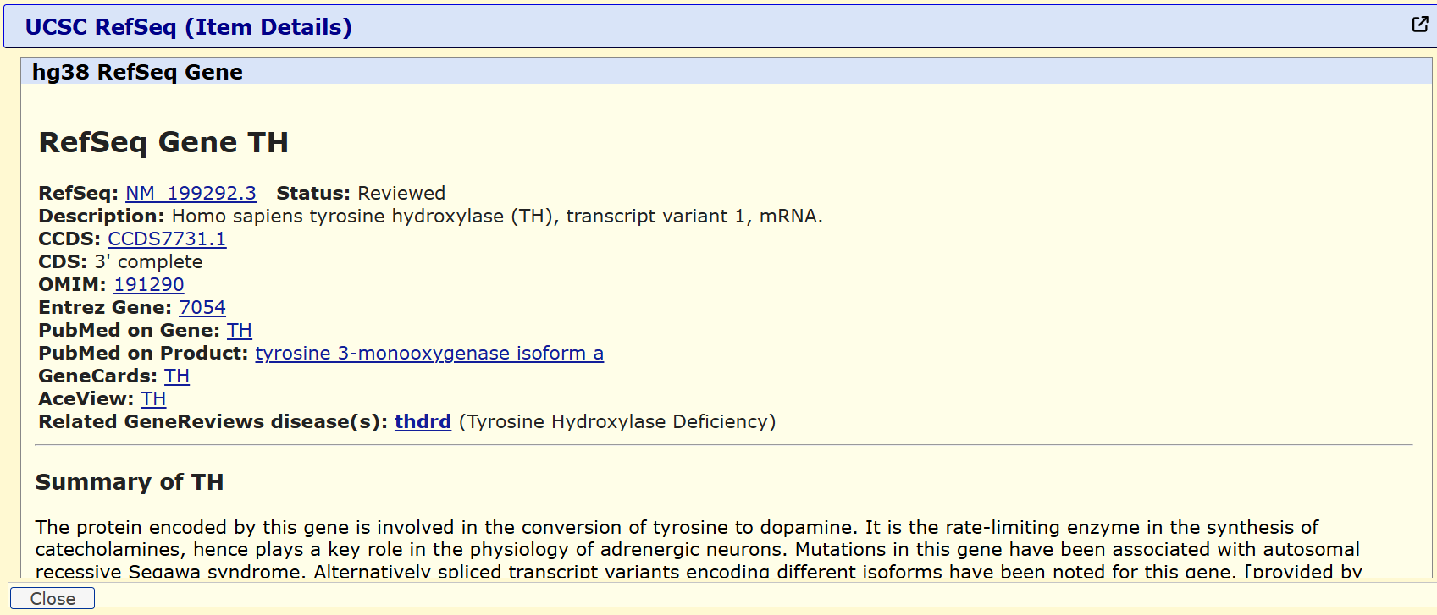
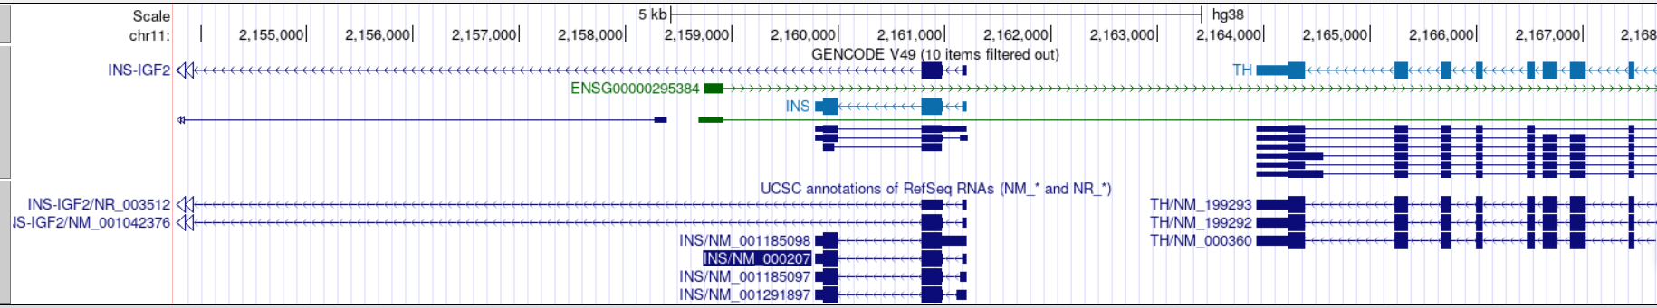

Part B: Exploring Genomic Features
Look at the various tracks displayed in UCSC. You should see:
- Genes (RefSeq genes, Ensembl genes)
- Sequence conservation (PhastCons conservation track)
- Repeats and structural variants
Q3: Is the insulin gene region highly conserved across species? (Look at conservation track - high dark bar = conserved)
Answer: Yes / No. Evidence: ________________yes________________________
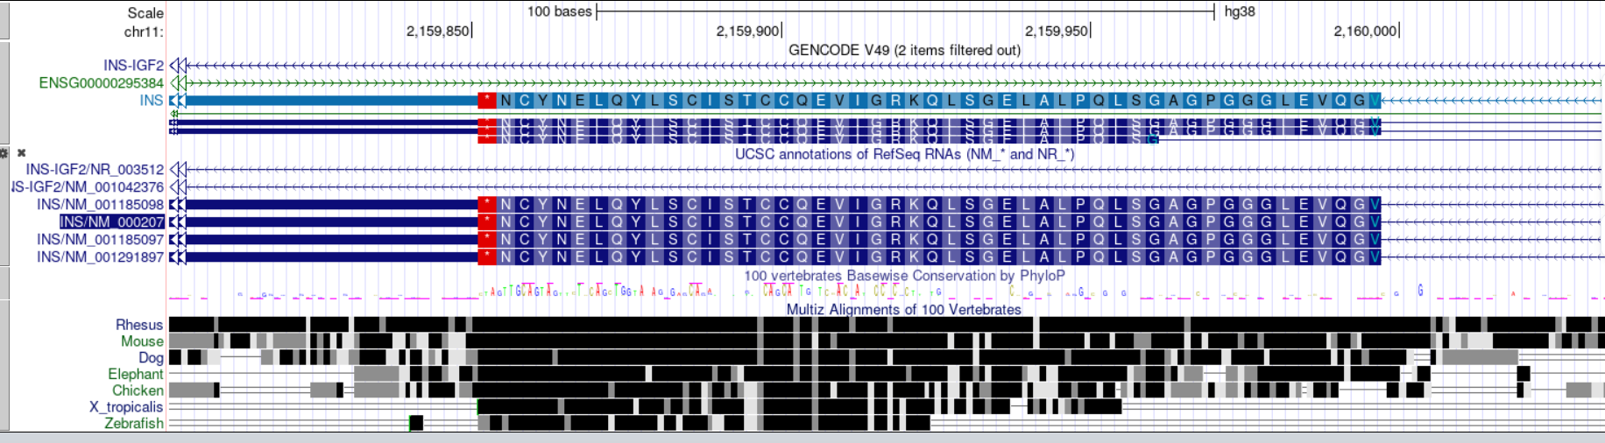

Exercise 3: Finding Variants in ClinVar
Objective: Search for disease-associated variants in the insulin gene.
- Go to https://www.ncbi.nlm.nih.gov/clinvar
- Search for: 'insulin' AND 'pathogenic'
- Click on one of the pathogenic variants and read the details
Q1: Find ONE pathogenic insulin variant. What is the variant (e.g., c.123A>G) and what disease does it cause?
Variant: ________c.361G>A________________ Disease: Coronary artery disorder

Q2: Is this a missense, nonsense, or frameshift mutation? How can you tell?
Answer: Missense mutation according to the HGVS data given for molecular consequence and it is also mentioned that it is a single nucleotide variant which changes the protein to
D121N.

Exercise 4: Connecting the Data
Based on what you found in Ensembl and UCSC, write a brief genomic summary of insulin (100-150 words). Include: chromosome location, gene structure, whether it's conserved, and why this genomic organization matters.
From the data obtained in UCSC about the insulin gene, chromosome location was found to be chr11:2159779-2161209 for the Refseq ID NM_000207.3 . It’s genomic size is 1431 and it it located on the 3’-5’ strand or the – strand. The RefSeq INS gene has a complete start and end CDS. From the Phastcons conservation track, it is clear that Rhesus, mouse and dog are the 3 species with high conservation of the INS gene sequence in Homo sapiens. This organisation helps in obtaining insulin gene sequence using rDNA technology from organisms which have been consistently displaying the same sequence as humans.

Reflection
How does understanding the genomic structure of insulin help you understand BLAST results from Day 1?
Results of UCSC and BLAST when compared, give insights on the conservation of insulin gene. In BLAST, the results are shown based on similarity, and not based on species which is why multiple paralogs were seen before the first ortholog. But in UCSC, it doesn’t automatically display and needs to be enabled using the comparative genomics filter.

