Lab 8 — Docker and Containers
  - Activity 1 — Docker Commands and Outputs

1. docker ps -a
Lists all Docker containers, including running and stopped containers. The output shows the lab8_hello Flask container running with port 5000 mapped to the host.
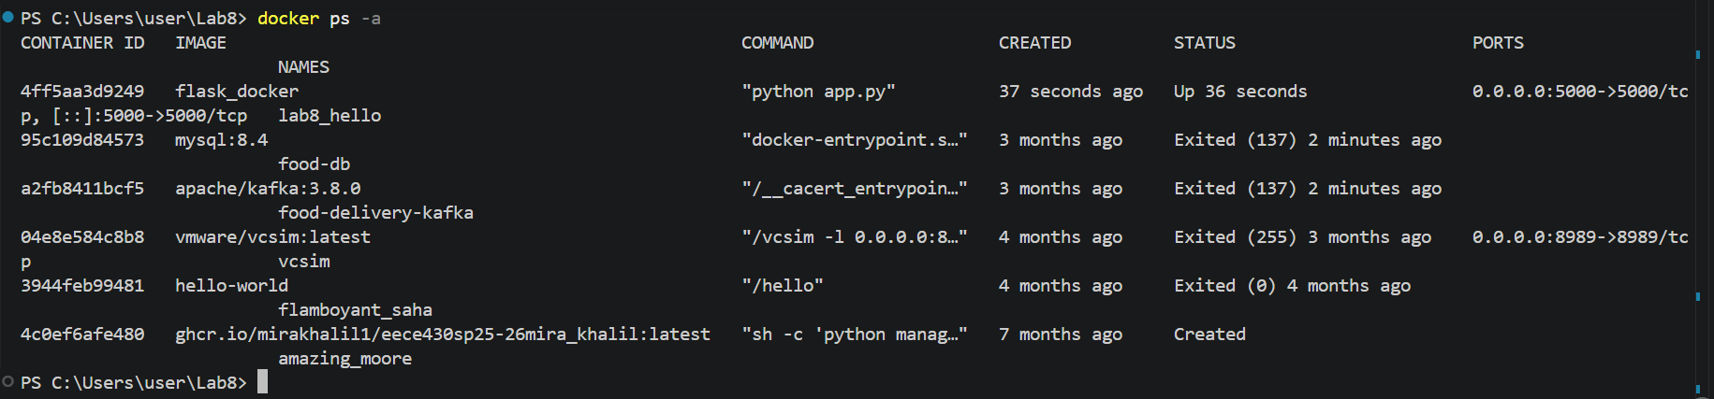

2. docker logs lab8_hello
Displays the logs generated by the lab8_hello container. The output confirms that Flask started on port 5000 and that the application handled a successful HTTP 200 request.
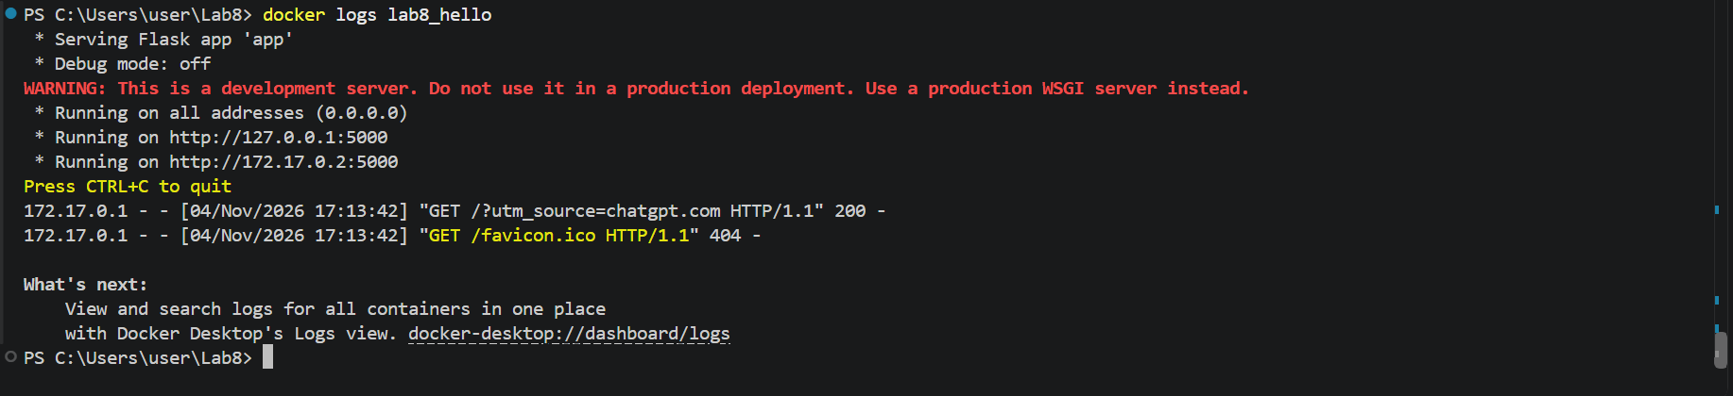

3. docker stop lab8_hello
Stops the running lab8_hello container without deleting it. The terminal prints the container name to confirm that the stop command completed.


