A Project Report On
J.A.R.V.I.S (JUST A RATHER VERY INTELLIGENT SYSTEM)

Submitted in partial fulfillment of the requirement for the BCA Semester-5 WADUP Subject Final Examination.
BACHELOR OF COMPUTER APPLICATIONS
(B.C.A.)

Academic Year 2026 – 27

Student Name - Miral Dhankecha
Enrollment No - 92400527161
Internal Guide
Tejas Chauhan


Rajkot-Morbi Road, At & PO : Gauridad, Rajkot 360 003. Gujarat. India.
CONTENTS

Chapters | Particulars | Page No.
1 | SYNOPSIS | 4
2  2.1  2.2  2.3  2.4 | PREAMBLE  General Introduction  Statement of Problem  Objective and Scope of the Study  Module Description with functionality | 5  5  7  8  10
3  3.1  3.2  3.3  3.4  3.5  3.6  3.7 | SYSTEM DESIGN AND DEVELOPMENT  System Architecture  Data Flow Diagram (DFD)  Database Design  Menu Design  Input Design  Output Design  Screen Design (Screen shots with short description) | 13  13  15  18  21  23  25  28
4 | CONCLUSION | 32
5 | LEARNING DURING PROJECT WORK | 33
6  6.1  6.2 | BIBLIOGRAPHY  Online References  Offline References | 34  34  34

FIGURE INDEX

Sr. No. | Figure No. | Particulars | Page No.
1 | Fig 2.1 | Main Interface of J.A.R.V.I.S System | 6
2 | Fig 2.2 | Folder Structure of J.A.R.V.I.S Project | 12
3 | Fig 2.3 | Execution of J.A.R.V.I.S Desktop Assistant | 12
4 | Fig 3.1 | System Architecture of J.A.R.V.I.S | 14
5 | Fig 3.2 | Level 0 Data Flow Diagram of J.A.R.V.I.S | 15
6 | Fig 3.3 | Level 1 Data Flow Diagram of J.A.R.V.I.S | 17
7 | Fig 3.4 | SQLite Database Structure of J.A.R.V.I.S | 20
8 | Fig 3.5 | Menu Design and Controls of J.A.R.V.I.S | 22
9 | Fig 3.6 | Input Design of J.A.R.V.I.S System | 24
10 | Fig 3.7 | Output Response System of J.A.R.V.I.S | 26
11 | Fig 3.8 | Weather Information Output of J.A.R.V.I.S | 26
12 | Fig 3.9 | Main Screen Design of J.A.R.V.I.S | 29
13 | Fig 3.10 | Command History Window of J.A.R.V.I.S | 30
14 | Fig 3.11 | Analytics Charts of J.A.R.V.I.S System | 31

TABLE INDEX

Sr. No. | Table No. | Particulars | Page No.
1 | Table 2.1 | Objectives and Features of J.A.R.V.I.S System | 8
2 | Table 2.2 | Module Description of J.A.R.V.I.S System | 10
3 | Table 3.1 | Structure of command_history Table | 18
4 | Table 3.2 | Structure of Memory Management Table | 19
5 | Table 3.3 | Menu and Button Functionality of J.A.R.V.I.S | 22

CHAPTER 1 : SYNOPSIS

J.A.R.V.I.S (Just A Rather Very Intelligent System) is an AI-based desktop virtual assistant developed using PHP language. The main objective of this project is to create an intelligent desktop assistant capable of performing voice-based as well as text-based operations for improving user interaction with computer systems. The system is designed with automation, voice recognition, graphical user interface, memory management, and database integration features.

The project uses various modern Python libraries and technologies such as CustomTkinter for graphical user interface design, SpeechRecognition for voice command processing, pyttsx3 for speech synthesis, SQLite for database management, OpenWeather API for live weather information, and multithreading for smooth background operations. The assistant can perform tasks such as opening and closing applications, searching the internet, playing songs, providing weather information, managing files and folders, storing user memory, and maintaining command history.

The system also contains Natural Language Processing (NLP) based command understanding for processing user instructions in different forms. In addition, the project includes analytics features for monitoring command usage and system performance through graphical charts.

The J.A.R.V.I.S project demonstrates the implementation of Artificial Intelligence concepts, desktop automation, database handling, API integration, GUI development, and real-time interaction in a single integrated software system. This project provides practical exposure to software engineering concepts and modern AI-based desktop assistant technologies.

CHAPTER 2 : PREAMBLE

2.1 GENERAL INTRODUCTION

Artificial Intelligence based virtual assistants are becoming an important part of modern computing systems. These assistants help users perform various tasks through voice commands, text interaction, and automation features. AI assistants improve productivity, simplify human-computer interaction, and reduce manual effort in performing repetitive operations. Modern desktop assistants combine technologies such as speech recognition, natural language processing, graphical user interfaces, database management, and automation systems to create intelligent software solutions.

The J.A.R.V.I.S (Just A Rather Very Intelligent System) project is a desktop-based AI virtual assistant developed using Python programming language. The system is designed to provide voice-controlled and text-controlled interaction between the user and the computer system. The assistant can understand user commands, execute desktop operations, provide live weather information, search the internet, manage files and folders, and maintain conversation history.

The project integrates multiple technologies including CustomTkinter for modern GUI development, SpeechRecognition for voice input processing, pyttsx3 for speech output, SQLite for database storage, OpenWeather API for real-time weather information, and multithreading for efficient background task execution.

The main purpose of this system is to create an intelligent desktop assistant capable of automating common computer operations while providing an interactive and user-friendly experience. The project demonstrates practical implementation of AI concepts, desktop automation, API integration, GUI development, and database management within a single software application.

- Screenshort :-
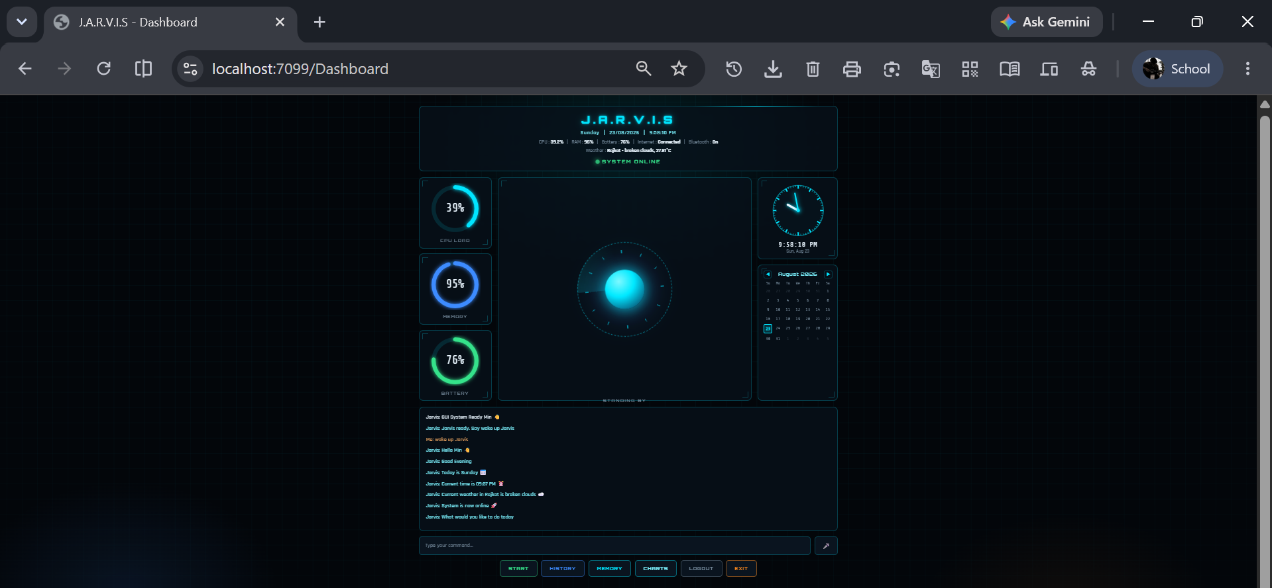

Figure 2.1 : Main Interface of J.A.R.V.I.S System

2.2 STATEMENT OF PROBLEM

Modern computer systems provide a large number of applications and functionalities, but performing daily operations manually can be time-consuming and repetitive. Users often need to open applications, search information on the internet, manage files, check weather updates, and perform multiple system operations repeatedly. Traditional systems require direct manual interaction using keyboard and mouse, which reduces efficiency and productivity.

Most basic desktop assistants available in small-scale projects lack intelligent interaction, voice communication, memory management, real-time automation, and graphical interfaces. Many systems are unable to process natural language commands effectively and cannot provide smooth interaction between users and the operating system. In addition, some assistants do not maintain conversation history, command logs, or user preferences, which limits personalization and user experience.

The J.A.R.V.I.S project is developed to solve these limitations by creating an intelligent AI-based desktop assistant capable of voice interaction, text-based communication, application automation, file management, weather reporting, command history management, and memory storage. The system aims to simplify human-computer interaction by providing a centralized and interactive assistant platform capable of automating common desktop tasks efficiently.

The project is also working to make things easier for users by giving them answers right away, supporting graphical user interfaces, and using automation technologies all in one software environment. This means that users can get help quickly, use a interface that's easy to understand, and have tasks done automatically, all in one place.

2.3 OBJECTIVE AND SCOPE OF THE STUDY

The main objective of the J.A.R.V.I.S (Just A Rather Very Intelligent System) project is to develop an intelligent desktop-based virtual assistant capable of interacting with users through voice commands and text commands. The system is designed to automate common computer operations and provide a user-friendly environment for performing various desktop tasks efficiently.

The project aims to integrate Artificial Intelligence concepts, Natural Language Processing (NLP), speech recognition, desktop automation, graphical user interface design, database management, and API integration into a single software system. The assistant is capable of opening and closing applications, searching the internet, playing songs, managing files and folders, providing live weather information, maintaining command history, and storing user memory for personalized interaction.

Table 2.1 : Objectives and Features of J.A.R.V.I.S System

No. | Objective / Feature | Description
1 | Voice Interaction | System accepts voice commands using speech recognition
2 | Text Command Support | User can interact using typing mode
3 | Application Automation | Open and close desktop applications
4 | Browser Automation | Search internet and play songs online
5 | Weather Information | Provides live weather updates
6 | File Management | Create, open, and delete files/folders
7 | Memory System | Stores user-related information
8 | Command History | Saves previous commands and responses
9 | GUI Interface | Interactive desktop interface using CustomTkinter
10 | Analytics System | Displays usage statistics using charts

The system has another key goal: to cut down on manual work and boost productivity. It does this by letting users control computer tasks with simple, everyday language. The project also aims to create a user-friendly and interactive interface using CustomTkinter, and to process information in real-time using multithreading techniques. This way, the system can handle multiple tasks at once, making it more efficient and responsive to user needs. By using natural language instructions, users can work more easily and quickly, without needing to learn complex commands or codes. The system's interactive interface and real-time processing capabilities make it a powerful tool for getting work done.

The scope of this project can be extended further by integrating advanced AI technologies such as machine learning, large language models, facial recognition, chatbot systems, reminder scheduling, smart home integration, and cloud-based synchronization. Therefore, the J.A.R.V.I.S project provides a strong foundation for developing future intelligent automation systems and AI-powered virtual assistants.

2.4 MODULE DESCRIPTION WITH FUNCTIONALITY

The J.A.R.V.I.S system is built using a modular approach, where different parts of the system are broken down into separate modules. This makes it easier to keep everything organized, fix problems, and add new features later on. Each module has its own job and works together with the others to make the system run smoothly. By keeping things modular, it's simpler to manage the code and make changes as needed, which saves time and headaches in the long run.

Table 2.2 : Module Description of J.A.R.V.I.S System

No. | Module Name | Functionality
1 | GUI Module | Handles graphical user interface and user interaction
2 | Voice Processing Module | Manages speech recognition and voice output
3 | NLP Module | Processes and understands user commands
4 | Command Router Module | Redirects commands to appropriate functions
5 | Automation Module | Controls applications, browser, and file operations
6 | Weather Module | Provides live weather information using API
7 | Database Module | Stores command history and execution details
8 | Memory Module | Saves and retrieves personalized user data
9 | Analytics Module | Generates charts and usage statistics

The GUI Module takes care of creating the graphical user interface, and it uses CustomTkinter to do this. It's in charge of a lot of things, like showing chat messages, handling user interactions, creating buttons, and displaying status indicators and system information. On the other hand, the Voice Processing Module is responsible for recognizing speech and communicating through text-to-speech, and it uses libraries like SpeechRecognition and pyttsx3 to make this happen.

The NLP Module is pretty cool - it helps figure out what users are trying to say by getting rid of extra words and making sure all the commands are in a format that the system can understand. Then there's the Command Router Module, which is like a traffic cop - it makes sure the user's commands get to the right place, whether that's an automation module or a utility module, so everything runs smoothly.

The system has several key modules that work together to keep everything running smoothly. For example, there's the Automation Module, which is in charge of controlling the application, handling browser operations, and taking care of file and system-related tasks. Then, there's the Weather Module, which talks to the OpenWeather API to get the latest weather updates and environmental info. Additionally, the Database Module is responsible for storing important data like command history, responses, timestamps, and execution status, all using the SQLite database management system. This way, all the different parts of the system can share information and work together seamlessly.

The Memory Module stores personalized user information such as name, birthday, favorite color, and college details for improved user interaction. The Analytics Module generates charts and graphical reports for command usage analysis and system performance monitoring. Together, these modules create an intelligent, interactive, and automated desktop assistant system.

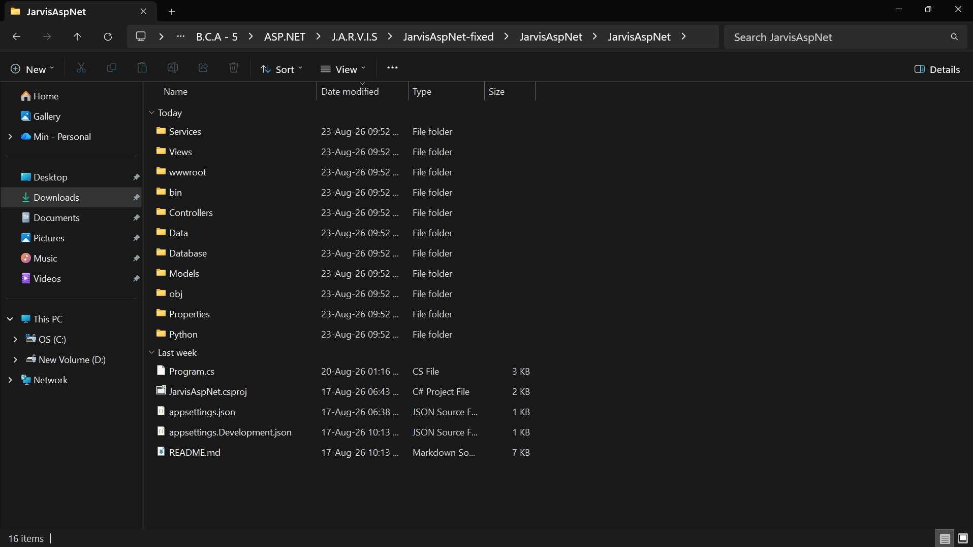
- Screenshort :

Figure 2.2 : Folder Structure of J.A.R.V.I.S Project

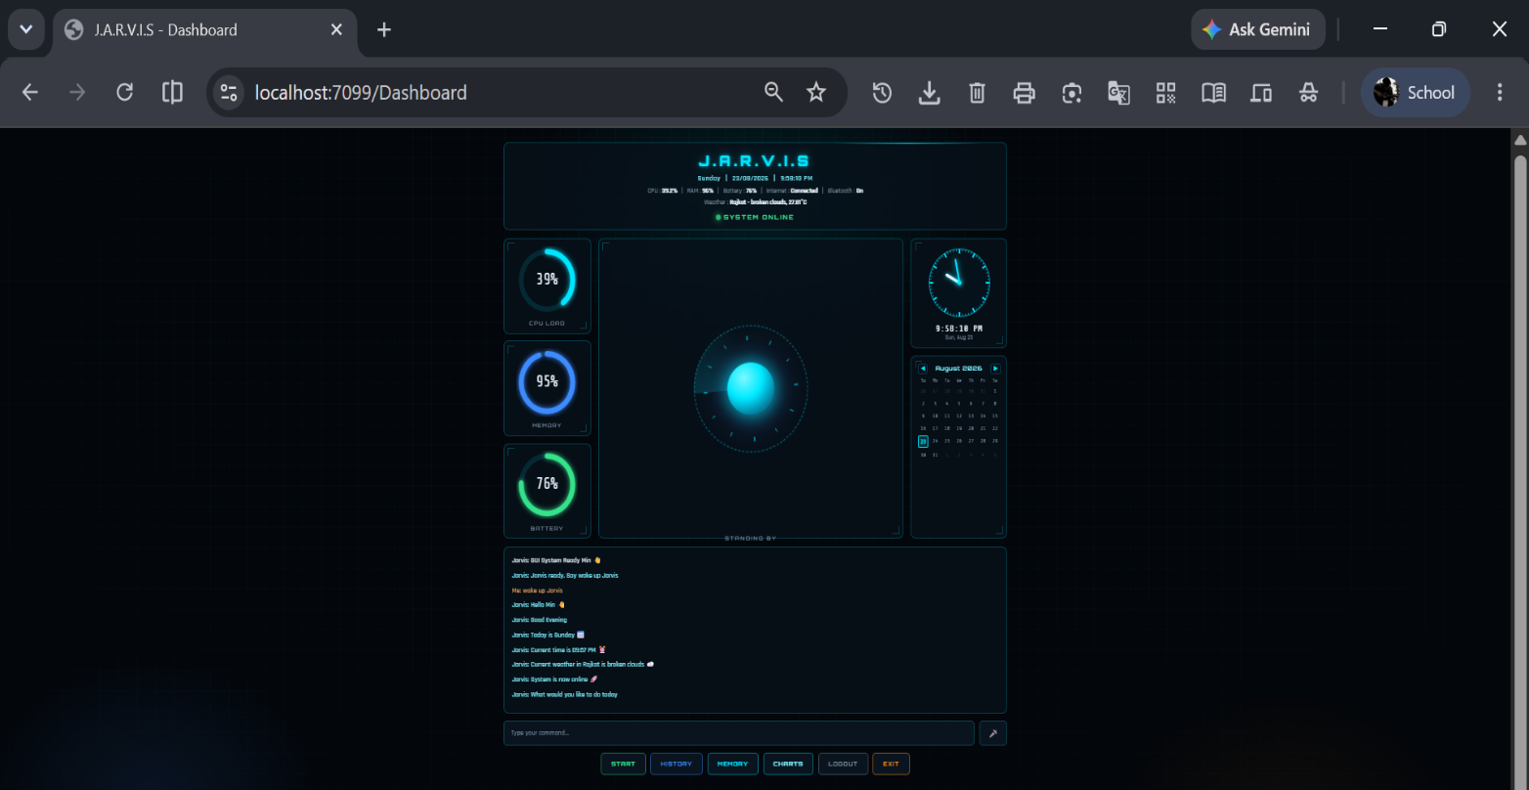
- Screenshort :

Figure 2.3 : Execution of J.A.R.V.I.S Desktop Assistant
CHAPTER 3 — SYSTEM DESIGN AND DEVELOPMENT

3.1 SYSTEM ARCHITECTURE

The J.A.R.V.I.S system is built around a modular and layered software architecture, which is really good for managing tasks, keeping things running smoothly, and making it easy to add new features. This architecture is designed to break down different functions into separate modules, so each one can focus on its own specific job. By doing this, the system becomes more organized, easier to debug, and more flexible for future updates. It's like building with blocks, where each block has its own special role, making it simpler to add or remove blocks as needed. This approach helps the system run more efficiently and makes it easier to maintain and scale up.

The system's design starts with the part where users talk to it, called the User Interface Layer. Here, people can give orders using their voice or by typing on the screen, which is made with a special tool called CustomTkinter. Then, there's the Voice Processing Layer, which does two main things: it uses SpeechRecognition to turn what the user says into text, and it uses pyttsx3 to turn the system's answers into speech that the user can hear.

The Natural Language Processing (NLP) Layer processes user commands by removing unnecessary words and converting commands into standardized instructions. After command processing, the Command Router Layer analyzes the command type and forwards it to the appropriate module such as automation, weather service, memory management, file handling, or browser control.

The functional modules layer is where you'll find the parts of the system that make things happen. This includes things like automating tasks, working with the browser, getting the weather, managing files, handling databases, generating analytics, and storing memory. Then there's the database layer, which uses something called SQLite to store important information like command history, responses, timestamps, and what the user has done before.

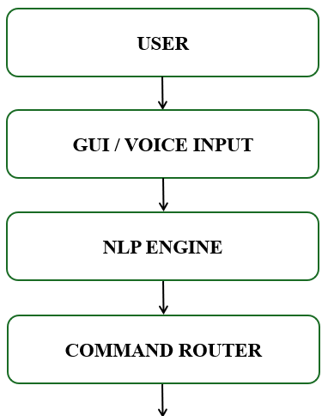
- Diagram of Architecture :-
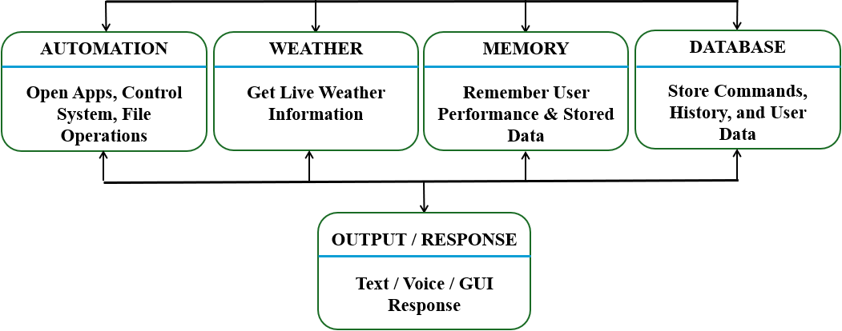
Figure 3.1 : System Architecture of J.A.R.V.I.S

The modular architecture ensures smooth communication between system components and provides efficient execution of real-time desktop assistant operations.

3.2 DATA FLOW DIAGRAM (DFD)

The Data Flow Diagram (DFD) of the J.A.R.V.I.S system represents the movement of data between different modules and processes within the application. It describes how user commands are received, processed, executed, and converted into meaningful responses by the system. The DFD helps in understanding the logical flow of information and communication between system components.

LEVEL 0 : DFD STRUCTURE :-

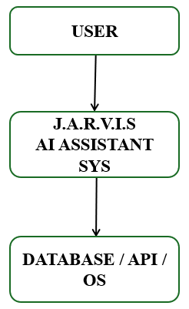
Figure 3.2 : Level 0 Data Flow Diagram of J.A.R.V.I.S

The Level 0 DFD provides a high-level overview of the J.A.R.V.I.S system. It shows the interaction between the user, the assistant system, and external resources such as the operating system, APIs, and database.

In the J.A.R.V.I.S system, the user provides input either through voice commands or text commands using the graphical user interface. The Voice Processing Module converts speech into text using speech recognition technology. The command is then forwarded to the NLP Engine, where unnecessary words are removed and the instruction is converted into a standardized command format.

After command processing, the Command Router analyzes the request and redirects it to the appropriate functional module such as application automation, browser control, weather service, file management, or memory management. If required, the system interacts with external services such as the OpenWeather API or accesses the SQLite database for storing and retrieving information.

So, what happens next is that the final result is sent back to the user in a way that's easy to understand, using both text and voice. The DFD, or Data Flow Diagram, gives a clear picture of how the system works and shows how all the different parts talk to each other to make the intelligent desktop assistant work smoothly and efficiently. It's like a map that helps us see how everything fits together and how it all works as a team.

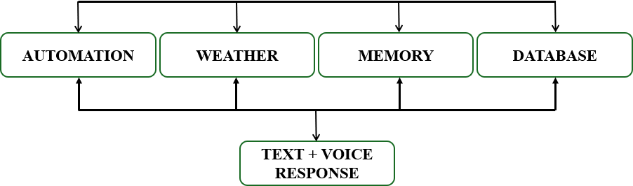
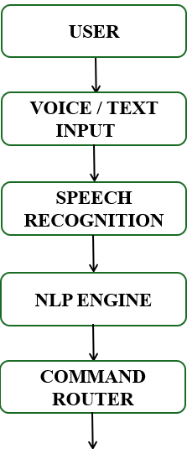
LEVEL 1 : DFD DTRUCTURE :-

Figure 3.3 : Level 1 Data Flow Diagram of J.A.R.V.I.S

The Level 1 DFD illustrates the internal flow of data within the system. User commands pass through speech recognition and NLP processing before being routed to the appropriate functional module. The generated result is then delivered as text and voice output.

3.3 DATABASE DESIGN

The J.A.R.V.I.S system relies on SQLite to manage its database, which stores a range of important information, including command history, responses, timestamps, execution status, and user-related memory details. SQLite is a great choice for this purpose, as it's a lightweight and efficient relational database system that doesn't require a separate server, making it perfect for desktop-based applications. To interact with the database, the system uses the sqlite3 library, which is a Python library that allows for easy data insertion, retrieval, and management operations. This setup enables the J.A.R.V.I.S system to efficiently store and retrieve data, making it a robust and reliable solution. Overall, the use of SQLite and the sqlite3 library provides a simple yet effective way to manage the system's database needs.

Table 3.1 : Structure of command_history Table

Field Name | Data Type | Description
ID | GUI Module | Primary key with auto increment
COMMAND | Voice Processing Module | Stores user command
RESPONSE | NLP Module | Stores the virtual assistant's response
TIME | Command Router Module | Stores how long it takes to run
DATE | Automation Module | This field stores the current date.
DAY | Weather Module | This stores the current day
STATUS | Database Module | This stores the status of how something was executed.

The main database for this project is called "jarvis.db". It has several tables to store information about the commands that are run and how users interact with the system. Whenever a user runs a command, the database saves the command itself, the response it got, how long it took to run, the date, day, and whether it was successful or not. The system also keeps some personal details about each user, like their name, birthday, favorite color, and where they went to college, to make the interaction more personalized and friendly. This helps the system understand the user better and give them a more tailored experience.

TABLE 3.2 — Memory Table Structure

Field Name | Data Type | Description
Key | TEXT | Memory identifier
Value | TEXT | Stored user information

The database module improves system reliability by maintaining historical records of operations and enabling future analysis of user activity. The command history records are also used by the analytics module for generating graphical reports such as successful versus failed commands and most frequently used commands.

The database architecture of the system is designed to support modular communication between different components including command routing, memory management, analytics generation, and GUI-based history visualization. This design ensures efficient data storage, retrieval, and maintenance within the J.A.R.V.I.S desktop assistant system.

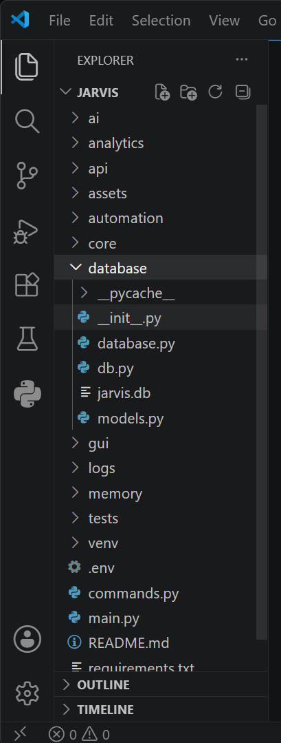
- Screenshort :-

Figure 3.4 : Database Modual Structure of J.A.R.V.I.S

The diagram shows how the SQLite database is set up in the J.A.R.V.I.S system. It's used to store things like what commands have been given, what happened when they were executed, and information about the user. This makes it easier to manage and get the data when it's needed.

3.4 MENU DESIGN

The J.A.R.V.I.S system has a really simple and easy-to-use interface, made with CustomTkinter. This makes it easy for people to navigate and control the desktop assistant. Everything is laid out in a clear and organized way, so users can find what they need without getting confused by technical stuff. The menu and controls are designed to work smoothly together, making it a breeze to use the system's different features.

The main screen has a conversation area where you can see everything you've said and what the system has said back. You can also type in what you want to say using the input box. But that's not all - you can even talk to it using your voice, and it will understand what you're saying because it has special technology that can recognize speech and turn text into speech too.

The system has a bunch of control buttons that help you navigate and use the voice assistant. You've got your START button, which turns on the voice assistant and gets it listening to what you have to say all the time. Then there's the STOP button, which shuts it down and stops it from listening. If you want to see what you've done before, you can hit the HISTORY button, and it'll open up a window that shows you all the commands you've given and the responses you've gotten - all stored nicely in a SQLite database. And when you're all done, you can just hit the EXIT button, and it'll close everything down safely.

The interface also shows you important details about your system, like the current date and time, how much your computer is being used, how much memory is being used, your battery life, if you're connected to the internet, and even the current weather. The way the menu is set up is meant to make it easier for you to use, get around, and interact with the J.A.R.V.I.S desktop assistant in real-time.

Table 3.3 : Menu and Button Functionality of J.A.R.V.I.S

Button / Menu | Functionality
Start | Activates voice assistant and starts listening
Stop | This will stop the assistant from working and listening to your voice
History | Opens command history window
Exit | Closes the application safely
Input Box | Accepts typed user commands
Chat Area | Displays conversations and responses

- Screenshort :-

Figure 3.5 : Menu Design and Controls of J.A.R.V.I.S
The above figure shows the menu design and control interface of the J.A.R.V.I.S desktop assistant. The interface contains control buttons such as START, STOP, HISTORY, and EXIT along with the chat area and command input box for user interaction.

3.5 INPUT DESIGN

The input design of the J.A.R.V.I.S system is developed to provide smooth and flexible interaction between the user and the desktop assistant. The system supports both voice-based input and text-based input for executing commands and controlling system operations. This dual-input mechanism improves accessibility and allows users to interact with the assistant according to their convenience.

The voice input system works by using a special library in Python called SpeechRecognition. This library helps the assistant listen to what you're saying through your computer's microphone. When you turn it on, it's always listening for commands. When it hears you say something, it uses a special engine to turn your spoken words into text that the computer can understand. Then, it sends that text to another part of the system that figures out what you mean and does what you asked. It's also got a special "wake-up" command that lets you turn it on just by talking to it.

The system also lets you type in commands using a text box in the interface. When you type something in, it gets processed in a similar way to voice commands. This means you can use it to do things like automate apps, control your browser, manage files, get the weather, and use memory functions. It's basically another way to interact with the system and get things done.

The system is designed to handle commands accurately and make it easy for users to interact with it. It also has ways to deal with mistakes, like when the system doesn't understand what you're saying or when there's a problem with the microphone. This helps the system run smoothly and efficiently, even when things don't go as planned. By handling errors well, the system can keep working properly and give users a better experience.

- Screenshort :-

Figure 3.6 : Input Design of J.A.R.V.I.S System

The design of the output makes sure that the assistant and the user can communicate effectively. It's clear, easy to use, and works in real-time, so everything happens quickly and smoothly. This way, the system is always responsive and easy to interact with, making it a great experience for the user.

3.6 OUTPUT DESIGN

The output design of the J.A.R.V.I.S system is developed to provide clear, interactive, and real-time responses to the user. The system generates both text-based and voice-based outputs for improving user experience and creating natural human-computer interaction. The output system is designed using graphical interface components and speech synthesis technologies integrated within the desktop assistant.

When you give a command, the system shows what it's doing in a special window. This window is like a conversation, where you can see what the system is saying back to you. The system can do lots of things, like help with automating tasks, working with your browser, telling you the weather, managing files, handling memory, and more. It can even tell you if your commands are working or not. All of this happens in the same window, so you can easily see what's going on and what the system is doing.

The voice output feature is made possible by the pyttsx3 text-to-speech engine, which lets the assistant turn text responses into spoken words, allowing it to communicate with the user in a more natural way. This not only makes the assistant more accessible, but it also gives it a more intelligent and modern feel, similar to what you'd find in other AI systems. By doing so, it creates a more user-friendly experience, making it easier for people to interact with the assistant.

The system can also show special information like the current weather, a list of past commands, charts to help with analysis, and details about how the system is working, such as how much of the CPU and RAM are being used, the battery level, the date, the time, and whether the internet is connected. If something goes wrong, like a command is incorrect or can't be carried out, the system will display an error message to let you know what happened.

The output design ensures effective communication between the assistant and the user while maintaining clarity, responsiveness, and real-time interaction throughout the system.

- Screenshort :-

Figure 3.7 : Output Response System of J.A.R.V.I.S
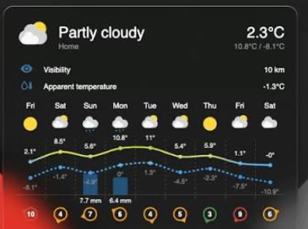

Figure 3.8 : Weather Information Output Of J.A.R.V.I.S

The above figure illustrates the output response mechanism of the J.A.R.V.I.S desktop assistant. The system displays command execution results in the chat interface and also provides voice responses using text-to-speech technology. The output includes automation results, weather information, memory retrieval, file operations, and system status messages.

3.7 SCREEN DESIGN

The screen design of the J.A.R.V.I.S system is developed to provide an attractive, modern, and user-friendly graphical interface for efficient human-computer interaction. The graphical user interface is designed using the CustomTkinter library, which provides modern widgets, dark theme support, and customizable components for professional desktop application development.

The system's main screen has a chat-like area where you can see what you've asked and what J.A.R.V.I.S has said back. It's like a conversation. There's also a box where you can type in what you want to say, and some buttons to help you control things. These buttons are things like "start", "stop", "look at history", and "exit". The people who made the screen tried to make it easy to use and understand, so you can get around quickly and easily. They wanted to keep it simple, so it's not too hard to read or navigate.

The system also shows what's happening right now, like the current date and time, how much the computer is being used, how much memory is being used, the battery level, if you're connected to the internet, and the latest weather. It even gives you little signs that say things like "LISTENING", "PROCESSING", and "SYSTEM OFFLINE" so you know what the system is doing at any given time.

The project includes a separate window that shows you what commands you've used before and what the system said back. This information is kept in a special database called SQLite. It also has some graphs that help you see how often you use certain commands and whether they work or not. These graphs are made using a tool called Matplotlib, which is good at turning numbers into pictures.

The design of the screen makes it easier for people to use, which improves their overall experience and provides an interactive way to work with the J.A.R.V.I.S desktop assistant system. This means users can operate the system more efficiently.

- Screenshort :-
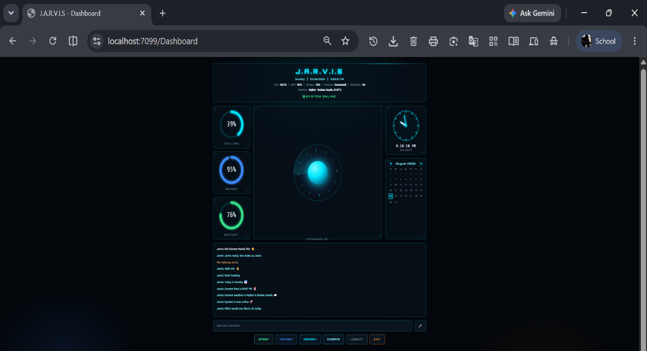

Figure 3.9 : Main Screen Design of J.A.R.V.I.S

The above figure shows the main graphical user interface of the J.A.R.V.I.S desktop assistant. The interface contains system monitoring information, chat interaction area, command input box, and control buttons for managing assistant operations.
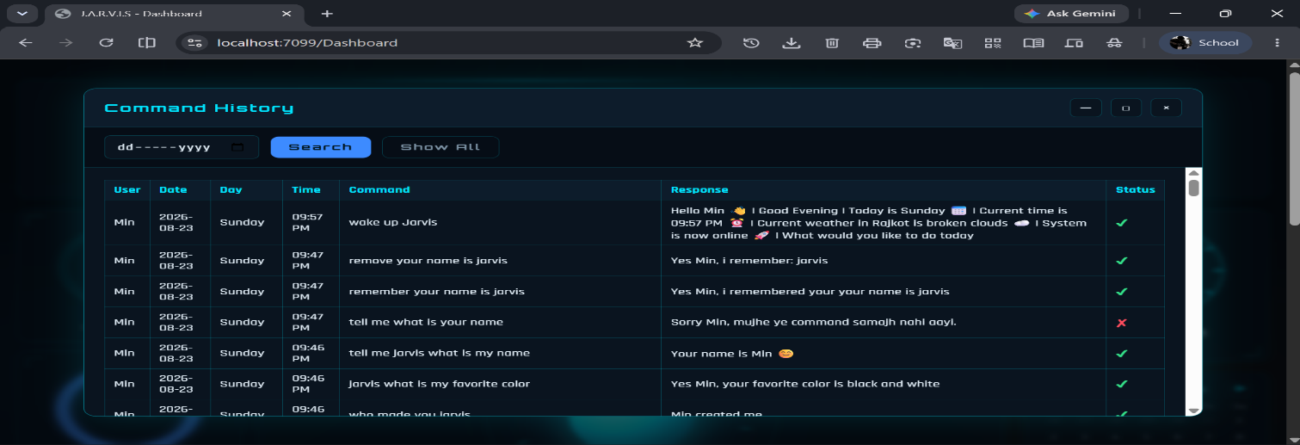

Figure 3.10 : Command History Window of J.A.R.V.I.S

The picture shows what the command history window looks like in the J.A.R.V.I.S system. This window displays a list of commands that were run before, the responses that were generated, the time and date they were run, and whether they were successful or not. All of this information is stored in a database called SQLite.
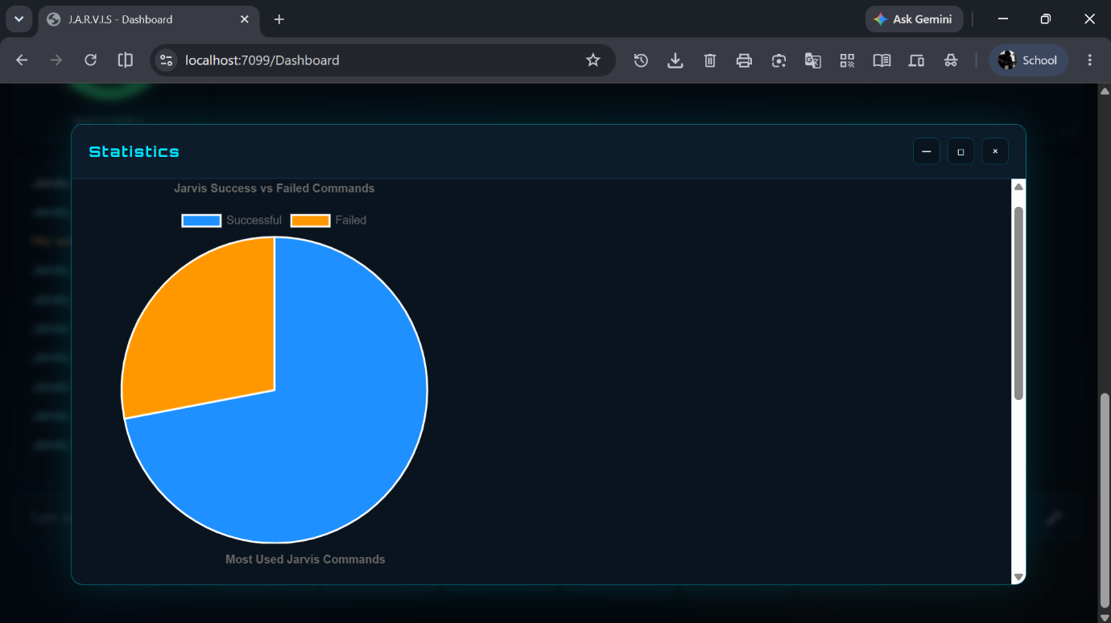
Figure 3.11 : Analytics Charts of J.A.R.V.I.S System

The above figure presents the analytics charts generated by the J.A.R.V.I.S system. The charts visualize command execution statistics, including successful versus failed commands and the most frequently used commands, helping in system performance analysis.

4. CONCLUSION

The J.A.R.V.I.S (Just A Rather Very Intelligent System) project successfully demonstrates the implementation of an AI-based desktop virtual assistant using Python programming language and modern software development technologies. The system integrates voice recognition, natural language processing, desktop automation, graphical user interface design, database management, and API integration into a single interactive platform.

The project is capable of performing multiple intelligent operations such as voice-based communication, text-based interaction, application automation, browser control, weather reporting, file and folder management, memory storage, command history maintenance, and analytics generation. The use of CustomTkinter provides a modern graphical interface, while SpeechRecognition and pyttsx3 enable natural voice interaction between the user and the system.

The implementation of SQLite database management improves system reliability by storing command history and user-related information efficiently. The modular architecture of the project ensures better maintainability, scalability, and future expansion possibilities. The integration of real-time weather information, system monitoring, and analytics features further enhances the practical usability of the assistant.

This project gives you hands-on experience with Artificial Intelligence, software engineering, and creating user interfaces. You'll also learn about connecting to external systems, handling multiple tasks at the same time, and automating tasks on your computer. The J.A.R.V.I.S system is a smart and easy-to-use desktop assistant that helps people interact with computers better and automates routine tasks. It's really good at making computers easier to use and doing things on its own.

The project can be further enhanced in the future by integrating machine learning algorithms, cloud synchronization, facial recognition, smart home automation, large language models, and advanced conversational AI technologies.

5. LEARNING DURING PROJECT WORK

Working on the J.A.R.V.I.S project was a great learning experience. It taught us a lot about software development and Artificial Intelligence. We got to work on a real-world desktop application using Python, which is a popular programming language. We also learned about modern software engineering concepts, which are essential for building efficient and effective software systems. This project was a hands-on experience that helped us gain practical knowledge and technical skills in multiple areas.

One of the biggest things I learned from this project was how to use voice recognition and text-to-speech systems. I used two libraries, SpeechRecognition and pyttsx3, to make it work. I also got a better understanding of Natural Language Processing, or NLP, which is how computers can understand what people are saying. This helped me figure out how to process and understand the commands that users gave.

I got hands-on experience with creating user interfaces using CustomTkinter, which included designing the layout, handling events, updating things in real-time, and managing how users interact with the system. This project also taught me about multithreading, which is a way to handle multiple tasks at the same time, like listening to voice commands and monitoring the system, all in the background.

Database management concepts were learned through the implementation of SQLite for storing command history and user memory information. The project additionally improved understanding of API integration using OpenWeather API for fetching real-time weather data from external servers.

Working on this project really helped improve my ability to solve problems and debug issues. I also got better at breaking down code into smaller parts and designing software architecture. Overall, this project gave me hands-on experience with AI-powered automation, building desktop apps, and creating intelligent software that works in real-time.

6. BIBLIOGRAPHY

1. Python Software Foundation, “Python Documentation,” Available at: https://docs.python.org/

2. CustomTkinter Documentation, “CustomTkinter GUI Library,” Available at: https://customtkinter.tomschimansky.com/

3. SpeechRecognition Library Documentation, Available at: https://pypi.org/project/SpeechRecognition/

4. pyttsx3 Documentation, “Text-to-Speech Conversion Library,” Available at: https://pypi.org/project/pyttsx3/

5. SQLite Documentation, “SQLite Database Engine,” Available at: https://www.sqlite.org/docs.html

6. OpenWeather API Documentation, Available at: https://openweathermap.org/api

7. Matplotlib Documentation, “Python Data Visualization Library,” Available at: https://matplotlib.org/stable/index.html

8. Geocoder Python Library Documentation, Available at: https://geocoder.readthedocs.io/

9. Psutil Documentation, “System Monitoring Library,” Available at: https://psutil.readthedocs.io/

10. W3Schools Python Tutorial, Available at: https://www.w3schools.com/python/

11. Real Python Tutorials, Available at: https://realpython.com/

12. Stack Overflow Developer Community, Available at: https://stackoverflow.com/

13. Visual Studio Code Documentation, Available at: https://code.visualstudio.com/docs

14. Microsoft Windows Developer Documentation, Available at: https://learn.microsoft.com/

15. Software Engineering Concepts and Practices Reference Materials.

