A Project Report On
J.A.R.V.I.S (JUST A RHTHER VERY INTELLIGENT SYSTEM) ERY INTELLIGENT SYSTEM)

Submitted in partial fulfillment of the requirement for the BCA Semester-4 Python Programming Subject Final Examination.
BACHELOR OF COMPUTER APPLICATIONS
(B.C.A.)

Academic Year 2025 – 26

Student Name – Miral Dhankecha (92400527161)

Internal Guide
Mr. Amit Gohil


Rajkot-Morbi Road, At & PO : Gauridad, Rajkot 360 003. Gujarat. India.

CONTENTS

Chapters | Particulars | Page No.
1 | SYNOPSIS | 1
2  2.1  2.2  2.3  2.4 | PREAMBLE  General Introduction  Statement of Problem  Objective and Scope of the Study  Module Description with functionality | 2  2  3  3
3  3.1  3.2  3.3  3.4 | SYSTEM DESIGN AND DEVELOPMENT  Data Flow Diagram (DFD)  Table Structure  Menu Design  Screen Design (Screen shots with short description) | 4,5,6,7  8  9  10,11
4 | CONCLUSION | 12
5 | LEARNING DURING PROJECT WORK | 13
6  6.1  6.2 | BIBLIOGRAPHY  Online References  Offline References | 14

FIGURE INDEX

Sr. No. | Figure No. | Particulars | Page No.
1 | Fig 1 | JARVIS GUI Interface | 10
2 | Fig 2 | Command Execution (Open Application) | 10
3 | Fig 3 | Voice command Processing | 10
4 | Fig 4 | Command Usage Analysis (Bar Chart) | 11
5 | Fig 5 | Response Time Analysis (Line Chart) | 11
6 | Fig 6 | File Creation and Deletion Output | 10

TABLE INDEX

Sr. No. | Table No. | Particulars | Page No.
1 | Table 1 | Moduale Description | 3
2 | Table 2 | Table Structure (Project File) | 8
3 | Table 3 | Menu Design | 9

1

CHAPTER 1: SYNOPSIS

JARVIS AI Desktop Assistant is an automation program implemented in Python for making human-computer interaction more convenient via voice commands and textual commands. The program enables the user to conduct several actions like launching applications, manipulating files and directories, performing searches on the Internet, and gathering live data on weather conditions. The application utilizes the speech recognition API and text-to-speech engine to process voice commands and generate voice feedback, respectively.

Apart from that, the software has a graphical user interface (GUI), which improves usability and creates a live interaction mode. The application also possesses a data analytics module capable of monitoring the number of commands used and the duration of responses graphically. The project employs various Python modules like SpeechRecognition, Pyttsx3, Requests, and Tkinter.

In general, the software seeks to enhance productivity by automating repetitive actions and introducing a smart assistant feature in the desktop platform.

2

CHAPTER 2: PREAMBLE

2.1 General Introduction

In the modern digital world, the process of human interaction with machines has been significantly affected by the impact of automation and artificial intelligence. Virtual assistants have become a necessity in the modern computing world, allowing humans to carry out tasks efficiently with the least amount of human intervention.

The J.A.R.V.I.S system has been developed to act as a smart assistant to the user, allowing it to comprehend the user’s command and act on it effectively. This minimizes the involvement of human intervention and increases productivity by allowing the system to automate tasks.

This project has been developed to create a user-friendly assistant using the Python programming language, which has the capability to perform multiple tasks.

2.2 Statement of Problem

Many users encounter difficulties in efficiently handling many tasks on a computer, especially when there are repetitions. This has always required time and effort for users.

There exists a need for a system that can:

* Minimize manual work
* Execute tasks faster
* Support voice interaction
* Enhance user convenience

This project aims to solve these challenges by creating an intelligent assistant for automating tasks and efficiently processing user requests.

3

2.3 Objective and Scope

Objectives :-
The objectives of this study are:
* To create a virtual assistant using Python
* To facilitate voice and text-based interaction
* To perform basic computer automation
* To enhance user productivity

Scope :-
The proposed system has the following scope:
* It can open applications like Chrome and Notepad
* It can perform searches on Google and YouTube
* It can create and delete files
* It can give information on time and weather

The proposed system has some limitations because it can only perform certain commands and has basic AI capabilities.

2.4 Module Description

The system is divided into different modules, each of which has specific functionality. They are as follows:

1. Input Module :-

* Accepts voice and text commands from the user

2. Voice Recognition Module :-

* Converts the voice into text

3. Command Processing Module :-

* Recognizes the command from the user and performs the task

4. Automation Module :-

* Handles tasks like opening applications, searching, etc.

5. AI Response Module :-

* Provides intelligent response for unknown queries

6. Output Module :-

* Converts text into speech
4

CHAPTER 3: SYSTEM DESIGN AND DEVELOPMENT

Data Flow Diagram (DFD) :-

Introduction :-

The Data Flow Diagram is the diagram that describes the movement of data within the JARVIS system. The whole process starts with an input from the user either by voice or typing. If the input was given by voice, the speech recognition module converts the voice to text input which is then forwarded to the command processing module.

The command processing module takes care of the input analysis, and then the processed input is delivered to any one of the following modules; application control module, file manager module, search engine module, or weather module depending on the input requirement. The corresponding action is taken by the selected module(s), and a response is generated by it.

The response is then relayed to the text-to-speech module and the GUI.

5

3.1 Level 0 DFD (Context Diagram) :-

Description :-

Level 0 DFD gives the high-level interaction process between the user and the JARVIS AI System.

The user provides inputs via voice/text.
JARVIS system processes the inputs.
JARVIS generates the response/output in voice/graphical formats.
Components
External Entity: User
Process: JARVIS AI System
Output: Voice Output & GUI Output

Level – 0 :-

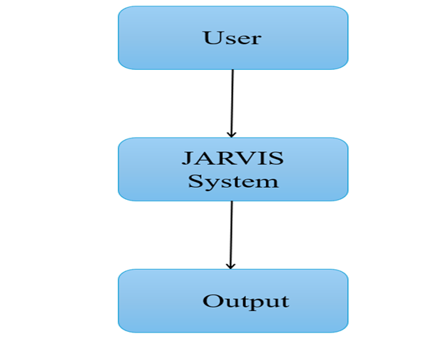

6

3.2 Level 1 DFD (System Flow Diagram)

Description :-

Level 1 DFD gives an elaborate interaction process within the main system in order to process inputs and generate outputs.

Flow Explanation :-

Inputs are collected from the user via voice/text.
They are then fed to the Input Module.
They are then fed to the Main Controller (main.py file).
It then determines where to send the request: Brain or Automation Module
It then forwards the processed data back to the Output Module.
The system then generates voice and GUI output.

Modules :-

Input Module (voice/text recognition)
Main Controller (main.py file)
Brain Module (AI Engine/Memory)
Automation Module (command processing/smart control)
Output Module (voice GUI outputs)

Level – 1
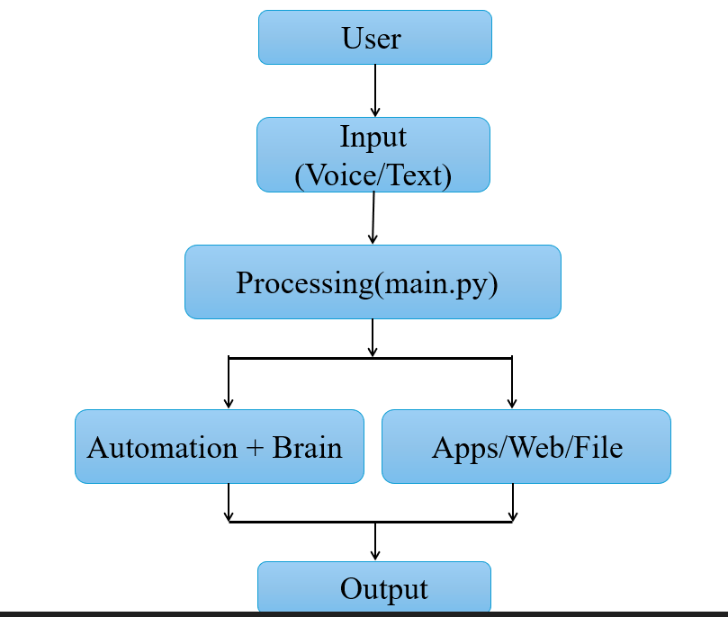
7

3.3 Level 2 DFD (Detailed Architecture Diagram)

Description :-

Level 2 DFD shows the detailed architecture of JARVIS AI System according to its project setup.

Detailed Flow :-

User input collection occurs through the following methods:
voice_input.py (voice commands)
Typing input system
It sends the user input to the main controller (main.py file)
The main controller then sends the request to either of the modules (Brain/Automation Module).
Processing is carried out by brain.py file.
Processing is carried out by memory.py file.
Processing is carried out by personality.py file.
Processing is carried out by commands.py file.
Processing is carried out by smart_control.py file.
Result is then sent to output module.
Processing is done in voice_output.py
Processing is done using GUI interface
Result is sent to the user.

Level – 2 :-

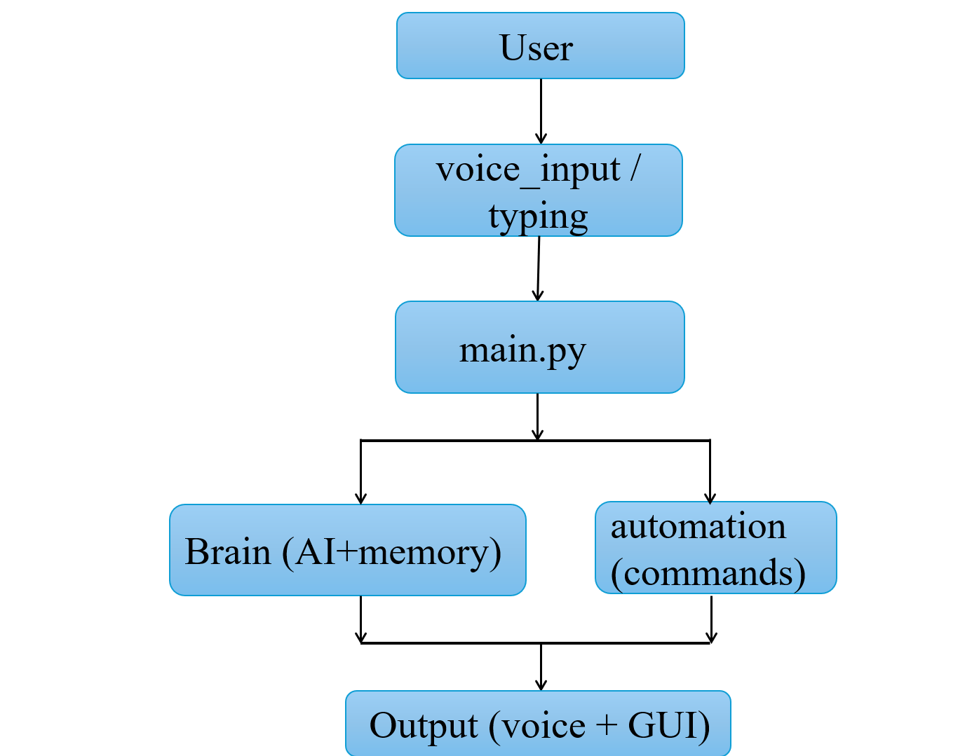

8

3.2 Table Structure :-

The table structure of the JARVIS AI Desktop Assistant is a way of organizing various files in the application. The files in the program are designed to perform distinct functionalities within the system to ensure modularity and efficiency. main.py performs the overall running of the application and also deals with the interactions between the user and the application. commands.py is concerned with carrying out instructions from the user for automated activities. gui_jarvis.py is used to create the graphical user interface. chart.py performs analysis of performance data in graphical format while weather.py deals with real-time weather data through an API.

Tables :-

Table No | File Name | Description
Table 1 | main.py | Main execution and control
Table 2 | commands.py | Command logic and automation
Table 3 | gui_jarvis.py | Graphical user interface
Table 4 | chart.py | Data analysis chart
Table 5 | weather.py | Weather API handling

9

3.3 Menu Design :-

The JARVIS AI Desktop Assistant offers a convenient menu design, which is a friendly interface for the system. The system is designed with many choices where the users can do various activities using the software. The Voice Mode is used to give commands using voice input. On the other hand, Typing Mode is where the users enter the commands manually by typing them into the system. The Open App option opens the applications installed in the computer, whereas the Close App closes these apps. In addition, users can use the Search feature to search for something using Google. Lastly, Play is the menu for playing music videos from YouTube.

Menu :-

Menu Option | Description
Voice Mode | Accepts voice commands
Typing Mode | Accepts text input
Open App | Opens applications
Close App | Closes applications
Search | Perform google Search
Play | Plays songs on YouTube
Exit | Shut down assistant

10

3.4 Screen Design (Screenshots with Description) :-

Figure 3.2: Graphical User Interface of JARVIS System :-

The system comprises of the graphical user interface which has been designed using CustomTkinter. This graphical user interface consists of a chat box where the inputs provided by the users and the outputs received from the system will be shown.

The user can type the commands in the command entry or the users may also switch on the voice mode for using voice commands. Further, there are other features like real-time text animation as well as voice output that make the system interactive.

Further, there are graphs presented to show how the commands are utilized and the time taken for response to a command. All these aspects have been taken care off to ensure that the system is easy to operate and understand.

GUI Windows And Output :-

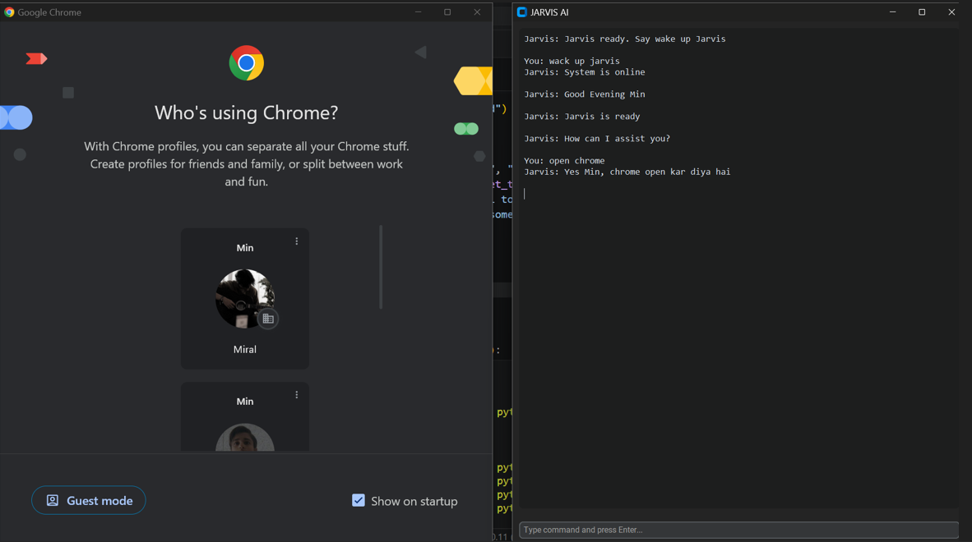

11

Chart 1 :- Command Usage Analysis (Bar Chart)
Figure 1:-

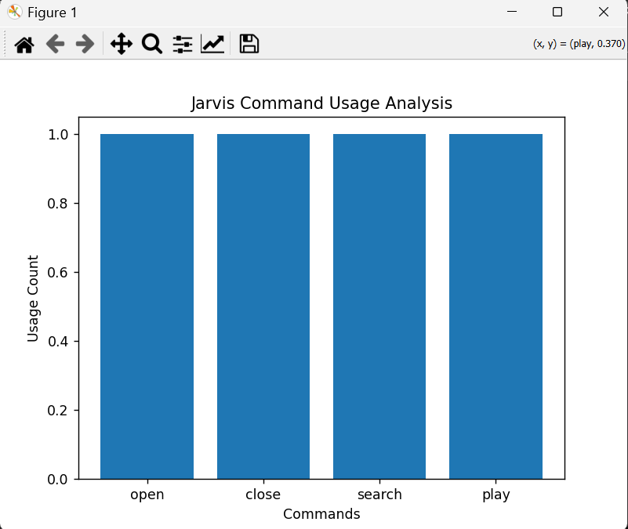

Chart 2:- Response Time Analysis (Line Chart)
Figure 2 :-

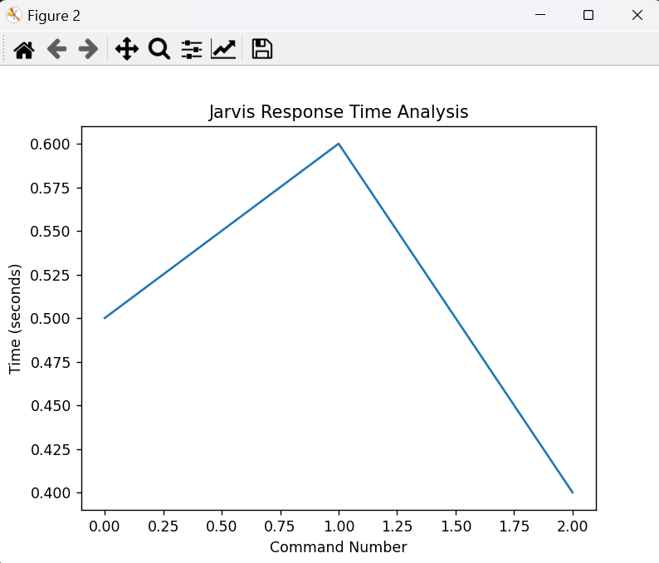

12

CHAPTER 4: CONCLUSION

The development of the project “J.A.R.V.I.S (Just A Rather Very Intelligent System)” has provided a clear example of how a virtual assistant can be developed using Python. This assistant can carry out different tasks automatically based on voice or text commands. This will greatly improve human interaction with computers.

This project has greatly fulfilled its main objectives since users can perform different operations such as opening applications, searching information on the internet, and updating information in real-time such as time and weather. The inclusion of these two technologies will greatly improve the usability of the developed system.

Even though the developed system can only perform operations based on given commands and AI responses, it can be used as a stepping stone for developing more advanced systems in the future. This is mainly based on the potential of artificial intelligence and automation in simplifying operations for users.

In conclusion, this project has greatly fulfilled all its objectives and can be used as a stepping stone for developing more advanced systems.

13

CHAPTER 5: LEARNING DURING PROJECT WORK

During the development of the J.A.R.V.I.S system, various technical and practical concepts were learned and implemented successfully.

Technical Learning :-

* Knowledge about the Python programming language and the module-based coding style
* Knowledge about how to implement speech recognition and text-to-speech functions
* Knowledge about working with libraries like OS, Webbrowser, and API
* Knowledge about how to work with real-time data like weather information
* Knowledge about command processing and automation techniques

Practical Learning :-

* Learning about problem-solving techniques
* Learning about how to structure a whole software project
* Learning about how to manage time while developing a project
* Learning about how to understand user requirements and system design

Personal Learning :-

* Learning about how to enhance logical and analytical capabilities
* Learning about how to build confidence while developing real-world applications
* Learning about how to understand artificial intelligence-related concepts

14

CHAPTER 6: BIBLIOGRAPHY

6.1 Online References :-

* Python Official Documentation – https://www.python.org/doc/
* Open Weather API Documentation – https://openweathermap.org/api
* Speech Recognition Library Documentation – https://pypi.org/project/SpeechRecognition/
* Stack Overflow – https://stackoverflow.com/
* YouTube Tutorials (Python Automation & AI Assistant Development)

6.2 Offline References :-

* Study Material Provided by Faculty
* Class Notes and Practical Sessions
* Reference Books on Python Programming and Artificial Intelligence

