09/25/2025
Below is the pipeline for post-processing IVIM of the pelvis with given ROIs drawn in MIM. The marker >> represents a line of code in matlab.

It is step-by-step, for easiest use… may over-explain.

Any questions, please reach out to Mira Liu (mirabai.liu@mountsinai.org)

The code is run in MATLAB R2024b.

- Get images from all b-values into one folder (the path to this folder is referred to as “path_to_dicoms” from here on in the pipeline
  - This should be one dicom for every b-value of every slice.
  - e.g. for a case with 10 b-values and 33 slices, there should be 330 individual dicoms in this folder.
  - Name this folder “DICOM”
- Sort these by slice and by b-value to get a folder “DICOM_sorted”
  - We want it to be slice 1: b0, b#1, b#2, b#3, b#4… slice 2: b0, b#1, b#2…
    - >>SortIVIM_Pelvis(path_to_dicoms/PIPELINE_TEST_RUN/','DICOM');
- Get a separate folder with only the b=0 dicoms
  - This should be one dicom for b=0 of every slice
  - e.g. for a case with 10 b-values and 33 slices, there should be 33 individual dicoms, each with b=0.
  - Name this folder “b0_Dicoms”
  - Folder structure should now look like this:
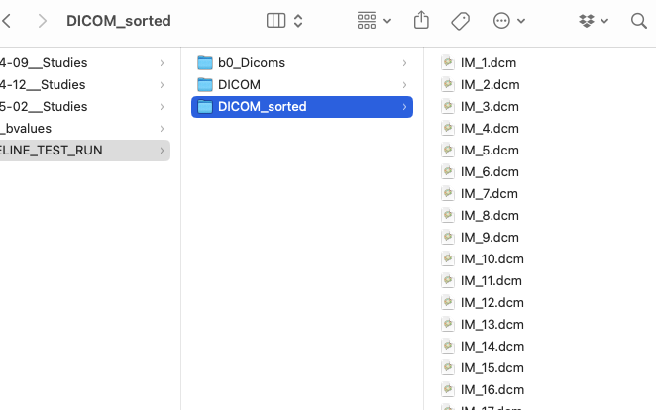

- Add the RT-STRUCT dicom file to b0_Dicoms folder renamed as “RT_Struct.dcm”
- Convert the RT-STRUCT from to MAT ROIs
  - This uses the code in the folder “Read-RTSTRUCT-to-matlab_MIM” – make sure this code is part of the working directory.
  - Set directory to the path to the b0_DICOM folder
    - >> directory = (path_to_dicoms/PIPELINE_TEST_RUN/b0_Dicoms');
    - >> files_out = scanDir(directory);
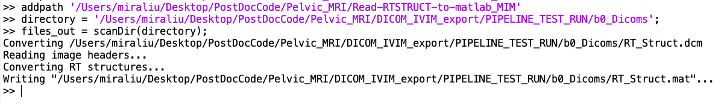

- This should now have a .mat file called “RT_Struct.mat”
  - This RT_Struct.mat is the mask! We can now read it in matlab as images.
  - Load the RT_struct into matlab
    - >>load(path_to_dicoms/PIPELINE_TEST_RUN/b0_Dicoms/RT_Struct.mat')
  - Load the images into matlab
    - >> [images, images_info] = dicomfolder(path_to_dicoms/PIPELINE_TEST_RUN/b0_Dicoms/');
  - Get the list of ROIs in the structure
    - >> ROI_names = {};
for j = 1:size(contours,2)
ROI_names{end+1}= contours(j).ROIName
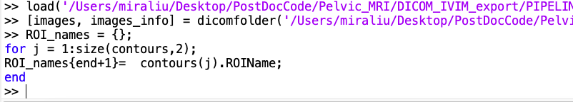
end

  - Get an example mask, say “Blbclitoris_AW_DM” (but can choose any name in the ROI names list) and plot it
    - >> exact_match_mask = strcmp(ROI_names, 'Blbclitoris_AW_DM')
    - >> n = find(exact_match_mask);
    - >> mask = contours(n).Segmentation;
    - >> mask = flip(permute(mask,[2, 1, 3]),3);
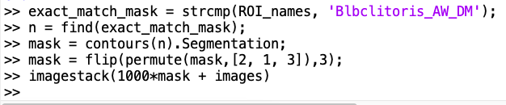
    - >>imagestack(1000*mask + images)

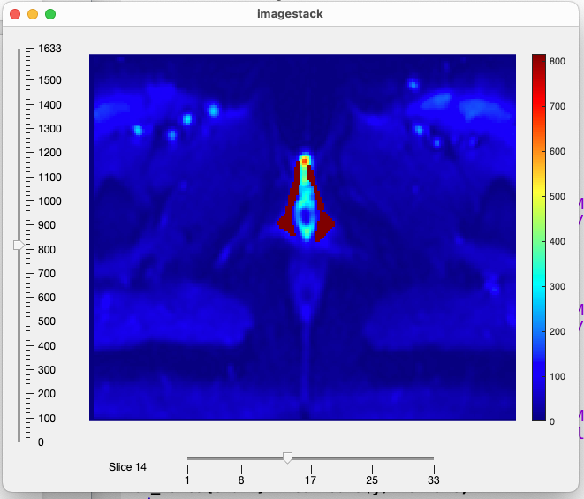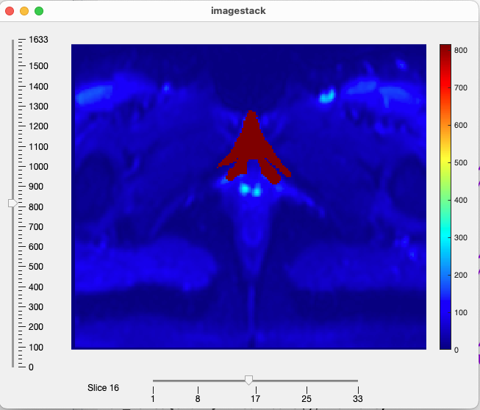Can choose which slice to show on the bottom slider
Can choose the range of values on the left slider

- Now get the Signal within these ROIs.
  - Get all of the ROIs in one volume and save it as a matfile in the original b0_Dicoms folder
    - >>All_Masks = zeros(size(images));
>> for j = 1:size(contours,2)
mask = contours(j).Segmentation;
mask = flip(permute(mask,[2, 1, 3]),3);
All_Masks = All_Masks + mask;
end
>> imagestack(All_Masks)
>> save(fullfile(directory,'AllMasks.mat'), 'All_Masks')
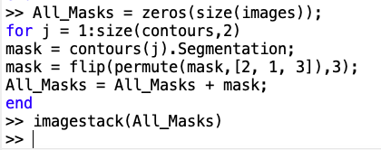
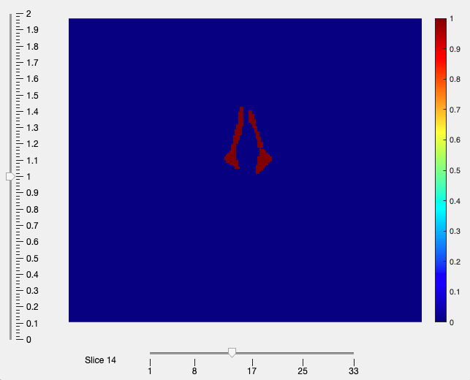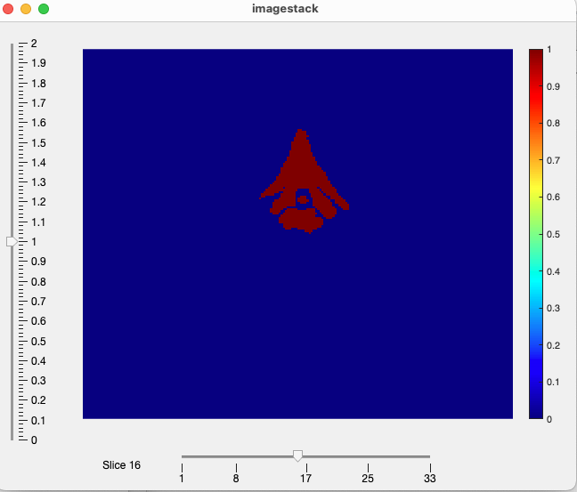
Can choose which slice to show on the bottom slider
Can choose the range of values on the left slider

- Run the Bayesian fit for IVIM on the sorted dicoms, with the b0 RT-structure for reference
  - Run the Bayesian fit on the slices that have an ROI drawn on them
  - Currently also only analyzes the ROIs themselves, to save computation. Can also write it to analyze voxels outside of the ROIs, but that will just take more time regarding processing.
    - >>RunBayesianIVIM_Pelvis(path_to_dicoms/PIPELINE_TEST_RUN/','DICOM_sorted')

Should now have 3 matlab files! B0 is the b0 map, the Bayesian is the IVIM fit with a Bayesian algorithm, and the segmented fit is the IVIM with a two-step segmented fit. Load them into matlab and you have volumes of the parameter maps!
