11/6/2025
Below is the pipeline for getting data from T1 with variable flip angle and B1 correction of the pelvis with given ROIs drawn in MIM. The marker >> represents a line of code in matlab.

It is step-by-step for easiest use.
Any questions, please reach out to Mira Liu (mirabai.liu@mountsinai.org) preferably with a screenshot of the code run and the output error.

The code is run in MATLAB R2024b.

- Get images from all of the T1 B1 Corr folder into one folder (the path to this folder is referred to as “path_to_dicoms” from here on in the pipeline. This is the same as targetpath in my screenshots of code.)
  - It seems there are 2 dicoms for each slice. (so if there are 30 slices imaged, there should be 60. If there are only 30 even better)
  - Name this folder “DICOM”.
- Sort these dicoms to get only the T1 B1 Corr maps to get a new folder “DICOM_sorted”
  - Run the following code
    - >> targetpath = path_to_dicoms
    - >> targetfolder= ‘DICOM’
    - >> SortT1_Pelvis(targetpath, targetfolder);
    - 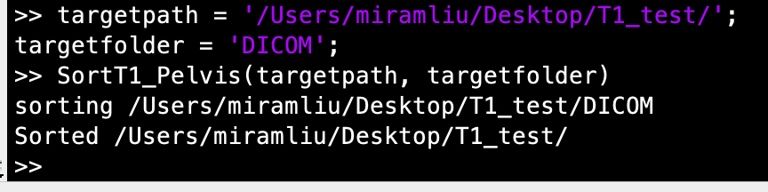
- Add the RT-STRUCT dicom file to DICOM_sorted folder renamed as “RT_Struct.dcm”.
- Convert the RT-STRUCT from to MAT ROIs
  - This uses the code in the folder “Read-RTSTRUCT-to-matlab_MIM” – make sure this code is part of the working directory.
  - Set directory to the path to the b0_DICOM folder
    - >> directory = (path_to_dicoms/DICOM);
    - >> files_out = scanDir(directory);
  - Note: due to inconsistency in how the slices were exported, you may get a warning. That’s fine! We correct it later: See example code with the warning below
  - 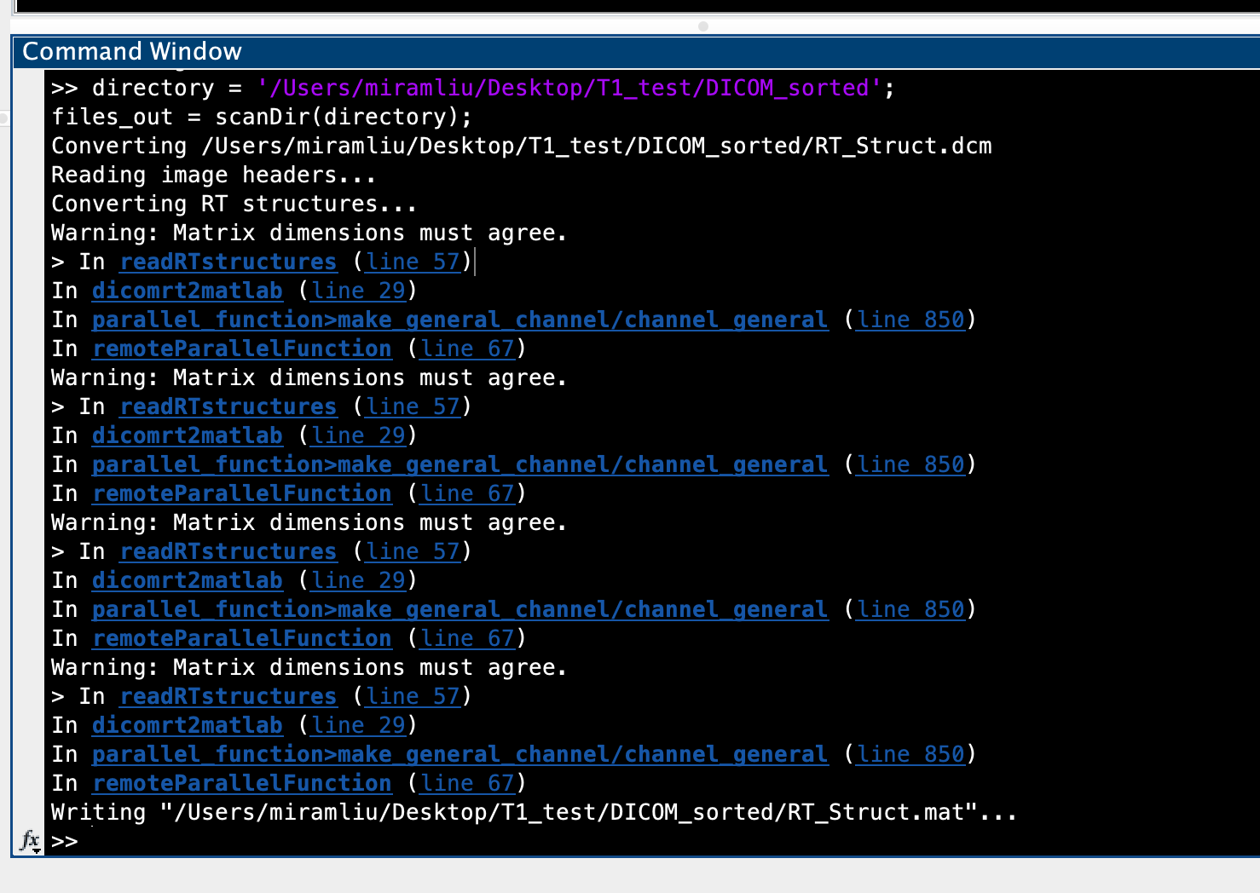

- there should now be a .mat file called “RT_Struct.mat” in the DICOM_sorted folder
  - This RT_Struct.mat is the mask! We can now read it in matlab as images.
  - Load the RT_struct into matlab
    - >>load(path_to_dicoms/DICOM_sorted/RT_Struct.mat')
  - Load the images into matlab
    - >> [images, images_info] = dicomfolder(path_to_dicoms/DICOM_sorted/');
  - Get the list of ROIs in the structure
    - >> ROI_names = {};
for j = 1:size(contours,2)
ROI_names{end+1}= contours(j).ROIName;
end

  - 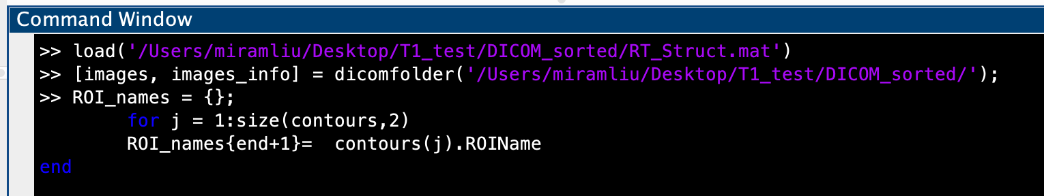

- Get example say “Blbclitoris_RT_DM” (but can choose any name in the ROI names list) and plot it
    - >> exact_match_mask = strcmp(ROI_names, 'Blbclitoris_AW_DM');
    - >> n = find(exact_match_mask);
    - >> mask = contours(n).Segmentation;
    - >> mask = flip(permute(mask,[2, 1, 3]),3);
  - Note here is where we correct the spacing: there is double slices. So here we only keep every other slice as follows:
    - >> mask = mask(:,:,1:2:59);
    - >>imagestack(10000*mask + images)
    - 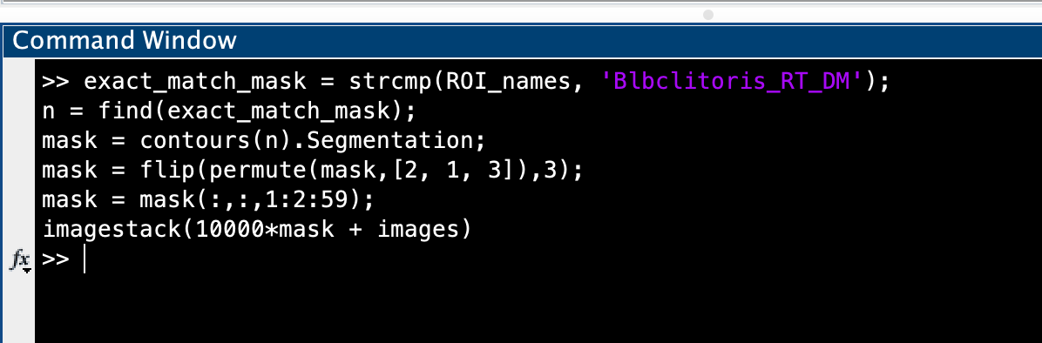

  - Should show images like the following that you can scroll through
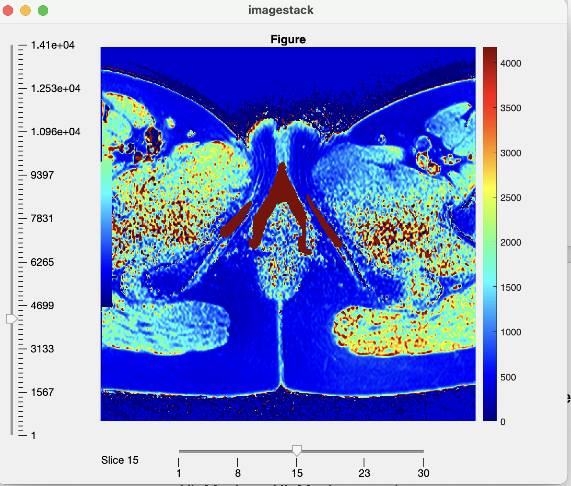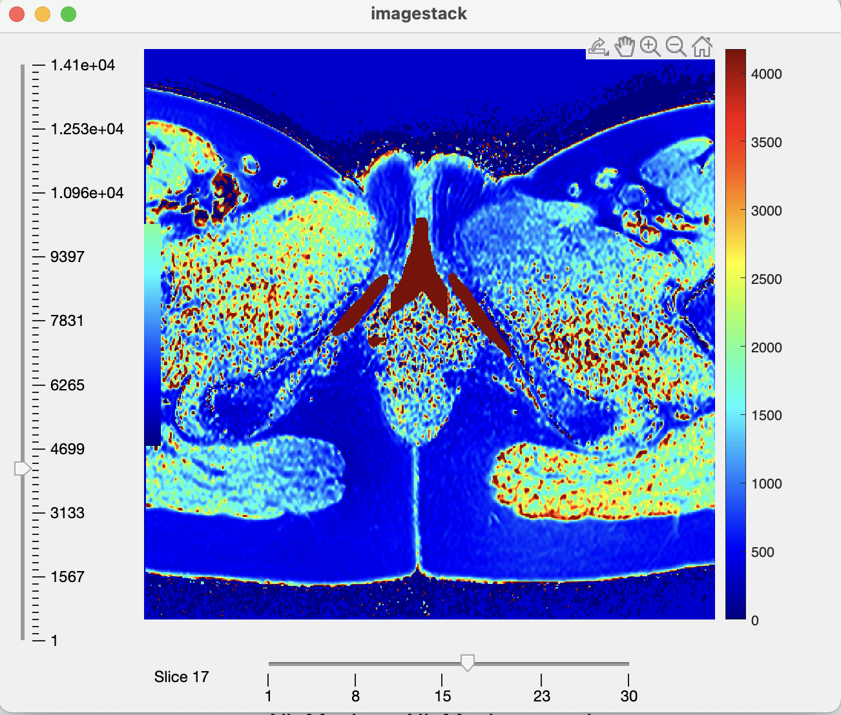
Can choose which slice to show on the bottom slider
Can choose the range of values on the left slider

- Now save the image as a matfile saved as T1
  - >> T1 = images;
  - >> save([path_to_dicoms, ‘/’, ‘T1B1Corr_map.mat','images')
    - 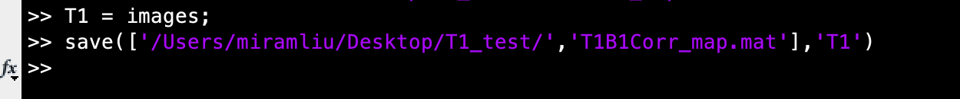

- Now you have the masks and the parameter maps in matfile! Run the code as described in Statistical_Analysis_11042025 to extract the parameters of interest for T1.
  - An example of the code run to export the T1 information is below. See Statistical_Analysis_11042025 for more detail.
    - >> ExcelFileName = '/Users/miramliu/Desktop/T1_test/Testing_Export_T1.xlsx';
    - >> load('/Users/miramliu/Desktop/T1_test/DICOM_sorted/RT_Struct.mat');
    - >> load('/Users/miramliu/Desktop/T1_test/T1B1Corr_map.mat')
    - >> Statistical_Analysis_T1('test PT', 'Test_sheet1', ExcelFileName, contours, T1)
    - 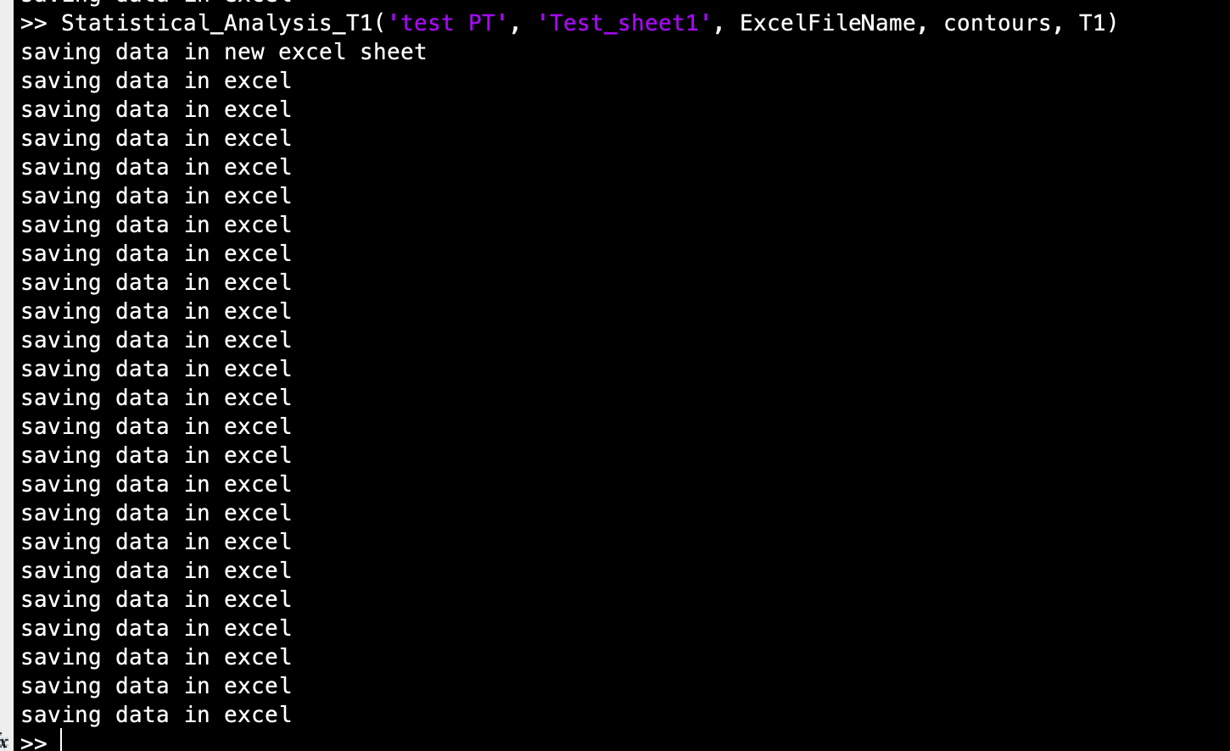

  - This will export the data into an excel file on the sheet you gave it as shown below. If some of the ROIs were empty, the excel names will be left blank!

