Step by step for statistical analysis of Parameter maps!

Assumed completion of the Pipeline itself (e.g. IVIM_Pipeline) which should leave you with the RT_struct.mat and a mat file of parameters (e.g. DICOM_sorted_Bayesian.mat).

Now we extract information from the ROIs in RT_struct and the parameters we have from the post-processed MRIs!

- MAKE AN EXCEL SHEET FOR EXPORT.
  - I put it in all caps because it’s annoying but when I originally wrote this code, MATLAB couldn’t create excel sheets if they didn’t exist yet, they could only edit existing ones.
  - So first create an excel file on your computer the usual way, and name it whatever makes sense (I named mine “Testing_Export.xlsx” and put it on my desktop.
  - Then save the name to that excel file in Matlab as “ExcelFileName”.
    - >> ExcelFileName = 'Users/miramliu/Desktop/Testing_Export.xlsx';
    - 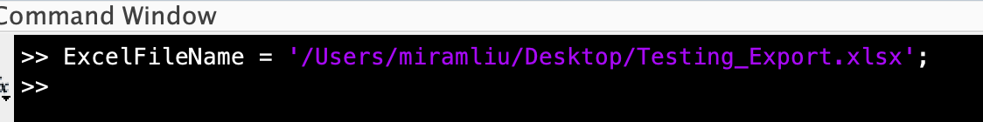
- Import the RT_struct and the Parameter maps you want (I’m using IVIM as the example here – can do it with T1 as well or any post-processed map in matfile).
  - Load it into work space – should now see the variables “countors” and the parameter maps of interest in your workspace (image shown below)
    - 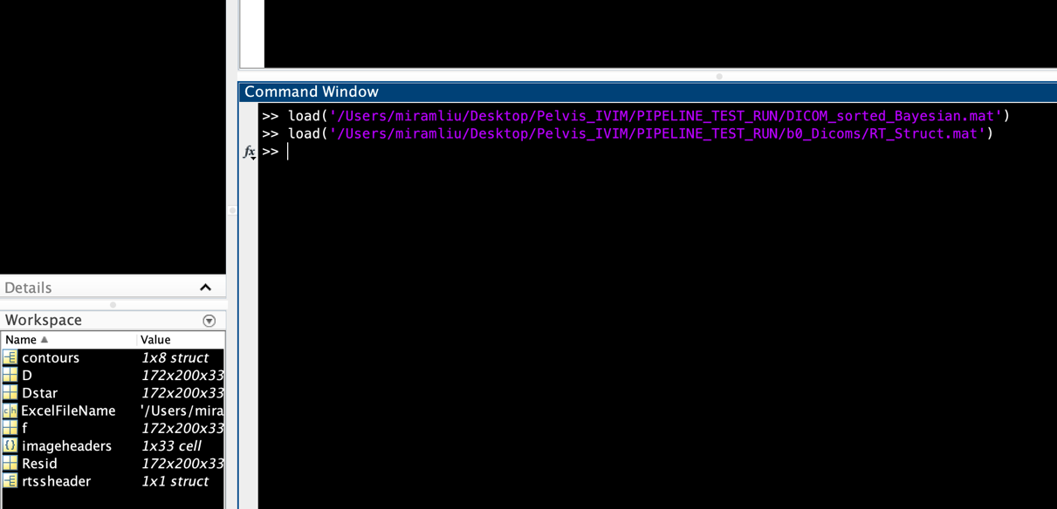
- Run Statistical_Analysis
  - Give it the patient ID, the excel sheet name you want (I’d recommend naming it after the parameter you are running it on, for example IVIM f or IVIM Dstar), the path to the excel file, as well as the variable ‘contours’, and the parameter map itself
  - The code below runs statistical analysis on a patient I call test PT, saved in Test_sheet 1, within the excel file from step 1, and applies the contours from the RT_struct, and runs it on the IVIM parameter D (last input)
    - >> Statistical_Analysis('test PT', 'Test_sheet1', ExcelFileName, contours, D)

Below is the entire run (should be quick) seen on my end!

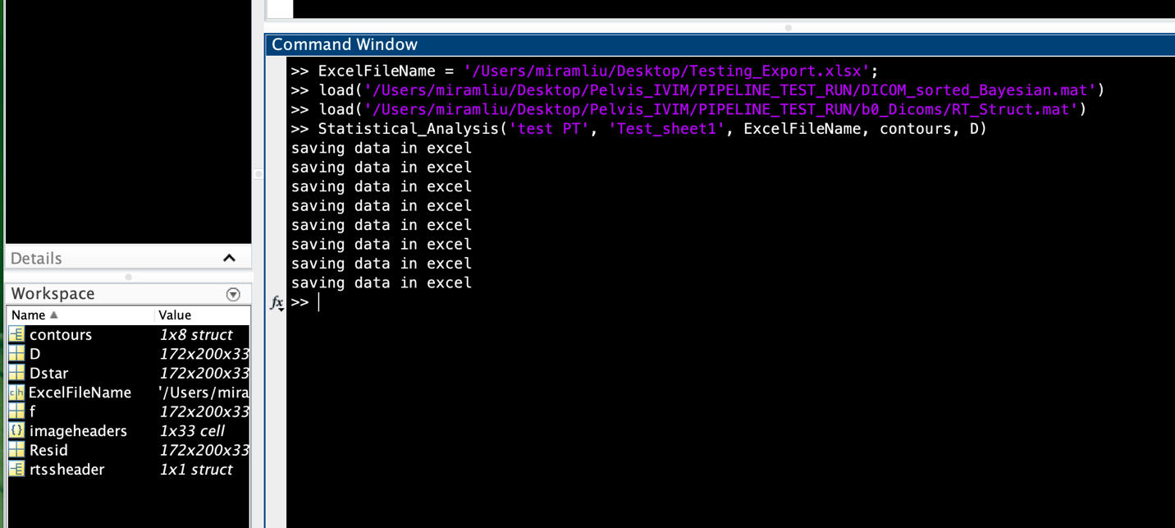

Example output in the excel file you just created is shown below!

