1. **Generate an ER graph**

***N=800* and *p=0.0005***

Actual average degree <k>: 0.3775 Expected average degree: 0.3995

***N=800* and *p=0.001***

Actual average degree <k>: 0.8725 Expected average degree: 0.799

***N=800* and *p=0.002***

Actual average degree <k>: 1.63 Expected average degree: 1.598

***N=800* and *p=0.005***

Actual average degree <k>: 4.0375 Expected average degree: 3.995

***N=800* and *p=0.01***

Actual average degree <k>: 7.8475 Expected average degree: 7.99

**Commentary:** The general trend is that as the probability increases, the average degree increases. We see this demonstrated above as the first graph is disconnected with very many components. As the probability increases, the number of components decreases until there is 1 component left, making it a connected graph. We also see that the log-log plot of the degree distribution gradually forms a Gaussian distribution.

1. **Generate a BA graph**

***N=2100, m0=5, m=1***

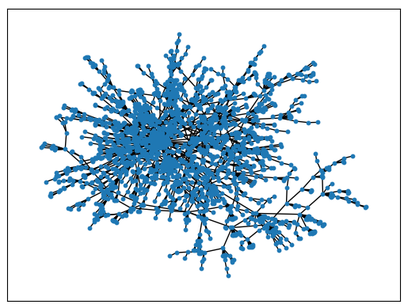

**Commentary:** As described in the algorithm to produce this BA graph, we start with a star graph $S_{5}$. We then add nodes, one at a time, and add an edge from the new node to an existing node in the graph until there are N nodes. This produces the result as seen above, where we see “branches” with many nodes of degree 1. We can see the log-log plot of the degree distribution follows the power law with minimum degree 1.

***N=2000, m0=2, m=2***

**Commentary:** Similar to the discussion above, we begin with $S_{2}$ and add nodes one at a time until N nodes. Each added node will instead have an edge between the new node and 2 existing nodes in the graph. The resulting graph has a minimum degree of 2, as we can see from the drawing and from the degree distribution. We can also see that the log-log plot of the degree distribution follows the power law.