* 1. **“Zachary’s Karate Club”**

Graph:

In the graph above, nodes 1 and 34 are hubs. Notice that all other nodes have a very low degree (1-3). Meanwhile nodes 1 and 34 have a degree of approximately half the size of the network.

* 1. **“Les Misérables”**

Graph: Valjean, Cosette, and Marius are highlighted yellow

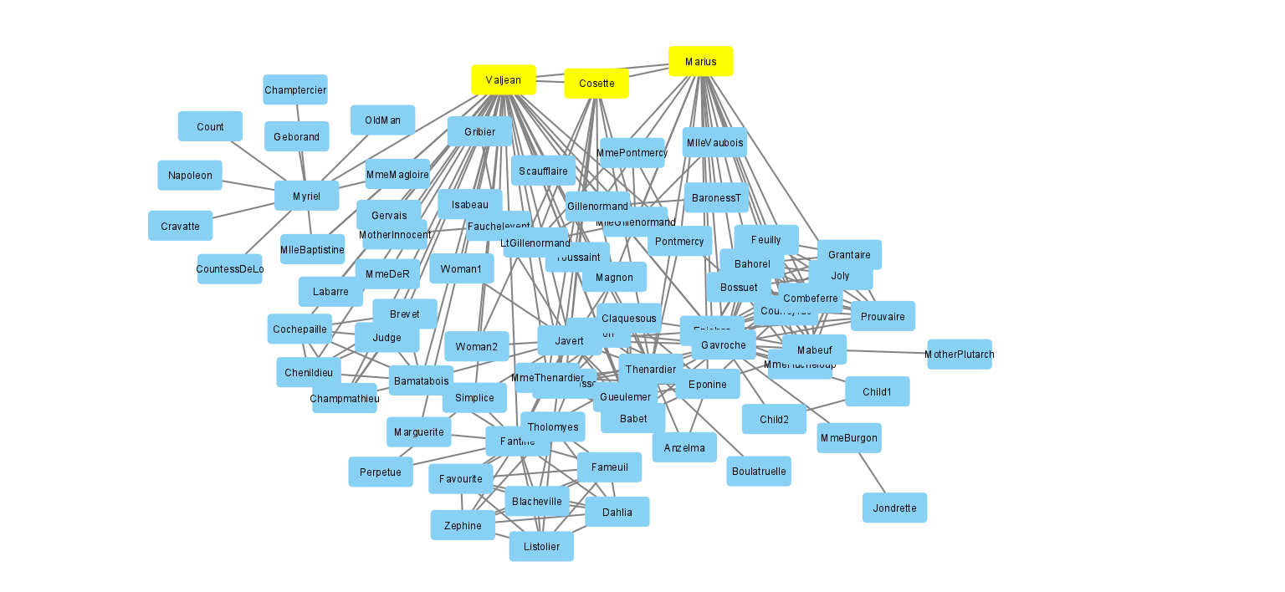

* 1. **US companies co-ownership**

Graph:

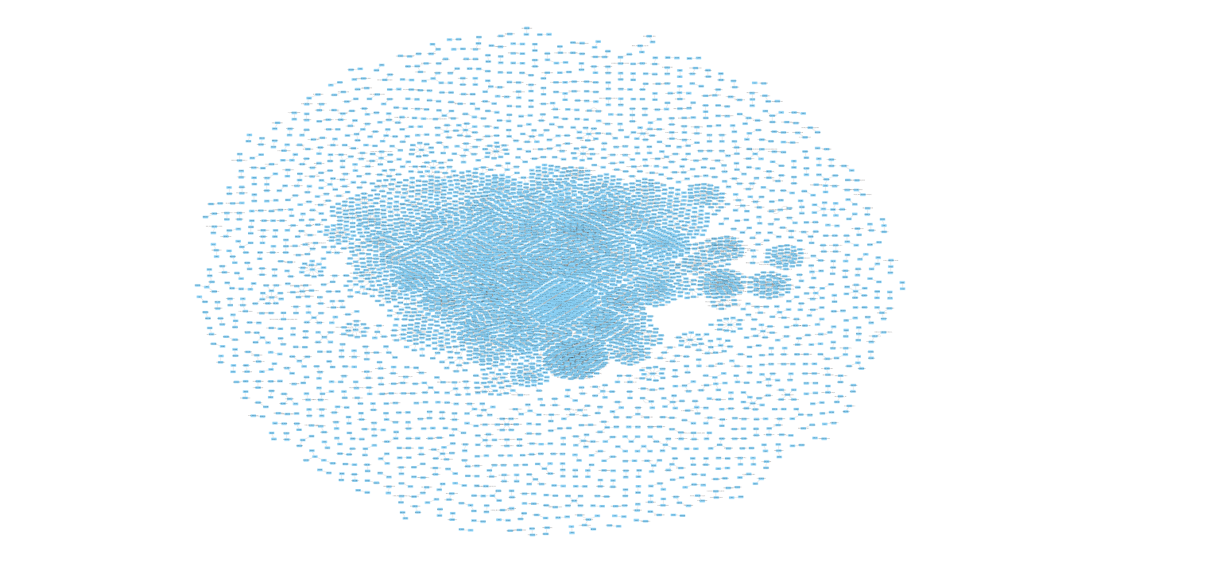

**3.1 Analyze network**

Number of the node with largest betweenness centrality in:

* Karate Club: node 1 with betweenness centrality of 0.4376…
* Les Misérables: node Valjean with betweenness centrality of 0.5699…

**3.2 Plot different distributions**

Degree distributions in Karate Club: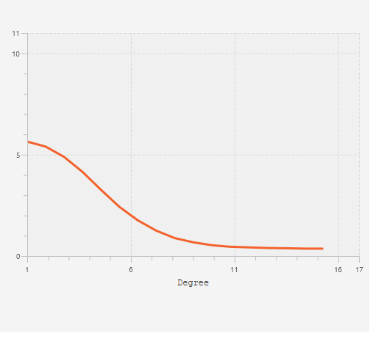

Degree distributions in Les Misérables:

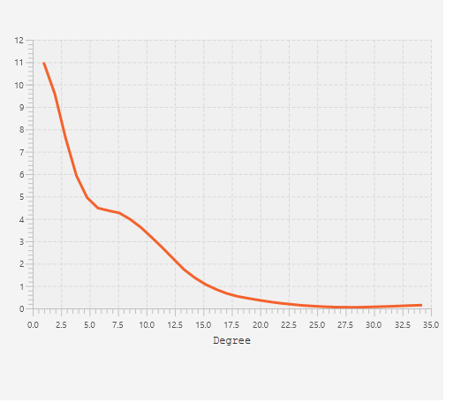

Distribution of shortest path lengths in Karate Club:

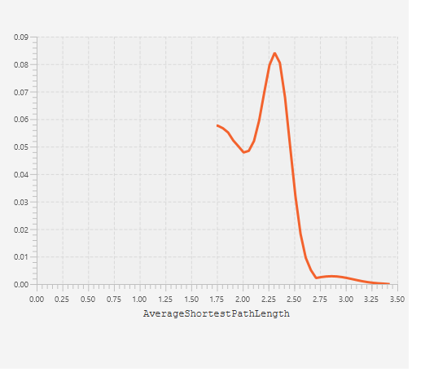

Distribution of shortest path lengths in Les Misérables:

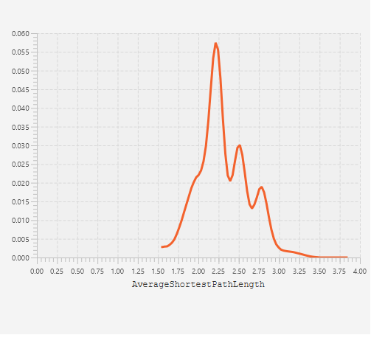

**3.3 Style the network using analysis results**

Les Misérables:

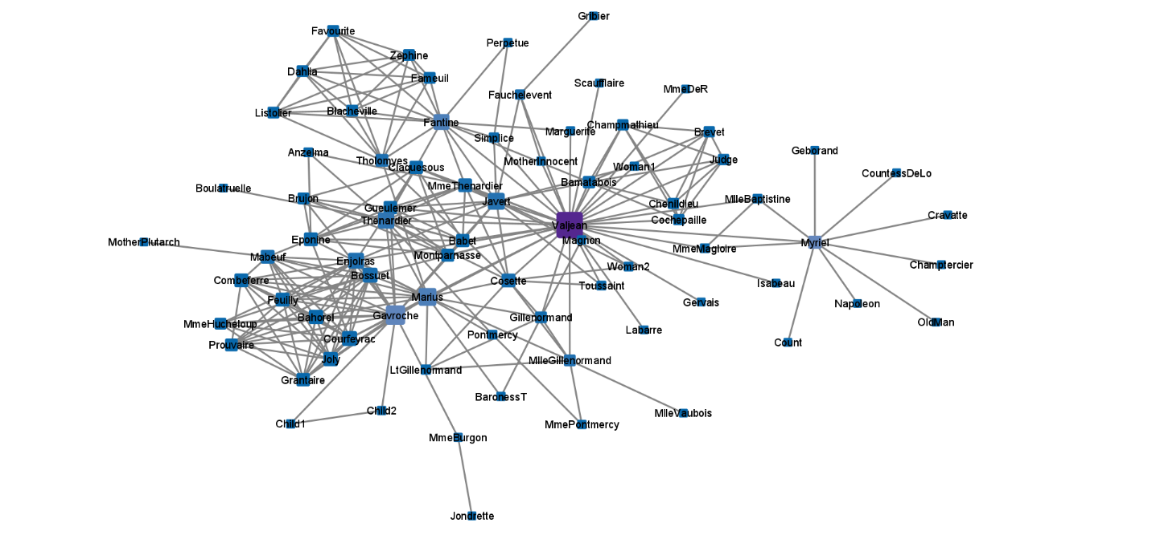

US Companies:

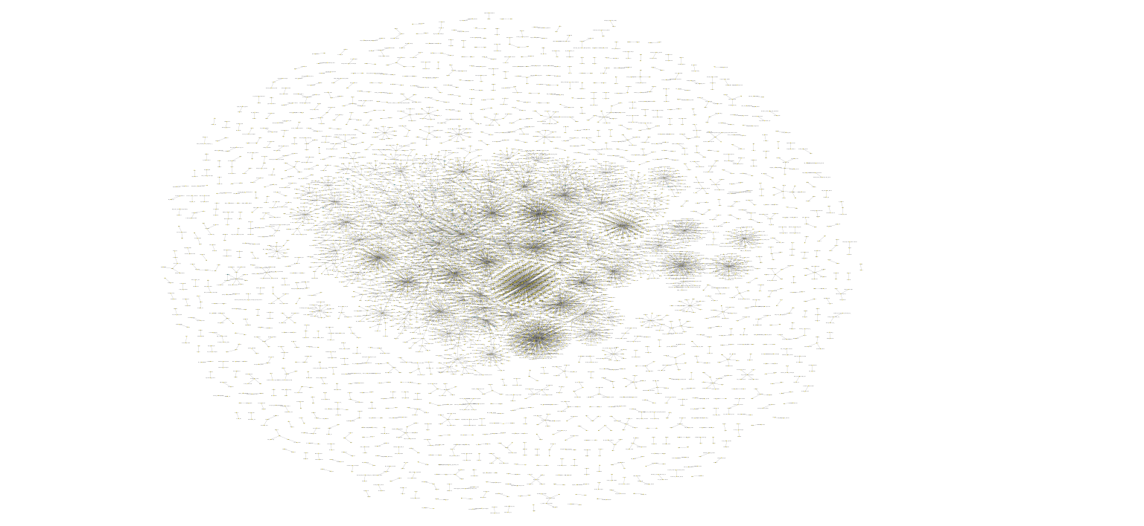

**4.2 Use ClusterMaker2**

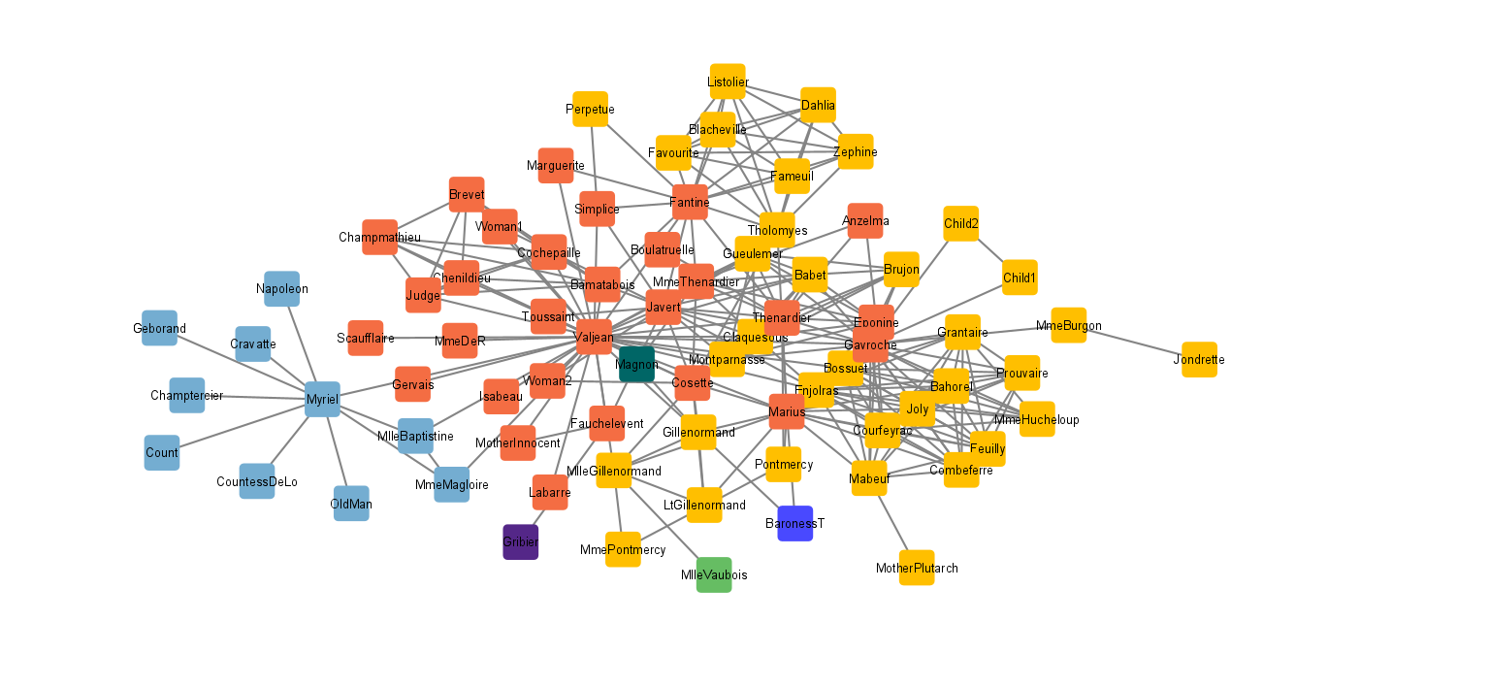

There are 3 main colors: blue, orange, and yellow. I think these clusters represent how much the characters interact with each other.

**4.3 Apply to Karate Club**

The two cluster algorithms I used are Community Clustering (GLay) and Affinity Propagation. I styled the network in such a way that the fill color of the nodes is based on _APCluster and the size of the node is based on _glayCluster. From the image above, I noticed that the neighbors of node 34 are small, and the neighbors of node 1 are big. I believe that the sizes of the nodes represent the different factions in which the Karate Club split.