**Average Cascade Size by Company**

+-----------+----------------------+

| Company | Cascade Size (avg) |

+===========+======================+

| HON | 45.2565 |

+-----------+----------------------+

| MMM | 45.1125 |

+-----------+----------------------+

| WFC | 44.803 |

+-----------+----------------------+

| UTX | 44.6096 |

+-----------+----------------------+

| FLR | 44.2734 |

+-----------+----------------------+

| USB | 44.2639 |

+-----------+----------------------+

| AXP | 44.2458 |

+-----------+----------------------+

| GE | 44.2409 |

+-----------+----------------------+

| DD | 44.1501 |

+-----------+----------------------+

| IFF | 44.1437 |

+-----------+----------------------+

| GD | 43.6184 |

+-----------+----------------------+

| DIS | 43.491 |

+-----------+----------------------+

| AIG | 43.444 |

+-----------+----------------------+

| COL | 43.3449 |

+-----------+----------------------+

| ROK | 43.3017 |

+-----------+----------------------+

| JPM | 43.1786 |

+-----------+----------------------+

| SLB | 43.0535 |

+-----------+----------------------+

| DOW | 42.8011 |

+-----------+----------------------+

| AIT | 42.7636 |

+-----------+----------------------+

| JNJ | 42.7598 |

+-----------+----------------------+

| IP | 42.6484 |

+-----------+----------------------+

| FDX | 42.4093 |

+-----------+----------------------+

| NSC | 42.2844 |

+-----------+----------------------+

| BC | 42.1777 |

+-----------+----------------------+

| BA | 42.1496 |

+-----------+----------------------+

| OXY | 42.1083 |

+-----------+----------------------+

| BAC | 42.0322 |

+-----------+----------------------+

| WY | 41.9759 |

+-----------+----------------------+

| HRS | 41.9117 |

+-----------+----------------------+

| CL | 41.7887 |

+-----------+----------------------+

| AA | 41.6487 |

+-----------+----------------------+

| XRX | 41.5361 |

+-----------+----------------------+

| ORCL | 41.184 |

+-----------+----------------------+

| HAL | 41.0465 |

+-----------+----------------------+

| F | 40.8933 |

+-----------+----------------------+

| AGC | 40.5939 |

+-----------+----------------------+

| MO | 40.1304 |

+-----------+----------------------+

| PEP | 40.0098 |

+-----------+----------------------+

| BAX | 39.9948 |

+-----------+----------------------+

| KO | 39.9908 |

+-----------+----------------------+

| BEL | 39.9207 |

+-----------+----------------------+

| WMB | 39.645 |

+-----------+----------------------+

| T | 39.5467 |

+-----------+----------------------+

| BHI | 39.4563 |

+-----------+----------------------+

| CSC | 39.2258 |

+-----------+----------------------+

| MCD | 39.1536 |

+-----------+----------------------+

| CPB | 39.0603 |

+-----------+----------------------+

| IBM | 38.9561 |

+-----------+----------------------+

| BMY | 38.8815 |

+-----------+----------------------+

| CI | 38.3754 |

+-----------+----------------------+

| PG | 38.2151 |

+-----------+----------------------+

| MRK | 37.7505 |

+-----------+----------------------+

| CHA | 37.1433 |

+-----------+----------------------+

| AEP | 37.0636 |

+-----------+----------------------+

| DAL | 36.011 |

+-----------+----------------------+

| ARC | 35.939 |

+-----------+----------------------+

| AVP | 35.5076 |

+-----------+----------------------+

| UIS | 35.331 |

+-----------+----------------------+

| ETR | 35.0518 |

+-----------+----------------------+

| WMT | 34.9678 |

+-----------+----------------------+

| SO | 34.924 |

+-----------+----------------------+

| S | 27.789 |

+-----------+----------------------+

**Infection graphs from the most viral starting node (HON)**

In the 4 graphs below, we see that HON consistently infects its neighbors, and its neighbors are also consistently infecting other nodes.

Seed = 1: This graph has 51 infected nodes.

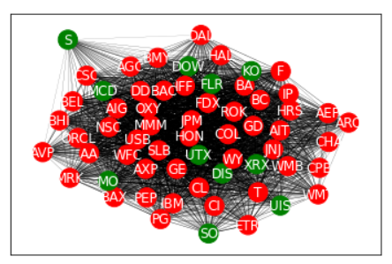

Seed = 2: : This graph has 54 infected nodes.

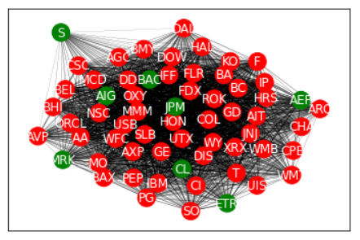

Seed = 3: This graph has 46 infected nodes.

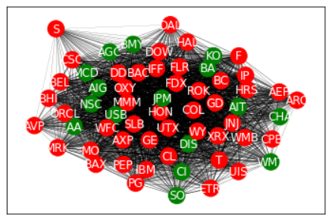

Seed = 4: This graph has 47 infected nodes.

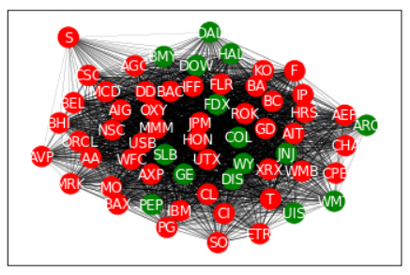

**Infection graphs from the least viral starting node (S)**

Seed = 11: This graph has 41 infected nodes. We can see that only a few neighbors of S were infected. With fewer neighbors infected, there were fewer infected nodes overall.

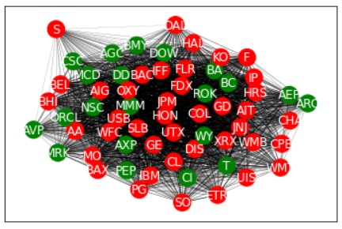

Seed = 12: This graph has 48 infected nodes. We can see that quite a few neighbors of S were infected, hence the increase from seed = 11.

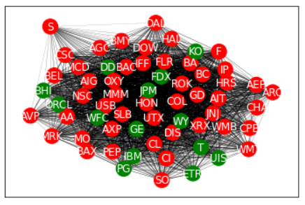

Seed = 13: This graph shows that the starting node, S, failed to infect any of its neighbors, so there is only 1 infected node in the graph.

Seed = 14: Same as above

We can see that from these 4 graphs that sometimes S fails to infect its neighbors. Thus, the average cascade side is skewed left for when none of S’s neighbors are infected.