MindMap

Software Manual

**Table of contents**

1. **Using the MindMap** 
   1. About the MindMap…………………………………………………3
   2. File……………………………………………………………………4
   3. Edit……………………………………………………………………5
   4. Theme…………………………………………………………………6
   5. Adjust…………………………………………………………………7
   6. Zooming feature………………………………………………………8
2. **Using the Card**
   1. Editing description……………………………………………………9
   2. Saving the description………………………………………………9
   3. Upload image…………………………………………………………9
3. **Using the MindMap**

1. **About the MindMap**

The MindMap can be **used** to help you plan and organize your thinking before you start writing or get stuck into a project. With the help of this software, you can develop all your ideas and see where they relate to each other before deciding the best way to go about the task at hand.

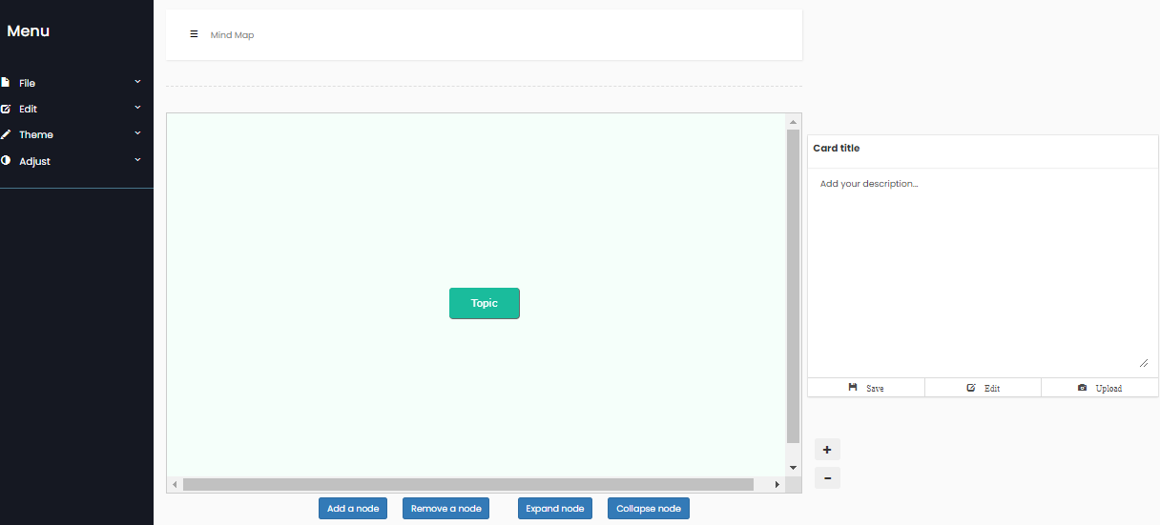

Fig. 01

1. **File**

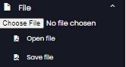

Fig. 02

The **File** option in the sidebar will let the user open or save their data on the MindMap.

* **Open File:** The user can open a previously saved *.json* file with the information saved. This way the user can edit the previous file.
* **Save File:** The user can save and download the information on the MindMap as *.json* file which will allow them to open and edit it later.

1. **Edit**

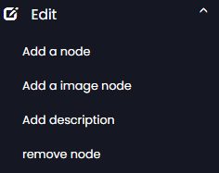

Fig. 03

The **Edit** option will let the user add and modify child nodes on their MindMap.

* **Add a node**: The user can add as many nodes as they wish. The user is given a default parent node and they can start by adding a node from the “Topic” node. The user has to select a node first in order to add another node. In order to rename a node, the user has to double click on the node.
* **Add an image node:** The user has the option to add an image on their node. The image will be displayed inside the node.
* **Add description:** The user can add a description of each node which will be visible on the card beside the MindMap.
* **Remove Node:** The user can remove a selected node if they wish.
  1. **Theme**

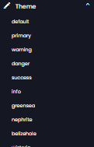

Fig. 04

The **Theme** option allows the user to change the color of the nodes in their MindMap

* The user is given the option to choose from **16** different colors for their nodes. Some examples of the colors are shown on **Fig. 04** above.
  1. **Adjust**

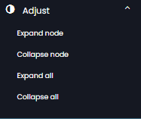

Fig. 05

The **Adjust** option allows the user to expand, collapse each node or the entire MindMap.

* **Expand node:** The user can expand from a selected node that they previously collapsed.
* **Collapse node:** The user can collapse a selected node which will hide all the nodes that were created within that node.
* **Expand all:** The user can expand all the nodes that were collapsed in the MindMap.
* **Collapse all:** The user can collapse all the child nodes that was created from the “Topic” node.
  1. Zooming feature



Fig. 06

The **+**,**-** buttons allows the user to zoom in and out of their MindMap. The user may also use this feature by scrolling the mouse.

1. **Using the Card**

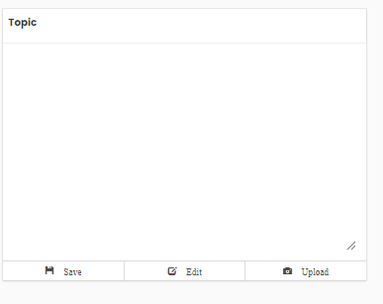

Fig. 07

The **Card** allows the user to add descriptions for each node as well as upload images.

1. Editing description

The user can write a description for each node by clicking the **Edit** button as shown on **Fig. 07** which will allow them to write a description for that node up to any length.

1. Saving the description

The user can save the description they have written which they can view later. The description will also be saved if the user chooses to save their file.