Ahsanullah University of Science and Technology
Department of Computer Science and Engineering

 | 
Project Name : |  | My Property
Couse Name: |  | Database Lab
Couse ID: |  | CSE 3104
Semester : |  | FALL 2018
Student ID : |  | Student Name
160204077 |  | Mir Arif Hasan
160204064 |  | Ashraful Hoque

Introduction:
My property is a software where anyone can find flats/apartments by searching on different parameters. Anyone can book/buy flats on this platform. Also a flat owner can give flats advertisement for his flats. We the one where bachelors also find flats and can get on rent.

Motivation and Objective:
Our objective is to digitalize the flat searching tradition.

Database Tables:

Table 01: Address
Field | Type | Constraint
AddressId | Int | P.K (IS: 1)
City | Varchar(50) | Not Null
Area | Varchar(50) | Not Null
Road | Varchar(5) | Not Null
Block | Varchar(5)
Sector | Varchar(5)
House | Varchar(5) | Not Null

Table 02: Users
Field | Type | Constraint
UsersID | Int | P.K (IS: 3000)
AddressID | int | Not Null
FirstName | Varchar(30) | Not Null
LastName | Varchar(30) | Not Null
phone | Varchar(20) | Not Null
Email | Varchar(30)
Password | Varchar(15) | Not Null

Table 03: Property
Field | Type | Constraint
PropertyID | Int | P.K (IS: 7000,1)
AddressID | Varchar(80) | F.K.(AddressID
OwnerID | Varchar(80) | F.K.(UserID)
BuyerID | Int
Title | Varchar(300) | Not Null
Purpose | Varchar(4) | Not Null
Status | Varchar(15) | Not Null
RentTo | Varchar(15) | Not Null
RentalPrice | Int
AdvancePrice | Int
SellingPrice | Int
Img | Image
Area | Int | Not Null
Bedroom | Int | Not Null
Bathroom | Int | Not Null
Balcony | Int | Not Null
MainView | Varchar(20)
Lift | Int
Parking | Varchar(3)
ElectricityBackup | Varchar(3)
CCTVSecuirity | Varchar(3)
Intercom | Varchar(3)
Description | Varchar(1000)

Table 04: BookRequest
Field | Type | Constraint
OwnerID | Int | F.K.(UsersID)
BuyerID | Int | F.K.(UsersID)
PropertyID | int | F.K.(PropertyID)

Table 05: History
Field | Type | Constraint
HistoryID | Int | P.K.(IS: 10000,1)
OwnerID | Int | F.K.(UsersID)
BuyerID | Int | F.K.(UsersID)
PropertyID | Int | F.K.(PropertyID)
FromDate | dateTime | Not Null
EndDate | dateTime

Entity Relationship Diagram: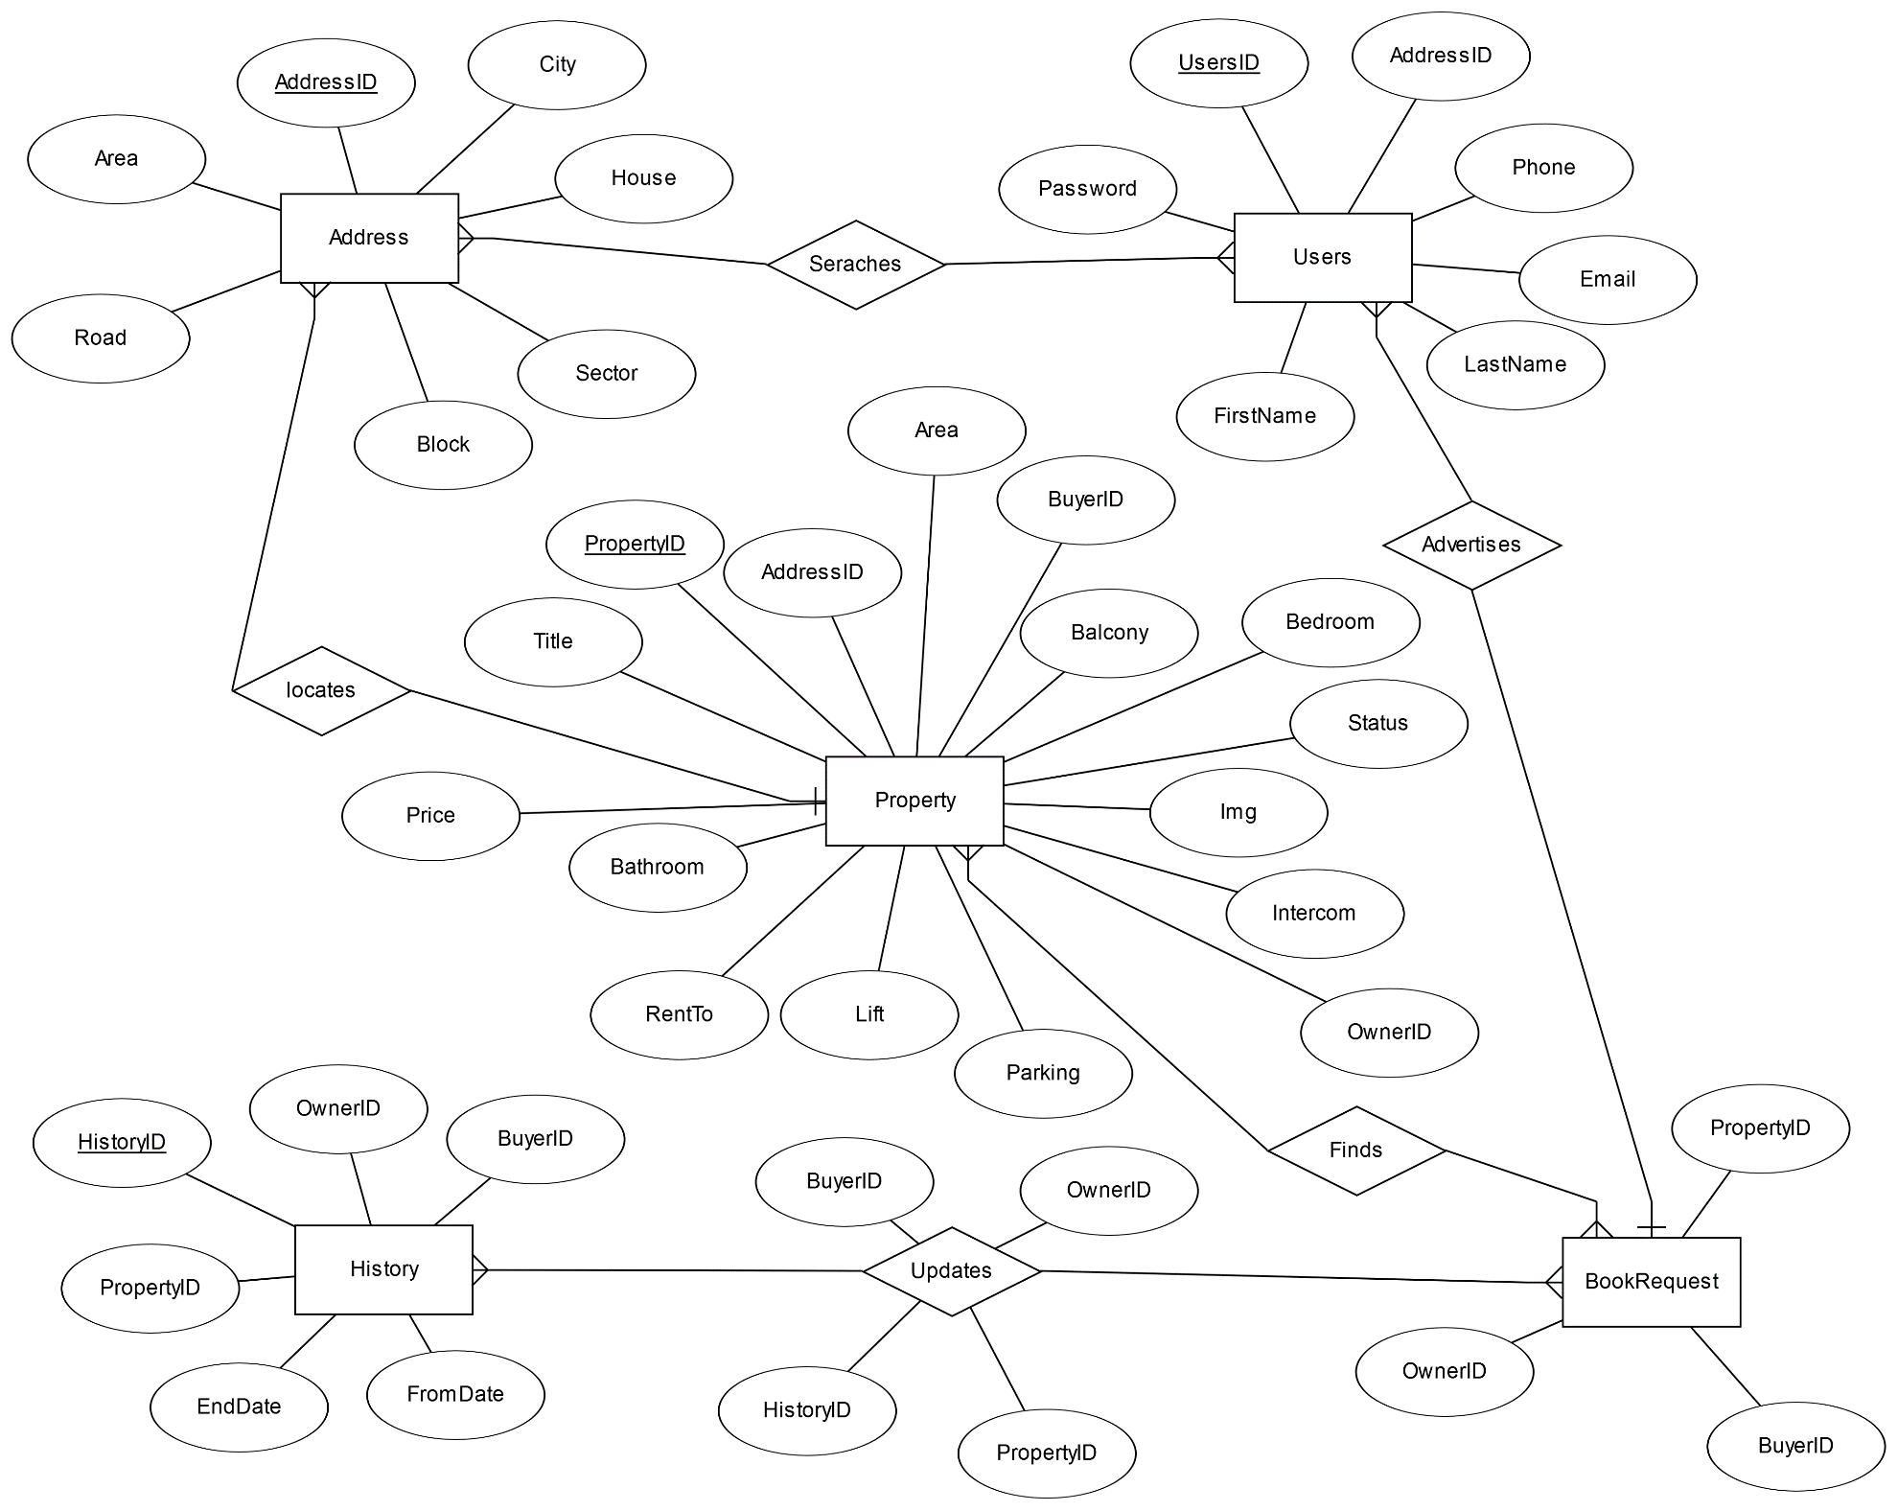

Query Tables Construction

CREATE TABLE Address(
AddressID int IDENTITY(1, 1) PRIMARY KEY,
City varchar(50) NOT NULL,
Area varchar(50) NOT NULL,
Road varchar(5) NOT NULL,
Block varchar(5),
Sector varchar(5),
House varchar(5) NOT NULL
);

CREATE TABLE Users(
UsersID int IDENTITY(3000,1) PRIMARY KEY,
AddressID int NOT NULL FOREIGN KEY REFERENCES Address (AddressID),
FirstName varchar(30) NOT NULL,
LastName varchar(30) NOT NULL,
Phone varchar(20) NOT NULL,
Email varchar(30),
Password varchar(15) NOT NULL
);

CREATE TABLE Property(
PropertyID int IDENTITY(7000,1) PRIMARY KEY,
AddressID int NOT NULL FOREIGN KEY REFERENCES Address (AddressID),
OwnerID int NOT NULL FOREIGN KEY REFERENCES Users (UsersID),
BuyerID int,

Title varchar(300) NOT NULL,
Purpose varchar(4) NOT NULL, --Rent/Sell/Both
Status varchar(15) NOT NULL, --Available or not
RentTo varchar(15) NOT NULL, --Family/Bachalor/Both
RentalPrice int,
AdvancePrice int,
SellingPrice int,
Img image,

Area int NOT NULL, --Sq. Ft.
Bedroom int NOT NULL,
Bathroom int NOT NULL,
Balcony int NOT NULL,
MainView varchar(20), --Ex: South/East etc.

Lift int,
Parking varchar(3), --YES/NO
ElectricityBackup varchar(3), --Yes/No
CCTVSecurity varchar(3), --Yes/No
Intercom varchar(3), --Yes/No
Description varchar(1000)
);

CREATE TABLE BookRequest(
OwnerID int NOT NULL FOREIGN KEY REFERENCES Users (UsersID),
BuyerID int NOT NULL FOREIGN KEY REFERENCES Users (UsersID),
PropertyID int NOT NULL FOREIGN KEY REFERENCES Property (PropertyID)
);

CREATE TABLE History(
HistoryID int IDENTITY(10000,1) PRIMARY KEY,
OwnerID int NOT NULL FOREIGN KEY REFERENCES Users (UsersID),
BuyerID int NOT NULL FOREIGN KEY REFERENCES Users (UsersID),
PropertyID int NOT NULL FOREIGN KEY REFERENCES Property (PropertyID),
FromDate datetime NOT NULL,
EndDate datetime
);

Query Insertion of Data
INSERT INTO Address VALUES ('Dhaka', 'Basabo', '1', '', '', '56');
INSERT INTO Users VALUES ('1', 'Arif', 'Hasan', '01996846517', 'arif.ishan05@gmail.com', '1234')

INSERT INTO Property VALUES ('1', '3000', null, 'Sample room', 'Both', 'Available', 'Any', '10000', null, '16000', null, '1200', '3', '2', '2', 'South', '0', 'Yes', 'No', 'No', 'Yes', 'Good day.');

Insert into BookRequest values ('3002', '3000', '7001')

Insert into History values('"+user.getUsersID()+"', '"+buyerID+"', '"+pid+"', '"+dateFormat.format(date)+"', null, '0')

INSERT INTO Property(AddressID, OwnerID, Title, Purpose, Status, RentTo, RentalPrice, AdvancePrice, SellingPrice, Img, Area, Bedroom, Bathroom, Balcony, MainView, Lift, Parking, ElectricityBackup, CCTVSecurity, Intercom, Description) "
+ "VALUES (?,?,?,?,?,?,?,?,?,?,?,?,?,?,?,?,?,?,?,?,?)

INSERT INTO Address VALUES ('" + address.getCity() + "', '" + address.getArea() + "', '" + address.getRoad() + "', '"+ address.getBlock() + "', '" + address.getSector() + "', '"+ address.getHouse() + "');

Insert into BookRequest values ('"+rs.getInt("OwnerID")+"', '"+user.getUsersID()+"', '"+rs.getInt("PropertyID")+"')

INSERT INTO " + tableName + " VALUES('" + user.getAddressID() + "', '" + user.getFirstName() + "', '" + user.getLastName() + "', '" + user.getPhone() + "', '" + user.getEmail() + "', '" + user.getPassword() + "');

Query for Value Update, Setting Constraints and Rules

UPDATE Property set Title='"+property.getTitle()+"', Purpose='"+property.getPurpose()+"', Status='"+property.getStatus()+"',RentTo='"+property.getRentTo()+"',RentalPrice='"+property.getRentalPrice()+"',SellingPrice='"+property.getSellingPrice()+"',AdvancePrice='"+property.getAdvancePrice()+ "', Area='"+property.getArea()+"',Bedroom='"+property.getBedroom()+"',Bathroom='"+property.getBathroom()+"', Balcony='"+property.getBalcony()+"', MainView='"+property.getMainView()+"', Lift='"+property.getLift()+"', Parking='"+property.getParking()+
"', ElectricityBackup='"+property.getElectricityBackup()+"', CCTVSecurity='"+property.getCCTVSecurity()+"', Intercom='"+property.getIntercom()+"', Description='"+property.getDescription()+"' WHERE PropertyID='"+property.getPropertyID()+"';";
statement.execute(sql);

"Update Property set BuyerID=NULL where PropertyID='"+property.getPropertyID()+"'";

Update History set EndDate='"+dateFormat2.format(date2)+".000', Flag='1' where PropertyID='"+property.getPropertyID()+"' and Flag='0'"Query for Aggregate functions you have used

Screen Shots of my project interface design:

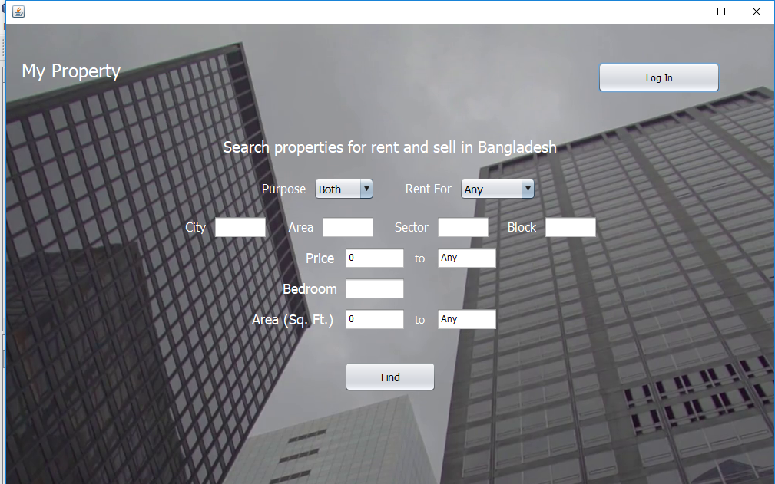
Image 01: Home Page

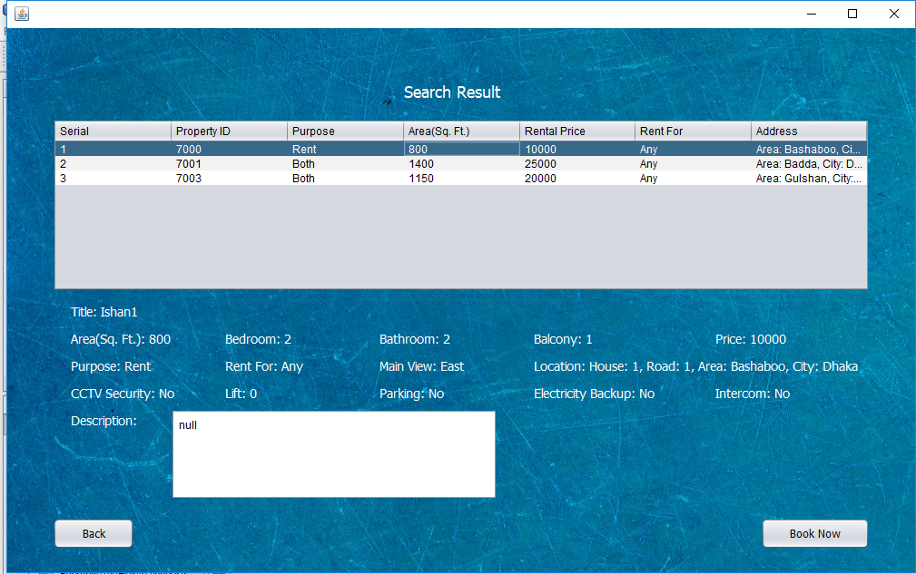
Image 02: Search result page

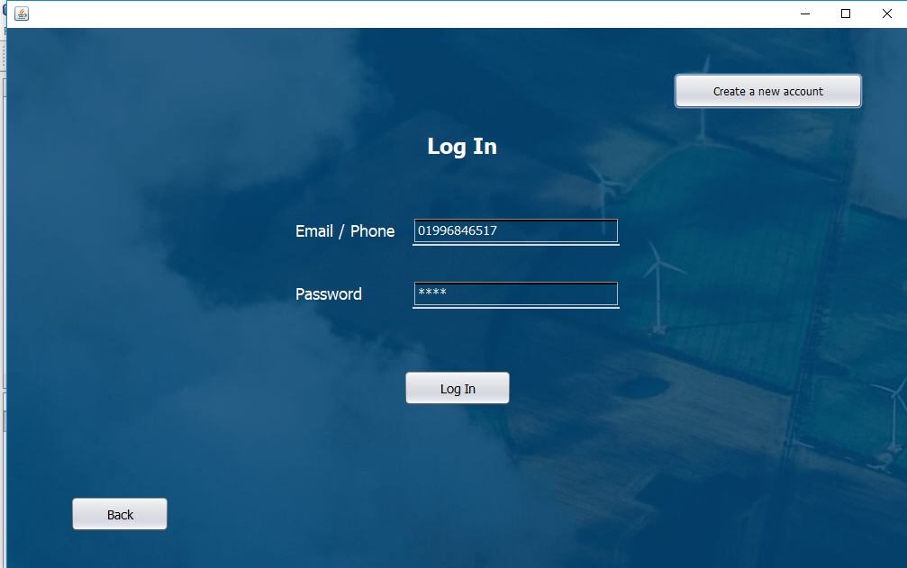

Image 03: login page

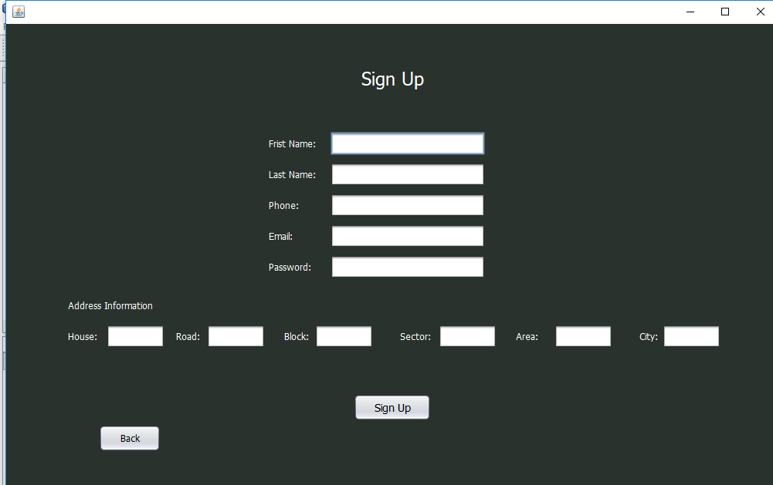
Image 04: Sign up page

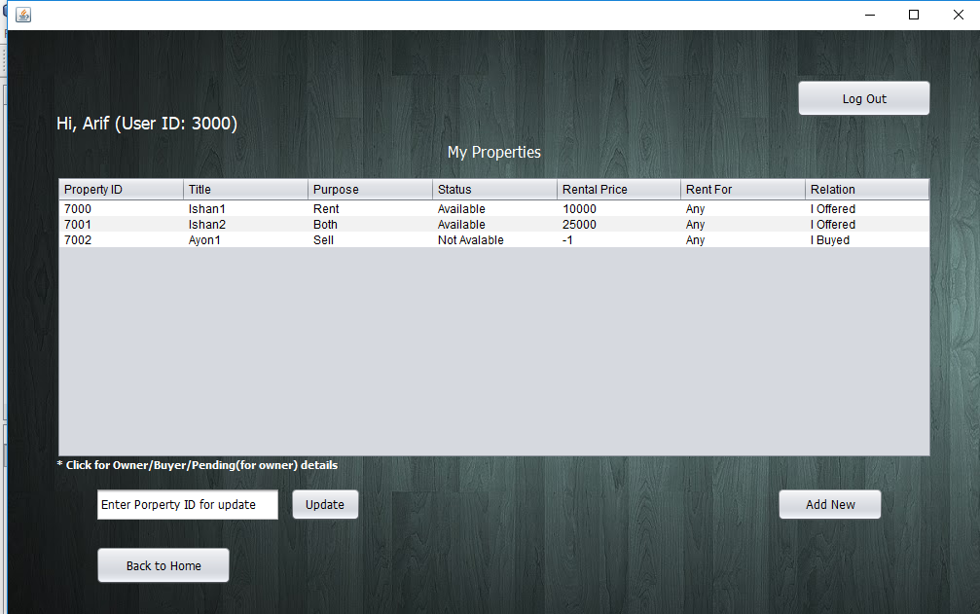
Image 05: Profile page

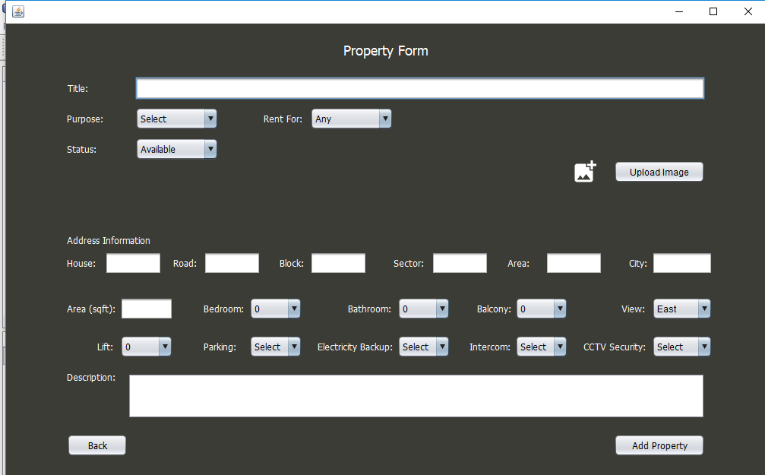
Image 06: Property Form

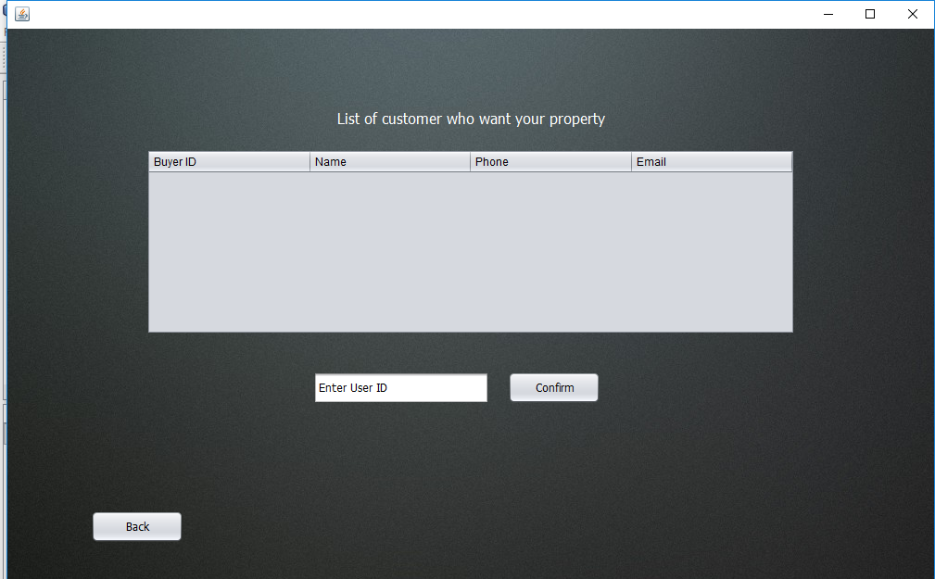
Image 07: List of buyer who want to buy

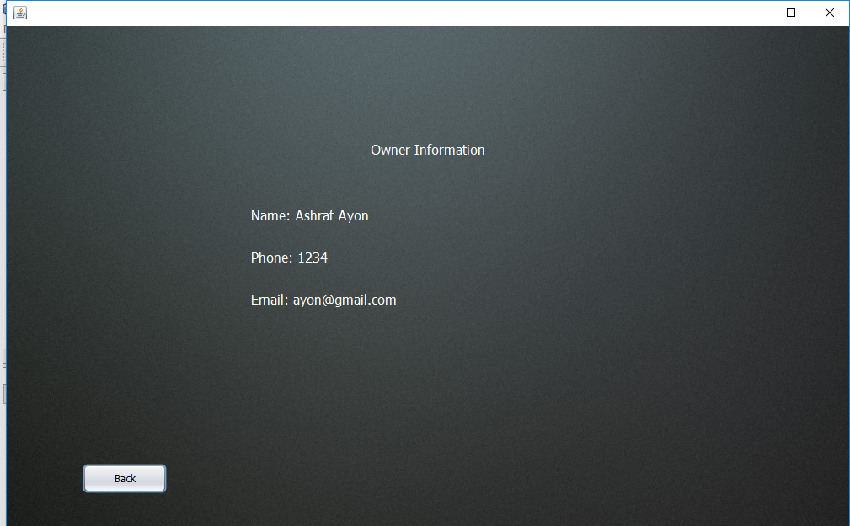
Image 08: List of Owner/ Buyer Information Page

Conclusion:
Our future goal is to integrate Real Estate Company. That’s way we choose to reduce peoples flat searching troubles.

Contribution:

