**Assignment #1. HTML Basics (Page Structure)**

Student: Nurgazy Miras

Group: IT-2402 **Part 1. Introduction to HTML**

**Step 0. Create a new HTML file named index.html**

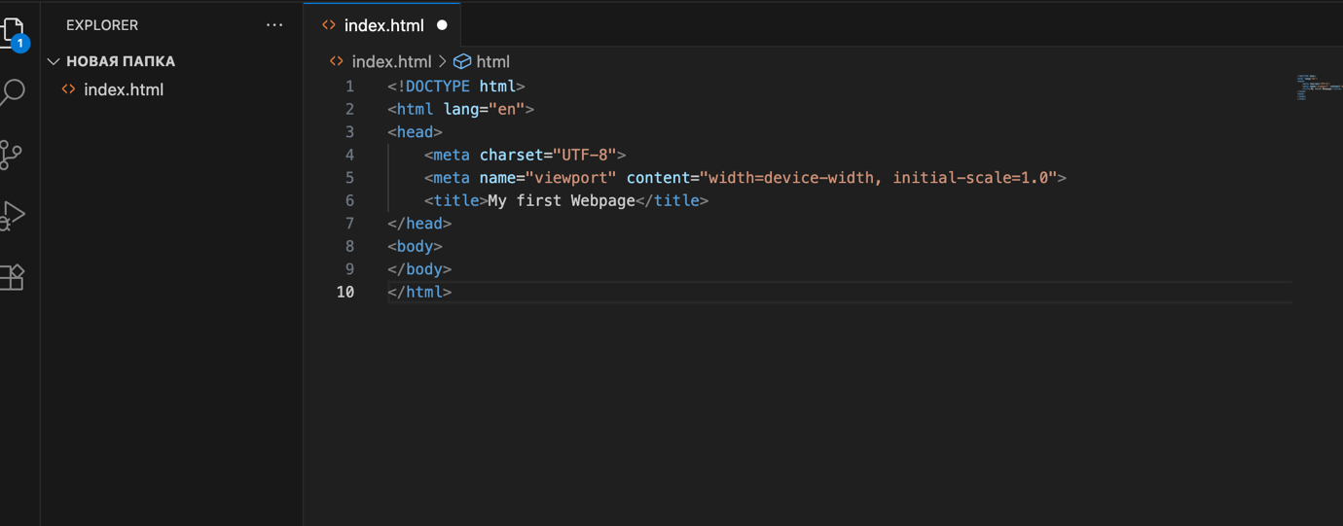

**Step 1. Structure text using HTML tags**

* Add headings <h1> to <h3> with your name, course, and "About Me".
* Add a short paragraph <p> describing yourself.

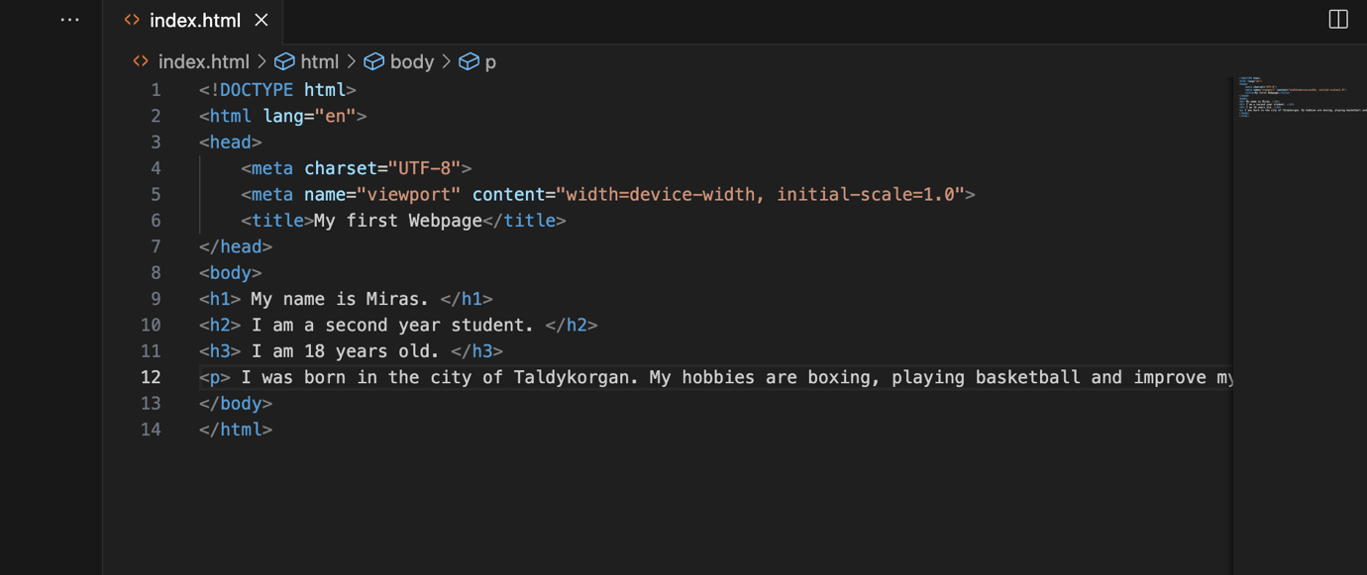

**Step 2. HTML Lists**

* Create an ordered list <ol> of your hobbies.
* Create an unordered list <ul> of your favorite websites.
* 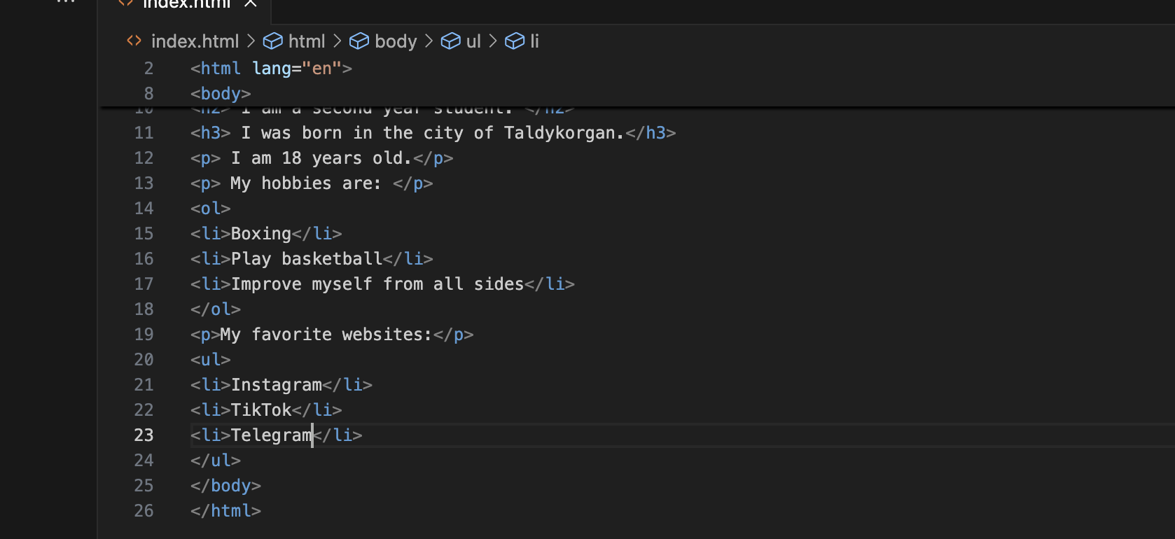

**Step 3. Images and Links**

* Insert your photo using the <img> tag.
* Add at least two clickable links with <a> (e.g., to your favorite websites).

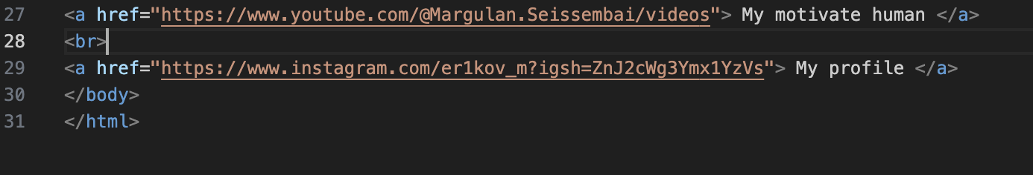

**Step 4. HTML Buttons**

* Add a simple button with text "Click Me". (No functionality required yet).
* 

**Part 2. Intermediate HTML**

**Step 5. Tables**

* Create a table with 3 columns: "Subject", "Day", "Time".

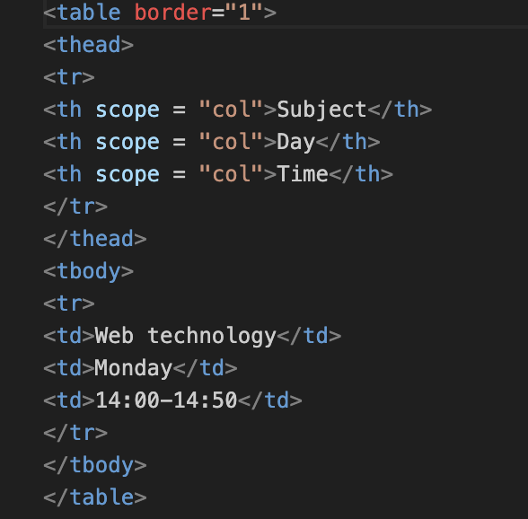

* Fill in a simple weekly class schedule.

Изображение выглядит как текст, снимок экрана, программное обеспечение, Мультимедийное программное обеспечение

Содержимое, созданное искусственным интеллектом, может быть неверным.

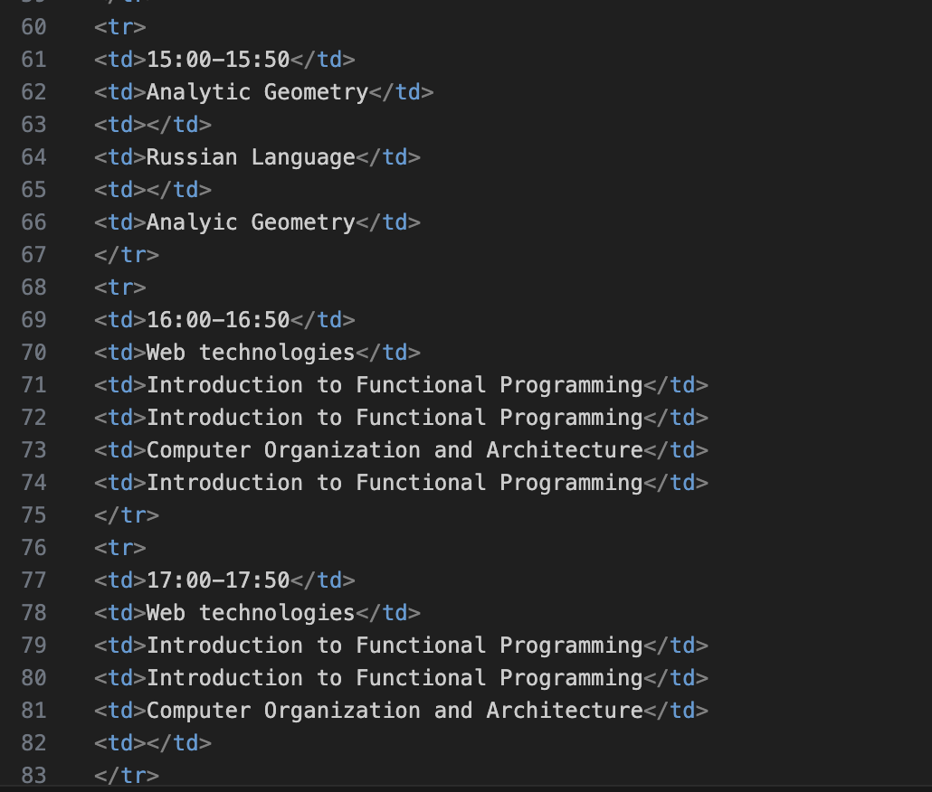

**Step 6. Using Tables for Layout (Optional Challenge)**

* Create a two-column layout using a table: left column (menu), right column (main content).

**Step 7. Typing Emojis**

Add at least 3 emojis inside a paragraph about your mood today.



**Step8. HTML Forms**

* Create a form with the following fields:
  + Name (text input)
  + Email (email input)
  + Favorite Color (color input)
  + A Submit button

