Assignment #2. CSS Styling (Colors, Fonts, Layout)

Student: Miras Nurgazy

Group: IT-2402

Objective:

By the end of this assignment, students will be able to:
- Understand how to apply styles using CSS (inline, internal, external).
- Use selectors, classes, and IDs effectively.
- Apply CSS properties to control colors, fonts, and layout.
- Work with intermediate concepts like the box model, positioning, and float/clear.
- Create a styled multi-page website using HTML + CSS.

Part 1. Introduction to CSS

Task 1. Inline CSS

- Change the color of one paragraph using inline style (e.g. style="color:blue;")
.

Task 2. Internal CSS
- Inside <head>, use <style> to define rules (e.g., set body background color, change heading font).
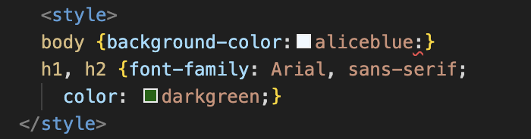

Task 3. External CSS
- Create a file style.css.
- Link it to your HTML with <link rel="stylesheet"
href="style.css">.

- Move your CSS rules into this file.

- 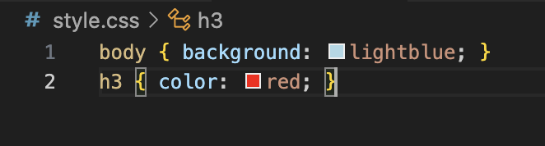

Task 4. CSS Syntax & Selectors
- Use element selectors (e.g., p {}), class selectors (.classname {}), and ID selectors (#idname {}).

- Apply different colors and fonts to show the difference.
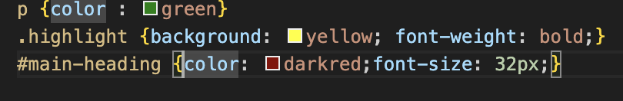

Task 5. Classes vs. IDs
- Create a class .highlight to style multiple elements.
- Create an ID #main-heading to style your main <h1>.

Part 2. Intermediate CSS

Task 6. Favicons
- Add a small favicon to your site using:
<link rel="icon" type="image/png" href="favicon.png">

Task 7. HTML Divs
- Use <div> to group content into sections (header, main content, footer).
- Style them with background colors and padding.
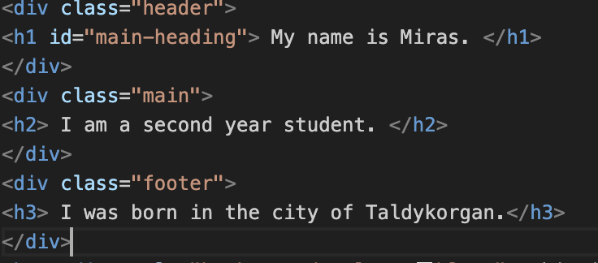

Task 8. Box Model
- Add borders, margins, and padding to some elements.
- Experiment with different values to see spacing effects.

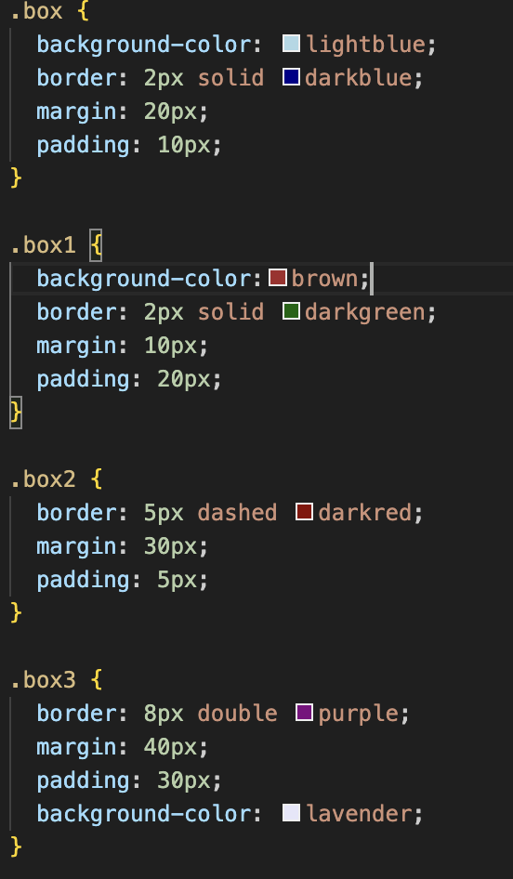

.box {
background-color: lightblue;
border: 2px solid darkblue;
margin: 20px;
padding: 10px;
}

.box1 {
background-color:brown
border: 2px solid darkgreen;
margin: 10px;
padding: 20px;
}

.box2 {
Task 9. CSS Positioning
- Create one element with static position (default).
- Another with relative (shifted slightly).
- Another with absolute (fixed relative to page).
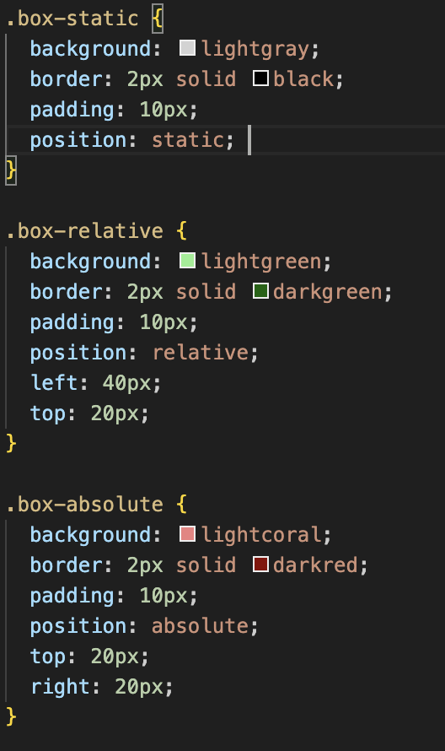

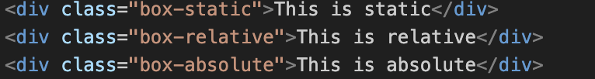
Task 10. CSS Sizing
- Use px, %, em, and rem units to style headings and images.

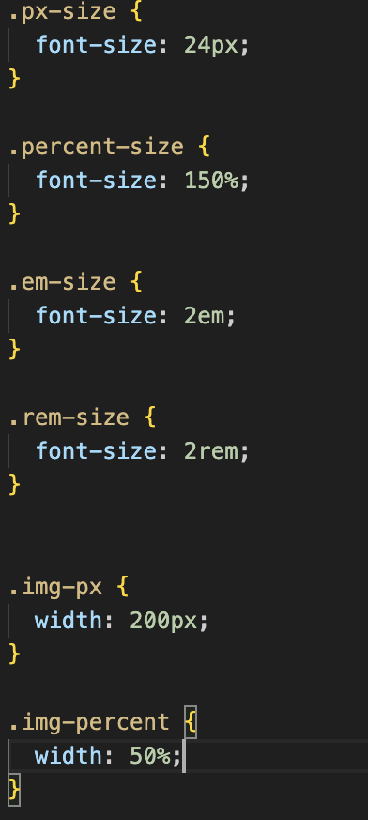

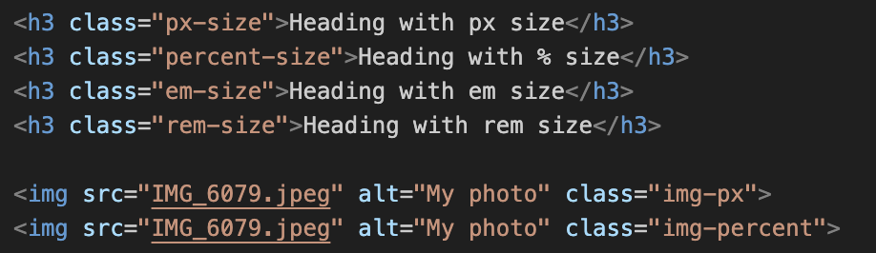

Task 11. Float and Clear
- Create a simple layout with two boxes floated left and right.
- Use clear to fix overlapping issues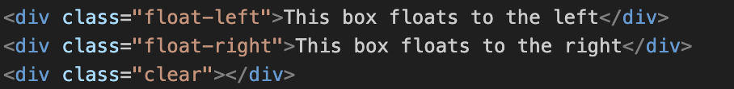.
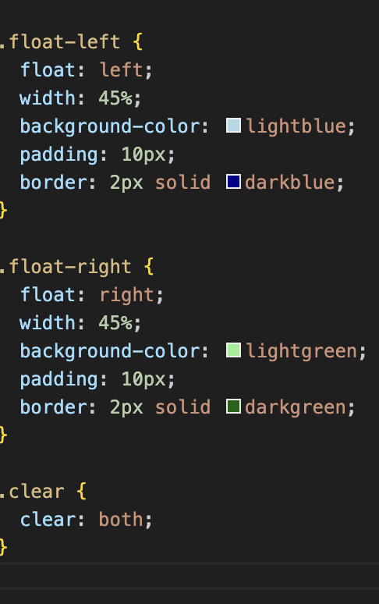

Summary:
In this assignment I created my first personal website using HTML and CSS.
I learned how to use inline, internal, and external CSS to style my page.
I practiced with selectors, classes, and IDs to change colors, fonts, and layout.I added different elements: headings, lists, images, links, a button, a table, emojis, and a form.
I also used the box model with borders, margins, and padding.
Then I tried positioning (static, relative, absolute) and changed element sizes with px, %, em, and rem.
Finally, I made two boxes with float left and right, and used clear to fix the layout.This work helped me understand the basics of CSS and how to make a simple website look better.

